**IMMANUEL UNITED CHURCH OF CHRIST**

**July 27, 2025**

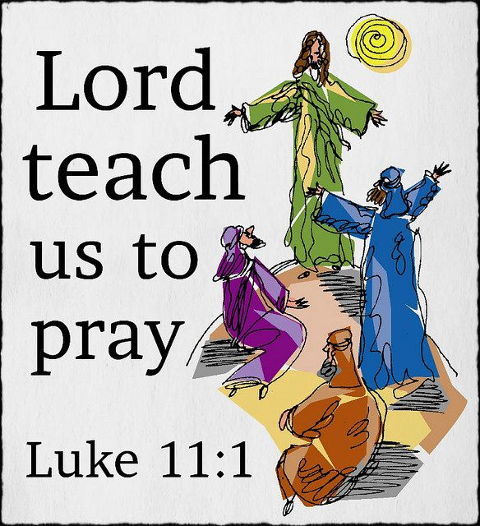

**5812 Ford Rd. N. Mt. Vernon, IN 47620 (812) 985-3115**

**Facebook:** Immanuel United Church of Christ **Church Website:** [www.immanueluccmv.com](http://www.immanueluccmv.com)

**Church Email:** [info@immanueluccmv.com](mailto:info@immanueluccmv.com) **Administrative** **Assistant:** Janie Meinschein

**Our Vision? *“To grow a vibrant church by sharing Christ with the community . . .”***

**Our Mission? *“To invite, inspire, involve, increase . . .”***

**Seventh Sunday after Pentecost**

July 27, 2025

**RINGING OF THE BELL** Keith Deig

**WELCOME AND WORDS OF GREETING** Angela Clark

**PRELUDE “Quiet Meditation”** By Colin Mawby

**\*CALL TO WORSHIP** (Based on Psalm 138)Angela Clark

Leader: I will give the Lord thanks with my whole heart.

**People: Before all the gods of this world I will sing God's praise.**

Leader: I will give thanks for God’s steadfast love and faithfulness for God’s name and word is exalted above everything.

**People: When I called upon the Lord, God answered, and my soul was strengthened.**

Leader: Though I walk in the middle of trouble, God preserves me against the anger of my enemies. God stretches out his hand and delivers us.

**People: God's steadfast love endures forever. Let us rejoice and be glad in him, both now and forevermore. Amen.**

**\*OPENING HYMN #381** ***“All People That on Earth Do Dwell”***

**\*PRAYER OF INVOCATION** (Unison)Angela Clark

**Loving and caring God, we are here to worship you, to be fed, to learn, and to act. We praise you and we thank you. You hear our calls, questions, and laments and are always faithful to answer. Be present with us now, O God. Let your Holy Spirit flow over and through us. Help us to conform our hearts, our minds, and our wills to your endless acceptance and graciousness. Strengthen us and guide us. Make all of humanity into one family – a family of joy and of love, of comfort and of hope. We ask it in the name of Jesus, our Lord and our Savior, our brother and our friend. Amen.**

**\*GLORIA PATRI**

***Glory be to the Father, and to the Son, and to the Holy Ghost;***

***As it was in the beginning, is now, and ever shall be,***

***world without end. Amen.***

**SCRIPTURE – Luke 11:1-13** Angela Clark

**1**He was praying in a certain place, and after he had finished, one of his disciples said to him, “Lord, teach us to pray, as John taught his disciples.” **2**So he said to them, “When you pray, say: Father, may your name be revered as holy. May your kingdom come. **3**Give us each day our daily bread.**4**And forgive us our sins, for we ourselves forgive everyone indebted to us. And do not bring us to the time of trial.”

**5**And he said to them, “Suppose one of you has a friend, and you go to him at midnight and say to him, ‘Friend, lend me three loaves of bread, **6**for a friend of mine has arrived, and I have nothing to set before him.’ **7**And he answers from within, ‘Do not bother me; the door has already been locked, and my children are with me in bed; I cannot get up and give you anything.’ **8**I tell you, even though he will not get up and give him anything out of friendship, at least because of his persistence he will get up and give him whatever he needs.

**9**“So I say to you, Ask, and it will be given to you; search, and you will find; knock, and the door will be opened for you. **10**For everyone who asks receives, and everyone who searches finds, and for everyone who knocks, the door will be opened. **11**Is there anyone among you who, if your child asked for a fish, would give a snake instead of a fish? **12**Or if the child asked for an egg, would give a scorpion? **13**If you, then, who are evil, know how to give good gifts to your children, how much more will the heavenly Father give the Holy Spirit to those who ask him!”

Leader: Good News can be found here.

**People: We will search and find. Amen.**

**STORYTIME – All Ages and Stages**  *“Knock, Knock”*Rev. Jason Emmerson

**HYMN #51** ***“I Heard the Voice of Jesus Say”***

**LORD’S PRAYER LITANY**

Leader: Join me in our Lord’s Prayer Litany.  
Our Father in heaven, holy and majestic is your name.

**People: Mystery beyond our knowing and yet as close to us as our breathing, in humble admiration, we pray.**

Leader: Your Kingdom come, your will be done, on earth as in heaven

**People: We pray for your “Good News” vision of justice and mercy to be made real in our world – even now.**

Leader: Give us today our daily bread.

**People: We pray for your vision that all may have enough; enough sustenance, enough warmth, enough shelter, enough healing for all of your children – in this community, in California, in Texas, in Gaza, in Ukraine – among our neighbors, our brothers and sisters, everywhere.**

Leader: Forgive us for our sins, as we forgive those who sin against us. Lead us not into temptation and deliver us from the evil we do, and the evil done to us.

**People: We pray for the grace to let go of our grudges and shame – all that which hurting our full embrace your vision for goodness and forgiving life. We pray that we might follow you, Lord, safely through the obstacle courses of life.**

Leader: For the kingdom, the power and the glory are yours, Lord. Now and forever.

**People: We give thanks, Lord, for being present and for being surround by your amazing presence – one that defies definition in this life and beyond.**

Leader: Be with us. Hear our prayers. Amen.

**People: Comfort us and give us strength. Amen.**

**SERVICE OF GIVING**

**Invitation**

Leader: We are to be people of generosity, healing, and peace. Our gifts enable our collective ministry and mission to be a growing, vibrant witness for God. Let us give.

**Offertory “Gentle Breeze”** By Colin Mawby

\***Response No. 382**

***Praise God, from whom all blessings flow;***

***Praise Him, all creatures here below;***

***Praise Him above, ye heavenly host;***

***Praise Father, Son, and Holy Ghost. Amen.***

**\*Prayer of Dedication** (Unison)

**Giving God, we commit these gifts into your hands and our ourselves into your loving care. We dedicate our work to your service and our homes to your praise. We promise you that we will do our best in all that we say and do. Bless us that we may be a blessing to others. We ask it through Jesus Christ. Amen**

**SCRIPTURE – Luke 10:38-42**

Leader: Our second reading is from Luke, chapter 10, verses 38 to 42.

**38**Now as they went on their way, he entered a certain village where a woman named Martha welcomed him. **39**She had a sister named Mary, who sat at Jesus’s feet and listened to what he was saying. **40**But Martha was distracted by her many tasks, so she came to him and asked, “Lord, do you not care that my sister has left me to do all the work by myself? Tell her, then, to help me.” **41**But the Lord answered her, “Martha, Martha, you are worried and distracted by many things, **42**but few things are needed—indeed only one. Mary has chosen the better part, which will not be taken away from her.”

Leader: The Word of God for the People of God.

**People: Thanks be to God. Amen.**

**SERMON “Don’t Hang Up”** Rev. Jason Emmerson

**\*CLOSING HYMN** **#507 *“Come, All Christians, Be Committed”***

**\*BENEDICTION**

Leader: For all that you have given to us, Father, we thank you. For all that you have revealed to us, Jesus, we praise you. For all that you have commanded, Holy Spirit, we pledge our obedience.

**People: For all that we are called to do, we commit ourselves anew as we go into the world as your people, the body of Christ. Amen.**

**\*BENEDICTION SONG *“Lord of Life, Lord of Love”***

**Lord, of life, Lord of Love, Walk forever beside us.**

**Day by Day, Show the Way, With your Vision to guide us,**

**Striving to Follow Your Will and Way, Nothing can divide us,**

**Lord of Life, Lord of Love, Walk forever beside us.**

**POSTLUDE “God Will Take Care of You”** By Martin

arr. By A.C. Whiteworth

Used by Permission. CCLI License # 20658309, Streaming # 20658316

**+++++++++++++++++++++++++++++++++++++++++++++++++++++++++++++++++++++++++++++**

**Today** **August 3**

|  |  |  |
| --- | --- | --- |
| Lay Leader:  Ushers/Greeters:  Pianist/Organist:  Children’s Moments: | Angela Clark  Chris Moers  Gail Angel  Rev. Jason Emmerson | OPEN  OPEN  OPEN  Rev. Robert Walker |

**OUR IMMANUEL UCC PRAYER LIST**

***\*Charles Behrick*** ***\*David Behrick******\*Cherry Chase******\*Janice Jones***

***Ken Willett******David Frye Kenny Meinschein***

***Teresa Topper*** *(Friend of Chris Moers)* ***Tom Howard*** *(Brother of Angela Clark)*

***Kiersten Ferguson-Cremin*** *(Niece of Paula Boarman)*



We invite you to sign our Guest Book,

located in the Narthex., as well as the

attendance book in the pews.

 ***TODAY***

***We welcome our Guest Minister:***

***Rev. Jason Emmerson***

***With Angela Clark as Lay Leader***

**ADULT SUNDAY SCHOOL** will resume next Sunday.

**LUNCH BUNCH** – Wednesday, July 30th at 12 noon at Tequila’s. Everyone is welcome!!



|  |
| --- |
| **Tequila's Mexican Restaurant 10915 Baymeadows Road - Order Pickup and ...**  **LUNCH BUNCH AT TEQUILA’S**  Wednesday, July 30th at 12:00 noon  Co-leaders of Lunch Bunch are Betty Schuessler and Ruth Duckworth.  *Lunch Bunch meets monthly on the last Wednesday of the month  Mark your calendars! |
| **Gentle Exercise Class . . . designed for 40+**  Every **Thursday morning at 9:30** **am** in the Fellowship Hall  Breath & Movement 45 mins~  Discussion on creating a positive mindset 15 min~  Led by De Brown, certified Yoga Instructor and Immanuel UCC member!  *Suggested donation: $5- |
| Join Us Next Sunday | Igniter Media | WorshipHouse Media  ***Next Sunday, August 3rd***  ***Guest Minister: Rev. Robert Walker*** |



**SUNDAY** **27th**  **SEVENTH SUNDAY AFTER PENTECOST**

NO ADULT SUNDAY SCHOOL

10:00 a.m. Worship

5:30 p.m. – 6:30 p.m. AA Meeting

**MONDAY 28th**

**TUESDAY** **29th**

**WEDNESDAY** **30th** 12:00 p.m.Lunch Bunch at Tequila’s

**THURSDAY** **31st** 9:30 a.m. Gentle Exercise Class

**FRIDAY** **1st**

**SATURDAY** **2nd**

**SUNDAY** **3rd EIGHTH SUNDAY AFTER PENTECOST**

9:00 a.m. Adult Sunday School

10:00 a.m. Worship & Communion

5:30 p.m. – 6:30 p.m. AA Meeting



*July 28 – Charles Naab*

*August 2 – Rose Brighton Wagner*



*August 2 – Eliza & Robert Boarman*