IMMANUEL UNITED CHURCH OF CHRIST
July 19, 2026 @ 10:00 a.m.

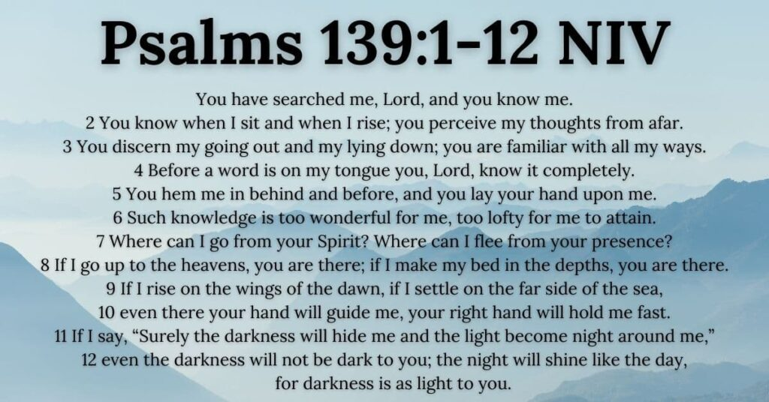

5812 Ford Rd. N. Mt. Vernon, IN 47620 (812) 985-3115
Facebook: Immanuel United Church of Christ Church Website: www.immanueluccmv.com
Church Email: info@immanueluccmv.com Secretary: Janie Meinschein (812) 483-3578
Council President: Bret Baldwin (930) 465-5471
Our Vision? “To grow a vibrant church by sharing Christ with the community . . .”
Our Mission? “To invite, inspire, involve, increase . . .”

Eighth Sunday after Pentecost

July 19, 2026 – Guest Speaker: Billy Thompson

RINGING OF THE BELL Keith Deig

WELCOME AND ANNOUNCEMENTS Bret Baldwin

PRELUDE

*PRAISE HYMN #2025 (black hymnal) “As The Deer”

*CALL TO WORSHIP Bret Baldwin

Lay Leader: God is mighty in word and deed.

People: God’s mercy is everlasting.

Lay Leader: Blessed be the Holy and Living God!

People: Glory to God forever!

*OPENING HYMN #616 “Stand up, Stand Up for Jesus”

*PRAYER OF CONFESSION (Unison) Bret Baldwin

Holy God, you call us to boldly proclaim your name. Too often we fail to do so. Forgive us. By the power of your Spirit, give us courage, and lead us away from fear to new life. May we return to faithful living, in Christ’s name we pray. Amen.

*WORDS OF ASSURANCE Bret Baldwin

Listen to the Good News:
God’s grace and mercy are never ending. Our sins are forgiven!
Praise be to God!

*GLORIA PATRI
Glory be to the Father, and to the Son, and to the Holy Ghost;
As it was in the beginning, is now, and ever shall be,
world without end. Amen.

CHILDREN’S MOMENTS

PRAYERS OF THE PEOPLE Billy Thompson
Pastoral Prayer ~ Lord’s Prayer

SERVICE OF GIVING Bret Baldwin

Lay Leader: God’s goodness overflows. Let us bear witness to the love of God and
present our offerings of thanksgiving to our loving God with generous hearts.

Offertory

*Response #515 “We Give Thee But Thy Own” (vs 1)

We give Thee but Thine own,
What-e’re the gift may be:
All that we have is Thine alone,
A trust, O Lord, from Thee.

*Prayer of Dedication (In Unison) Bret Baldwin

Gracious God, may we remember that all we have is a gift from you. Pour out your Spirit upon these gifts that they may increase your blessings to others through the grace and mercy of Christ. Amen.

SCRIPTURE – Psalm 139: 1-12 Bret Baldwin
See Front Cover of Bulletin

SERMON HYMN #443 “I Need Thee Every Hour”

SERMON “Facts, Faith, and Feelings” Billy Thompson

*CLOSING HYMN #67 “Blessed Assurance, Jesus Is Mine”

*BENEDICTION Billy Thompson

*BENEDICTION SONG “Let There Be Peace on Earth”

Let there be peace on earth and let it begin with me;
let there be peace on earth, the peace that was meant to be.
With God our Maker, family all are we.
Let us walk with each other, in perfect harmony.

Let peace begin with me, let this be the moment now.
With every step I take, may this be my solemn vow:
To take each moment and live each moment
in peace eternally.
Let there be peace on earth, and let it begin with me.

POSTLUDE
Used by Permission. CCLI License # 20658309, Streaming # 20658316

+++++++++++++++++++++++++++++++++++++++++++++++++++++++++++++++++++++++++++++
Today July 26
Lay Leader:  Ushers/Greeters:  Pianist/Organist: | Bret Baldwin  Tony & Tina Kissinger  Beth Folz | Melody Oeth  Chris Moers  Beth Folz

ATTENDANCE | LAST WEEK: 36 LAST YEAR: 32

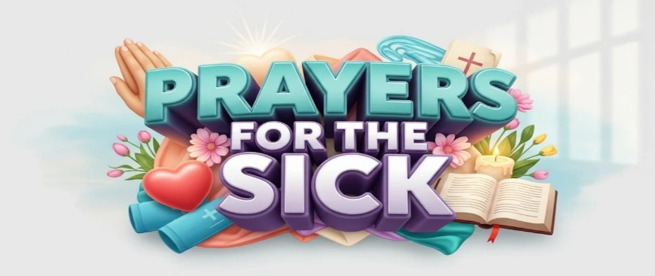

OUR IMMANUEL UCC PRAYER LIST

*Members of Immanuel

*Charles Behrick *David Behrick *Cherry Chase *Janice Jones

*Dan Riddle *Ruth Rueger *Carol Williams

David Frye Norma Houghton Tom Howard Denis Lambrech Kenny Meinschein

Dale Strupp Teresa Topper Evelyn Will Ken Willett Eli Williams

If you have names to be added or deleted from the Prayer List, please obtain permission from the person or a family member for their name to be published.



We wish to welcome all in the name of Christ.
We invite you to worship with us every Sunday...
and to become a part of this faith household.

We invite you to sign our Guest Book, located in the Narthex.

WE WELCOME TO OUR CHURCH:

Today: Billy Thompson will bring the message to us.
Billy is the Faith Relations Manager for Habitat for Humanity of Evansville.

Next Sunday: We welcome Lee Keitel who will deliver the sermon.



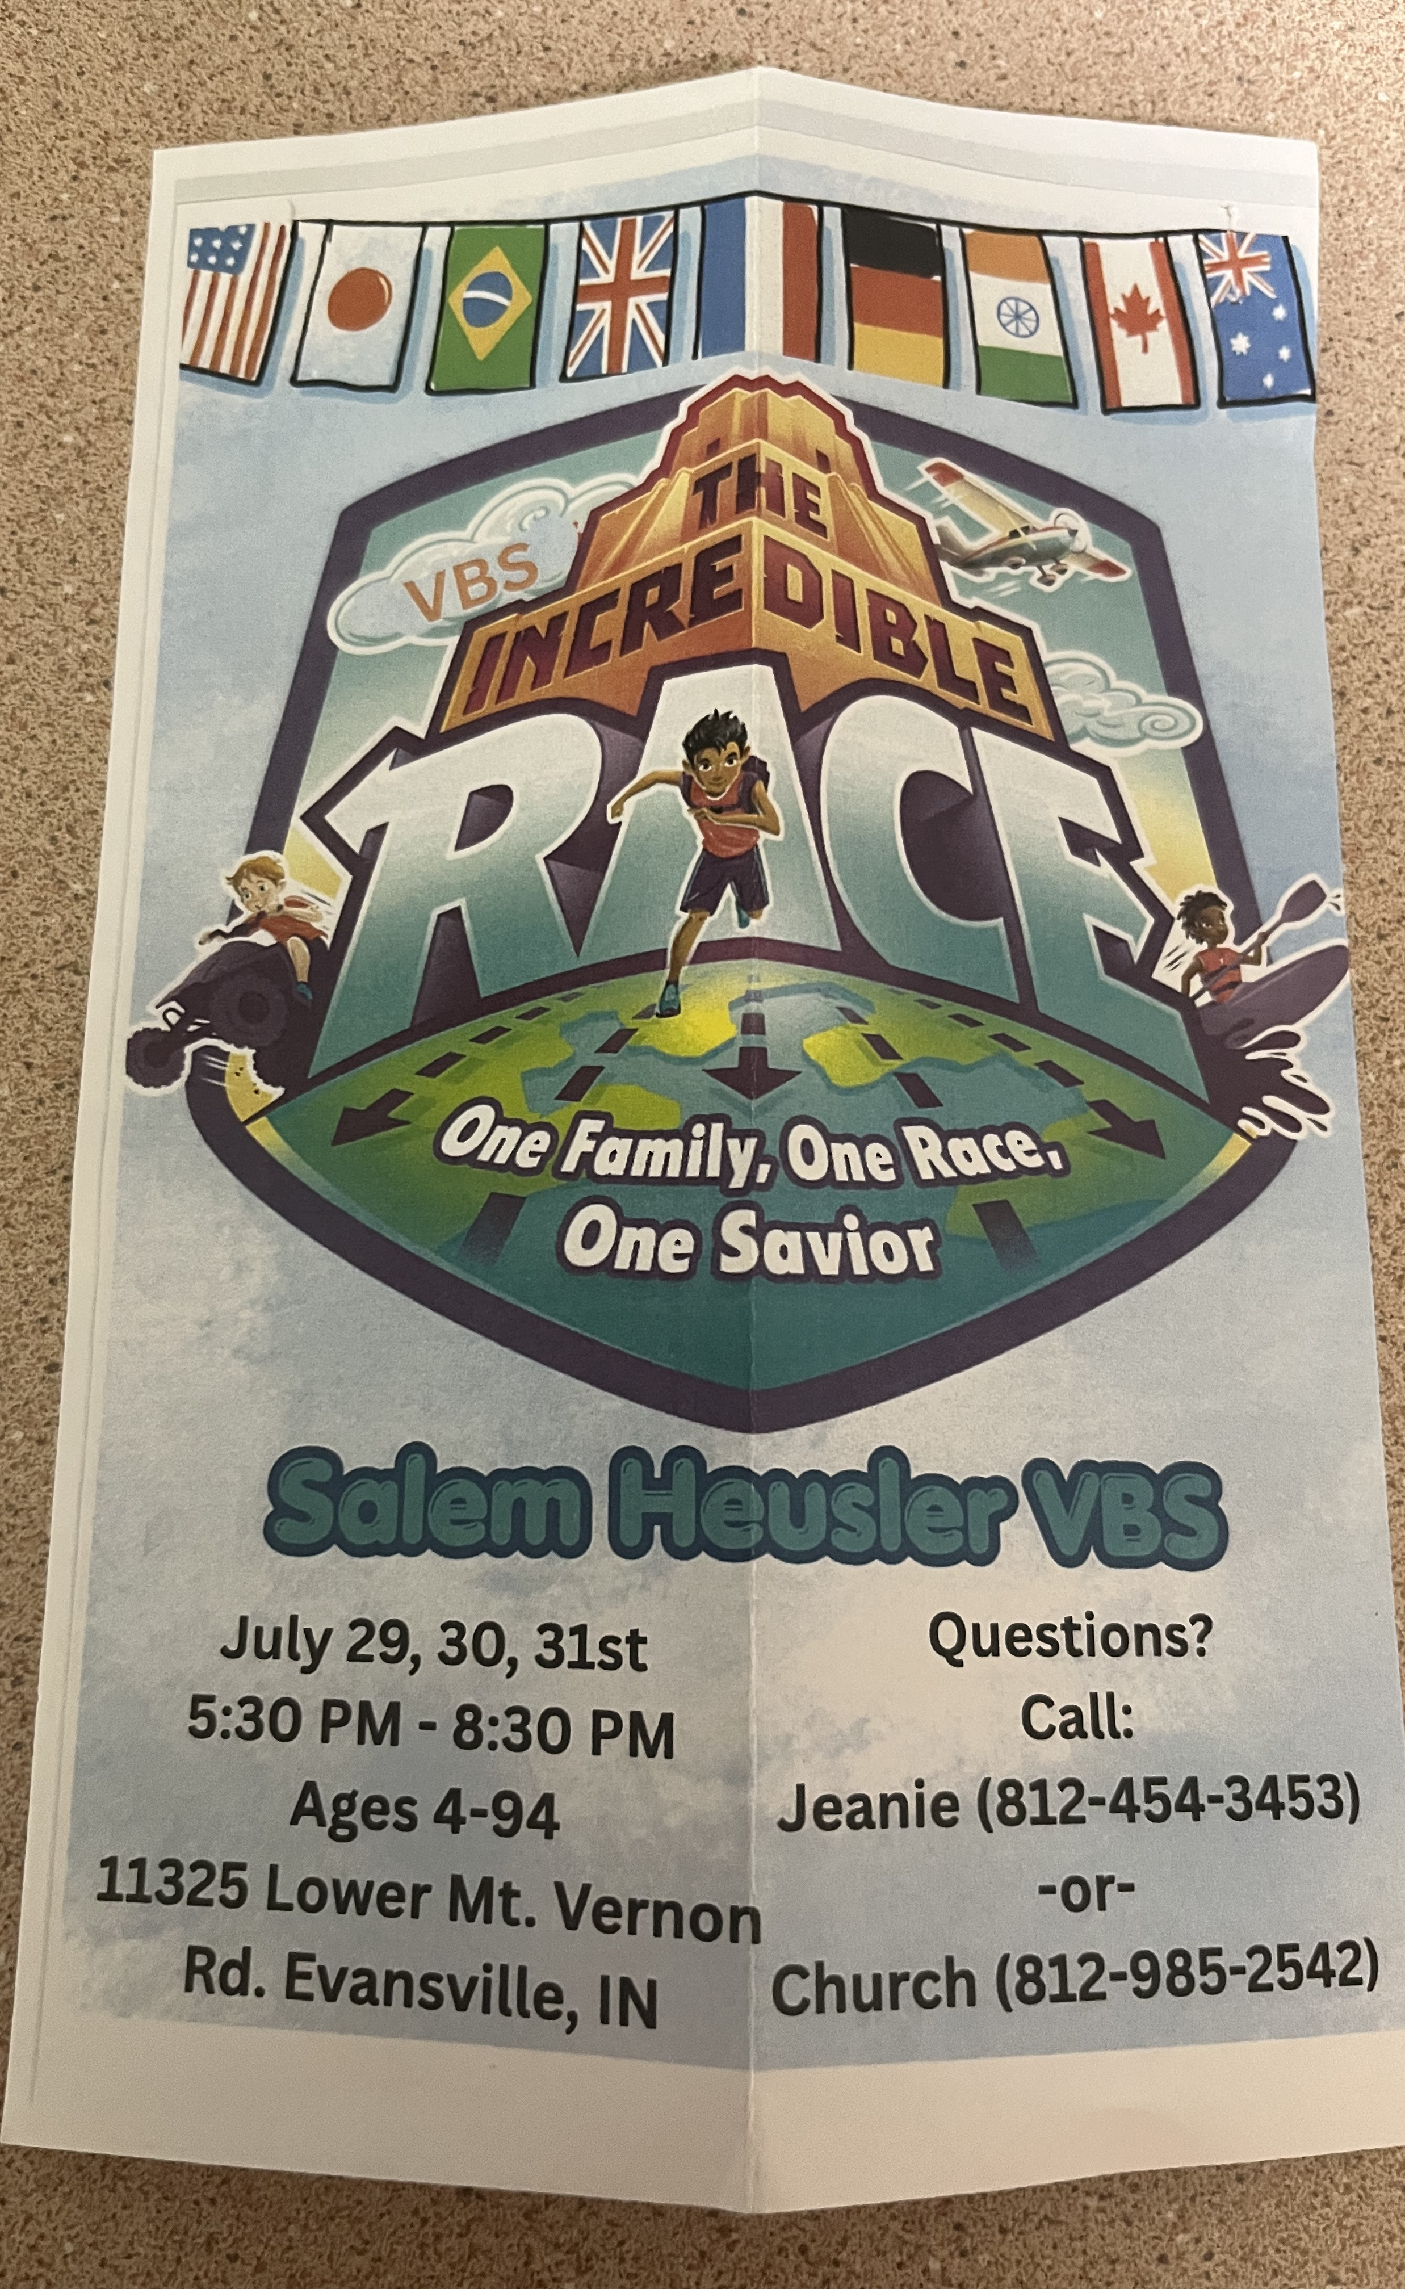

THIS WEEK

SUNDAY 19th EIGHTH SUNDAY AFTER PENTECOST
No Adult Sunday School until August
10:00 a.m. Worship
11:00 a.m. Fellowship Hall Reserved
5:30 p.m. – 6:30 p.m. AA Meeting

MONDAY 20th

TUESDAY 21st

WEDNESDAY 22nd

THURSDAY 23rd 9:30 a.m. Exercise Class
5:30 p.m. Council Meeting

FRIDAY 24th

SATURDAY 25th Fellowship Hall Reserved

SUNDAY 26th NINTH SUNDAY AFTER PENTECOST
No Adult Sunday School until August
10:00 a.m. Worship Service
5:30 p.m. – 6:30 p.m. AA Meeting



July 21 – Becky Brenner

