**IMMANUEL UNITED CHURCH OF CHRIST**

**July 13, 2025**

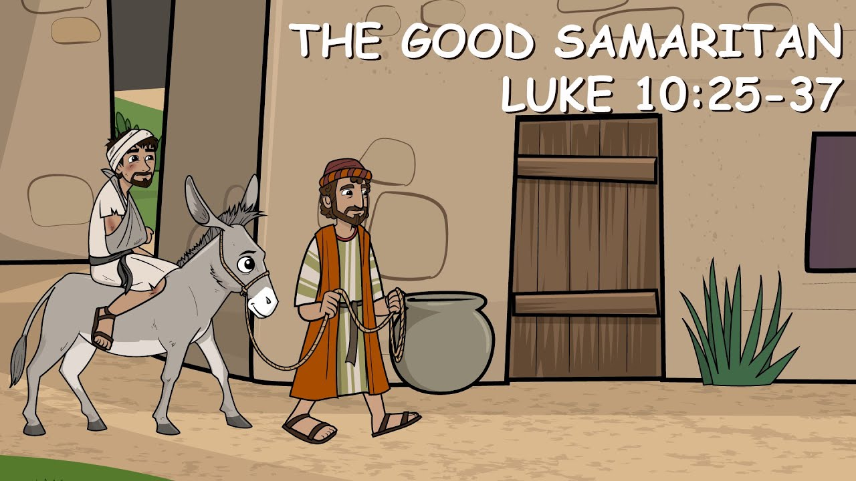

**5812 Ford Rd. N. Mt. Vernon, IN 47620 (812) 985-3115**

**Facebook:** Immanuel United Church of Christ **Church Website:** [www.immanueluccmv.com](http://www.immanueluccmv.com)

**Church Email:** [info@immanueluccmv.com](mailto:info@immanueluccmv.com) **Administrative** **Assistant:** Janie Meinschein

**Our Vision? *“To grow a vibrant church by sharing Christ with the community . . .”***

**Our Mission? *“To invite, inspire, involve, increase . . .”***

**Fourth Sunday after Pentecost**

***July 13, 2025 – Guest Preacher: Dr. Tom Hickey***

**RINGING OF THE BELL** Keith Deig

**WELCOME AND WORDS OF GREETING** Bret Baldwin

**PRELUDE**

**\*PRAISE HYMN #2025 (black hymnal) *“As The Deer”***

**\*CALL TO WORSHIP** Bret Baldwin

Lay Leader: God is mighty in word and deed.

**People: God’s mercy is everlasting.**

Lay Leader: Blessed be the Holy and Living God!

**People: Glory to God forever!**

**\*OPENING HYMN #409 *“Who Is on the Lord’s Side”***

**\*PRAYER OF CONFESSION (Unison)** Bret Baldwin

**Holy God, you call us to boldly proclaim your name. Too often we fail to do so. Forgive us. By the power of your Spirit, give us courage, and lead us away from fear to new life. May we return to faithful living, in Christ’s name we pray. Amen.**

**\*WORDS OF ASSURANCE** Bret Baldwin

Listen to the Good News:

God’s grace and mercy are never ending. Our sins are forgiven!

Praise be to God!

**\*GLORIA PATRI**

**Glory be to the Father, and to the Son, and to the Holy Ghost;**

**As it was in the beginning, is now, and ever shall be,**

**world without end. Amen.**

**CHILDREN’S MOMENTS** Deb Wells

**PRAYERS OF THE PEOPLE** Dr. Tom Hickey

Pastoral Prayer ~ Lord’s Prayer

**SERVICE OF GIVING** Bret Baldwin

Lay Leader: God’s goodness overflows.

Let us bear witness to the love of God and present our offerings of

thanksgiving to our loving God with generous hearts.

**Offertory**

\***Response #515 *“We Give Thee But Thy Own”* (vs 1)**

**We give Thee but Thine own, What-e’er the gift may be:**

**All that we have is Thine a-lone, A trust, O Lord, from Thee.**

**\*Prayer of Dedication (In Unison)** Bret Baldwin

**Gracious God, may we remember that all we have is a gift from you. Pour out your Spirit upon these gifts that they may increase your blessings to others through the grace and mercy of Christ. Amen.**

**SCRIPTURE – Luke 10:25-37** Bret Baldwin

**25**On one occasion an expert in the law stood up to test Jesus. “Teacher,” he asked, “what must I do to inherit eternal life?”

**26**“What is written in the Law?” he replied. “How do you read it?”

**27**He answered, “‘Love the Lord your God with all your heart and with all your soul and with all your strength and with all your mind’[[a](https://www.biblegateway.com/passage/?search=luke%2010:25-37&version=NIV#fen-NIV-25391a)]; and, ‘Love your neighbor as yourself.’[[b](https://www.biblegateway.com/passage/?search=luke%2010:25-37&version=NIV#fen-NIV-25391b)]”

**28**“You have answered correctly,” Jesus replied. “Do this and you will live.”

**29**But he wanted to justify himself, so he asked Jesus, “And who is my neighbor?”

**30**In reply Jesus said: “A man was going down from Jerusalem to Jericho, when he was attacked by robbers. They stripped him of his clothes, beat him and went away, leaving him half dead. **31**A priest happened to be going down the same road, and when he saw the man, he passed by on the other side. **32**So too, a Levite, when he came to the place and saw him, passed by on the other side. **33**But a Samaritan, as he traveled, came where the man was; and when he saw him, he took pity on him. **34**He went to him and bandaged his wounds, pouring on oil and wine. Then he put the man on his own donkey, brought him to an inn and took care of him. **35**The next day he took out two denarii[[c](https://www.biblegateway.com/passage/?search=luke%2010:25-37&version=NIV#fen-NIV-25399c)] and gave them to the innkeeper. ‘Look after him,’ he said, ‘and when I return, I will reimburse you for any extra expense you may have.’

**36**“Which of these three do you think was a neighbor to the man who fell into the hands of robbers?”

**37**The expert in the law replied, “The one who had mercy on him.”

Jesus told him, “Go and do likewise.”

**HYMN #212 *“Tell Me the Stories of Jesus”***

**SERMON *“The Good Samaritan”*** Dr. Tom Hickey

**\*CLOSING HYMN** **#402 *“O Jesus, I Have Promised”***

**\*BENEDICTION** Dr. Tom Hickey

**\*BENEDICTION RESPONSE *“Lord of Love, Lord of Life”***

**Lord, of life, Lord of Love, Walk forever beside us.**

**Day by Day, Show the Way, With your Vision to guide us,**

**Striving to Follow Your Will and Way, Nothing can divide us,**

**Lord of Life, Lord of Love, Walk forever beside us.**

**POSTLUDE**

Used by Permission. CCLI License # 20658309, Streaming # 20658316

**+++++++++++++++++++++++++++++++++++++++++++++++++++++++++++++++++++++++++++++**

**Today** **July 20**

|  |  |  |
| --- | --- | --- |
| Lay Leader:  Ushers/Greeters:  Pianist/Organist:  Children’s Moments: | Bret Baldwin  OPEN  Beth Folz  Deb Wells | Bobbie Hoebeke  Tony & Tina Kissinger  OPEN  OPEN |

|  |  |
| --- | --- |
| **ATTENDANCE** | LAST WEEK: 56 LAST YEAR: 56 |



**OUR IMMANUEL UCC PRAYER LIST**

***\*Charles Behrick*** ***\*David Behrick******\*Janice Jones******\*Becky Brenner***

***Ken Willett******David Frye Kenny Meinschein***

***Maxine Burdick*** *(Sister of Cherry Chase)* ***Teresa Topper*** *(Friend of Chris Moers)*

***Tom Howard*** *(Brother of Angela Clark)* ***Charlie Hoehn*** *(Father of Charlene Baldwin)*

***Kiersten Ferguson-Cremin*** *(Niece of Paula Boarman)*



**WE WELCOME OUR GUESTS!**

We invite you to sign our Guest Book, located in the Narthex.,

as well as the attendance book in the pews.

***TODAY***

***We welcome our Guest Speaker:***

***Dr. Tom Hickey***

***With Bret Baldwin as Lay Leader***

**ADULT SUNDAY SCHOOL** will not meet for the next 3 weeks. It will resume on August 3rd.



|  |
| --- |
| Download High Quality volunteer clipart food pantry Transparent PNG ...Essentials Toilet Tissue 2ply White 12 Pack | Woolworths**Monday, July 14**  **8:00 a.m.**  **God’s Storehouse & Food Pantry**  **At St. Peter’s UCC, Wadesville** |
| **Gentle Exercise Class . . . designed for 40+**  Every **Thursday morning at 9:30** **am** in the Fellowship Hall  Breath & Movement 45 mins~  Discussion on creating a positive mindset 15 min~  Led by De Brown, certified Yoga Instructor and Immanuel UCC member!  *Suggested donation: $5- |
| Join Us Next Sunday | Igniter Media | WorshipHouse Media ***Next Sunday, July 20th***  ***Guest Minister: Rev. Jason Emmerson***  ***With Bobbie Hoebeke as Lay Leader*** |



**SUNDAY** **13th** **FIFTH SUNDAY AFTER PENTECOST**

NO ADULT SUNDAY SCHOOL

10:00 a.m. Worship

5:30 p.m. – 6:30 p.m. AA Meeting

**MONDAY 14th** 8:00 a.m. God’sStorehouse

**TUESDAY** **15th**

**WEDNESDAY** **16th**

**THURSDAY** **17th** 9:30 a.m. Gentle Exercise Class

**FRIDAY** **18th**

**SATURDAY** **19th**

**SUNDAY** **20th SIXTH SUNDAY AFTER PENTECOST**

NO ADULT SUNDAY SCHOOL

10:00 a.m. Worship

5:30 p.m. – 6:30 p.m. AA Meeting



*July 14 – Mac Bailey*

*July 17 – Marge Kissinger*

*July 18 – Amber McNamara*



*July 14 – Jim & Pam Robinson*