IMMANUEL UNITED CHURCH OF CHRIST
July 12, 2026 @ 10:00 a.m.

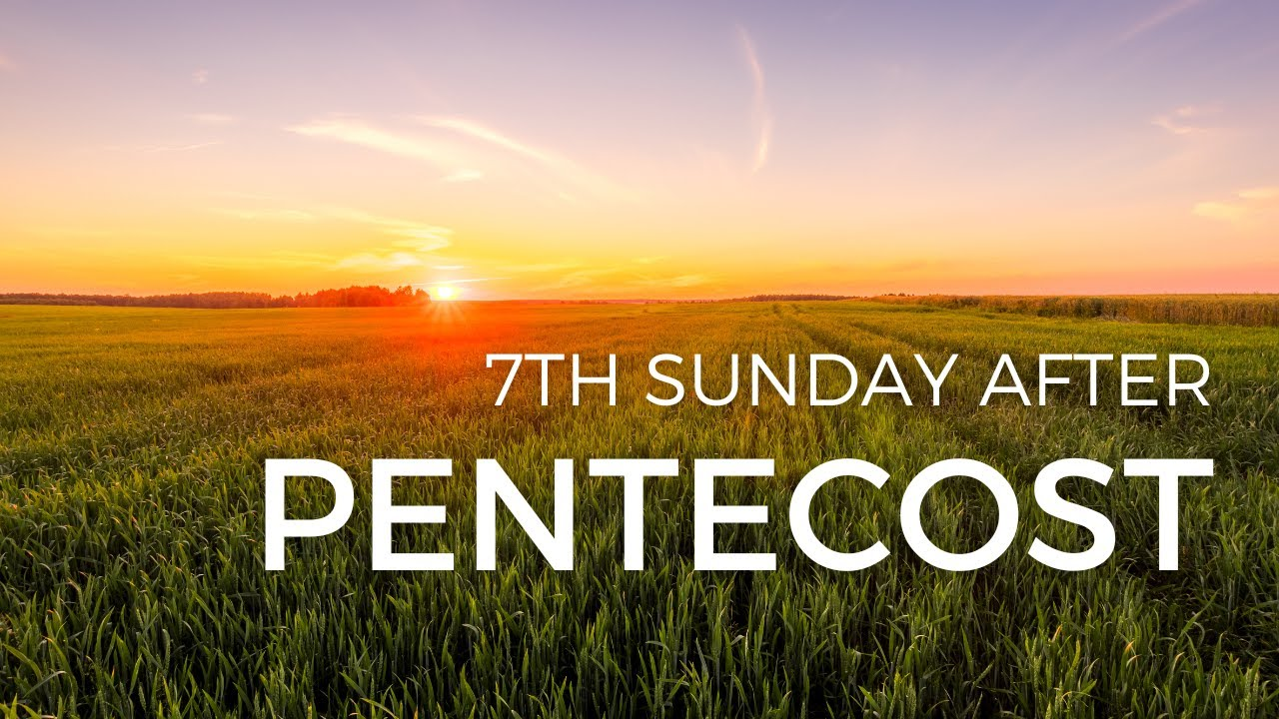

5812 Ford Rd. N. Mt. Vernon, IN 47620 (812) 985-3115
Facebook: Immanuel United Church of Christ Church Website: www.immanueluccmv.com
Church Email: info@immanueluccmv.com Secretary: Janie Meinschein (812) 483-3578
Council President: Bret Baldwin (930) 465-5471
Our Vision? “To grow a vibrant church by sharing Christ with the community . . .”
Our Mission? “To invite, inspire, involve, increase . . .”

Seventh Sunday after Pentecost
July 12, 2026 – Wendi Nelson

RINGING OF THE BELL Keith Deig

WELCOME AND WORDS OF GREETING Jennifer Willett

PRELUDE

*PRAISE Hymn #98 “Great Is Thy Faithfulness”

*CALL TO WORSHIP Jennifer Willett

Leader: We gather today carrying many different burdens and blessings.

People: God welcomes each of us just as we are.

Leader: Some come with joy. Some come with questions. Some come carrying mountains that seem too difficult to climb.

People: We come trusting that God is greater than every challenge we face.

Leader: Jesus calls us to remain in Him, for He is the Vine and we are the branches.

People: As we stay close to Christ, we receive strength, hope, and new life.

Leader: Let us lift our eyes to the One who is faithful in every season.

All: Let us worship God!

*OPENING HYMN #92 “The Solid Rock”
*PRAYER OF CONFESSION (Unison) Jennifer Willett

Gracious and loving God, Too often we focus on the problems before us instead of Your presence with us. We become discouraged by what we cannot control. We allow fear to replace trust. We try to carry burdens that You have invited us to place in Your hands. Forgive us when we lose sight of Your goodness. Help us to turn our eyes toward Jesus, who is our hope, our strength, and our peace. Teach us to remain connected to Christ each day, trusting that Your love will sustain us through every season. In Christ's name we pray. Amen.

*WORDS OF ASSURANCE Jennifer Willett

Leader: Friends, hear the Good News.
God's love is constant. God’s mercy is new every morning.
Nothing can separate us from the love of God revealed in Jesus Christ.
In Christ we are forgiven, renewed, and invited to begin again.

People: Thanks be to God! Amen.

*GLORIA PATRI

Glory be to the Father, and to the Son, and to the Holy Ghost;
As it was in the beginning, is now, and ever shall be,
world without end. Amen.

CHILDREN’S MOMENTS

PRAYERS OF THE PEOPLE
Silent Prayer ~ Pastoral Prayer ~ The Lord’s Prayer

SERVICE OF GIVING:
Offertory “I Need Thee Every Hour" (Instrumental)

*Response # 382

Praise God, from whom all blessings flow;
Praise Him, all creatures here below;
Praise Him above, ye heavenly host;
Praise Father, Son, and Holy Ghost. Amen

*Prayer of Dedication (In Unison) Jennifer Willett

Generous God, Everything we have comes from You. Receive these gifts and use them to share Your love, bring hope where there is despair, and serve our neighbors near and far. May we also offer ourselves—our time, our talents, and our hearts—in joyful service to You. In Jesus' name we pray. Amen.

SCRIPTURE READING: John 15:1–11, Matthew 17:20. Hebrews 12:1–2 Jennifer Willett

John 15: 1-11 15

I am the true vine, and my Father is the gardener. ² He cuts off every branch in me that bears no fruit, while every branch that does bear fruit he prunes^{[a]} so that it will be even more fruitful. ³ You are already clean because of the word I have spoken to you. ⁴ Remain in me, as I also remain in you. No branch can bear fruit by itself; it must remain in the vine. Neither can you bear fruit unless you remain in me.

⁵ “I am the vine; you are the branches. If you remain in me and I in you, you will bear much fruit; apart from me you can do nothing. ⁶ If you do not remain in me, you are like a branch that is thrown away and withers; such branches are picked up, thrown into the fire and burned. ⁷ If you remain in me and my words remain in you, ask whatever you wish, and it will be done for you. ⁸ This is to my Father’s glory, that you bear much fruit, showing yourselves to be my disciples.

⁹ “As the Father has loved me, so have I loved you. Now remain in my love. ¹⁰ If you keep my commands, you will remain in my love, just as I have kept my Father’s commands and remain in his love. ¹¹ I have told you this so that my joy may be in you and that your joy may be complete.

Matthew 17:20

²⁰ He replied, “Because you have so little faith. Truly I tell you, if you have faith as small as a mustard seed, you can say to this mountain, ‘Move from here to there,’ and it will move. Nothing will be impossible for you.”

Hebrews 12: 1-2

12 Therefore, since we are surrounded by such a great cloud of witnesses, let us throw off everything that hinders and the sin that so easily entangles. And let us run with perseverance the race marked out for us, ² fixing our eyes on Jesus, the pioneer and perfecter of faith. For the joy set before him he endured the cross, scorning its shame, and sat down at the right hand of the throne of God.

SERMON HYMN #500 “Abide with Me”
SERMON “What Are You Looking At? The Secret of Mountain-Moving Faith” Wendi Nelson
*CLOSING HYMN #621 “Turn Your Eyes Upon Jesus”
*BENEDICTION Wendi Nelson

*BENEDICTION SONG “Lord of Life, Lord of Love”

Lord, of life, Lord of Love, Walk forever beside us.
Day by Day, Show the Way, With your Vision to guide us,
Striving to Follow Your Will and Way, Nothing can divide us, Lord of Life, Lord of Love, Walk forever beside us.

POSTLUDE

Used by Permission. CCLI License # 20658309, Streaming # 20658316
+++++++++++++++++++++++++++++++++++++++++++++++++++++++++++++++++++++++++++++

Today July 19
Lay Reader  Ushers/Greeters:  Pianist/Organist: | Jennifer Willett  Nelda Hickey  Beth Folz | OPEN  Tina & Tony Kissinger  Beth Folz

ATTENDANCE | LAST WEEK: 55 LAST YEAR: 56

OUR IMMANUEL UCC PRAYER LIST

*Members of Immanuel

*Charles Behrick *David Behrick *Cherry Chase *Janice Jones

*Dan Riddle *Ruth Rueger David Frye Norma Houghton

Tom Howard Denis Lambrech Kenny Meinschein Teresa Topper

Evelyn Will Ken Willett Eli Williams

If you have names to be added or deleted from the Prayer List, please obtain permission from the person or a family member for their name to be published.
++++++++++++++++++++++++++++++++++++++++++++++++++++++++++++++++++
GOOD MORNING, CHURCH FAMILY!

Today we are blessed to have Wendi Nelson with us to share God’s Word. We thank the Lord for bringing her here safely and for the message He has placed on her heart. Let’s open our hearts and our minds as we listen to the message. We believe God has something special for each of us through their words. Next Sunday, we welcome Billy Thompson, who is the manager of Faith Relations for Habit of Humanity of Evansville.

We wish to welcome all visitors in the name of Christ.
We invite you to worship with us every Sunday..
and to become a part of this faith household.
We invite you to sign our Guest Book, located in the Narthex.
++++++++++++++++++++++++++++++++++++++++++++++++++++++++++++++++++



THIS WEEK

SUNDAY 12th SEVENTH SUNDAY AFTER PENTECOST
No Adult Sunday School until August
10:00 a.m. Worship
5:30 p.m. – 6:30 p.m. AA Meeting

MONDAY 13th 8:30 a.m. God’s Storehouse

TUESDAY 14th

WEDNESDAY 15th

THURSDAY 16th 9:30 a.m. Exercise Class

FRIDAY 17th

SATURDAY 18th

SUNDAY 19th EIGHTH SUNDAY AFTER PENTECOST
No Adult Sunday School until August
10:00 a.m. Worship Service
11:00 a.m. Fellowship Hall Reserved
5:30 p.m. – 6:30 p.m. AA Meeting



July 14 – Mac Bailey
July 17 – Marge Kissinger
July 18 – Amber McNamara



July 14 – Jim & Pam Robinson

** PLEASE NOTE: NEW PHONE NUMBER: Bret Baldwin (930-465-5471)

