IMMANUEL UNITED CHURCH OF CHRIST
June 7, 2026 @ 10:00 a.m.

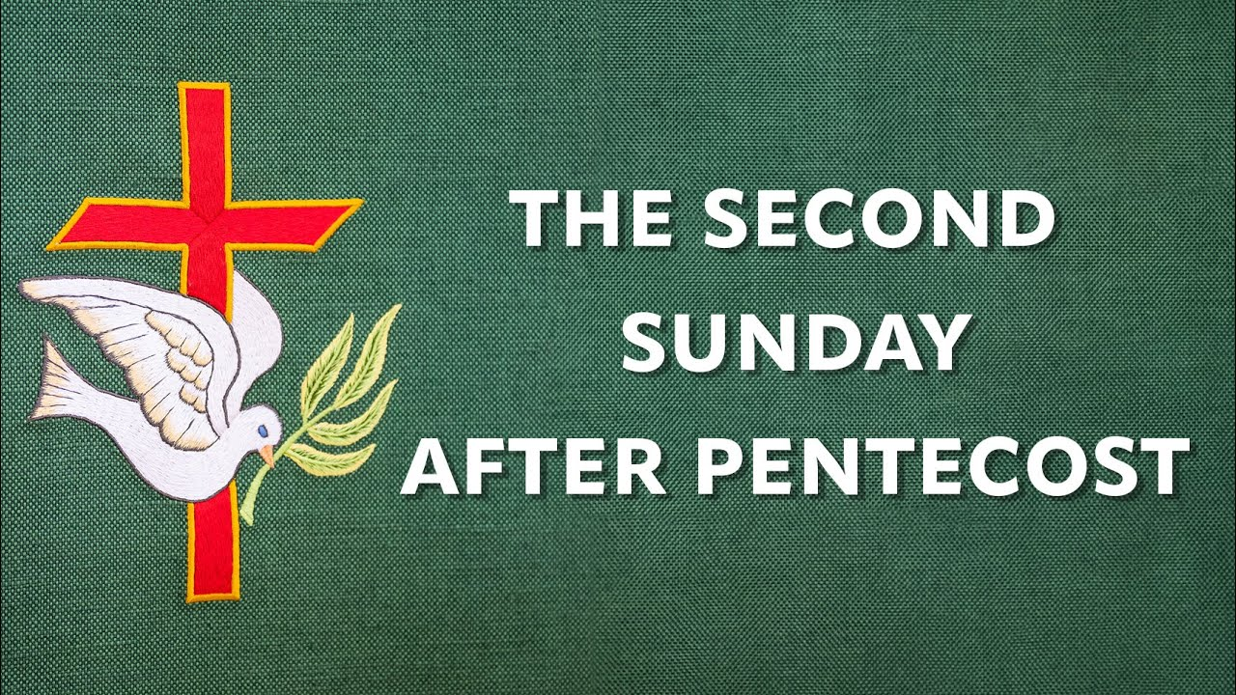

5812 Ford Rd. N. Mt. Vernon, IN 47620 (812) 985-3115
Facebook: Immanuel United Church of Christ Church Website: www.immanueluccmv.com
Church Email: info@immanueluccmv.com Administrative Assistant: Janie Meinschein
Pastor:
Our Vision? “To grow a vibrant church by sharing Christ with the community . . .”
Our Mission? “To invite, inspire, involve, increase . . .”

Second Sunday after Pentecost
June 7, 2026
Rev. Steve Angel

RINGING OF THE BELL Keith Deig

WELCOME AND WORDS OF GREETING Bobbie Hebeke

PRELUDE “Have Thine Own Way, Lord” by George Stebbins,
arr. ACV Whitworth

*PRAISE SONG #342 “Come, Christians, Join to Sing”

*CALL TO WORSHIP (Unison) Bobbie Hoebeke

Happy are we for God’s steadfast love surrounds us, instructs us, and teaches us the ways of spiritual understanding. Happy are we for through Christ Jesus we faithfully become the righteous people of God. So let us shout with joy that this is the day the Lord has made. Come to the feast and sing of the glorious words of God. Amen and Amen.

*OPENING Hymn #394 “Rejoice, Ye Pure in Heart”

*PRAYER OF CONFESSION (Unison) Bobbie Hoebeke

Lord God, you have given me a tongue; you have given me ears; you have given me a spirit; yet I have misused and abused these gifts. I cannot hide my face from you nor can I keep my heart from sinning against you. Yes, I have sinned. Yet it is you, God, who helped me set things right between you and my neighbors. It is you who said to me, Let us stand together and confront these sins.” Open my ears to the truth. Let me speak with honor and respect. Soften my heart so I may love more easily as you have loved me. All this we ask in the name of Jesus your Son and Christ, our Lord. Amen.

*WORDS OF ASSURANCE Rev. Steve Angel

*GLORIA PATRI
Glory be to the Father, and to the Son, and to the Holy Ghost;
As it was in the beginning, is now, and ever shall be,
world without end. Amen, Amen.

TIME FOR THE YOUNG AT HEART OPEN

PRAYERS OF THE PEOPLE
Pastoral Prayer ~ The Lord’s Prayer

SERVICE OF GIVING
Offertory “Air” by Purcell, arr. Martin Setchell
*Response No. 382

Praise God, from whom all blessings flow;
Praise Him, all creatures here below;
Praise Him above, ye heavenly host;
Praise Father, Son, and Holy Ghost. Amen.

*Prayer of Dedication (In Unison) Bobbie Hoebeke

Generous God, we bless you for life renewed through Christ’s love and through springtime growth in fields and gardens. Use the gifts we offer to bring hope and renewal to the world you love in the name of Jesus Christ, our Risen Lord. Amen

SCRIPTURE – Romans 4: 13-25 Bobbie Hoebeke
¹³ It was not through the law that Abraham and his offspring received the promise that he would be heir of the world, but through the righteousness that comes by faith. ¹⁴ For if those who depend on the law are heirs, faith means nothing and the promise is worthless, ¹⁵ because the law brings wrath. And where there is no law there is no transgression.
¹⁶ Therefore, the promise comes by faith, so that it may be by grace and may be guaranteed to all Abraham’s offspring—not only to those who are of the law but also to those who have the faith of Abraham. He is the father of us all. ¹⁷ As it is written: “I have made you a father of many nations.”^{[a]} He is our father in the sight of God, in whom he believed—the God who gives life to the dead and calls into being things that were not.
¹⁸ Against all hope, Abraham in hope believed and so became the father of many nations, just as it had been said to him, “So shall your offspring be.”^{[b]} ¹⁹ Without weakening in his faith, he faced the fact that his body was as good as dead—since he was about a hundred years old—and that Sarah’s womb was also dead. ²⁰ Yet he did not waver through unbelief regarding the promise of God, but was strengthened in his faith and gave glory to God, ²¹ being fully persuaded that God had power to do what he had promised. ²² This is why “it was credited to him as righteousness.” ²³ The words “it was credited to him” were written not for him alone, ²⁴ but also for us, to whom God will credit righteousness—for us who believe in him who raised Jesus our Lord from the dead. ²⁵ He was delivered over to death for our sins and was raised to life for our justification.
*SERMON HYMN # 457 “Take Time to Be Holy”

SERMON “Christ Jesus Sets Us Right with God” Rev. Steve Angel

HOLY COMMUNION: THE LORD HAS INVITED US TO HIS TABLE

*Hymn for Preparation #564 “Let Us Break Bread Together”

The Words of Institution

The Prayer for the Spirit

Breaking Bread, Pouring of the Cup

Sharing the Elements

*Prayer of Thanksgiving (Unison)

Eternal God, you have called your people from east and west and north and south to feast at the table of Jesus Christ. We thank you for Christ’s presence and for the spiritual food of Christ’s body and blood. By the power of your Holy Spirit, keep us faithful to your will. God is with us to the streets, to the fields, to our home, and to our places of labor and leisure that whether we are gathered or scattered, we may be the servant church of the servant Christ, in whose name we rejoice to pray. Amen.

*CLOSING HYMN #402 “O Jesus, I Have Promised”

*PASTORAL COMMISSION & BENEDICTION Rev. Steve Angel

*BENEDICTION SONG “This Little Light of Mine”

This little light of mine, I’m gonna let it shine
This little light of mine, I’m gonna let it shine
This little light of mine, I’m gonna let it shine,
Let it shine, let it shine, let it shine.

POSTLUDE “My Heart Ever Faithful” by Bach

Used by Permission. CCLI License # 20658309, Streaming # 20658316

+++++++++++++++++++++++++++++++++++++++++++++++++++++++++++++++++++++++++++++

Today June 14
Lay Reader  Ushers/Greeters:  Pianist/Organist: | Bobbie Hoebeke  Nelda Hickey  Gail Angel | Bret Baldwin  Tony & Tina Kissinger  Beth Folz

ATTENDANCE: Last Week: 45 Last Year: 37

OUR IMMANUEL UCC PRAYER LIST

*Members of Immanuel

*Charles Behrick *David Behrick *Cherry Chase *Janice Jones

*Dan Riddle David Frye Norma Houghton Tom Howard

Denis Lambrech Kenny Meinschein Teresa Topper Evelyn Will

Ken Willett Eli Williams

If you have names to be added or deleted from the Prayer List, please obtain permission from the person or a family member for their name to be published.



We wish to welcome all in the name of Christ.
We invite you to worship with us every Sunday...
and to become a part of this faith household.

We invite you to sign our Guest Book, located in the Narthex.

ANNOUNCEMENTS

DIAPERS: Thank you to everyone who donated diapers to the Mission Team for needy new Mothers! God loves a cheerful giver!
A NOTE FROM JANIE – I will be out of the office and on vacation starting Tuesday, June 9th and returning home on Monday, June 22. If you have anything that needs to be in the next 2 bulletins please let me know by today. I will be working on these bulletins on Monday (tomorrow). PS: We need someone to sign up for LAY LEADER for June 21st & 28th.

WE WELCOME TO OUR CHURCH

TODAY
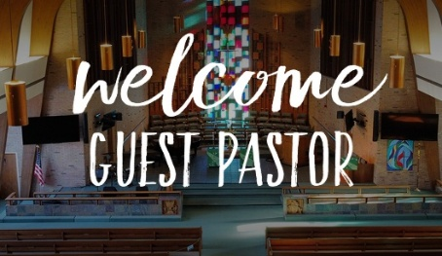

Rev. Steve Angel (Sermon & Communion)



NEXT SUNDAY, JUNE 14

Rev. Bob Walker (Sermon)

THIS WEEK

SUNDAY 7th SECOND SUNDAY AFTER PENTECOST
No Adult Sunday School until August
10:00 a.m. Worship & Communion
5:30 p.m. – 6:30 p.m. AA Meeting

MONDAY 8th 8:30 a.m. God’s Storehouse
6:00 p.m. Diligent Lads 4-H club meeting

TUESDAY 9th

WEDNESDAY 10th 6:45 p.m. Perry M & M 4-H Club meeting

THURSDAY 11th 9:30 a.m. Exercise Class

FRIDAY 12th

SATURDAY 13th

SUNDAY 14th THIRD SUNDAY AFTER PENTECOST
No Adult Sunday School until August
10:00 a.m. Worship Service
5:30 p.m. – 6:30 p.m. AA Meeting



June 8 – Cindy Naab June 7 – Bob & Janet Walker
June 9 – Wil Thielman June 10 – Tom & Nelda Hickey
June 13 – Jessica Lawrence June 14 – Kathy & Martin Guerrero



Gentle Exercise Class
designed for 40+

Every Thursday morning at 9:30 am in the Fellowship Hall
Breath & Movement 45 mins~
Discussion on creating a positive mindset 15 min~
Led by De Brown, certified Yoga Instructor and Immanuel UCC member!
*Suggested donation: $5-

