IMMANUEL UNITED CHURCH OF CHRIST
June 28, 2026 @ 10:00 a.m.

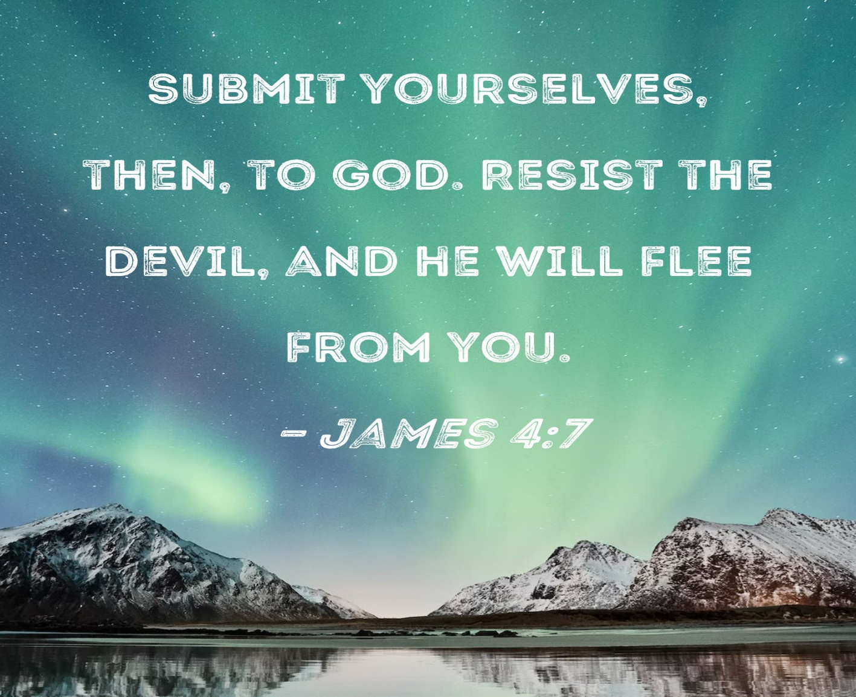

5812 Ford Rd. N. Mt. Vernon, IN 47620 (812) 985-3115
Facebook: Immanuel United Church of Christ Church Website: www.immanueluccmv.com
Church Email: info@immanueluccmv.com Administrative Assistant: Janie Meinschein
Pastor:
Our Vision? “To grow a vibrant church by sharing Christ with the community . . .”
Our Mission? “To invite, inspire, involve, increase . . .”

Fifth Sunday after Pentecost
June 28, 2026

RINGING OF THE BELL Keith Deig

WELCOME AND ANNOUNCEMENTS Paula Boarman

PRELUDE

*PRAISE SONG #556 “There’s a Quiet Understanding” (verse 1)

*CALL TO WORSHIP Paula Boarman

Leader: The glory of God shines like a consuming fire.

People of God: We come before God with awe.

Leader: We have seen the glory of God in the face of Jesus.

People of God: We come before God with humbled hearts.

Leader: The voice of God thunders like a mighty storm.

People of God: We bow before God.

Leader: Out of the cloud, God speaks: “This is my beloved Son; listen to Him!”

People of God: We come before God listening with our whole heart, mind, and soul.

*OPENING HYMN #1 “For the Beauty of the Earth”

*PRAYER OF CONFESSION (Unison) Paula Boarman

God of all glory, beauty, majesty, and grace, when we deny the miracles all around us, forgive us and transform us so that our lives may shine forth with your glory, beauty, majesty, and grace; through Jesus Christ our Lord. Amen.

*WORDS OF ASSURANCE Paula Boarman

This is the good news of the gospel:
In Jesus Christ we are forgiven. Thanks be to God!

*GLORIA PATRI

Glory be to the Father, and to the Son, and to the Holy Ghost;
As it was in the beginning, is now, and ever shall be,
world without end. Amen.

CHILDREN’S MOMENTS OPEN

PRAYERS OF THE PEOPLE
Silent Prayer ~ Pastoral Prayer ~ The Lord’s Prayer

SERVICE OF GIVING
Offertory
*Response No. 382

Praise God, from whom all blessings flow;
Praise Him, all creatures here below;
Praise Him above, ye heavenly host;
Praise Father, Son, and Holy Ghost. Amen.

*Prayer of Dedication (In Unison) Paula Boarman

Loving God, you reveal your goodness in so many ways. You inspire us and lead us! Please receive these gifts from our humble hands. May these gifts reflect your goodness. Inspire us and lead us to do work that glorifies your Holy Name. Amen.

SCRIPTURE – James 4: 7-10 Paula Boarman

⁷ Submit yourselves, then, to God. Resist the devil, and he will flee from you. ⁸ Come near to God and he will come near to you. Wash your hands, you sinners, and purify your hearts, you double-minded. ⁹ Grieve, mourn and wail. Change your laughter to mourning and your joy to gloom. ¹⁰ Humble yourselves before the Lord, and he will lift you up.

SERMON HYMN #212 “Tell Me the Stories of Jesus”

SERMON “It All Starts with Submitting” Adam McCloud

*CLOSING HYMN #402 “O Jesus, I Have Promised”

*BENEDICTION Adam McCloud

*BENEDICTION SONG #681 “Let There Be Peace on Earth”

Let there be peace on earth, and let it begin with me.
Let there be peace on earth, the peace that was meant to be.
With God as our Maker, family all are we, Let me walk with my family in perfect harmony.
Let peace begin with me, let this be the moment now.
With every step I take, let this be my solemn vow: To take each moment and live each moment
In peace eternally! Let there be peace of earth and let it begin with me.

POSTLUDE

SEMI-ANNUAL MEETING FOLLOWS WORSHIP

Used by Permission. CCLI License # 20658309, Streaming # 20658316
+++++++++++++++++++++++++++++++++++++++++++++++++++++++++++++++++++++++++++++

Today July 5
Lay Reader  Ushers/Greeters:  Pianist/Organist: | Paula Boarman  Chris Moers  Beth Folz | Bobbie Hoebeke  Terri, Emmerson & Lennox McCormick

OUR IMMANUEL UCC PRAYER LIST

*Members of Immanuel

*Charles Behrick *David Behrick *Cherry Chase *Janice Jones

*Dan Riddle David Frye Norma Houghton Tom Howard

Denis Lambrech Kenny Meinschein Teresa Topper Evelyn Will

Ken Willett Eli Williams Tripp Everett Zimmerman

If you have names to be added or deleted from the Prayer List, please obtain permission from the person or a family member for their name to be published.


We wish to welcome all in the name of Christ.
We invite you to worship with us every Sunday...
and to become a part of this faith household.

We invite you to sign our Guest Book, located in the Narthex.

WE WELCOME TO OUR CHURCH

TODAY

Adam McCloud (Sermon)
After worship, we will have our semi-annual meeting
and a potluck.



NEXT SUNDAY, JULY 5
Rev. Bob Walker (Sermon & Communion)


We will have our semi-annual meeting after worship today
We will also have a potluck after the meeting.

THIS WEEK

SUNDAY 28th FIFTH SUNDAY AFTER PENTECOST
Semi-Annual Meeting after Worship + Potluck
No Adult Sunday School until August
10:00 a.m. Worship
5:30 p.m. – 6:30 p.m. AA Meeting

MONDAY 29th

TUESDAY 30th

WEDNESDAY 1st

THURSDAY 2nd 9:30 a.m. Exercise Class

FRIDAY 3rd

SATURDAY 4th

SUNDAY 5th SIXTH SUNDAY AFTER PENTECOST
No Adult Sunday School until August
10:00 a.m. Worship Service
5:30 p.m. – 6:30 p.m. AA Meeting



June 28 – Lucille Ann Reller

July 3 – Ashton Wagner

July 5 – Tom Hickey



Gentle Exercise Class
designed for 40+

Every Thursday morning at 9:30 am in the Fellowship Hall
Breath & Movement 45 mins~
Discussion on creating a positive mindset 15 min~
Led by De Brown, certified Yoga Instructor and Immanuel UCC member!
*Suggested donation: $5-

