**IMMANUEL UNITED CHURCH OF CHRIST**

**June 22, 2025**

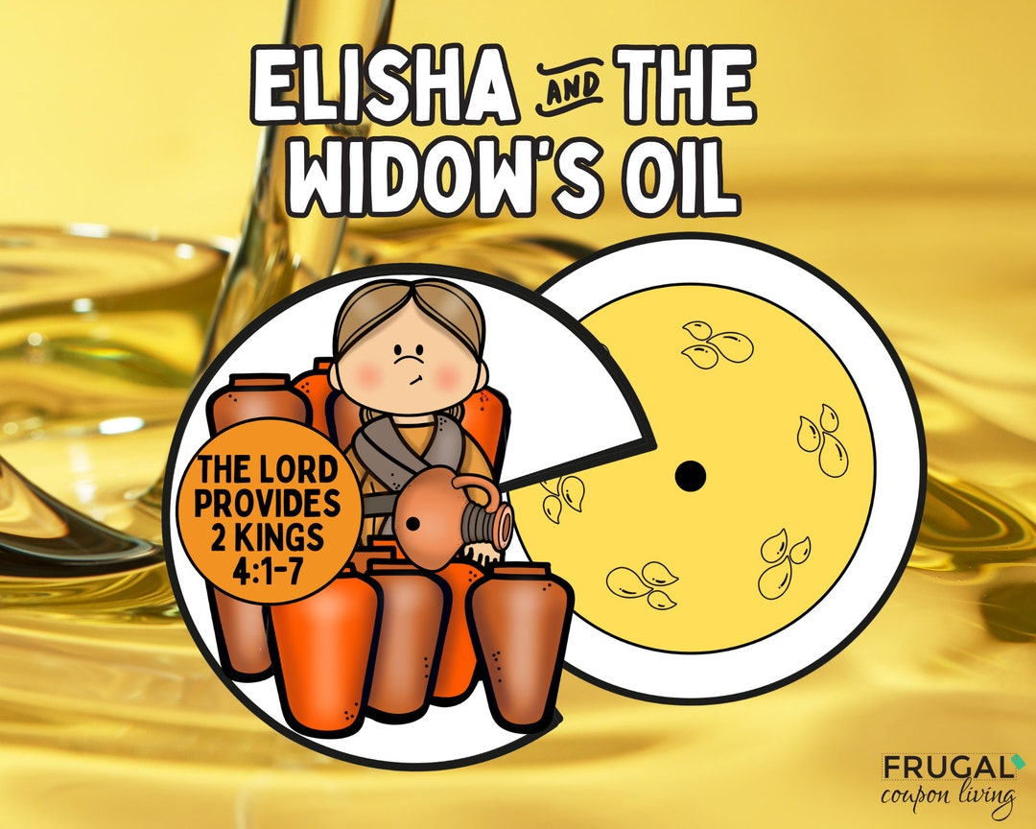

**5812 Ford Road N. Mt. Vernon, IN 47620 (812) 985-3115**

**Facebook: Immanuel United Church of Christ Church Website:** [www.immanueluccmv.com](http://www.immanueluccmv.com)

**Church Email:** [info@immanueluccmv.com](mailto:info@immanueluccmv.com) **Administrative Assistant: Janie Meinschein**

**Our Vision? *“To grow a vibrant church by sharing Christ with the community . . .”***

**Our Mission? *“To invite, inspire, involve, increase . . .”***

**Second Sunday after Pentecost**

June 22, 2025

**RINGING OF THE BELL** Keith Deig

**WELCOME AND WORDS OF GREETING** Dennis Clark

**PRELUDE *“Meditation”*** By Roy E. Nolte

**\*PRAISE SONG #155 *“Spirit of the Living God”***

**\*CALL TO WORSHIP** Dennis Clark

L: God of this new day, we praise you with joy!

**P: With joy in our hearts, we come before you to worship with thanks and praise.**

L: You are the giver of all things good. You give us the gift of grace. We praise your Holy Name!

**P: We sing praises and marvel that you loved us so much that you sent your Son, Jesus!**

**\*OPENING HYMN #377 *“Joyful, Joyful, We Adore Thee”***

**\*PRAYER OF CONFESSION (Unison)** Dennis Clark

**Gracious God, too often our hearts are cold and without gratitude. Too often our hands are passive and reluctant to carry out acts of mercy. We confess that our hearts, at times, do not carry your loving compassion. Grant us mercy and the gift of grace. May our hearts be warmed, so that we can become—more and more—bearers of your love. Amen.**

**\*WORDS OF ASSURANCE** Dennis Clark

Our loving God, ever merciful, loves us with abundant love.

God forgives us, and fills our hearts with loving compassion. Thanks be to God!

**\*GLORIA PATRI**

**Glory be to the Father, and to the Son, and to the Holy Ghost;**

**As it was in the beginning, is now, and ever shall be,**

**world without end. Amen.**

**\*PASSING OF THE PEACE**

Pastor: “The Peace of our Lord be with you.”

**People: “And also with you.”**

**CHILDREN’S MOMENTS** OPEN

**PRAYERS OF THE PEOPLE** Billy Thompson

Silent Prayer ~ Pastoral Prayer ~ Our Lord’s Prayer

**SERVICE OF GIVING**

**Offertory *“Andante”*** By Beethoven

\***Response No. 382**

**Praise God, from whom all blessings flow;**

**Praise Him, all creatures here below;**

**Praise Him above, ye heavenly host;**

**Praise Father, Son, and Holy Ghost. Amen.**

**\*Prayer of Dedication (In Unison)** Dennis Clark

**Almighty and everlasting God, we offer our thanks unto you. We give thanks for your abundant grace. Your blessings touch our lives and refresh us anew. Accept these gifts from our humble hands. Empower and equip us to be your loving servants in service to you and a blessing to others. We pray this in Jesus’ name. Amen.**

**SCRIPTURE – 2 Kings 4:1-7** Dennis Clark

**4**The wife of a man from the company of the prophets cried out to Elisha, “Your servant my husband is dead, and you know that he revered the Lord. But now his creditor is coming to take my two boys as his slaves.”

**2**Elisha replied to her, “How can I help you? Tell me, what do you have in your house?”

“Your servant has nothing there at all,” she said, “except a small jar of olive oil.”

**3**Elisha said, “Go around and ask all your neighbors for empty jars. Don’t ask for just a few. **4**Then go inside and shut the door behind you and your sons. Pour oil into all the jars, and as each is filled, put it to one side.”

**5**She left him and shut the door behind her and her sons. They brought the jars to her and she kept pouring. **6**When all the jars were full, she said to her son, “Bring me another one.”

But he replied, “There is not a jar left.” Then the oil stopped flowing.

**7**She went and told the man of God, and he said, “Go, sell the oil and pay your debts. You and your sons can live on what is left.”

**HYMN #611 *“Precious Lord, Take My Hand”***

**SERMON “Together We Can”** Billy Thompson

**\*CLOSING HYMN**  **#473 *“Make Me a Blessing”***

**\*BENEDICTION**

**\*BENEDICTION SONG #652 *“Lord of Life, Lord of Love”***

***Lord, of life, Lord of Love, Walk forever beside us.***

***Day by Day, Show the Way, With your Vision to guide us,***

***Striving to Follow Your Will and Way, Nothing can divide us,***

***Lord of Life, Lord of Love, Walk forever beside us.***

**POSTLUDE *“Moderato in C”*** By Roy E. Nolte

Used by Permission. CCLI License # 20658309, Streaming # 20658316

**+++++++++++++++++++++++++++++++++++++++++++++++++++++++++++++++++++++++++++++**

**Today** **June 29**

|  |  |  |
| --- | --- | --- |
| Lay Leader:  Ushers/Greeters:  Pianist/Organist:  Children’s Moments: | Dennis Clark  Tony & Tina Kissinger  Gail Angel  Billy Thompson | Bret Baldwin  Nelda Hickey, Chris Moers  Beth Folz  Billy Thompson |

|  |  |
| --- | --- |
| **ATTENDANCE** | LAST WEEK: 47 LAST YEAR: 51 |



**OUR IMMANUEL UCC PRAYER LIST**

***\*Charles Behrick*** ***\*David Behrick******\*Janice Jones *Ruth Rueger******\*Becky Brenner***

***Ken Willett******David Frye Kenny Meinschein***

***Maxine Burdick*** *(Sister of Cherry Chase)* ***Teresa Topper*** *(Friend of Chris Moers)*

***Tom Howard*** *(Brother of Angela Clark)* ***Charlie Hoehn*** *(Father of Charlene Baldwin)*

***Kiersten Ferguson-Cremin*** *(Niece of Paula Boarman)*

**WE WELCOME OUR GUESTS!**

We invite you to sign our Guest Book, located in the Narthex.,

as well as the attendance book in the pews.

***TODAY***

***We welcome our Guest Speaker: Billy Thompson***

***With Dennis Clark as Lay Leader***

***We will have our Semi-Annual Congregational Meeting following Worship.***

***After the meeting, please join us in the Fellowship Hall for a Potluck lunch with Fried Chicken.***



|  |
| --- |
| Tequila's Mexican Restaurant 10915 Baymeadows Road - Order Pickup and ...  **LUNCH BUNCH AT TEQUILA’S**  Wednesday, June 25th at 12:00 noon  Co-leaders of Lunch Bunch are Betty Schuessler and Ruth Duckworth.  *Lunch Bunch meets monthly on the last Wednesday of the month  Mark your calendars! |
| **Gentle Exercise Class . . . designed for 40+**  Every **Thursday morning at 9:30** am in the Fellowship Hall  On June 26th the instructor will not be available;  the class will be led by the regularly attending participants.  Thank you for volunteering!!  Breath & Movement 45 mins~  Discussion on creating a positive mindset 15 min~  Led by De Brown, certified Yoga Instructor and Immanuel UCC member!  *Suggested donation: $5- |
| Join Us Next Sunday | Igniter Media | WorshipHouse Media ***Next Sunday, June 29th***  ***Guest Speaker: Dr. Tom Hickey***  ***With Bret Baldwin as Lay Leader***  *We will also have a reception honoring the*  *2025 graduates of our church family.*  *Join us in the social hall for cookies and punch following worship* |



**SUNDAY** **22nd**  **SECOND SUNDAY AFTER PENTECOS**

9:00 a.m. Adult Sunday School

10:00 a.m. Worship

Semi-Annual Meeting after worship

Pot Luck lunch with Fried Chicken after meeting

5:30 p.m. – 6:30 p.m. AA Meeting

**MONDAY 23rd**

**TUESDAY** **24th**

**WEDNESDAY** **25th** 12:00 p.m. Lunch Bunch at Tequila’s

**THURSDAY** **26th** 9:30 a.m. Gentle Exercise Class

**FRIDAY** **27th**

**SATURDAY** **28th**

**SUNDAY** **29th THIRD SUNDAY AFTER PENTECOST**

9:00 a.m. Adult Sunday School

10:00 a.m. Worship

Reception for 2025 Graduates following Worship

5:30 p.m. – 6:30 p.m. AA Meeting



*June 27 – Andy Baldwin*

*June 28 – Lucille Ann Reller*



*June 24 – Matt & Jackie McCormick*