**Dedication and Blessing Festival**

June 15, 2025

**RINGING OF THE BELL** Keith Deig

**WELCOME AND WORDS OF GREETING** Rev. Jason Emmerson

**OPENING MUSIC *“We Are Climbing Jacob’s Ladder”*** Dulcimers

**DEDICATION OF OUR CHURCH**

Leader: This is a temple of God’s indwelling Holy Spirit. Immanuel Church does not belong to us but, like us, was bought at the price of Christ’s sacrifice. So, we come, in sorrow and with confidence, to ask forgiveness and embrace the joyous commissioning set before us by the Lord – today and always.

**\*SONG #2022** ***“Great Is the Lord”***

*(Remain standing)*

Leader: Zeal for your church has eaten me up and the taunts of those who taunt you have fallen upon me. Lord, have mercy.

**People: Lord, have mercy.**

Leader: I would rather stand at the entrance of the church of my God than dwell in the house of ungodliness. Christ, have mercy.

**People: Christ, have mercy.**

Leader: The Lord will always defend your coming out from and your going into this time of and place of worship. Lord, have mercy.

**People: Lord, have mercy.**

**\*PRAYER OF DEDICATION**

Leader: Let’s pray together.

**People: Almighty God, in your glory we celebrate the dedication of this house of prayer – Immanuel Church. We praise you for the many blessings you have given to those who worship you here. We pray that all who seek you in this place may find you, and, being filled with the Holy Spirit, may become a living temple acceptable to you. Bind us together through Jesus Christ your Son our Lord, who is alive and reigns with you, in the unity of the Holy Spirit, one God, now and forever. Amen.**

**\*SONG #2226** ***“Bind Us Together”***

**DEDICATION OF OUR MINISTRY**

Leader: The risen Christ is here in the midst of us. We bring our prayers to him as Lord of our church’s ministry and mission. And for the Church universal, of which this building is a visible symbol,

**People: Lord, receive our thanks and prayer.**

Leader: For this congregation, our faithful fellowship, as we remember your promise that when two or three are gathered in your name you are there in the midst of them,

**People: Lord, receive our thanks and prayer.**

Leader: For ourselves, the body of Christ, that we may be calm and know that you are God; For the fulfilling of our needs and wants for ourselves and our neighbors as you see best for us,

**People: Lord, receive our thanks and prayer.**

Leader: For your blessings in the past and for giving us a Good News vision for the future; For the gift of the Holy Spirit and new life its baptism,

**People: Lord, receive our thanks and prayer.**

Leader: For the forgiveness of our sins when we fall short of your glory; For your never-ending acceptance and invitation; For a glimpse of your eternal kingdom seen everyday through our forgiveness of and service with others,

**People: Lord, receive our thanks and prayer.**

Leader: For the blessing of our daily service, our gifts and offering today, and for our many years receiving your goodness; For the faith of those who have gone before us and for grace to persevere like them,

**People: Lord, receive our thanks and prayer.**

**SONG #2036** ***“Give Thanks”***

Leader: O God, from living stones you prepare an everlasting dwelling – a place for your majesty. Grant that in the power of the Holy Spirit those who serve you here may always be kept within your presence. This we pray through Jesus Christ our Lord…

**People: Our Father, who art in heaven, Hallowed be thy Name. Thy Kingdom come; Thy will be done on earth, as it is in heaven. Give us this day our daily bread. And forgive us our debts, as we forgive our debtors. Lead us not into temptation but deliver us from evil. For thine is the kingdom, the power, and the glory, forever and ever. Amen.**

**MUSICAL BLESSING “It is Well With My Soul”** Handbell Choir

**“Holy, Holy, Holy”**

**BIBLE READING – Genesis 11:1-9** Dr. Tom Hickey

**1**Now the whole earth had one language and the same words. **2**And as they migrated from the east, they came upon a plain in the land of Shinar and settled there. **3**And they said to one another, “Come, let us make bricks and fire them thoroughly.” And they had brick for stone and bitumen for mortar. **4**Then they said, “Come, let us build ourselves a city and a tower with its top in the heavens, and let us make a name for ourselves; otherwise, we shall be scattered abroad upon the face of the whole earth.” **5**The Lord came down to see the city and the tower, which mortals had built. **6**And the Lord said, “Look, they are one people, and they have all one language, and this is only the beginning of what they will do; nothing that they propose to do will now be impossible for them. **7**Come, let us go down and confuse their language there, so that they will not understand one another’s speech.” **8**So the Lord scattered them abroad from there over the face of all the earth, and they left off building the city. **9**Therefore it was called Babel, because there the Lord confused the language of all the earth, and from there the Lord scattered them abroad over the face of all the earth.

Leader: The Word of God for the People of God.

**People: Thanks be to God. Amen.**

**MESSAGE *“Don’t Be Too Proud of This Technological Terror”***

**\*SONG** **#** **2051 *“I Was There to Hear Your Borning Cry”***

*(Relocate to outdoor dedication area – weather permitting)*

**\*DEDICATION OF THE PLAYGROUND, POLLINATOR PLOT, AND REMEMBERANCE GARDEN**

Pastor: The Lord be with you

**People: And also, with you.**

Leader 1: For as the new heavens and the new earth, which I will make, shall remain before me, says the Lord, so shall your descendants and your name remain. (Isaiah 66:22)

Leader 2: For as the rain and the snow come down from heaven and do not return there until they have watered the earth, making it bring forth and sprout, giving seed to the sower and bread to the eater, so shall my word be that goes out from my mouth; it shall not return to me empty, but it shall accomplish that which I purpose and succeed in the thing for which I sent it. (Isaiah 55:10-11)

Leader 3: For as the earth brings forth its shoots and as a field causes what is sown in it to spring up, so the Lord God will cause righteousness and praise to spring up before all the nations. (Isaiah 61:11)

Pastor: O God, you show me the path of life.

**People: In your presence there is fullness of joy; in your right hand are pleasures forevermore.** (Psalm 16:11)

Pastor: We offer these special places into the life and ministry of the people of this church today and forever. Let’s pray.

Leader 1: God, our Creator, at the dawn of creation you placed your children in a garden to find delight in their work and worship together:

**People: Be present with us as we walk around the pollinator field and remembrance garden, and as we run and sit and enjoy the playground. Open our eyes to the beauty, creativity, and joy of creation.**

Leader 2: Jesus, our Companion, on many occasions you withdrew with your friends to into the outdoors, amid the fields, and into gardens for quiet, refreshment, remembrance and to be energized for days ahead:

**People: Be present with all who come to seek your company in these special places. Renew them in their connection to creation, their playfulness among friends and family, and their stillness and reflection before you.**

Leader 3: Holy Spirit of truth and power, our advocate and friend, our ever-present inspiration to do our best and then always try to do better:

**People: Be present with all who come to these special places when all seems lost and awaken them to new life and possibility. Be present with all who come seeking direction and strength, fill their hearts with the love of God, and send them out in witness to Jesus.**

Pastor: We now dedicate the Playground, Pollinator Plot, and Remembrance Garden to God’s Mission, and the ongoing ministry and memory of the blessed people who make dirt, plastic, concrete, rubber, metal, etc. into house of worship where creatures and creation thrives – thanks to God.

**People: For this Playground, the Pollinator Plot, and Remembrance Garden, the hands and hearts that made them possible, and the everlasting goodness of God that makes all things possible. We give thanks seeking the grace of Jesus Christ, the love of God, and the fellowship of the Holy Spirit, to be right here with us all. Amen.**

**CLOSING MUSIC *“Oh How I Love Jesus”*** Dulcimers

**\*CLOSING BLESSING**  Rev. Jason Emmerson

Pastor: May the glory of Christ always fill this house of worship, the people, and these special places, to comfort and energize your hearts; and may blessing of God almighty, and the encouragement of the Holy Spirit, be among you and remain with you everywhere you go. Amen.

**\*CLOSING SONG *“Lord of Life, Lord of Love”***

***Lord, of life, Lord of Love, Walk forever beside us.***

***Day by Day, Show the Way, With your Vision to guide us,***

***Striving to Follow Your Will and Way, Nothing can divide us,***

***Lord of Life, Lord of Love, Walk forever beside us.***

Used by Permission. CCLI License # 20658309, Streaming # 20658316

**+++++++++++++++++++++++++++++++++++++++++++++++++++++++++++++++++++++++++++++**

**Today** **June 22**

|  |  |  |
| --- | --- | --- |
| Lay Leader:  Ushers/Greeters:  Pianist/Organist:  Children’s Moments: | Dr. Tom Hickey  OPEN  Gail Angel  Rev. Jason Emmerson | Dennis Clark  Tony & Tina Kissinger  Gail Angel  Billy Thompson |

|  |  |
| --- | --- |
| **ATTENDANCE** | LAST WEEK: 45 LAST YEAR: 45 |



**OUR IMMANUEL UCC PRAYER LIST**

***\*Charles Behrick*** ***\*David Behrick******\*Janice Jones *Ruth Rueger******\*Becky Brenner***

***Ken Willett******David Frye Kenny Meinschein***

***Maxine Burdick*** *(Sister of Cherry Chase)* ***Teresa Topper*** *(Friend of Chris Moers)*

***Tom Howard*** *(Brother of Angela Clark)* ***Charlie Hoehn*** *(Father of Charlene Baldwin)*

***Kiersten Ferguson-Cremin*** *(Niece of Paula Boarman)*

**WE WELCOME OUR GUESTS!**

We invite you to sign our Guest Book, located in the Narthex.,

as well as the attendance book in the pews.

***WE WELCOME Rev. Jason Emmerson as our Guest Minister today***

**DEDICATION OF THE PLAYGROUND, POLLINATOR PLOT,**

**AND REMEMBERANCE GARDEN**

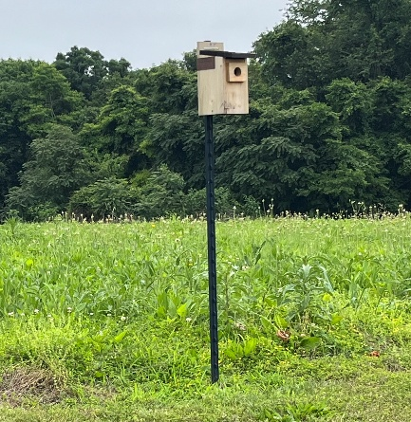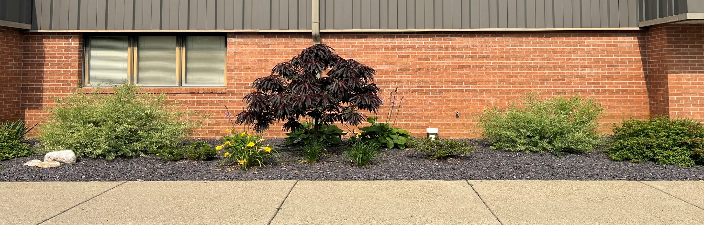

***Remembrance Garden From God’s Creation***

Daffodils Sophie & Ed Jourdan

Pink Ladies Esther & Frank

Creeping Phlox Bob & Marilyn Seifert

Hostas Ed, Alpha & Erna Hausman

Spring Bulbs Bonnie & Roy Brown (parents of Tim Brown)

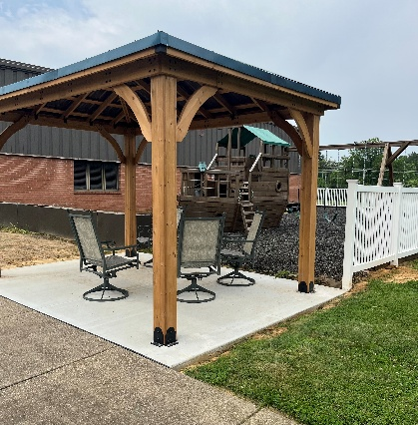

***Donated Items***

Miniature Iris Jennifer Willett

Coral Bells Jennifer Willett, Tina Kissinger

Daylilies Deb Wells

Varigated Sedum Tina & Tony Kissinger

Patio Peaches Deb Wells

Rocks From Michigan (Tina & Tony Kissinger, Ann & Andy Baldwin

Bird Bath Jennifer Willett, Terri McCormick

Plant Barrier Gail & Steve Angel; extra from playground

**A SPECIAL THANKS TO ALL WHO HELPED SPREAD ROCK, PLANT PLANTS**

**AND WORK TO KEEP IT LOOKING GOOD!!!**



|  |
| --- |
| **Gentle Exercise Class . . . designed for 40+**  Every **Thursday morning at 9:30** am in the Fellowship Hall  On June 19, and 26th the instructor will not be available;  the class will be led by the regularly attending participants.  Thank you for volunteering!!  Breath & Movement 45 mins~  Discussion on creating a positive mindset 15 min~  Led by De Brown, certified Yoga Instructor and Immanuel UCC member!  *Suggested donation: $5- |
| church council clipart - Clip Art Library - Clip Art Library  ***Thursday, June 19***  ***Council Meeting***  ***5:30 p.m. in the Parlor*** |
| Join Us Next Sunday | Igniter Media | WorshipHouse Media  ***Next Sunday, June 22nd***  ***Guest Speaker: Billy Thompson***  ***With Dennis Clark as Lay Leader***  ***We will have our Semi-Annual Congregational Meeting following Worship.***  How to make the crispiest fried chicken - Business Insider***After the meeting, please join us in the Fellowship Hall for a Potluck with Fried Chicken.*** |



**SUNDAY** **15th**  **TRINITY SUNDAY**

**FATHER’S DAY**

9:00 a.m. Adult Sunday School

10:00 a.m. Worship in Fellowship Hall

5:30 p.m. – 6:30 p.m. AA Meeting

**MONDAY 16th**

**TUESDAY** **17th**

**WEDNESDAY** **18th**

**THURSDAY** **19th** 9:30 a.m. Gentle Exercise Class

5:30 p.m. Council Meeting

**FRIDAY** **20th**

**SATURDAY** **21st**

**SUNDAY** **22nd SECOND SUNDAY AFTER PENTECOST**

9:00 a.m. Adult Sunday School

10:00 a.m. Worship

Semi-Annual Congregation Meeting after Worshp

Potluck Dinner following Meeting

5:30 p.m. – 6:30 p.m. AA Meeting



*June 20 – Janie Meinschein*



*June 21 – Gary & Amy Snodgrass*