IMMANUEL UNITED CHURCH OF CHRIST
May 31, 2026

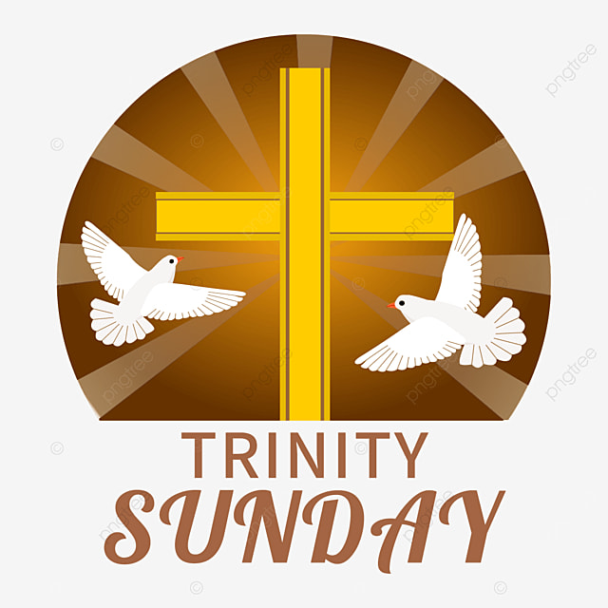

5812 Ford Rd. N. Mt. Vernon, IN 47620 (812) 985-3115
Facebook: Immanuel United Church of Christ Church Website: www.immanueluccmv.com
Church Email: info@immanueluccmv.com Administrative Assistant: Janie Meinschein

Our Vision? “To grow a vibrant church by sharing Christ with the community . . .”
Our Mission? “To invite, inspire, involve, increase . . .”

TRINITY SUNDAY
May 31, 2026

RINGING OF THE BELL Keith Deig

WELCOME AND WORDS OF GREETING Judy Deig

PRELUDE

*PRAISE SONG #155 “Spirit of the Living God”

*CALL TO WORSHIP Judy Deig

L: What a blessing to come together to worship our Almighty God.

P: We gather in the renewing life the Spirit gives to us!

L: We seek to open ourselves to the power of God’s Spirit’s in our midst!

P: We bring praise and song, joy and laughter before God. Let us lift up our voices in
praise and song, rejoicing in God’s love.

*OPENING HYMN #616 “Stand Up, Stand Up for Jesus”

*PRAYER OF CONFESSION (Unison) Judy Deig

Compassionate and merciful God, sometimes we miss the mark, and don’t live as we ought. When we become distracted and when sloth gets the better of us—forgive us. Erase our complacency. Infuse us with your zeal, that we might live with fervor. Help us to model our lives after your Son, Jesus. We pray this in His name. Amen.

*WORDS OF ASSURANCE Judy Deig

The Good News is that Christ calls us to new and everlasting life.
God’s love is now and forever more. Thanks be to God!

*GLORIA PATRI

Glory be to the Father, and to the Son, and to the Holy Ghost;
As it was in the beginning, is now, and ever shall be,
world without end. Amen.

CHILDREN’S MOMENTS OPEN

PRAYERS OF THE PEOPLE Wendi Nelson
Silent Prayer~Pastoral Prayer~Lord’s Prayer

SERVICE OF GIVING
Offertory

*Response No. 382

Praise God, from whom all blessings flow;
Praise Him, all creatures here below;
Praise Him above, ye heavenly host;
Praise Father, Son, and Holy Ghost. Amen.

*Prayer of Dedication (In Unison) Judy Deig

Almighty and gracious God, while giving thanks for the many blessings in our life, we seek to share our blessings. Please accept this offering from our hands, and lead us into ways of service. All that we are and all that we do, belong to you. May our lives be a reflection of your love, and may our hands and hearts be of service to your Holy Name. Amen.

SCRIPTURE Judy Deig

Ephesians 4: 4-6 ⁴There is one body and one Spirit, just as you were called to one hope when you were called; ⁵one Lord, one faith, one baptism; ⁶one God and Father of all, who is over all and through all and in all.

John 10: 30 I and the Father are one

John 1:14 The Word became flesh and made his dwelling among us. We have seen his glory, the glory of the one and only Son, who came from the Father, full of grace and truth.

HYMN - #323 “Holy! Holy! Holy! Lord God Almighty”

SERMON Wendi Nelson

“Too Great to Grasp, Too Near to Ignore; Living in the Fellowship of the Triune God”

*CLOSING HYMN #341 “Come, Thou Almighty King”
*BENEDICTION Wendi Nelson

*BENEDICTION SONG #681 “Let There Be Peace on Earth”

Let there be peace on earth, and let it begin with me.
Let there be peace on earth, the peace that was meant to be.
With God as our Maker, family all are we, Let me walk with my family in perfect harmony.
Let peace begin with me, let this be the moment now.
With every step I take, let this be my solemn vow:
To take each moment and live each moment In peace eternally!
Let there be peace of earth and let it begin with me.
POSTLUDE

Used by Permission. CCLI License # 20658309, Streaming # 20658316
+++++++++++++++++++++++++++++++++++++++++++++++++++++++++++++++++++++++++++++

Today June 7
Lay Leader:  Ushers/Greeters:  Pianist/Organist: | Judy Deig  Chris Moers  Beth Folz | Bobbie Hoebeke  OPEN  Gail Angel

ATTENDANCE | LAST WEEK: 38 LAST YEAR: 37

OUR IMMANUEL UCC PRAYER LIST



*Charles Behrick *David Behrick *Cherry Chase *Janice Jones

*Dan Riddle David Frye Norma Houghton Tom Howard

Denis Lambrech Kenny Meinschein Teresa Topper Evelyn Will

Ken Willett Eli Williams

If you have names to be added or deleted from the Prayer List, please obtain permission from the person or a family member for their name to be published.



We wish to welcome all in the name of Christ.
We invite you to worship with us every Sunday...
and to become a part of this faith household.

We invite you to sign our Guest Book, located in the Narthex.

ANNOUNCEMENTS

OUR THOUGHTS AND PRAYERS go out to Keith and Letha Deig. Letha’s brother, Glenn A. Gee, passed away on Friday, May 22nd at the age of 79. Visitation was on Thursday at Alexander Funeral Home West in Evansville. Burial will be at a later time. May you find peace in knowing he is at rest, and may your faith bring you strength in the days ahead.

WE WELCOME TO OUR CHURCH


TODAY

Wendi Nelson (Sermon)


NEXT SUNDAY, June 7th

Rev. Steve Angel (Sermon & Communion)



Gentle Exercise Class
designed for 40+

Every Thursday morning at 9:30 am in the Fellowship Hall
Breath & Movement 45 mins~
Discussion on creating a positive mindset 15 min~
Led by De Brown, certified Yoga Instructor and Immanuel UCC member!
*Suggested donation: $5-



MONTH OF MAY

We will be collecting diapers or donations during the month of May.
These diapers will be donated to the Evansville Christian Life Center
Any or all donations are appreciated.

THIS WEEK

SUNDAY 31st TRINITY SUNDAY
No adult Sunday School till August
10:00 a.m. Worship
5:30 p.m. – 6:30 p.m. AA Meeting

MONDAY 1st

TUESDAY 2nd

WEDNESDAY 3rd

THURSDAY 4th 9:30 a.m. Exercise Class

FRIDAY 5th

SATURDAY 6th

SUNDAY 7th SECOND SUNDAY AFTER PENTECOST
No adult Sunday School till August
10:00 a.m. Worship Service
5:30 p.m. – 6:30 p.m. AA Meeting



May 31 – Matthew & Stephanie Michael

TRINITY SUNDAY

Trinity Sunday is the first Sunday after Pentecost to honor the Holy Trinity—the Father, Son and Holy Spirit. Although the word “trinity” does not appear in Scripture, it is taught in Matthew 28:18-20 and 2 Corinthians 13:14 (and many other biblical passages). The concept of the trinity can never be completely understood or rationalized, but it is clearly taught in Scripture. Understanding of all scriptural doctrine is by faith which comes through the work of the Holy Spirit; therefore, it is appropriate that this mystery is celebrated the first Sunday after Pentecost, when the outpouring of the Holy Spirit first occurred.
Today, Trinity Sunday is to explain, to the best of man’s ability, the clues written in Scripture to guide us to a fuller understanding of our triune God. The Father is God from the beginning (John 1:1); Jesus revealed Himself as equal to the Father in John 10:30, “I and the Father are one.” Together, they sent the Holy Spirit (John 14:26). “Go therefore and make disciples of all nations, baptizing them in the name of the Father and of the Son and of the Holy Spirit” (Matthew 28:19).

