IMMANUEL UNITED CHURCH OF CHRIST
May 3, 2026 @ 10:00 a.m.

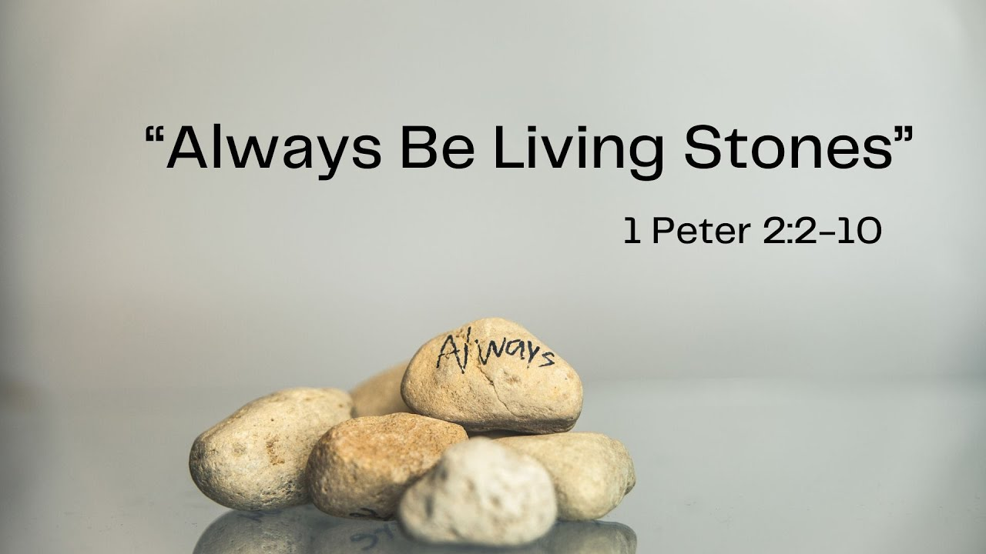



5812 Ford Rd. N. Mt. Vernon, IN 47620 (812) 985-3115
Facebook: Immanuel United Church of Christ Church Website: www.immanueluccmv.com
Church Email: info@immanueluccmv.com Administrative Assistant: Janie Meinschein
Pastor:
Our Vision? “To grow a vibrant church by sharing Christ with the community . . .”
Our Mission? “To invite, inspire, involve, increase . . .”

Fifth Sunday of Easter
May 3, 2026
Rev. Robert B. Walker

RINGING OF THE BELL Keith Deig

WELCOME AND WORDS OF GREETING Bret Baldwin

PRELUDE “Hear My Prayer” by Mendelssohn

*Hymn #641 Pass It On”

*CALL TO WORSHIP Bret Baldwin

Leader: God is our Rock and our Fortress.

People: In God, we find Refuge and Strength!

Leader: God’s house has many dwelling places.

People: We will dwell in the House of the Lord forever!

Leader: Christ Himself has gone to prepare a place for us.

People: For us, Jesus is the Way, the Truth, and the Life!

ALL: Let us worship God in Spirit and in Truth!

*Hymn #557 “Christ Is Made the Sure Foundation”

*PRAYER OF CONFESSION Unison Bret Baldwin

Steadfast God, we confess Jesus as the way, the truth and the life for us, yet we often fail to follow him, too often gone our own way, distorted the truth and led hollow lives. Forgive us for falling short of your purpose for our lives. Give us courage to follow Jesus, who continues to show us the way. Amen.

*WORDS OF ASSURANCE Rev. Bob

*GLORIA PATRI
Glory be to the Father, and to the Son, and to the Holy Ghost;
As it was in the beginning, is now, and ever shall be,
world without end. Amen, Amen.

TIME FOR THE YOUNG AT HEART Rev. Bob

HYMN BEFORE OUR PRAYER #155 “Spirit of the Living God”

Spirit of the Living God, Fall afresh on me.
Spirit of the Living God, Fall afresh on me.
Melt me, mold me, Fill me, use me.
Spirit of the Living God, Fall afresh on me.

PRAYERS OF THE PEOPLE
Pastoral Prayer ~ The Lord’s Prayer

SERVICE OF GIVING
Call to Sharing – Rev. Bob
Offertory “Adagio” by Andre
*Response No. 382

Praise God, from whom all blessings flow;
Praise Him, all creatures here below;
Praise Him above, ye heavenly host;
Praise Father, Son, and Holy Ghost. Amen.

*Prayer of Dedication (In Unison) Bret Baldwin

Generous God, we bless you for life renewed through Christ’s love and through springtime growth in fields and gardens. Use the gifts we offer to bring hope and renewal to the world you love in the name of Jesus Christ, our Risen Lord. Amen

SCRIPTURE – 1 Peter 2:2-10 Bret Baldwin

² Like newborn babies, crave pure spiritual milk, so that by it you may grow up in your salvation, ³ now that you have tasted that the Lord is good.
⁴ As you come to him, the living Stone—rejected by humans but chosen by God and precious to him— ⁵ you also, like living stones, are being built into a spiritual house to be a holy priesthood, offering spiritual sacrifices acceptable to God through Jesus Christ. ⁶ For in Scripture it says:
“See, I lay a stone in Zion,
a chosen and precious cornerstone,
and the one who trusts in him
will never be put to shame.”
⁷ Now to you who believe, this stone is precious. But to those who do not believe,
“The stone the builders rejected
has become the cornerstone,”
⁸ and,
“A stone that causes people to stumble
and a rock that makes them fall.”

They stumble because they disobey the message—which is also what they were destined for.
⁹ But you are a chosen people, a royal priesthood, a holy nation, God’s special possession, that you may declare the praises of him who called you out of darkness into his wonderful light. ¹⁰ Once you were not a people, but now you are the people of God; once you had not received mercy, but now you have received mercy.

*SERMON HYMN # 299 “He Lives”

SERMON “You Are A Chosen People” Rev. Bob

CONFIRMATION: AFFIRMATION OF BAPTISM FOR EMMA LAWRENCE

Brett Baldwin, President of The Council
Ann Baldwin, Teacher of The Confirmation Class, 2026
Rev. Bob Walker, UCC Minister

HOLY COMMUNION: THE LORD HAS INVITED US TO HIS TABLE

*Hymn for Preparation #458 “Take My Life, and Let It Be Consecrated”

The Words of Institution

The Prayer for the Spirit

Breaking Bread, Pouring of the Cup

Pastor: “Alleluia! Fear not! I am the first and the last and the Living One!
People: I died and I am alive forevermore! Alleluia!

Sharing the Elements

*Prayer of Thanksgiving Unison

Eternal God, you have called your people from east and west and north and south to feast at the table of Jesus Christ. We thank you for Christ’s presence and for the spiritual food of Christ’s body and blood. By the power of your Holy Spirit, keep us faithful to your will. God with us to the streets, to the fields, to our home, and to our places of labor and leisure that whether we are gathered or scattered, we may be the servant church of the servant Christ, in who name we rejoice to pray. Amen.

*CLOSING HYMN #323 “Holy! Holy! Holy! Lord God Almighty”

*PASTORAL COMMISSION & BENEDICTION Rev. Bob

*BENEDICTION SONG “This Little Light of Mine”

This little light of mine, I’m gonna let it shine
This little light of mine, I’m gonna let it shine
This little light of mine, I’m gonna let it shine,
Let it shine, let it shine, let it shine.

POSTLUDE “I Know That My Redeemer Liveth” by Handel

Used by Permission. CCLI License # 20658309, Streaming # 20658316

+++++++++++++++++++++++++++++++++++++++++++++++++++++++++++++++++++++++++++++

Today May 10
Lay Reader  Ushers/Greeters:  Pianist/Organist: | Bret Baldwin  OPEN  Gail Angel | OPEN  OPEN  Beth Folz

ATTENDANCE: Last Week: 38 Last Year: 42

OUR IMMANUEL UCC PRAYER LIST

*Members of Immanuel

*Charles Behrick *David Behrick *Janice Jones *Dan Riddle

Mark Brenner David Frye Norma Houghton Tom Howard

Denis Lambrech Kenny Meinschein Mildred Taylor Teresa Topper

Ken Willett Eli Williams


WE WELCOME OUR GUESTS!
We invite you to sign our Guest Book, located in the Narthex.

TODAY AND NEXT SUNDAY, May 10th, we welcome Rev. Bob Walker as our minister.


CONGRATULATIONS TO

Emma Lawrence

Who receives her First Communion and Rite of Confirmation today.
She becomes our newest and youngest member of Immanuel church.
She is the daughter of Duane and Jessica Lawrence.
Her grandparents are Tony & Tina Kissinger and Tony and Yvonne Lawrence.
Her great grandmother is Marge Kissinger.

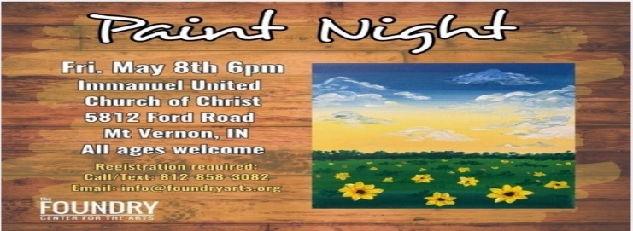


Gentle Exercise Class
designed for 40+

Every Thursday morning at 9:30 am in the Fellowship Hall
Breath & Movement 45 mins~
Discussion on creating a positive mindset 15 min~
Led by De Brown, certified Yoga Instructor and Immanuel UCC member!
*Suggested donation: $5-


MONTH OF MAY

We will be collecting diapers or donations during the month of May.
These diapers will be donated to the Evansville Christian Life Center
Any or all donations are appreciated.



GRADUATION TIME

If you have a graduate
- going from grade school into Middle or Junior High
- Middle or Junior High into High School
- High School/plans or going into college
- graduating from college/plans

Please list their name and where they will be graduating from.
Please leave a note in the office so Janie can put it in the June newsletter.
I need this information by May 17th.

THIS WEEK

SUNDAY 3th FIFTH SUNDAY AFTER EASTER
9:00 a.m. Adult Sunday School
10:00 a.m. Worship
5:30 p.m. – 6:30 p.m. AA Meeting

MONDAY 4th

TUESDAY 5th ELECTION DAY

WEDNESDAY 6th

THURSDAY 7th 9:30 a.m. Exercise Class

FRIDAY 8th 6:00 p.m. Paint Night

SATURDAY 9th

SUNDAY 10th SIXTH SUNDAY OF EASTER
MOTHER’S DAY
9:00 a.m. Adult Sunday School
10:00 a.m. Worship Service
5:30 p.m. – 6:30 p.m. AA Meeting



May 3 - Gail Angel
May 8 – Sarah Alexander

ELECTION DAY IS TUESDAY, MAY 5TH, 2026.


