IMMANUEL UNITED CHURCH OF CHRIST
May 24, 2026

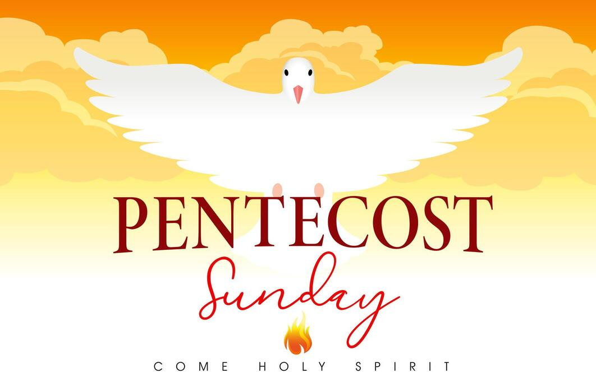

5812 Ford Rd. N. Mt. Vernon, IN 47620 (812) 985-3115
Facebook: Immanuel United Church of Christ Church Website: www.immanueluccmv.com
Church Email: info@immanueluccmv.com Administrative Assistant: Janie Meinschein

Our Vision? “To grow a vibrant church by sharing Christ with the community . . .”
Our Mission? “To invite, inspire, involve, increase . . .”

PENTECOST SUNDAY
May 24, 2026

RINGING OF THE BELL Keith Deig

WELCOME AND WORDS OF GREETING Paula Boarman

PRELUDE

*PRAISE SONG #155 “Spirit of the Living God”

*CALL TO WORSHIP Paula Boarman

L: We have come to celebrate the birthday of the church.

P: We have come to celebrate the gift of the Holy Spirit.

L: We have come to celebrate Pentecost and to open ourselves to God’s Spirit. May we be filled with Holy Spirit power!

P: Christ is with us indeed. The Holy Spirit is here now—within us and among us!

*OPENING HYMN #690 “America, the Beautiful”

*PRAYER OF CONFESSION (Unison) Paula Boarman

Ever present God, we gather here seeking your love. Too often we impede your love from entering our lives and, instead, focus on the petty, and not the profound. There is much wonder and mystery to life! Humble us so that we may come before you and experience anew your Presence.
When we are narrow-minded, widen our perspective so that we catch glimpses of your Spirit at work! Forgive us for our limitations, and grant us the grace to grow with Spirit’s help. Amen.

*WORDS OF ASSURANCE Paula Boarman

Our loving God, ever merciful, loves us with an eternal love.
God forgives and sets us on a path of new life. Thanks be to God.

*GLORIA PATRI

Glory be to the Father, and to the Son, and to the Holy Ghost;
As it was in the beginning, is now, and ever shall be,
world without end. Amen.

CHILDREN’S MOMENTS OPEN

PRAYERS OF THE PEOPLE
Silent Prayer ~ Pastoral Prayer ~ Our Lord’s Prayer

SERVICE OF GIVING
Offertory
*Response No. 382

Praise God, from whom all blessings flow;
Praise Him, all creatures here below;
Praise Him above, ye heavenly host;
Praise Father, Son, and Holy Ghost. Amen.

*Prayer of Dedication (In Unison) Paula Boarman

Thank you, God, for this opportunity to share in your blessings. We lift these gifts unto you, and ask that you empower us to use them for your glory and for the benefit of the world. Lead us, we pray, to become instruments of your love, leading us outward to witness to your Spirit at work! We pray this in Jesus’ name. Amen.

SCRIPTURE Paula Boarman

John 7:37-39 On the last day of the feast, the great day, Jesus stood up and cried out, “If anyone thirsts, let him come to me and drink. Whoever believes in me, as the Scripture has said, ‘Out of his heart will flow rivers of living water.’” Now this he said about the Spirit, whom those who believed in him were to receive, for as yet the Spirit had not been given, because Jesus was not yet glorified.

Acts 2: 2-4 When the day of Pentecost arrived, they were all together in one place. 2 And suddenly there came from heaven a sound like a mighty rushing wind, and it filled the entire house where they were sitting. 3 And divided tongues as of fire appeared to them and rested on each one of them. 4 And they were all filled with the Holy Spirit and began to speak in other tongues as the Spirit gave them utterance.

Joel 2:28-29 And it shall come to pass afterward, that I will pour out my Spirit on all flesh; your sons and your daughters shall prophesy, your old men shall dream dreams, and your young men shall see visions. Even on the male and female servants in those days I will pour out my Spirit.

Acts 2:38 And Peter said to them, “Repent and be baptized every one of you in the name of Jesus Christ for the forgiveness of your sins, and you will receive the gift of the Holy Spirit. 39 For the promise is for you and for your children and for all who are far off, everyone whom the Lord our God calls to himself.”

HYMN #159 “Sweet, Sweet Spirit”

SERMON “Fanning the Flame for a Burning Church” Wendi Nelson

*CLOSING HYMN #692 “Battle Hymn of the Republic”

*BENEDICTION Wendi Nelson

*BENEDICTION SONG #681 “Let There Be Peace on Earth”

Let there be peace on earth, and let it begin with me.
Let there be peace on earth, the peace that was meant to be.
With God as our Maker, family all are we, Let me walk with my family in perfect harmony.
Let peace begin with me, let this be the moment now.
With every step I take, let this be my solemn vow:
To take each moment and live each moment In peace eternally!
Let there be peace of earth and let it begin with me.

POSTLUDE

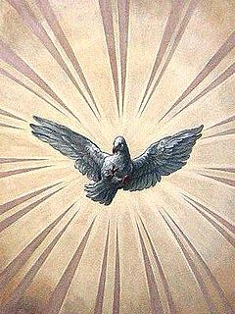
Pentecost
The Christian holiday of Pentecost is a moveable feast, which is celebrated on the 50th day from Easter Sunday. It commemorates the descent of the Holy Spirit upon the Apostles and other followers of Jesus Christ while they were in Jerusalem celebrating the Feast of Weeks, as described in the Acts of the Apostles.

Used by Permission. CCLI License # 20658309, Streaming # 20658316
+++++++++++++++++++++++++++++++++++++++++++++++++++++++++++++++++++++++++++++

Today May 31
Lay Leader:  Ushers/Greeters:  Pianist/Organist: | Paula Boarman  OPEN  Beth Folz | Judy Deig  Chris Moers  Beth Folz

ATTENDANCE | LAST WEEK:58 LAST YEAR: 55

OUR IMMANUEL UCC PRAYER LIST



*Charles Behrick *David Behrick *Cherry Chase *Janice Jones

*Dan Riddle David Frye Norma Houghton Tom Howard

Denis Lambrech Kenny Meinschein Teresa Topper Evelyn Will

Ken Willett Eli Williams

If you have names to be added or deleted from the Prayer List, please obtain permission from the person or a family member for their name to be published.



We wish to welcome all in the name of Christ.
We invite you to worship with us every Sunday...
and to become a part of this faith household.

We invite you to sign our Guest Book, located in the Narthex.

A SPECIAL THANK YOU to Wendi Nelson for leading our worship service this morning, Paula Boarman for being the lay leader and to Beth Folz for providing our beautiful music. Next week, Wendi Nelson will be back to lead our worship service.

ARTICLES FOR THE JUNE NEWSLETTER are due today. If you have anything that you would like in the newsletter, please either lay it on my desk or put in wire mesh folder outside of the office.

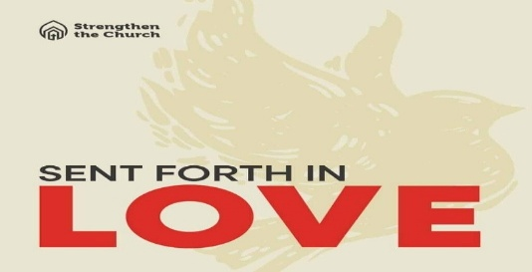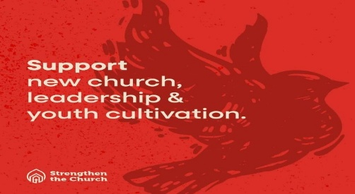

STRENGTHEN THE CHURCH OFFERING
THEME: Sent Forth in Love

The Strengthen the Church Offering reflects the shared commitment of people across the United Church of Christ to cooperatively build up the UCC. Conferences and the national setting equally share the gifts given by members and friends through their local congregations. The funds raised support leadership development, new churches, youth ministry, and innovation in existing congregations.

By your generosity to this offering, you build up the Body of Christ.

As God call our congregations to be the church in new ways, your generosity will plant new churches, awaken new ideas in existing churches, and develop the spiritual life in our youth and young adults.
This offering will be taken up today.


LUNCH BUNCH
WEDNESDAY, May 27th AT 12:00 P.M.
Everyone is invited!



Gentle Exercise Class
designed for 40+

Every Thursday morning at 9:30 am in the Fellowship Hall
Breath & Movement 45 mins~
Discussion on creating a positive mindset 15 min~
Led by De Brown, certified Yoga Instructor and Immanuel UCC member!
*Suggested donation: $5-



MONTH OF MAY

We will be collecting diapers or donations during the month of May.
These diapers will be donated to the Evansville Christian Life Center
Any or all donations are appreciated.

THIS WEEK

SUNDAY 24th PENTECOST SUNDAY
NO ADULT SUNDAY SCHOOL TILL AUGUST
10:00 a.m. Worship
5:30 p.m. – 6:30 p.m. AA Meeting

MONDAY 25th MEMORIAL DAY

TUESDAY 26th

WEDNESDAY 27th 12:00 p.m. Lunch Bunch at Hawg n Sauce

THURSDAY 28th 9:30 a.m. Exercise Class

FRIDAY 29th

SATURDAY 30th

SUNDAY 31st TRINITY SUNDAY
NO ADULT SUNDAY SCHOOL TILL AUGUST
10:00 a.m. Worship Service
5:30 p.m. – 6:30 p.m. AA Meeting



May 31 – Matthew & Stephanie Michael



