IMMANUEL UNITED CHURCH OF CHRIST
May 17, 2026

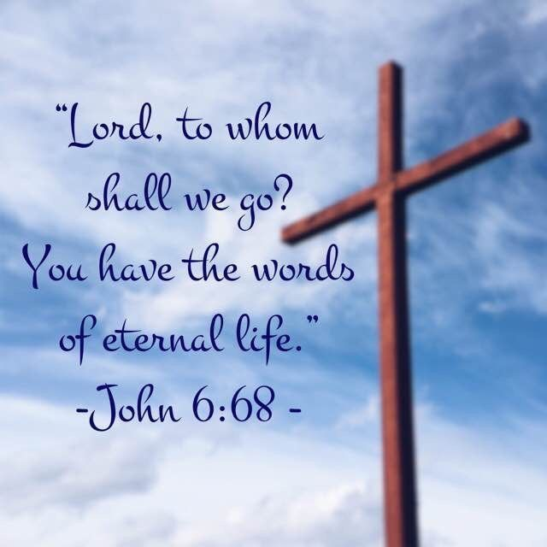

5812 Ford Rd. N. Mt. Vernon, IN 47620 (812) 985-3115
Facebook: Immanuel United Church of Christ Church Website: www.immanueluccmv.com
Church Email: info@immanueluccmv.com Administrative Assistant: Janie Meinschein

Our Vision? “To grow a vibrant church by sharing Christ with the community . . .”
Our Mission? “To invite, inspire, involve, increase . . .”

Seventh Sunday of Easter
May 17, 2026

RINGING OF THE BELL Keith Deig

WELCOME AND WORDS OF GREETING Justin Wagner

PRELUDE

*PRAISE SONG #29 “Wonderful Words of Life”

*CALL TO WORSHIP Justin Wagner

L: What a glorious vision! Jesus gave us the glorious promise of an Advocate, and then Jesus
ascended to God, the Father!

P: What joy there must have been in the hearts of the disciples.

L: May God find such joy in our hearts and spirits!

P: Prepare us, Lord, for the mighty works you place before us.

*OPENING HYMN #606 “He Leadeth Me, O Blessed Thought”

*PRAYER OF CONFESSION (Unison) Justin Wagner

We have to confess, O Lord, that we sometimes doubt and place trust in what can be proven—but nothing more. May we hear the message in the scripture of Jesus’ ascension, and believe! Forgive us for our arrogant doubts and attitudes of smugness. Help us remember that everything Jesus taught us was to prepare us to help build God’s realm here on earth. We are called to be people of faith. May we learn to allow for mystery in life. Let us look with eyes of faith and believe in miracles! Glory to the Father, the Son, and the Holy Spirit. Amen.

*WORDS OF ASSURANCE Justin Wagner

Rejoice, and believe in Him who came that you may have abundant life.
We are forgiven and given new life now, and in life everlasting. Glory be to God!

*GLORIA PATRI

Glory be to the Father, and to the Son, and to the Holy Ghost;
As it was in the beginning, is now, and ever shall be,
world without end. Amen.

CHILDREN’S MOMENTS OPEN

PRAYERS OF THE PEOPLE
Silent Prayer ~ Pastoral Prayer ~ Our Lord’s Prayer

SERVICE OF GIVING
Offertory

*Response #382
Praise God, from whom all blessings flow;
Praise Him, all creatures here below;
Praise Him above, ye heavenly host;
Praise Father, Son, and Holy Ghost. Amen.

*Prayer of Thanksgiving (In Unison) Justin Wagner

Gracious God, thank you that you are God, and there is no other, you are God, and there is none like you. You love us with an eternal love and we give you our offerings as an expression of our love for you. We pray our gifts would be used to extend your kingdom in our land. May you, the God of all grace, who has called us into eternal glory by Christ Jesus, make us holy, strong and filled with peace. To you be glory and honor for ever and ever. Through Jesus Christ, our Lord, Amen.

SCRIPTURE – John 6: 65-69 Justin Wagner

⁶⁵ He went on to say, “This is why I told you that no one can come to me unless the Father has enabled them.”

⁶⁶ From this time many of his disciples turned back and no longer followed him.

⁶⁷ “You do not want to leave too, do you?” Jesus asked the Twelve.

⁶⁸ Simon Peter answered him, “Lord, to whom shall we go? You have the words of eternal life. ⁶⁹ We have come to believe and to know that you are the Holy One of God.”

SERMON HYMN #226 “Jesus Loves Me, This I Know”

SERMON “Where Could I Go?” Adam McCloud

*CLOSING HYMN #601 “Savior, Like a Shepherd Lead Us”

*BENEDICTION

*BENEDICTION SONG #681 “Let There Be Peace on Earth”

Let there be peace on earth, and let it begin with me.
Let there be peace on earth, the peace that was meant to be.
With God as our Maker, family all are we, Let me walk with my family in perfect harmony.
Let peace begin with me, let this be the moment now.
With every step I take, let this be my solemn vow:
To take each moment and live each moment In peace eternally!
Let there be peace of earth and let it begin with me.

POSTLUDE

Used by Permission. CCLI License # 20658309, Streaming # 20658316
+++++++++++++++++++++++++++++++++++++++++++++++++++++++++++++++++++++++++++++

Today May 24
Lay Leader:  Ushers/Greeters:  Pianist/Organist: | Justin Wagner  OPEN  Beth Folz | OPEN  OPEN  Beth Folz

ATTENDANCE | LAST WEEK:68 LAST YEAR: 55

OUR IMMANUEL UCC PRAYER LIST

*Charles Behrick *David Behrick *Cherry Chase *Janice Jones

*Dan Riddle *Marilyn Thielman David Frye Norma Houghton

Tom Howard Denis Lambrech Kenny Meinschein Teresa Topper

Evelyn Will Ken Willett Eli Williams


WE WELCOME OUR GUESTS!

We invite you to sign our Guest Book,
located in the Narthex.

OUR THOUGHTS AND PRAYERS go out to Dennis and Angela Clark. Dennis’s sister, Mildred Taylor passed away on Wednesday, May 6th in Herrin, IL. May memories ease your sorrow and may time bring you peace.

MT VERNON HIGH SCHOOL BACCALAUREATE will be this evening at 6pm.

NEWSLETTER ARTICLES are due in the church office on Sunday, May 24th.



WE WELCOME OUR SUNDAY WORSHIP SPEAKERS

Today, May 17 – Adam McCloud

May 24 & 31 – Wendi Nelson

THANK YOU SO MUCH FOR BRINGING THE MESSAGE TO US!


MONTH OF MAY

We will be collecting diapers or donations during the month of May.
These diapers will be donated to the Evansville Christian Life Center
Any or all donations are appreciated.



GRADUATION TIME

If you have a graduate
- going from grade school into Middle or Junior High
- Middle or Junior High into High School
- High School/plans or going into college
- graduating from college/plans

Please list their name and where they will be graduating from.
Please leave a note in the office so Janie can put it in the June newsletter.
I need this information by TODAY!

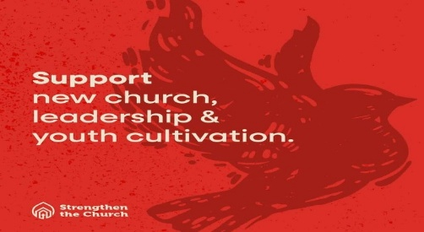

STRENGTHEN THE CHURCH OFFERING
THEME: Sent Forth in Love

The Strengthen the Church Offering reflects the shared commitment of people across the United Church of Christ to cooperatively build up the UCC. Conferences and the national setting equally share the gifts given by members and friends through their local congregations. The funds raised support leadership development, new churches, youth ministry, and innovation in existing congregations.

By your generosity to this offering, you build up the Body of Christ.

As God call our congregations to be the church in new ways, your generosity will plant new churches, awaken new ideas in existing churches, and develop the spiritual life in our youth and young adults.
This offering will be next Sunday, Pentecost Sunday, May 24, 2026

THIS WEEK

SUNDAY 17th SEVENTH SUNDAY OF EASTER
9:00 a.m. Adult Sunday School
10:00 a.m. Worship
5:30 p.m. – 6:30 p.m. AA Meeting

MONDAY 18th

TUESDAY 19th

WEDNESDAY 20th

THURSDAY 21st 9:30 a.m. Exercise Class

FRIDAY 22nd

SATURDAY 23rd

SUNDAY 24th PENTECOST SUNDAY
9:00 a.m. Adult Sunday School
10:00 a.m. Worship Service
5:30 p.m. – 6:30 p.m. AA Meeting



May 20 – Mary Ledbetter May 22 – Linda Deig & Ken Holder
May 23 – Mike Ledbetter



Gentle Exercise Class
designed for 40+

Every Thursday morning at 9:30 am in the Fellowship Hall
Breath & Movement 45 mins~
Discussion on creating a positive mindset 15 min~
Led by De Brown, certified Yoga Instructor and Immanuel UCC member!
*Suggested donation: $5-

