IMMANUEL UNITED CHURCH OF CHRIST
March 8, 2026

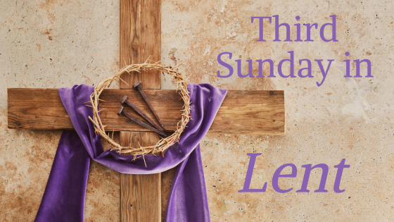



5812 Ford Rd. N. Mt. Vernon, IN 47620 (812) 985-3115
Facebook: Immanuel United Church of Christ Church Website: www.immanueluccmv.com
Church Email: info@immanueluccmv.com Administrative Assistant: Janie Meinschein
Pastor: Rev. Robert Walker Pastor Phone: 812-455-0087 (phone or text)
Our Vision? “To grow a vibrant church by sharing Christ with the community . . .”
Our Mission? “To invite, inspire, involve, increase . . .”

Third Sunday of Lent
March 8, 2026
Rev. Robert B. Walker

RINGING OF THE BELL Keith Deig

WELCOME AND WORDS OF GREETING Bret Baldwin

PRELUDE “Here I Am, Lord” Bell Choir

*Hymn #5 “Morning Has Broken”

*CALL TO WORSHIP Bret Baldwin

Leader: God’s Truth opens our eyes on the world.
People: God’s Spirit shatters our prejudice.

Leader: God’s Truth nourishes our hearts.

People: God’s Spirit encourages us in the face of fear.

Leader: God’s Truth frees us from past mistakes and misunderstanding.

People: God’s Spirit moves us to find new purpose in life.
So let us worship God in Truth and in Spirit!

*Hymn #51 “I Heard the Voice of Jesus Say”

*PRAYER OF CONFESSION (Unison) Bret Baldwin

God, our Redeemer, we are not proud of all you hear in our thoughts and prayers. We complain when we want things to change but don’t know what to do. We justify ourselves when you call us to change but we don’t want to. We blame others when things change and upset our expectations. Forgive us, God, when we are not listening for you. Amen.
*WORDS OF ASSURANCE Rev. Bob

*GLORIA PATRI
Glory be to the Father, and to the Son, and to the Holy Ghost;
As it was in the beginning, is now, and ever shall be,
world without end. Amen, Amen.

TIME FOR THE YOUNG AT HEART Rev. Bob

HYMN BEFORE OUR PRAYER #155 “Spirit of the Living God”

Spirit of the Living God, Fall afresh on me.
Spirit of the Living God, Fall afresh on me.
Melt me, mold me, Fill me, use me.
Spirit of the Living God, Fall afresh on me.

PRAYERS OF THE PEOPLE
Pastoral Prayer ~ The Lord’s Prayer
SERVICE OF GIVING
Offertory “Seek Ye First” Bell Choir
*Response No. 382

Praise God, from whom all blessings flow;
Praise Him, all creatures here below;
Praise Him above, ye heavenly host;
Praise Father, Son, and Holy Ghost. Amen.

*Prayer of Dedication (In Unison) Bret Baldwin

Generous God, we offer our gifts to you in gratitude for all that we have received in Christ and in creation. Bless our gifts and our lives, so that we can share in the building up of your kingdom in the world you love. In Jesus’ name, we pray. Amen.
SCRIPTURE – Romans 5:1-11 Bret Baldwin

Therefore, since we are justified by faith, we have peace with God through our Lord Jesus Christ. ² Through him we have obtained access to this grace in which we stand, and we rejoice in our hope of sharing the glory of God. ³ More than that, we rejoice in our sufferings, knowing that suffering produces endurance, ⁴ and endurance produces character, and character produces hope, ⁵ and hope does not disappoint us, because God’s love has been poured into our hearts through the Holy Spirit which has been given to us.

⁶ While we were still weak, at the right time Christ died for the ungodly. ⁷ Why, one will hardly die for a righteous man—though perhaps for a good man one will dare even to die. ⁸ But God shows his love for us in that while we were yet sinners Christ died for us. ⁹ Since, therefore, we are now justified by his blood, much more shall we be saved by him from the wrath of God. ¹⁰ For if while we were enemies we were reconciled to God by the death of his Son, much more, now that we are reconciled, shall we be saved by his life. ¹¹ Not only so, but we also rejoice in God through our Lord Jesus Christ, through whom we have now received our reconciliation.

SERMON “We Have Peace with God” Rev. Bob

*CLOSING HYMN #528 “God of Grace and God of Glory”

*PASTORAL COMMISSION & BENEDICTION Rev. Bob

As we continue our Lenten journey, remember the words of St Paul: that “suffering produces endurance, endurance produces character, character produces hope, and hope does not disappoint us, because God's love has been poured into our hearts through the Holy Spirit.” And so may God’s love strengthen your endurance, Christ’s mercy refine your character, and the Spirit’s power enliven your hope this day and in every day to come. Amen and….AMEN!

*BENEDICTION SONG #677 “They’ll Know We Are Christians by Our Love”

We are one in the Spirit, we are one in the Lord,
We are one in the Spirit, we are one in the Lord,
And we pray that all unity may one day be restored;
And they’ll know we are Christians by our love, by our love,
Yes, they’ll know we are Christians by our love.
POSTLUDE

Used by Permission. CCLI License # 20658309, Streaming # 20658316

+++++++++++++++++++++++++++++++++++++++++++++++++++++++++++++++++++++++++++++

Today March 15
Lay Reader  Ushers/Greeters:  Pianist/Organist: | Bret Baldwin  Tim & De Brown  Beth Folz | Paula Boarman  OPEN  Beth Folz

ATTENDANCE | LAST WEEK: 50 LAST YEAR: 44

OUR IMMANUEL UCC PRAYER LIST

*Members of Immanuel

*Charles Behrick *David Behrick *Janice Jones *Dan Riddle

Rick Ferguson Kiersten Ferguson-Cremin David Frye Tom Howard

Kenny Meinschein Jerry Smithhart Mildred Taylor

Teresa Topper Ken Willett

ANNOUNCEMENTS

WE WELCOME OUR GUESTS! We invite you to sign our Guest Book, located in the Narthex.


ONE GREAT HOUR OF SHARING

Next Sunday March 15
We will have a special offering

One Great Hour of Sharing is a special mission offering of the UCC and other denominations aimed at providing aid to vulnerable communities globally. Its mission includes disaster relief, refugee assistance, poverty, alleviation, food security, healthcare, education and women’s empowerment. The offering also supports long term development programs and advocacy for displaced persons and communities affected by conflict or natural disasters. Envelopes are attached to the bulletin.


God’s Storehouse
At St. Peter’s Church in Wadesville
Monday, March 9th at 8:00 a.m.

The 4-H group that meets here at Immanuel would love your support and all you have to do is eat! Tuesday, March 10th go to WEST side Azzip and show them this coupon at checkout.
A portion of your purchase will benefit the Perry M&Ms



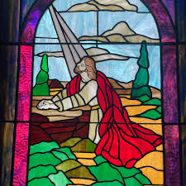
Lenten Devotions
“Come and See”
Wednesday, March 11th at 6:30 p.m.
Theme: “The Lines”
Scripture: John 21:18
Come dressed casually.
You are welcome to bring your Bible


Gentle Exercise Class . . .
designed for 40+

Every Thursday morning at 9:30 am in the Fellowship Hall
Breath & Movement 45 mins~
Discussion on creating a positive mindset 15 min~
Led by De Brown, certified Yoga Instructor and Immanuel UCC member!
*Suggested donation: $5-



Church Council Meeting
Thursday, March 12th at 5:30 p.m.

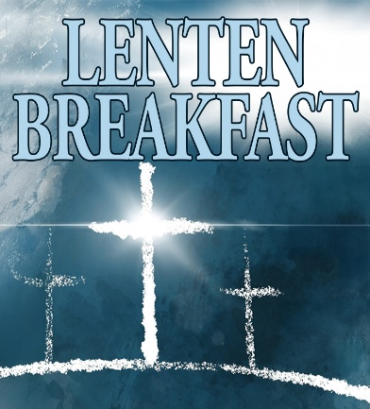

2026 Lenten Breakfast & Worship
“God Sent a Saviour Into the World
Breakfast begins at 8 am
Worship begins at 8:45 am
And ends by 9:30 am

March 14th – St. Lucas UCC 33 West Virginia Street, Evansville
March 21st – St. John’s East UCC 7000 Lincoln Avenue, Evansville
March 28th – St. Paul’s UCC-German Twp (Communion)
8701 Big Cynthiana Road, Evansville

Donations accepted at the door. All proceeds to be distributed to the United Caring Shelter and the Tri-State Food Bank via the Evansville Tri-State Association of the United Church of Christ.



SUNDAY 8th THIRD SUNDAY IN LENT
9:00 a.m. Adult Sunday School
10:00 a.m. Worship
5:30 p.m. – 6:30 p.m. AA Meeting

MONDAY 9th 8:30 a.m. God’s Storehouse

TUESDAY 10th

WED 11th 6:30 p.m. Lenten Devotions

THURSDAY 12th 9:30 a.m. Exercise Class
5:30 a.m. Council Meeting

FRIDAY 13th

SATURDAY 14th 8:00 a.m. Lenten Breakfast at St. Lucus UCC

SUNDAY 15th FOURTH SUNDAY IN LENT
9:00 a.m. Adult Sunday School
10:00 a.m. Worship (with One Great Hour of Sharing Offering)
5:30 p.m. – 6:30 p.m. AA Meeting



March 8 – Judy Deig, Robert Boarman
March 13 – Ruth Rueger



March 10 – Tony & Tina Kissinger
March 12 – Josh & Summer Deig

EASTER LILY MEMORIAL CROSS

An Easter tradition at Immanuel is the opportunity to remember friends and loved ones in the form of a lily placed on a special cross upon the alter for our Easter Sunday Worship.
If you want to participate, please return this form to the church office or give to a Church Council member by March 22nd.
A donation of $5.00 per memorial is suggested

Given in memory of _____________________________________________________________________________________________________________________________________________________________________________________________________________________________

Submitted by:
_______________________________________________________________________________________________________________

Donated total $__________________

