IMMANUEL UNITED CHURCH OF CHRIST
March 29, 2026

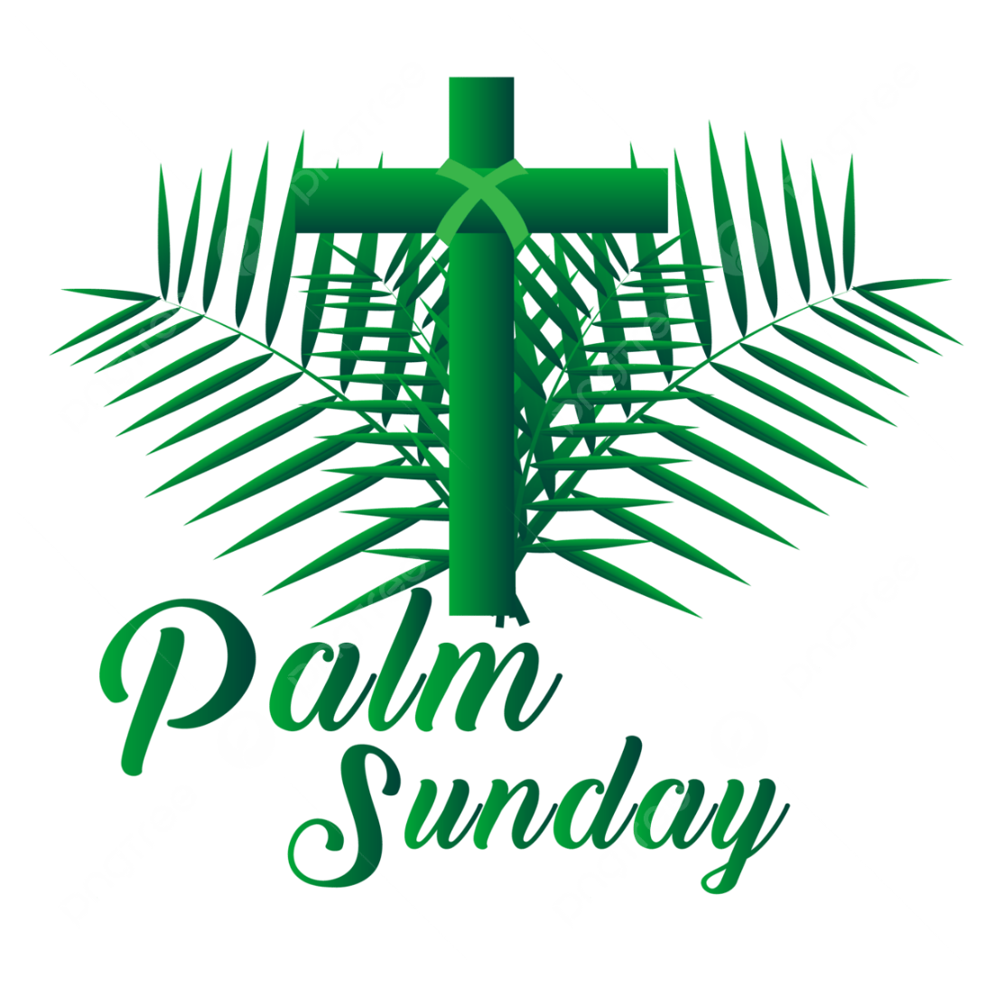

5812 Ford Rd. N. Mt. Vernon, IN 47620 (812) 985-3115
Facebook: Immanuel United Church of Christ Church Website: www.immanueluccmv.com
Church Email: info@immanueluccmv.com Administrative Assistant: Janie Meinschein
Pastor: Rev. Robert Walker Pastor Phone: 812-455-0087 (phone or text)
Our Vision? “To grow a vibrant church by sharing Christ with the community . . .”
Our Mission? “To invite, inspire, involve, increase . . .”

Palm Sunday
March 29, 2026
Rev. Robert B. Walker

RINGING OF THE BELL Keith Deig

WELCOME AND WORDS OF GREETING De Brown

PRELUDE “The Palms” by Jean Baptiste Faure
arr. By AC Whitworth

PRAISE SONG #69 “Standing on the Promises”

*CALL TO WORSHIP De Brown

L: Hosanna! We worship God for His mercy and majesty for Jesus, and we praise Him!

P: Hosanna in the highest!

L: The Ruler has come in humility!

P: Hosanna! Jesus comes to free us from all captivity!

OPENING HYMN #239 “Lift Up Your Heads, Ye Mighty Gates”

*PRAYER OF CONFESSION (Unison) De Brown

God of mystery and mercy, your mercy and forgiveness are a mystery to us. We fail to show mercy to others when they fall short of our expectations. We keep silent rather than speak up when others are in trouble. We prefer what is easy to what is right, even though your Spirit draws our attention. We seek your forgiveness, O God, and ask that you make us more forgiving. Inspire us how Jesus made his entrance into Jerusalem, and give us the courage to follow him. Amen.

*WORDS OF ASSURANCE Rev. Bob

*GLORIA PATRI

Glory be to the Father, and to the Son, and to the Holy Ghost;
As it was in the beginning, is now, and ever shall be,
world without end. Amen.

TIME FOR THE YOUNG AT HEART Rev. Bob

BLESSING OF THE PALMS Rev. Bob

PRAYERS OF THE PEOPLE
The Pastoral Prayer - The Lord’s Prayer Rev. Bob

SERVICE OF GIVING
Offertory “The Holy City” by Stephen Adams

*Response- No. 382

Praise God, from whom all blessings flow;
Praise Him, all creatures here below;
Praise Him above, ye heavenly host;
Praise Father, Son, and Holy Ghost. Amen.

*Prayer of Dedication (In Unison) De Brown

Gracious God, when we remember Jesus gave his life for us, our offering seems so small. Yet Jesus shows us that five loaves and two fish can feed a multitude; a man dying on a cross becomes Living Bread for a hungry world. Bless these small gifts with your goodness so that the miracle of Jesus’ love continues to amaze the world. Amen.

SCRIPTURE – Gospel of Matthew 21:1-11 De Brown

As they approached Jerusalem and came to Bethphage on the Mount of Olives, Jesus sent two disciples, ² saying to them, “Go to the village ahead of you, and at once you will find a donkey tied there, with her colt by her. Untie them and bring them to me. ³ If anyone says anything to you, say that the Lord needs them, and he will send them right away.”

⁴ This took place to fulfill what was spoken through the prophet:

⁵ “Say to Daughter Zion,
See, your king comes to you,
gentle and riding on a donkey,
and on a colt, the foal of a donkey.’”

⁶ The disciples went and did as Jesus had instructed them. ⁷ They brought the donkey and the colt and placed their cloaks on them for Jesus to sit on. ⁸ A very large crowd spread their cloaks on the road, while others cut branches from the trees and spread them on the road. ⁹ The crowds that went ahead of him and those that followed shouted,

“Hosanna to the Son of David!

“Blessed is he who comes in the name of the Lord!”

“Hosanna in the highest heaven!”

¹⁰ When Jesus entered Jerusalem, the whole city was stirred and asked, “Who is this?”

¹¹ The crowds answered, “This is Jesus, the prophet from Nazareth in Galilee.”

HYMN #248 “Hosanna, Loud Hosanna”

SERMON “He Rode into Our Lives” Rev. Bob

RECEPTION OF NEW MEMBERS Council President Bret Baldwin, Rev. Bob

*Congregational “Welcome and Reception” Bret Baldwin

Bret: Let us, the members of Immanuel United Church of Christ, stand and express our welcome and
affirm our mutual ministry in Christ.

People: We welcome you with joy in the common life of this church.
We promise you our friendship and prayers as we share the hopes
and labors of the church of Jesus Christ. By the power of the Holy Spirit
may we continue to grow together in God’s knowledge and love and be
witnesses of our risen Savior.

*A HYMN OF CELEBRATION #249 “All Glory, Laud and Honor”

*PASTORAL BENEDICTION Rev. Bob

*BENEDICTION SONG #681 “Let There be Peace on Earth”

Let there be peace on earth, and let it begin with me.
Let there be peace on earth, the peace that was meant to be.
With God as our Maker, family all are we, Let me walk with my family in perfect harmony.
Let peace begin with me, let this be the moment now.
With every step I take, let this be my solemn vow: To take each moment and live each moment
In peace eternally! Let there be peace of earth and let it begin with me.

POSTLUDE “All Glory, Laud and Honor” by Melchior Teschner
arr. By AC Whitworth

Used by Permission. CCLI License # 20658309, Streaming # 20658316

+++++++++++++++++++++++++++++++++++++++++++++++++++++++++++++++++++++++++++++

Today Maundy Thursday Easter Sunrise Easter Festival
Lay Reader  Ushers/Greeters:  Pianist/Organist: | De Brown  Chris Moers  Gail Angel | Bret Baldwin  Bret Baldwin Family  Beth Folz | Judy Deig  OPEN  Beth Folz | Bret Baldwin  OPEN  Beth Folz

ATTENDANCE | LAST WEEK: 50 LAST YEAR: 50

OUR IMMANUEL UCC PRAYER LIST

*Members of Immanuel

*Charles Behrick *David Behrick *Janice Jones *Dan Riddle

Rick Ferguson Kiersten Ferguson-Cremin David Frye Tom Howard

Denis Lambrich Kenny Meinschein Mildred Taylor

Teresa Topper Ken Willett
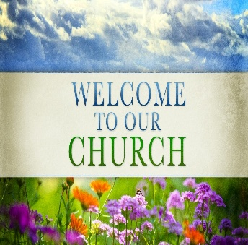

WE WELCOME OUR GUESTS!
We invite you to sign our Guest Book, located in the Narthex.

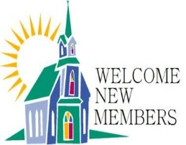  NEW MEMBER RECEPTION  FOLLOWING WORSHIP TODAY  The Dorcas Women’s Fellowship is hosting a reception for our new members:  Ruth Duckworth, Greg Renshaw, Rev. Bob Walker  Cake & Punch will be served  Everyone is invited to stay and welcome them. |   Gentle Exercise Class  designed for 40+  Every Thursday morning at 9:30 am in the Fellowship Hall  Breath & Movement 45 mins~  Discussion on creating a positive mindset 15 min~  Led by De Brown, certified Yoga Instructor and Immanuel UCC member!  *Suggested donation: $5-

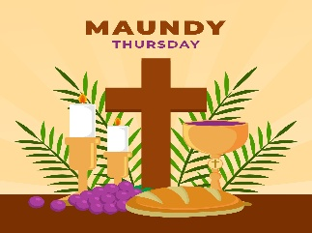
Thursday, April 2nd at 6:30 p.m.
Maundy Thursday Service
With Holy Communion
Minister: Rev. Bob Walker


Saturday, April 4th at 9:00 a.m.
Easter Breakfast and Egg Hunt
with the Easter Bunny
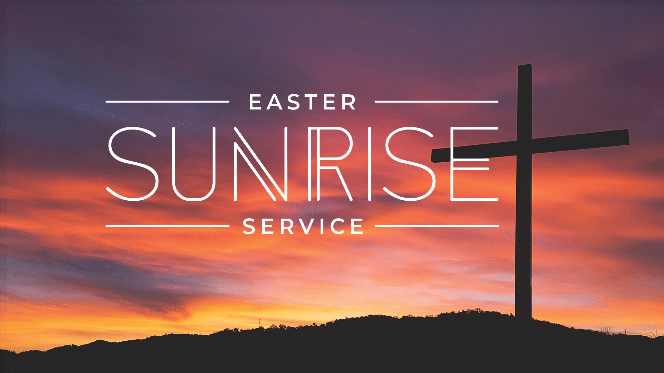
April 5th Easter Sunrise Service 7:30 a.m.
With Holy Communion
Minister: Rev. Bob Walker

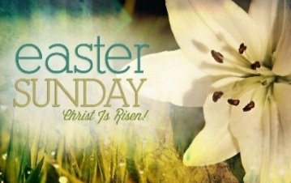
April 5th Easter Festival Service at 10:00 a.m.
With Holy Commuinion
Minister: Rev. Bob Walker

THIS WEEK

SUNDAY 29th PALM SUNDAY
9:00 a.m. Adult Sunday School
10:00 a.m. Worship
Cake & Punch Reception for New Members
5:30 p.m. – 6:30 p.m. AA Meeting

MONDAY 30th

TUESDAY 31st

WED 1st

THURSDAY 2nd 9:30 a.m. Exercise Class
6:30 p.m. Maundy Thursday service

FRIDAY 3rd GOOD FRIDAY

SATURDAY 4th 9:00 a.m. Easter Egg Hunt & Breakfast with the Easter Bunny

SUNDAY 5th 7:30 a.m. Easter Sunrise Service
Breakfast following Sunrise Service
10:00 a.m. Easter Festival Service
5:30 p.m. – 6:30 p.m. AA Meeting

March 30 – Tony Kissinger
April 2 – Greg Seifert
April 4 – Jeff O’Risky

SAVE THE DATE

