IMMANUEL UNITED CHURCH OF CHRIST
March 22, 2026

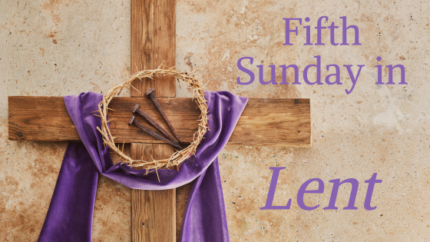

5812 Ford Rd. N. Mt. Vernon, IN 47620 (812) 985-3115
Facebook: Immanuel United Church of Christ Church Website: www.immanueluccmv.com
Church Email: info@immanueluccmv.com Administrative Assistant: Janie Meinschein
Pastor: Rev. Robert Walker Pastor Phone: 812-455-0087 (phone or text)
Our Vision? “To grow a vibrant church by sharing Christ with the community . . .”
Our Mission? “To invite, inspire, involve, increase . . .”

Fifth Sunday of Lent
March 15, 2026
Rev. Robert B. Walker

RINGING OF THE BELL Keith Deig

WELCOME AND WORDS OF GREETING Melody Oeth

PRELUDE “Adagio” By Cesar Franck

*Hymn #641 “Pass It On”

*CALL TO WORSHIP Melody Oeth

Leader: The hand of the Lord is upon us, bringing us into the midst of a valley.

People: It is a valley full of dry bones, a place that has seen better days.

Leader: Can these bones live?

People: O Lord God, You know!

Leader: Hear the word of the Lord, you dry bones: God will breathe new life into you, and you
shall live.

People: Come, O Spirit of God, from the four winds!

Leader: The Lord has spoken, and the Lord will do it!

ALL: Let us praise the One who brings life from death and hope from despair.
We come alive in the Lord!

*Hymn #32 “How Firm a Foundation”

*PRAYER OF CONFESSION (Unison) .Melody Oeth

Merciful God, we confess that we have sinned against you in thought, word, and deed, by what we have done, and by what we have left undone. We have not loved you with our whole heart; we have not loved our neighbors as ourselves. Have mercy on us and forgive us; so that we may delight in your will, and walk in your ways, to the glory of your Name. Amen.

*WORDS OF ASSURANCE Rev. Bob

*GLORIA PATRI
Glory be to the Father, and to the Son, and to the Holy Ghost;
As it was in the beginning, is now, and ever shall be,
world without end. Amen, Amen.

TIME FOR THE YOUNG AT HEART Rev. Bob

HYMN BEFORE OUR PRAYER #155 “Spirit of the Living God”

Spirit of the Living God, Fall afresh on me.
Spirit of the Living God, Fall afresh on me.
Melt me, mold me, Fill me, use me.
Spirit of the Living God, Fall afresh on me.

PRAYERS OF THE PEOPLE
Pastoral Prayer ~ The Lord’s Prayer

SERVICE OF GIVING
Call to Sharing – Rev. Bob
Offertory “Elevation” By Batman
*Response No. 382

Praise God, from whom all blessings flow;
Praise Him, all creatures here below;
Praise Him above, ye heavenly host;
Praise Father, Son, and Holy Ghost. Amen.

*Prayer of Dedication (In Unison) Melody Oeth

O God, accept and bless these gifts which we offer in response to the gracious gift of your life-giving Spirit to us. May these gifts and our lives be used to flesh out your love and justice, mercy and peace as they are revealed in and through Jesus, your Son and our Saviour. Amen.

SCRIPTURE – Ezekial 37:1-14 Melody Oeth
The hand of the Lord was upon me, and he brought me out by the Spirit of the Lord, and set me down in the midst of the valley; it was full of bones. ² And he led me round among them; and behold, there were very many upon the valley; and lo, they were very dry. ³ And he said to me, “Son of man, can these bones live?” And I answered, “O Lord God, thou knowest.” ⁴ Again he said to me, “Prophesy to these bones, and say to them, O dry bones, hear the word of the Lord. ⁵ Thus says the Lord God to these bones: Behold, I will cause breath to enter you, and you shall live. ⁶ And I will lay sinews upon you, and will cause flesh to come upon you, and cover you with skin, and put breath in you, and you shall live; and you shall know that I am the Lord.”
⁷ So I prophesied as I was commanded; and as I prophesied, there was a noise, and behold, a rattling; and the bones came together, bone to its bone. ⁸ And as I looked, there were sinews on them, and flesh had come upon them, and skin had covered them; but there was no breath in them. ⁹ Then he said to me, “Prophesy to the breath, prophesy, son of man, and say to the breath, Thus says the Lord God: Come from the four winds, O breath, and breathe upon these slain, that they may live.” ¹⁰ So I prophesied as he commanded me, and the breath came into them, and they lived, and stood upon their feet, an exceedingly great host.
¹¹ Then he said to me, “Son of man, these bones are the whole house of Israel. Behold, they say, ‘Our bones are dried up, and our hope is lost; we are clean cut off.’ ¹² Therefore prophesy, and say to them, Thus says the Lord God: Behold, I will open your graves, and raise you from your graves, O my people; and I will bring you home into the land of Israel. ¹³ And you shall know that I am the Lord, when I open your graves, and raise you from your graves, O my people. ¹⁴ And I will put my Spirit within you, and you shall live, and I will place you in your own land; then you shall know that I, the Lord, have spoken, and I have done it, says the Lord.”
SERMON HYMN # 161 “Breathe On Me, Breath of God”

SERMON “What Seems to Be Impossible” Rev. Bob

*CLOSING HYMN #319 “Immortal, Invisible, God Only Wise”

*PASTORAL COMMISSION & BENEDICTION Rev. Bob

As we move toward Holy Week and turn towards the Cross, remember the words of Jesus:

"I am the resurrection and the life. Those who believe in me, even though they die, will live, and everyone who lives and believes in me will never die. So may the tears of the Lord Jesus wash over your sorrows, the Spirit of God dwell in your hearts, and God’s promise of new life lead you through each day ahead. Go in peace!
Amen and….AMEN!

*BENEDICTION SONG #677 “They’ll Know We Are Christians by Our Love”

We are one in the Spirit, we are one in the Lord,
We are one in the Spirit, we are one in the Lord,
And we pray that all unity may one day be restored;
And they’ll know we are Christians by our love, by our love,
Yes, they’ll know we are Christians by our love.

POSTLUDE “There is a Green Hill Far Away” By Stebbins,
arr. by AC Whitworth

+++++++++++++++++++++++++++++++++++++++++++++++++++++++++++++++++++++++++++++

Today March 29
Lay Reader  Ushers/Greeters:  Pianist/Organist: | Melody Oeth  Justin, Ashton & Rose Wagner  Gail Angel | De Brown  Chris Moers  Gail Angel

ATTENDANCE | LAST WEEK: 59 LAST YEAR: 66

OUR IMMANUEL UCC PRAYER LIST

*Members of Immanuel

*Charles Behrick *David Behrick *Janice Jones *Dan Riddle

Rick Ferguson Kiersten Ferguson-Cremin David Frye Tom Howard

Kenny Meinschein Jerry Smithhart Mildred Taylor

Teresa Topper Ken Willett


WE WELCOME OUR GUESTS! We invite you to sign our Guest Book, located in the Narthex.

APRIL NEWSLETTER ARTICLES are due in the church office on Thursday, March 26th.

THIS WEEK


LUNCH BUNCH
At Tequilas in Mt. Vernon
Wednesday, March 25th
12:00 noon
Everyone is invited!

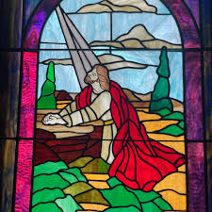  Lenten Devotions  “Come and See”  Wed, March 25th at 6:30 p.m.  Theme: “A Friend in Need---Joseph”  Scripture: Mark 15:43-46  Come dressed casually.  You are welcome to bring your Bibles! |   Gentle Exercise Class  designed for 40+  Every Thursday morning at 9:30 am in the Fellowship Hall  Breath & Movement 45 mins~  Discussion on creating a positive mindset 15 min~  Led by De Brown, certified Yoga Instructor and Immanuel UCC member!  *Suggested donation: $5-


2026 Lenten Breakfast & Worship
“God Sent a Saviour Into the World
Breakfast begins at 8 am
Worship begins at 8:45 am and ends by 9:30 a.m.
March 28th – St. Paul’s UCC-German Twp (Communion)
8701 Big Cynthiana Road, Evansville

UPCOMING…


March 29th
Palm Sunday Service 10:00 a.m.
Minister: Rev. Bob Walker

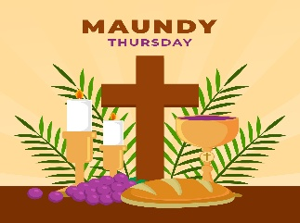
Thursday, April 2nd at 6:30 p.m.
With Holy Communion
Minister: Rev. Bob Walker


Saturday, April 4th at 9:00 a.m.
Easter Breakfast and Egg Hunt
with the Easter Bunny


April 5th Easter Sunrise Service 7:30 a.m.
With Holy Communion
Minister: Rev. Bob Walker


April 5th Easter Festival Service at 10:00 a.m.
With Holy Commuinion
Minister: Rev. Bob Walker

WEEKLY CALENDAR

SUNDAY 22nd FIFTH SUNDAY IN LENT
9:00 a.m. Adult Sunday School
10:00 a.m. Worship
5:30 p.m. – 6:30 p.m. AA Meeting

MONDAY 23rd

TUESDAY 24th

WED 25th 6:30 p.m. Lenten Devotions
12:00 noon Lunch Bunch at Tequila’s

THURSDAY 26th 9:30 a.m. Exercise Class
Newsletter Articles are due in office

FRIDAY 27th

SATURDAY 28th 8:00 a.m. Lenten Breakfast at St. Paul’s UCC German Twp

SUNDAY 29th PALM SUNDAY
9:00 a.m. Adult Sunday School
10:00 a.m. Worship
5:30 p.m. – 6:30 p.m. AA Meeting


March 23 – Cheryl Higgs
March 24 – Paul Reller
March 27 – Marilyn Thielman

SAVE THE DATE



