IMMANUEL UNITED CHURCH OF CHRIST
February 15, 2026

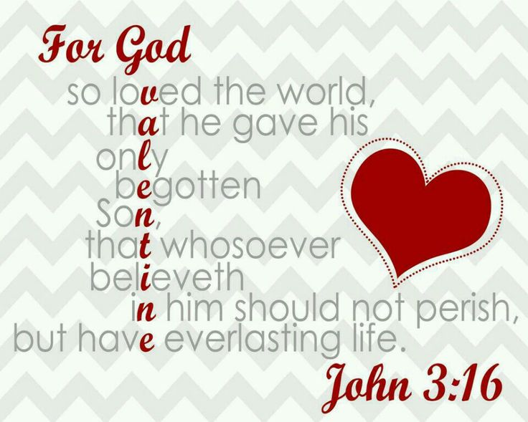

5812 Ford Rd. N. Mt. Vernon, IN 47620 (812) 985-3115
Facebook: Immanuel United Church of Christ Church Website: www.immanueluccmv.com
Church Email: info@immanueluccmv.com Administrative Assistant: Janie Meinschein
Pastor: Rev. Robert Walker Pastor Phone: 812-455-0087 (phone or text)
Our Vision? “To grow a vibrant church by sharing Christ with the community . . .”
Our Mission? “To invite, inspire, involve, increase . . .”

Transfiguration
February 15, 2026

RINGING OF THE BELL Keith Deig

WELCOME AND WORDS OF GREETING Mellisa Hall

PRELUDE

*CALL TO WORSHIP Mellisa Hall

L: Make a joyful noise to the Lord, all the earth. Worship the Lord with gladness; come into his presence with singing.

P: Know that the Lord is God. It is he that made us, and we are his; we are his people, and the sheep of his pasture.

L: Enter his gates with thanksgiving, and his courts with praise. Give thanks to him, bless his name.

All: For the Lord is good; his steadfast love endures forever, and his faithfulness to all generations. (Psalm 100)

*OPENING HYMN - #108 “Rock of Ages, Cleft for Me”

*PRAYER OF CONFESSION (Unison)

In your loving presence, God, we unwind the past month, starting with now and looking back, moment to moment. We gather in all the goodness and light in gratitude, and we give thanks. We attend to the shadows and what they say to us. We come to you with humble hearts seeking your healing, courage, and forgiveness. Amen

*WORDS OF ASSURANCE Mellisa Hall

The good news in Christ is that God loves us with an unending, steadfast love.
Praise to God!

*GLORIA PATRI

Glory be to the Father, and to the Son, and to the Holy Ghost;
As it was in the beginning, is now, and ever shall be,
world without end. Amen.

CHILDREN’S MOMENTS OPEN

PRAYERS OF THE PEOPLE Wendi Nelson
Silent Prayer ~ Pastoral Prayer ~Lord’s Prayer (In Unison)

Our Father who art in heaven, hallowed be thy name. Thy kingdom come, thy will be done on earth as it is in heaven. Give us this day our daily bread and forgive us our debts as we forgive our debtors. And lead us not into temptation, but deliver us from evil. For thine is the kingdom, and the power, and the glory forever. Amen.

SERVICE OF GIVING

Offertory
*Response #382
Praise God, from whom all blessings flow;
Praise Him, all creatures here below;
Praise Him above, ye heavenly host;
Praise Father, Son, and Holy Ghost. Amen.

*Prayer of Dedication (In Unison) Mellisa Hall

God of abundance--with thanksgiving, we offer these gifts, our time, and our talent. Please use these gifts to further your realm on earth. Accept these gifts from our hands. Bless this offering, we pray as we dedicate our lives anew to serve you.

SCRIPTURE Mellisa Hall
Philippians 1:5-6
⁵ because of your partnership in the gospel from the first day until now, ⁶ being confident of this, that he who began a good work in you will carry it on to completion until the day of Christ Jesus.

Romans 12:1-2
A Living Sacrifice
12 Therefore, I urge you, brothers and sisters, in view of God’s mercy, to offer your bodies as a living sacrifice, holy and pleasing to God—this is your true and proper worship. ² Do not conform to the pattern of this world, but be transformed by the renewing of your mind. Then you will be able to test and approve what God’s will is—his good, pleasing and perfect will.

2 Corinthians 3:18

¹⁸ And we all, who with unveiled faces contemplate^{[a]} the Lord’s glory, are being transformed into his image with ever-increasing glory, which comes from the Lord, who is the Spirit.

Galatians 5:22-23
²² But the fruit of the Spirit is love, joy, peace, forbearance, kindness, goodness, faithfulness, ²³ gentleness and self-control. Against such things there is no law.

John 15:4-5
⁴ Remain in me, as I also remain in you. No branch can bear fruit by itself; it must remain in the vine. Neither can you bear fruit unless you remain in me.
⁵ “I am the vine; you are the branches. If you remain in me and I in you, you will bear much fruit; apart from me you can do nothing.

HYMN #588 “In the Garden”

SERMON “Still Growing: Time With Jesus Changes Everything” Wendi Nelson

*CLOSING HYMN #560 “Blest Be the Tie That Binds”

*BENEDICTION

*BENEDICTION SONG
Lord, of life, Lord of Love, Walk forever beside us.
Day by Day, Show the Way, With your Vision to guide us,
Striving to Follow Your Will and Way, Nothing can divide us,
Lord of Life, Lord of Love, Walk forever beside us.

POSTLUDE “Be Still My Soul” The Dulicers
“Blessed Assurance”

Used by Permission. CCLI License # 20658309, Streaming # 20658316

+++++++++++++++++++++++++++++++++++++++++++++++++++++++++++++++++++++++++++++

Today February 22
Lay Reader  Ushers/Greeters:  Pianist/Organist: | Mellisa Hall  Bret Baldwin Family  Beth Folz | Judy Deig  OPEN  Beth Folz

ATTENDANCE | LAST WEEK: 51 LAST YEAR: 61

OUR IMMANUEL UCC PRAYER LIST



*Members of Immanuel

*Charles Behrick *David Behrick *Nelda Hickey

*Janice Jones *Dan Riddle

Rick Ferguson (Brother of Paula Boarman)
Kiersten Ferguson-Cremin (Niece of Paula Boarman)
David Frye - Friend
Tom Howard (Brother of Angela Clark)
Kenny Meinschein (Husband of Janie Meinschein)
Greg Renshaw (Husband of Julie Renshaw)
Jerry Smithhart (Friend of Chris Moers)
Mildred Taylor - Friend
Becky Teeple (Daughter of Paul & Carol Williams)
Dee Teeple (Son-in-law of Paul & Carol Williams)
Teresa Topper (Friend of Chris Moers)
Ken Willett (Husband of Jennifer Willett)

Today we welcome Wendi Nelson - Worship
Layleader: Mellisa Hall
Wendi is the daughter of Ron & Cheryl Higgs.
I have been married for 25 years and have 3 children, ages 23, 20 and 8. I also has 4 cats.
I love God’s people.
I enjoy family, teaching and also learning. I enjoy making art and music. My favorite season is Fall, except it seems to keep getting shorter!
I volunteer with For the Love of Africa Ministries and have been to Uganda twice.
I am the Kids ministry leader at The Oasis.
I teach fitness classes at the YMCA.
I am credentialed as a minister of the Gospel through the Assemblies of God; ordained through NACM. I will be graduating May 2026 with a BA in Biblical Studies with a Pastoral Ministry Major.

Next Sunday we welcome:
Rev. Robert Walker – Worship
Layleader: Judy Deig

WE WELCOME OUR GUESTS! We invite you to sign our Guest Book, located in the Narthex.

ANNUAL CONGREGATIONAL MEETING will be held after worship today. Please plan to attend.
We will have a potluck lunch following the meeting. The church will supply fried chicken. Everyone is invited.

SIGNUP SHEETS FOR LAY READERS AND GREETERS are in the Narthex. Please look at your schedule and sign up if you are able.

CHURCH COUNCIL will meet this Wednesday, February 18th at 5:30 p.m.

ASH WEDNESDAY WORSHIP SERVICE will be this Wednesday, February 18th at 6:30 p.m. with ashes, hymns, prayers and a time to reflect on the next 40 days until Easter.

LENTEN BREAKFAST AND WORSHIP begins Saturday, February 21st at Christ Church UCC at 8:00 a.m. Everyone (Men & Women) are welcome to attend.

LENTEN DEVOTIONS will begin on Wednesday, February 25th at 6:30 p.m. “Come & See”

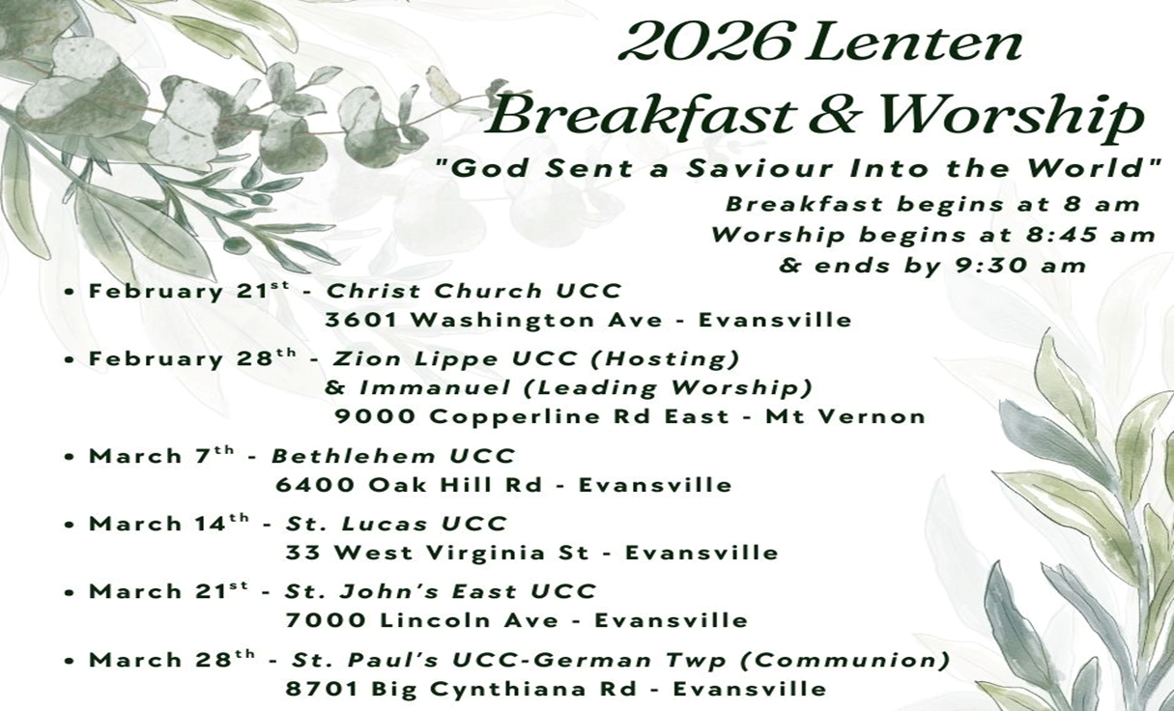

Donations accepted at the door. All proceeds to be distributed to the United Caring Shelter and the
Tri-State Food Bank via the Evansville Tri-State Association of the United Church of Christ.
Immanuel historically has had a great participation and attendance at these events. Zion-Lippe will host the breakfast and worship location and Immanuel UCC will present the worship message.
+++++++++++++++++++++++++++++++++++++++++++++++++++++++++++++++++++++++++++++
Welcome to the Lenten Devotions!

“Come and See” were the words of Jesus when he was getting his disciples for the first time. Some of them were friends, some were family, others did not know who the other disciples were but he called them to find out what he was going to do in his earthly ministry. “Come and see,” he said in John 1:39. I look forward to meeting anyone who comes to see how Jesus came to his saving ministry during his life that would come to his death on the cross, but God raised him to a New Life on Easter through his Resurrection! Here is what our schedule is for these gatherings here at Immanuel UCC!
- February 18, 6:30 p.m. – Ash Wednesday service in the sanctuary with ashes, hymns, prayers, and a time to reflect on the next 40 days (excluding Sundays) until Easter.

- February 25, 6:30 p.m. – “Come and See” Lenten devotions, hymn sing and Bible study. Come dressed casually. You are welcome to bring your Bibles!

Theme Scripture
- February 25 “Near the Cross” Luke 23:34
- March 4 “Praying in Private” Matthew 6:6
- March 11 “The Lines” John 21:18
- March 18 “Created and Is Creating” Isaiah 40:26
- March 25 “A Friend in Need ---Joseph” Mark 15:43-46

I look forward to seeing you here at Immanuel Church! - Rev. Bob Walker



SUNDAY 15th TRANSFIGURATION
9:00 a.m. Adult Sunday School
10:00 a.m. Worship
Annual Congregational Meeting after Worship
Pot Luck Lunch after Meeting
5:30 p.m. – 6:30 p.m. AA Meeting

MONDAY 16th PRESIDENT’S DAY

TUESDAY 17th

WED 18th 5:30 p.m. Council Meeting
6:30 p.m. Ash Wednesday Service

THURSDAY 19th 9:30 a.m. Exercise Class

FRIDAY 20th

SATURDAY 21st 8:00 a.m. Lenten Breakfast at Christ Church UCC

SUNDAY 22nd FIRST SUNDAY IN LENT
9:00 a.m. Adult Sunday School
10:00 a.m. Worship
5:30 p.m. – 6:30 p.m. AA Meeting



February 15 – Ann Baldwin
February 20 – Kevin Boarman


Gentle Exercise Class . . . designed for 40+
Every Thursday morning at 9:30 am in the Fellowship Hall
Breath & Movement 45 mins~
Discussion on creating a positive mindset 15 min~
Led by De Brown, certified Yoga Instructor and Immanuel UCC member!
*Suggested donation: $5-

