IMMANUEL UNITED CHURCH OF CHRIST
February 1, 2026

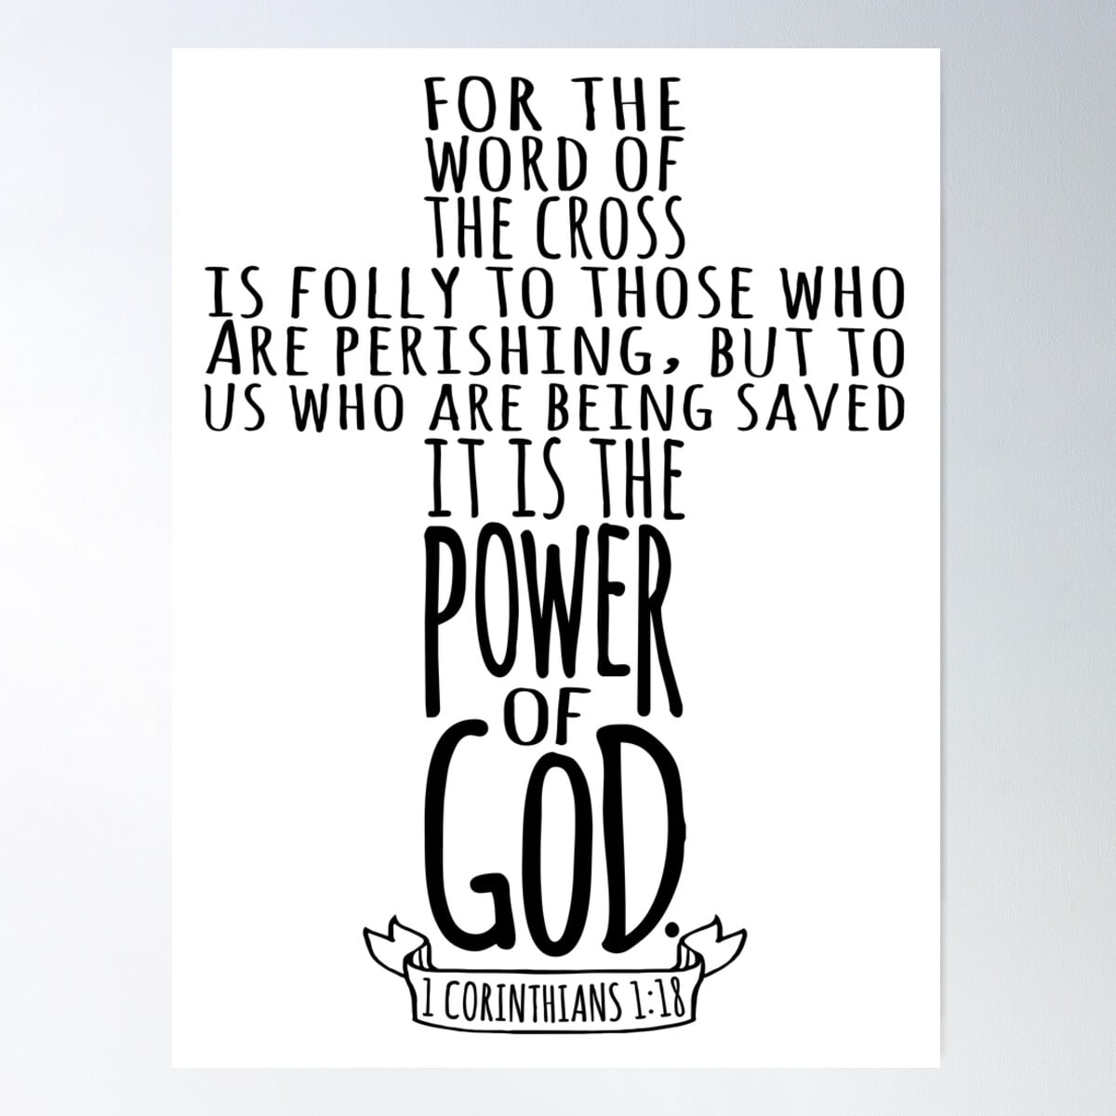

5812 Ford Rd. N. Mt. Vernon, IN 47620 (812) 985-3115
Facebook: Immanuel United Church of Christ Church Website: www.immanueluccmv.com
Church Email: info@immanueluccmv.com Administrative Assistant: Janie Meinschein
Our Vision? “To grow a vibrant church by sharing Christ with the community . . .”
Our Mission? “To invite, inspire, involve, increase . . .”

Fourth Sunday after Epiphany
February 1, 2026
Rev. Robert B. Walker

RINGING OF THE BELL Keith Deig

WELCOME AND WORDS OF GREETING Angela Clark

PRELUDE

*Hymn #337 “Praise to the Lord, the Almighty”

*CALL TO WORSHIP based on Micah 6:6-8 Angela Clark

Leader: The grace of our Lord Jesus Christ, the love of God, and the fellowship of the Holy Spirit
be with you all.

People: All also with you!

Leader: Be still before God and wait patiently, for he will appear. Delight in God, for he will satisfy your hunger. Call upon God, for he will answer.

People: With what shall we come before God? Who among the living is worthy to stand in his presence?

Leader: A gentle and contrite heart God will not despise. A humble spirit he will not turn away.

People: We will stand before God and trust in his righteousness, for God alone is holy, only he is full of glory.

*Hymn #159 “Sweet, Sweet Spirit”

*PRAYER OF CONFESSION (Unison) Angela Clark

Faithful God, you sent Jesus Christ to seek and save the lost yet it’s hard to recognize we have lost our way. We seek the next new thing instead of your gift of new life. We follow the trends of our culture rather than Jesus’ example. Wash over us with your cleansing Spirit, and renew our commitment to follow your purposes revealed in Christ Jesus. Amen.

*WORDS OF ASSURANCE Rev. Bob Walker

*GLORIA PATRI
Glory be to the Father, and to the Son, and to the Holy Ghost;
As it was in the beginning, is now, and ever shall be,
world without end. Amen.

TIME FOR THE YOUNG AT HEART Rev. Bob Walker

PRAYERS OF THE PEOPLE
Pastoral Prayer ~ The Lord’s Prayer

SERVICE OF GIVING
Offertory
*Response No. 382

Praise God, from whom all blessings flow;
Praise Him, all creatures here below;
Praise Him above, ye heavenly host;
Praise Father, Son, and Holy Ghost. Amen.

*Prayer of Dedication (In Unison) Angela Clark

Gracious God, we offer you our gifts with humble hearts. Each gift seems small on its own, so bless each one and those of your people throughout the Church. Through the work of your Holy Spirit, surprise us with all that our gifts can accomplish, in the name of Jesus Christ, our Lord. Amen.

SCRIPTURE – Gospel of I Corinthians 1:18-31 Angela Clark

¹⁸ For the word of the cross is folly to those who are perishing, but to us who are being saved it is the power of God. ¹⁹ For it is written,

“I will destroy the wisdom of the wise,
and the cleverness of the clever I will thwart.”

²⁰ Where is the wise man? Where is the scribe? Where is the debater of this age? Has not God made foolish the wisdom of the world? ²¹ For since, in the wisdom of God, the world did not know God through wisdom, it pleased God through the folly of what we preach to save those who believe. ²² For Jews demand signs and Greeks seek wisdom, ²³ but we preach Christ crucified, a stumbling block to Jews and folly to Gentiles, ²⁴ but to those who are called, both Jews and Greeks, Christ the power of God and the wisdom of God. ²⁵ For the foolishness of God is wiser than men, and the weakness of God is stronger than men.

²⁶ For consider your call, brethren; not many of you were wise according to worldly standards, not many were powerful, not many were of noble birth; ²⁷ but God chose what is foolish in the world to shame the wise, God chose what is weak in the world to shame the strong, ²⁸ God chose what is low and despised in the world, even things that are not, to bring to nothing things that are, ²⁹ so that no human being might boast in the presence of God. ³⁰ He is the source of your life in Christ Jesus, whom God made our wisdom, our righteousness and sanctification and redemption; ³¹ therefore, as it is written, “Let him who boasts, boast of the Lord.”

SERMON “Our Wisdom and Our Redemption” Rev. Bob Walker

*COMMUNION HYMN #564 “Let Us Break Bread Together”

CELEBRATION OF HOLY COMMUNION
INVITATION TO COMMUNION
COMMUNION PRAYER
WORDS OF INSTITUTION
SHARING THE BREAD AND CUP
*PRAYER OF THANKSGIVING

*CLOSING HYMN #454 “Trust and Obey”

*PASTORAL BENEDICTION Rev. Bob Walker

May the God of justice strengthen your will to serve.
May the Christ of compassion inspire your heart to love.
May the Holy Spirit walk with you in wisdom this day and always.
Amen and ….AMEN!

*BENEDICTION SONG “Go, Tell It on the Mountains!”

Go, tell it on the mountains, Over the hills and everywhere;
Go, tell it on the mountains that Jesus Christ is born!

POSTLUDE

Used by Permission. CCLI License # 20658309, Streaming # 20658316

+++++++++++++++++++++++++++++++++++++++++++++++++++++++++++++++++++++++++++++

Today February 8
Lay Reader  Ushers/Greeters:  Pianist/Organist: | Angela Clark  OPEN  Gail Angel | OPEN  OPEN  Beth Folz

ATTENDANCE | LAST WEEK: Cancelled (Snow) LAST YEAR: 50



Today we welcome:
Rev. Robert Walker – Worship & Holy Communion
Layleader: Angela Clark

Next Sunday February 8
Rev. Robert Walker will lead us in worship.

OUR IMMANUEL UCC PRAYER LIST



*Members of Immanuel

*Charles Behrick *David Behrick *Nelda Hickey

*Janice Jones *Dan Riddle

Rick Ferguson (Brother of Paula Boarman)
Kiersten Ferguson-Cremin (Niece of Paula Boarman)
David Frye - Friend
Tom Howard (Brother of Angela Clark)
Kenny Meinschein (Husband of Janie Meinschein)
Greg Renshaw (Husband of Julie Renshaw)
Jerry Smithhart (Friend of Chris Moers)
Mildred Taylor - Friend
Becky Teeple (Daughter of Paul & Carol Williams)
Dee Teeple (Son-in-law of Paul & Carol Williams)
Teresa Topper (Friend of Chris Moers)
Ken Willett (Husband of Jennifer Willett)

Announcements

WE WELCOME OUR GUESTS! We invite you to sign our Guest Book, located in the Narthex.

ANNUAL CONGREGATIONAL MEETING will be held after worship on Sunday, February 15th. Please plan to attend. We will have a potluck lunch following the meeting. The church will supply fried chicken. Everyone is invited.

OUR PRAYERS go out to the family of Lester Weiss who passed away on January 23, 2026. Lester was a long-time member of Immanuel Church. A private graveside service was held at Immanuel UCC Cemetery on Friday, January 30th. Memorial contributions may be made to Immanuel United Church of Christ, 5812 Ford Road, Mt. Vernon, IN 47620.



SUNDAY 1st FOURTH SUNDAY AFTER THE EPIPHANY
9:00 a.m. Adult Sunday School
10:00 a.m. Worship & Communion
5:30 p.m. – 6:30 p.m. AA Meeting

MONDAY 2nd

TUESDAY 3rd

WED 4th

THURSDAY 5th 9:30 a.m. Exercise Class

FRIDAY 6th

SATURDAY 7th

SUNDAY 8th FIFTH SUNDAY AFTER THE EPIPHANY
9:00 a.m. Adult Sunday School
10:00 a.m. Worship
5:30 p.m. – 6:30 p.m. AA Meeting



February 3 – Dennis Clark February 6 – Nathan & Audrey Allen
February 4 – Greg Oeth, Bill Bailey
February 5 – Paula Boarman, Janice Jones, Cindy Woodall
February 6 – Cherry Chase, Keith Deig
February 7 – Daryl Shuck

Join us!

Gentle Exercise Class . . . designed for 40+
Every Thursday morning at 9:30 am in the Fellowship Hall
Breath & Movement 45 mins~
Discussion on creating a positive mindset 15 min~
Led by De Brown, certified Yoga Instructor and Immanuel UCC member!
*Suggested donation: $5-

