`IMMANUEL UNITED CHURCH OF CHRIST
December 7, 2025
Rev. Robert B Walker, Minister

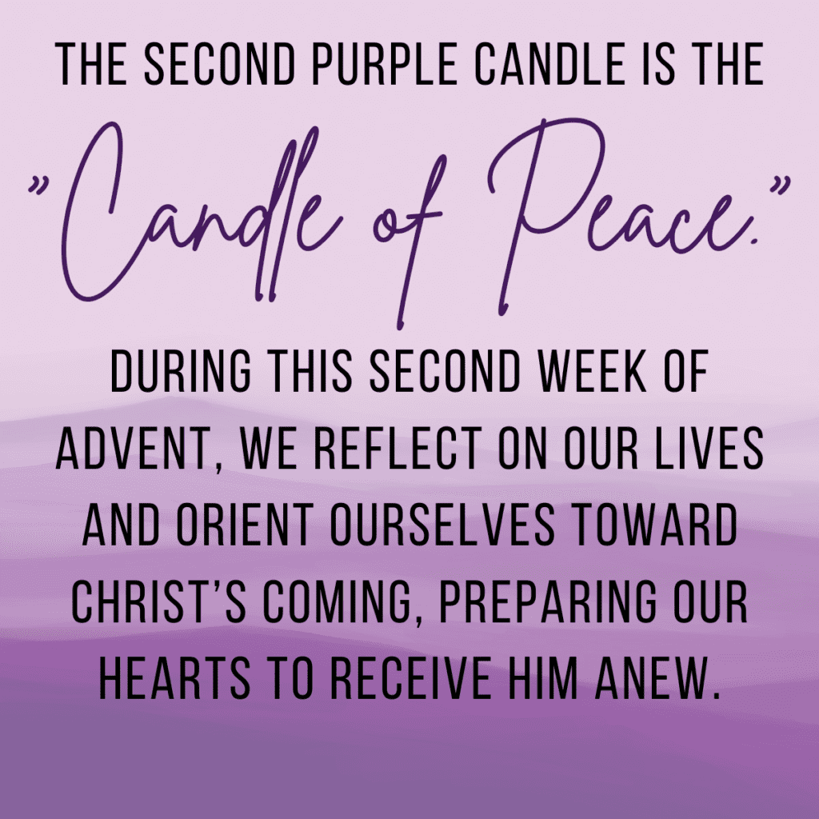

5812 Ford Rd. N. Mt. Vernon, IN 47620 (812) 985-3115
Facebook: Immanuel United Church of Christ Church Website: www.immanueluccmv.com
Church Email: info@immanueluccmv.com Administrative Assistant: Janie Meinschein
Our Vision? “To grow a vibrant church by sharing Christ with the community . . .”
Our Mission? “To invite, inspire, involve, increase . . .”

Second Sunday of Advent
December 7, 2025
Rev. Robert B. Walker, Minister

RINGING OF THE BELL Keith Deig

WELCOME AND ANNOUCEMENTS Bret Baldwin

PRELUDE “Jesus, God’s Supreme Gift” by Rex Kourtney

ADVENT WREATH LIGHTING #192 “Angels We Have Heard on High” (verse 1)

LIGHTING THE ADVENT CANDLE OF PEACE – (Deb Wells, Audrey Allen Family)

Lay Leader: We light this candle today to remind us that Christ is the Prince of Peace, the one
promised from the beginning of the world. We thank God for the hope he gives us
and for the peace he bestows.

People: Our peace is found in God and in his son, Jesus Christ. John the Baptist,
and all the prophets remind us, that to receive peace we must be prepared
for it.

Lay Leader: The God of Peace who is also call Immanuel, sends the light into all our hearts.
God works in our hearts at this time and help us prepare ourselves for the
peace that he brings.

People: The inner peace we have unites us so we can be standing together for
worship and work, for fellowship and mission in the name of the blessed
Child of God!

*PRAYER OF CONFESSION (In Unison) Bret Baldwin

God of peace and promise, we confess that we have taken your commitment to us for granted. We assume what we do is acceptable to you, You call us to repentance, but we resist acknowledging what needs to change in our hearts or our habits. Forgive our self-satisfied attitudes, and challenge us with your vision of a peaceable kingdom where all can be made new. Amen.

*WORDS OF ASSURANCE Rev. Bob Walker

*Gloria Patri
Glory be to the Father, and to the Son, and to the Holy Ghost;
As it was in the beginning, is now, and ever shall be,
world without end. Amen.

Time for the Young at Heart Rev. Bob Walker

SERVICE OF GIVING
Offertory – “Hymn of Peace” by Roy Nolte

Response #382
Praise God, from whom all blessings flow;
Praise Him, all creatures here below;
Praise Him above, ye heavenly host;
Praise Father, Son, and Holy Ghost. Amen

*Prayer of Dedication (In Unison) Bret Baldwin

God, our Peace and our Promise, receive our gifts as seeds of gratitude for your gift to us in Christ Jesus. Bless these seeds with growth so that peace will take root in people who face conflict and danger, and in places seeking to establish peace in the face of violence. Be their peace and their promise, through Christ our Lord. Amen.

SCRIPTURE – Isaiah 11:1-3 Bret Baldwin
¹ A shoot will come up from the stump of Jesse;
from his roots a Branch will bear fruit.
² The Spirit of the Lord will rest on him—
the Spirit of wisdom and of understanding,
the Spirit of counsel and of might,
the Spirit of the knowledge and fear of the Lord—
³ and he will delight in the fear of the Lord.
HYMN # 175 “While Shepherds Watched Their Flocks by Night”

SERMON “From a Stump to a Tree”

HYMN #166 “Let All Mortal Flesh Keep Silence”

CELEBRATION OF HOLY COMMUNION

INVITATION TO COMMUNION AND COMMUNION PRAYER
Pastor: The Lord be with you.
All: And also, with you.
Pastor: Lift up your hearts.
All: We lift them up to the Lord.

WORDS OF INSTITUTION
THE LORD’S PRAYER

SHARING THE BREAD AND CUP

PRAYER OF THANKSGIVING (In Unison):

Gracious God, may we who have received this sacrament live in the unity of your
Holy Spirit, that we may show forth your gifts to all the world.
We ask this in the name of Jesus Christ. Amen.

*CLOSING HYMN # 205 Go, Tell It on the Mountains”

*PASTORAL BENEDICTION

*BENEDICTION SONG #177 “Good Christian Men, Rejoice”(verse 3)

Good Christian men, rejoice With heart and soul and voice;
Now ye need not fear the grave: Peace! Peace! Jesus Christ was born to save!
Calls you one and calls you all To gain His everlasting hall.
Christ was born to save! Christ was born to save!

POSTLUDE “Postlude” by Haydn

Used by Permission. CCLI License # 20658309, Streaming # 20658316
+++++++++++++++++++++++++++++++++++++++++++++++++++++++++++++++++++++++++++++
Today December 14
Lay Leader  Ushers/Greeters:  Pianist/Organist: | Bret Baldwin  OPEN  Gail Angel | Melody Oeth  Bret Baldwin Family  Beth Folz

ATTENDANCE | LAST WEEK: 46 LAST YEAR: 39

OUR IMMANUEL UCC PRAYER LIST

*Charles Behrick *David Behrick *Becky Brenner *Janice Jones

*Dan Riddle Ken Willett David Frye Kenny Meinschein

Teresa Topper Becky Teeple Tom Howard Jack Norvell Denise Norvell

Today is the 2nd Sunday of Advent
Lighting the Candle of Peace: Deb Wells, Audrey Allen Family

Rev. Robert Walker – Worship

With Bret Baldwin as Lay Leader

Next Sunday is the 3rd Sunday of Advent
Lighting the Candle of Joy: Paul, Olivia & Lucy Reller
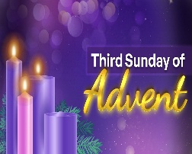
Rev. Robert Walker – Worship

With Melody Oeth as Lay leader

ANNOUNCEMENTS

HARVEST HOME FOOD PANTRY – Bring your gift of canned goods for our Harvest Baskets placed up front near the Alter. This offering goes to “The Harvest Home Food Pantry” at Salem Church



TODAY after Worship
CAKE & PUNCH CELEBRATION


We welcome 3 new Council Members
Angela Clark, Tim Brown, Diane Macke

And to say thank you to our outgoing Council Members
Janie Meinschein, Tina Kissinger, Chris Moers


SUNDAY, DECEMBER 14th after Worship

COOKIE & CANDY WALK
We invite you to come, donate, bake or buy homemade cookies and candies. Containers will be provided. We are asking you to START BAKING so you can bring your favorite cookies and candies to keep our Mission Fund able to assist the needy of our community. This is just one of the many efforts of Immanuel to glorify God by giving to others of the bounty He has given us.


CHRISTMAS POINSETTIAS
A Christmas tradition at Immanuel is the opportunity to remember friends and loved ones in the form of a poinsettia placed in our sanctuary during the Christmas season.
If you wish to participate, please return this form to the church office, or any church council member by
A donation of $8.00 per potted plant is suggested.
Given in memory of ____________________________________________
____________________________________________
____________________________________________
Submitted by:______________________________________
Donation total: _____________________



SUNDAY 7th SECOND SUNDAY OF ADVENT
9:00 a.m. Adult Sunday School
10:00 a.m. Worship & Communion
Cake & Punch Celebration after Worship
5:30 p.m. – 6:30 p.m. AA Meeting

MONDAY 8th 8:30 a.m. God’s Storehouse

TUESDAY 9th

WED 10th

THURSDAY 11th 9:30 a.m. Gentle Exercise Class
5:30 p.m. Council Meeting

FRIDAY 12th

SATURDAY 13th

SUNDAY 14th THIRD SUNDAY OF ADVENT
9:00 a.m. Adult Sunday School
10:00 a.m. Worship
Cookie & Candy Walk after Worship
5:30 p.m. – 6:30 p.m. AA Meeting



December 7 – Kathy Guerrero
December 9 – Tim Brown
December 12 – Jase Lawrence


Gentle Exercise Class . . . designed for 40+
Every Thursday morning at 9:30 am in the Fellowship Hall
Breath & Movement 45 mins~
Discussion on creating a positive mindset 15 min~
Led by De Brown, certified Yoga Instructor and Immanuel UCC member!
*Suggested donation: $5-

