IMMANUEL UNITED CHURCH OF CHRIST
December 21, 2025
Rev. Robert B Walker, Minister

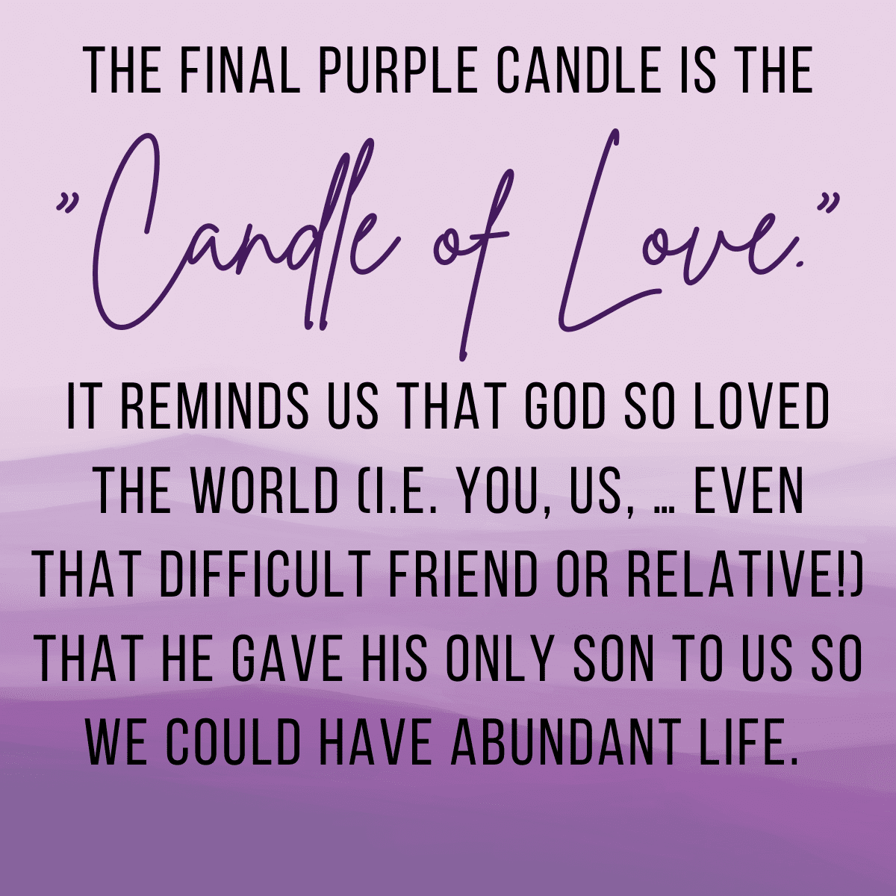

5812 Ford Rd. N. Mt. Vernon, IN 47620 (812) 985-3115
Facebook: Immanuel United Church of Christ Church Website: www.immanueluccmv.com
Church Email: info@immanueluccmv.com Administrative Assistant: Janie Meinschein
Our Vision? “To grow a vibrant church by sharing Christ with the community . . .”
Our Mission? “To invite, inspire, involve, increase . . .”

Fourth Sunday of Advent
December 21, 2025
Rev. Robert B. Walker, Minister

RINGING OF THE BELL Keith Deig

WELCOME AND WORDS OF GREETING Judy Deig

PRELUDE “Hark the Herald Angels Sing” Anna D’Lima

*ADVENT WREATH LIGHTING # 192 “Angels We Have Heard on High” (verse 3)

*LIGHTING THE ADVENT CANDLE OF LOVE – (Duane, Jessica, Emma, Jace & Brooks Lawrence)

Leader: We light the first three candles of Hope, Peace, and Joy we now light the fourth candle of
Love.

People: With love in our hearts, we proclaim Jesus as our Lord and Savior.

Leader: We light this candle today to remind us that God is love. We thank God for hope he gives
us, for the peace he bestows,

People: And for the joy he pours into our hearts, and for the love that redeems us and
shows us the way!

*ADVENT HYMN # 169 “O Come, O Come, Emmanuel”

*PRAYER OF ADORATION (In Unison) Judy Deig

Immanuel, God with us, we praise you for your presence throughout the amazing universe you have made. The shining stars sing your praise, which echoes in the depths of space. The smallest snowflake and a baby’s tiny fingers reflect your intricate love for the details of every life. In Jesus Christ, you were born among us. Inspire us with your loving Spirit as we move through Advent toward Christmas Day, so that our celebrations of love made flesh in Jesus will share the presence of your love. So may we live the praise we offer to you, Immanuel, God with us, now and evermore. Amen.

*GLORIA PATRI

Glory be to the Father, and to the Son, and to the Holy Ghost;
As it was in the beginning, is now, and ever shall be,
world without end. Amen.

CHILDREN’S MOMENTS – The Legend of The Candy Cane Bobbie Hoebeke

SPECIAL MUSIC “I Heard the Bells on Christmas Day” Anna D’Lima

ADVENT PASTORAL PRAYER & THE LORD’S PRAYER

SERVICE OF GIVING
Invitation to Share Rev. Bob Walker
Offertory “Brahms: Walz, Op.39 No. 1 Roman D’Lima
*Response #382
Praise God, from whom all blessings flow;
Praise Him, all creatures here below;
Praise Him above, ye heavenly host;
Praise Father, Son, and Holy Ghost. Amen.

*Prayer of Dedication (In Unison) Judy Deig

Gracious God, we thank you for your many gifts to us and our world. Most of all we thank you for your gift of love in and thru Jesus Christ. As He offered Himself for the world to you, so we offer ourselves and our gifts to you at this time. May your name always be glorified in what we say and do. Amen.

SCRIPTURE - Gospel of Matthew 1:18-25 Judy Deig

¹⁸ This is how the birth of Jesus the Messiah came about: His mother Mary was pledged to be married to Joseph, but before they came together, she was found to be pregnant through the Holy Spirit. ¹⁹ Because Joseph her husband was faithful to the law, and yet did not want to expose her to public disgrace, he had in mind to divorce her quietly.

²⁰ But after he had considered this, an angel of the Lord appeared to him in a dream and said, “Joseph son of David, do not be afraid to take Mary home as your wife, because what is conceived in her is from the Holy Spirit. ²¹ She will give birth to a son, and you are to give him the name Jesus, because he will save his people from their sins.”

²² All this took place to fulfill what the Lord had said through the prophet: ²³ “The virgin will conceive and give birth to a son, and they will call him Immanuel” (which means “God with us”).

²⁴ When Joseph woke up, he did what the angel of the Lord had commanded him and took Mary home as his wife. ²⁵ But he did not consummate their marriage until she gave birth to a son. And he gave him the name Jesus.

ADVENT HYMN #183 “I Wonder As I Wander”

SERMON “As We Consider All Things” Rev. Bob Walker

*ADVENT HYMN #184 “Hark! The Herald Angels Sing”

*PASTORAL BENEDICTION

*BENEDICTION SONG #177 “Good Christian Men, Rejoice” (verse 3)

Good Christian men, rejoice With heart and soul and voice;
Now ye need not fear the grave; Peace! Peace! Jesus Christ was born to save!
Calls you one and calls you all To gain His everlasting hall,
Christ was born to save! Christ was born to save!

POSTLUDE “Joy to the World” Anna D’Lima
Used by Permission. CCLI License # , Streaming #

+++++++++++++++++++++++++++++++++++++++++++++++++++++++++++++++++++++++++++++
Today December 24
Lay Reader  Ushers/Greeters:  Pianist/Organist: | Judy Deig  Dennis & Angela Clark  Beth Folz | Paula Boarman  Bret Baldwin & Family  Beth Folz

ATTENDANCE | LAST WEEK: 42 LAST YEAR: 54

OUR IMMANUEL UCC PRAYER LIST

*Charles Behrick *David Behrick *Janice Jones *Dan Riddle

David Frye Tom Howard Kenny Meinschein Denise Norvell

Jack Norvell Becky Teeple Teresa Topper Ken Willett

Today is the 4th Sunday of Advent

Lighting the Candle of Love:
Duane, Jessica, Emma, Jase & Brooks Lawrence
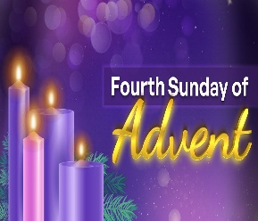
Rev. Robert Walker – Worship

With Judy Deig as Lay Leader

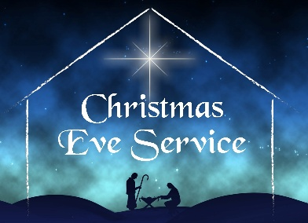

Join us Wednesday, December 24th for

Christmas Eve Service at 6:00 p.m

The Christ Candle will be lit by
Terri McCormick & Jennifer Willett Family

Rev. Robert Walker – Worship & Holy Communion
Paula Boarman – Lay Leader



WE WELCOME OUR GUESTS! We invite you to sign our Guest Book, located in the Narthex.

HARVEST HOME FOOD PANTRY – Bring your gift of canned goods for our Harvest Baskets. This offering goes to “The Harvest Home Food Pantry” at Salem Church. The Baskets are in the Narthex.

GENTLE EXERCISE CLASS – There will be no exercise class on December 25th or January 1st. It will resume on Thursday, January 8th at 9:30 a.m.

CHRISTMAS FUND – The Christmas Fund Offering will take place today. The Christmas Fund has been caring for active and retired clergy and lay employees of the United Church of Christ for over 100 years, providing emergency grants, supplementation of small annuities and health premiums, and Christmas “Thank you” gift checks each December to our lower-income retirees. United Church of Christ congregations and members have blessed the Christmas Fund with their generosity for many years. This year, your care and compassion will be especially appreciated by those servants of the church who are facing a time of need. The Christmas Fund envelopes are attached to the bulletin. Thank you!

ANNUAL REPORTS are due in the Church office on January 11, 2026



A Big Thank you
To Bobbie Hoebeke for offering a
very special Children’s Moments this morning!
”Legend of the Candy Cane”


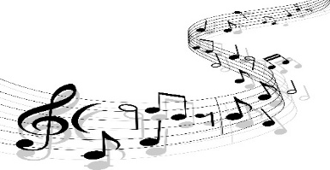

THANKS SO MUCH
Roman & Ann D’Lima
for the beautiful special music this morning!



SUNDAY 21ST FOURTH SUNDAY OF ADVENT
9:00 a.m. Adult Sunday School
10:00 a.m. Worship
5:30 p.m. – 6:30 p.m. AA Meeting

MONDAY 22nd

TUESDAY 23rd

WED 24th 6:00 p.m. Christmas Eve Service & Communion

THURSDAY 25th CHRISTMAS DAY

FRIDAY 26th

SATURDAY 27th

SUNDAY 28th FIRST SUNDAY AFTER CHRISTMAS
9:00 a.m. Adult Sunday School
10:00 a.m. Worship
5:30 p.m. – 6:30 p.m. AA Meeting



December 22 – Audrey Allen
December 25 – Nelda Hickey



December 22 – Paul & Olivia Reller

