IMMANUEL UNITED CHURCH OF CHRIST
December 14, 2025
Rev. Robert B Walker, Minister

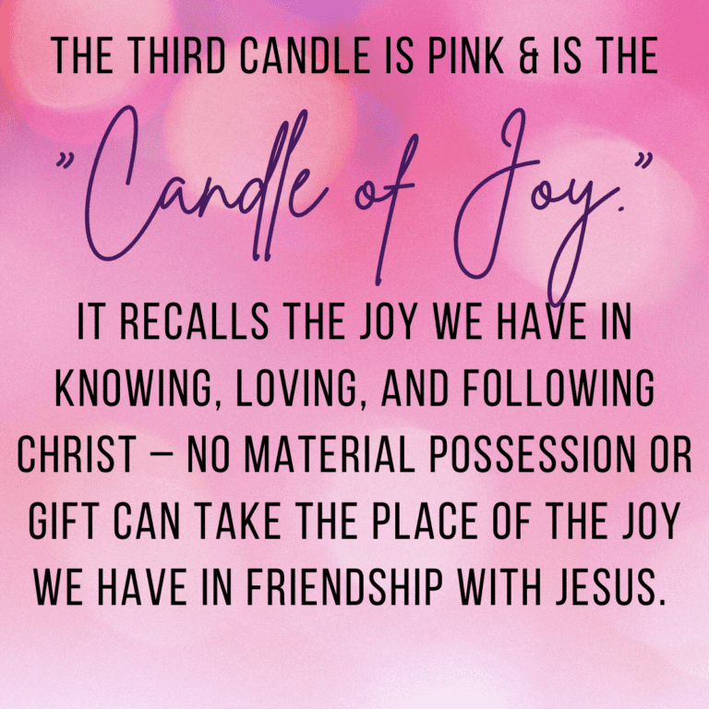

5812 Ford Rd. N. Mt. Vernon, IN 47620 (812) 985-3115
Facebook: Immanuel United Church of Christ Church Website: www.immanueluccmv.com
Church Email: info@immanueluccmv.com Administrative Assistant: Janie Meinschein
Our Vision? “To grow a vibrant church by sharing Christ with the community . . .”
Our Mission? “To invite, inspire, involve, increase . . .”

Third Sunday of Advent
December 14, 2025
Rev. Robert B. Walker, Minister

RINGING OF THE BELL Keith Deig

WELCOME AND WORDS OF GREETING Deb Wells

PRELUDE

*ADVENT WREATH LIGHTING # 192 “Angels We Have Heard on High” (verse 2)

*LIGHTING THE ADVENT CANDLE OF JOY – (Paul, Olivia & Lucy Reller)

Lay Leader: We light the first two candles of Hope and Peace, we now light the third candle of Joy
to proclaim the coming of joy into the world.

People: With joy in our hearts, we proclaim Jesus as our Lord and Savior.

Lay Leader: Our joy is in God and in his son Jesus Christ. Like hope and peace, joy is a gift from
God. It overtakes us and fills us when we remember what God has done and what
he has promised to do.

People: This joy is among us this day!

*OPENING HYMN # 182 “How Great Our Joy!” (Verses 1,2,3)

*PRAYER OF INVOCATION (In Unison) Deb Wells

Creator God, Maker of heaven and earth, with the sea and the stars, and everything in
between, we praise you for the wonders of this world and beyond it. You set all creation in
relationships both fruitful and fragile. You make deserts bloom and refresh the earth with
seasonal rain. As you care for the vulnerable and all your people, we praise with joyful
songs in our hearts this day, Our God, who is the Source, Savior and Spirit of life,
perfect in unity, splendour and truth. Amen.

*GLORIA PATRI

Glory be to the Father, and to the Son, and to the Holy Ghost;
As it was in the beginning, is now, and ever shall be,
world without end. Amen.

TIME FOR THE YOUNG AT HEART Rev. Bob Walker

ADVENT PASTORAL PRAYER & THE LORD’S PRAYER

SERVICE OF GIVING
Invitation to Share Rev. Bob Walker
Offertory

*Response #382
Praise God, from whom all blessings flow;
Praise Him, all creatures here below;
Praise Him above, ye heavenly host;
Praise Father, Son, and Holy Ghost. Amen.

*Prayer of Dedication (In Unison) Deb Wells

God, our Judge and our Joy, receive our gifts as seeds of gratitude for your gift to us in
Christ Jesus. Bless these seeds with growth so that joy will blossom for people depleted by challenges, and places overwhelmed by scarce resources. Be their joy and ours, through Christ our Lord. Amen.

SCRIPTURE – Luke 1:46b- Deb Wells

⁴⁶ And Mary said:
“My soul glorifies the Lord
⁴⁷ and my spirit rejoices in God my Savior,
⁴⁸ for he has been mindful
of the humble state of his servant.
From now on all generations will call me blessed,
⁴⁹ for the Mighty One has done great things for me—
holy is his name.
⁵⁰ His mercy extends to those who fear him,
from generation to generation.
⁵¹ He has performed mighty deeds with his arm;
he has scattered those who are proud in their inmost thoughts.
⁵² He has brought down rulers from their thrones
but has lifted up the humble.
⁵³ He has filled the hungry with good things
but has sent the rich away empty.
⁵⁴ He has helped his servant Israel,
remembering to be merciful
⁵⁵ to Abraham and his descendants forever,
just as he promised our ancestors.”

HYMN #174 “Lo! How a Rose E’er Blooming”

SERMON “From Generation to Generation” Rev. Bob Walker

*CLOSING HYMN #171 “Joy to the World!”

*PASTORAL BENEDICTION

*BENEDICTION SONG #182 “How Great Our Joy!” (Verse 4)

This gift of God we’ll cherish well, That ever joy our hearts shall fill.
How great our joy! Great our joy! Joy, joy, joy! Joy, joy, joy!
Praise we the Lord in heaven on high! Praise we the Lord in heaven on high!

POSTLUDE

Used by Permission. CCLI License #, Streaming #
+++++++++++++++++++++++++++++++++++++++++++++++++++++++++++++++++++++++++++++

Today December 21
Lay Leader  Ushers/Greeters:  Pianist/Organist: | Deb Wells  Tony & Tina Kissinger  Beth Folz | Judy Deig  Dennis & Angela Clark  Gail Angel

ATTENDANCE | LAST WEEK: 48 LAST YEAR: 53

OUR IMMANUEL UCC PRAYER LIST

*Charles Behrick *David Behrick *Janice Jones *Dan Riddle

David Frye Tom Howard Kenny Meinschein Denise Norvell

Jack Norvell Becky Teeple Teresa Topper Ken Willett

Today is the 3rd Sunday of Advent
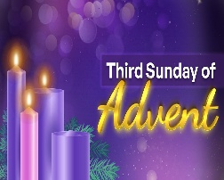
Lighting the Candle of Peace:
Paul, Olivia & Lucy Reller

Rev. Robert Walker – Worship

With Deb Wells as Lay Leader

Next Sunday is the 4th Sunday of Advent
Lighting the Candle of Love:
Duane, Jessica, Emma, Jase & Brooks Lawrence
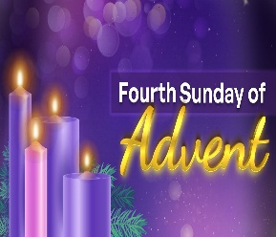
Rev. Robert Walker – Worship

With Judy Deig as Lay leader



WE WELCOME OUR GUESTS! We invite you to sign our Guest Book, located in the Narthex.

HARVEST HOME FOOD PANTRY – Bring your gift of canned goods for our Harvest Baskets placed up front near the Alter. This offering goes to “The Harvest Home Food Pantry” at Salem Church



TODAY AFTER WORSHIP

COOKIE & CANDY WALK
We invite you to come, donate, bake or buy homemade cookies and candies. Containers will be provided. We are asking you to START BAKING so you can bring your favorite cookies and candies to keep our Mission Fund able to assist the needy of our community. This is just one of the many efforts of Immanuel to glorify God by giving to others of the bounty He has given us.


CHRISTMAS POINSETTIAS
A Christmas tradition at Immanuel is the opportunity to remember friends and loved ones in the form of a poinsettia placed in our sanctuary during the Christmas season.
If you wish to participate, please return this form to the church office, or any church council member by today.
A donation of $8.00 per potted plant is suggested.
Given in memory of ____________________________________________
____________________________________________
____________________________________________
Submitted by:______________________________________
Donation total: _____________________



SUNDAY 14th THIRD SUNDAY OF ADVENT
9:00 a.m. Adult Sunday School
10:00 a.m. Worship
Cookie & Candy Walk after Worship
5:30 p.m. – 6:30 p.m. AA Meeting

MONDAY 15th

TUESDAY 16th

WED 17th

THURSDAY 18th 9:30 a.m. Gentle Exercise Class

FRIDAY 19th

SATURDAY 20th

SUNDAY 21st FOURTH SUNDAY OF ADVENT
9:00 a.m. Adult Sunday School
10:00 a.m. Worship
5:30 p.m. – 6:30 p.m. AA Meeting



December 20 – Bret & Traci Baldwin


Gentle Exercise Class . . . designed for 40+
Every Thursday morning at 9:30 am in the Fellowship Hall
Breath & Movement 45 mins~
Discussion on creating a positive mindset 15 min~
Led by De Brown, certified Yoga Instructor and Immanuel UCC member!
*Suggested donation: $5-

