IMMANUEL UNITED CHURCH OF CHRIST
November 2, 2025

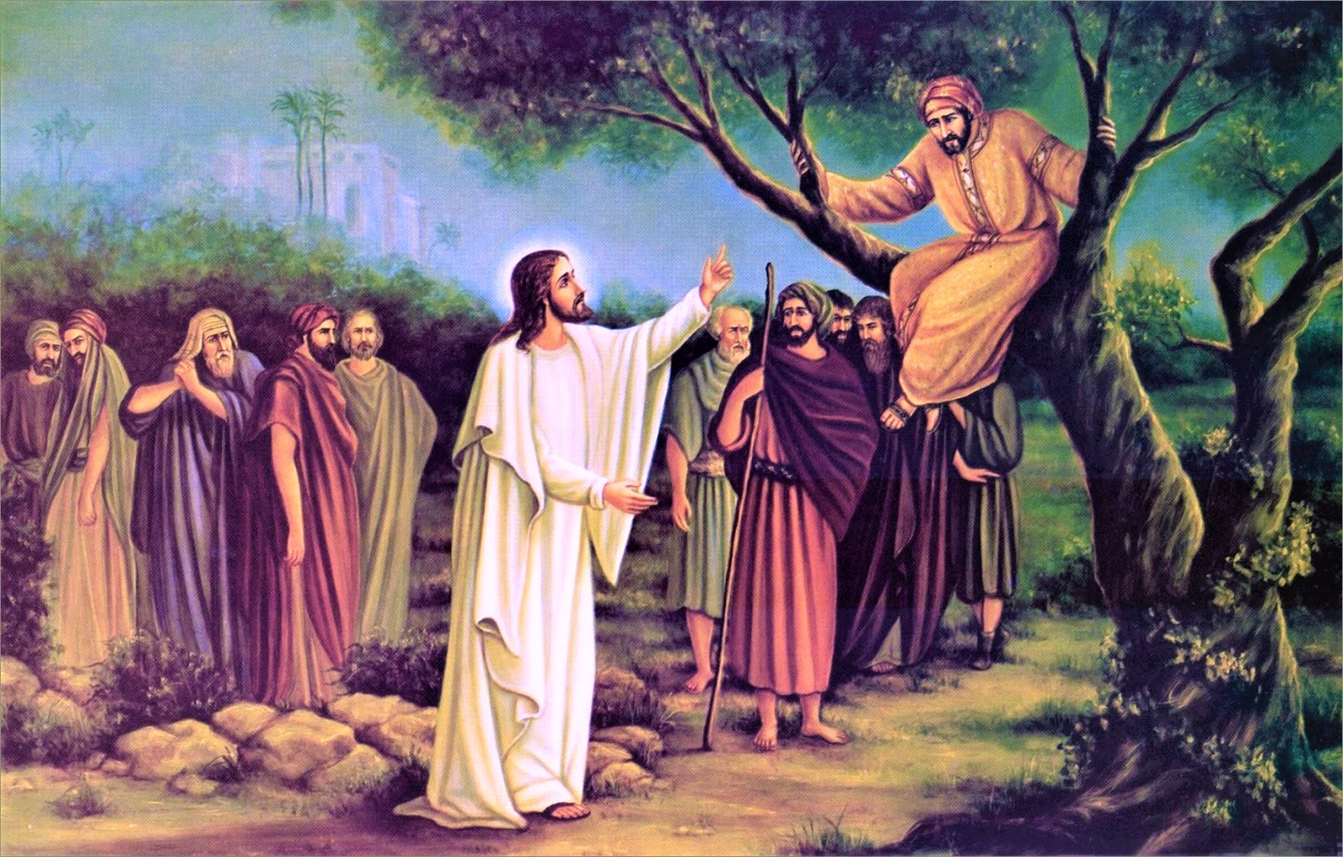

5812 Ford Rd. N. Mt. Vernon, IN 47620 (812) 985-3115
Facebook: Immanuel United Church of Christ Church Website: www.immanueluccmv.com
Church Email: info@immanueluccmv.com Administrative Assistant: Janie Meinschein
Our Vision? “To grow a vibrant church by sharing Christ with the community . . .”
Our Mission? “To invite, inspire, involve, increase . . .”

Twenty-First Sunday after Pentecost
November 2, 2025 Minister: Rev. Robert Walker

RINGING OF THE BELL Keith Deig

WELCOME AND WORDS OF GREETING Bobbie Hoebeke

PRELUDE

*CALL TO WORSHIP Bobbie Hoebeke

Lay Leader: Those who wait for the Lord shall renew their strength.

All: They shall mount up with wings as eagles;

Lay Leader: They shall run and not be weary.

All: They shall walk and not faint.

Lay Leader: In the company of all God’s saints and pilgrims, come and worship.

All: We come with prayer and praise to find our strength renewed!

*OPENING HYMN #323 “Holy! Holy! Holy! Lord God Almighty”

*PRAYER OF CONFESSION (Unison) Bobbie Hoebeke

Gracious God,
you have been faithful to us in every generation.
Yet we confess that we are not so faithful to you.
We shrink from costly discipleship and we seek cheap grace.
Forgive our fleeting enthusiasms and our shallow commitments
And guide us always with the love and mercy we witness in Jesus Christ our Lord.
Amen.

*WORDS OF ASSURANCE Rev. Robert B. Walker

*GLORIA PATRI
Glory be to the Father, and to the Son, and to the Holy Ghost;
As it was in the beginning, is now, and ever shall be,
world without end. Amen.

TIME FOR THE YOUNG AT HEART Rev. Robert B. Walker

PASTORAL PRAYER – THE LORD’S PRAYER Rev. Robert B. Walker

SERVICE OF GIVING
Invitation Rev. Robert B. Walker
Offertory
*Response No. 382
Praise God, from whom all blessings flow;
Praise Him, all creatures here below;
Praise Him above, ye heavenly host;
Praise Father, Son, and Holy Ghost. Amen.

*Prayer of Dedication (Unison) Bobbie Hoebeke

Generous God, you are faithful and fruitful in every generation. Bless our gifts and make them fruitful beyond our imagining in the work of your kingdom. Keep us faithful in this generation so we can offer the inheritance we have received in Christ to the generation that comes after us. Amen.

SCRIPTURE – Luke 19:1-10 Bobbie Hoebeke

Jesus entered Jericho and was passing through. ² A man was there by the name of Zacchaeus; he was a chief tax collector and was wealthy. ³ He wanted to see who Jesus was, but because he was short he could not see over the crowd. ⁴ So he ran ahead and climbed a sycamore-fig tree to see him, since Jesus was coming that way.

⁵ When Jesus reached the spot, he looked up and said to him, “Zacchaeus, come down immediately. I must stay at your house today.” ⁶ So he came down at once and welcomed him gladly.

⁷ All the people saw this and began to mutter, “He has gone to be the guest of a sinner.”

⁸ But Zacchaeus stood up and said to the Lord, “Look, Lord! Here and now I give half of my possessions to the poor, and if I have cheated anybody out of anything, I will pay back four times the amount.”

⁹ Jesus said to him, “Today salvation has come to this house, because this man, too, is a son of Abraham. ¹⁰ For the Son of Man came to seek and to save the lost.”

SERMON “Here and Now” Rev. Robert B. Walker

*HYMN #601 “Savior, Like a Shepherd Lead Us”

THE LORD INVITES US TO HIS TABLE

*Invitation for Communion Rev. Robert B. Walker
Prayer of Consecration
Sharing The Bread and Cup

*Prayer of Thanksgiving (Unison)

Eternal God, we give you thanks for this holy mystery in which you have given yourself to us. Grant that we may go into the world in the strength of your Spirit, to give ourselves for others, in the name of Jesus Christ our Lord. Amen.

*CLOSING HYMN #614 “For All the Saints” (Verses. 1,2,3,4,5)

*PASTORAL BENEDICTION Rev. Robert B. Walker

*BENEDICTION SONG “Let There Be Peace on Earth”

Let there be peace on earth and let it begin with me;
let there be peace on earth, the peace that was meant to be.
With God our Maker, family all are we.
Let us walk with each other, in perfect harmony.

Let peace begin with me, let this be the moment now.
With every step I take, may this be my solemn vow:
To take each moment and live each moment
in peace eternally.
Let there be peace on earth, and let it begin with me.
POSTLUDE

Used by Permission. CCLI License # 20658309, Streaming # 20658316
+++++++++++++++++++++++++++++++++++++++++++++++++++++++++++++++++++++++++++++
Today November 9
Lay Leader  Ushers/Greeters:  Pianist/Organist:  Children’s Moments: | Bobbie Hoebeke  Janie Meinschein  Beth Folz  OPEN | OPEN  OPEN  Gail Angel  OPEN

ATTENDANCE | LAST WEEK: 48 LAST YEAR: 58


OUR IMMANUEL UCC PRAYER LIST

*Charles Behrick *David Behrick *Becky Brenner *Janice Jones

Ken Willett David Frye Kenny Meinschein

Teresa Topper Tom Howard Kiersten Ferguson-Cremin





TODAY WE WELCOME OUR PART-TIME PASTOR

Rev. Robert Walker – Worship & Communion

With Bobbie Hoebeke as Lay Leader

NEXT SUNDAY, NOVEMBER 9th

Rev. Robert Walker – Worship

Budget & Election Congregational Meeting

Immediately following meeting: Thanksgiving Pot Luck

BUDGET & ELECTION CONGREGATIONAL MEETING

and Thanksgiving Potluck immediately following meeting

Next Sunday, November 9, 2025


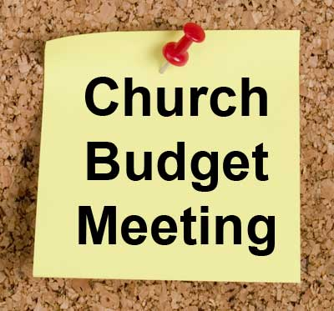

At our Annual Congregational Budget & Election meeting, we will elect three new members to serve a three-year term on Council.

Going off Council at the end of the year are Janie Meinschein, Tina Kissinger and Chris Moers. Thank you for your three years of service. The Council members continuing to serve their three-year term are Jennifer Willett, Audrey Allen, Justin Wagner, Bret Baldwin, Judy Deig and Bobbie Hoebeke.
Please join us for a Thanksgiving potluck immediately following the meeting. Bring a covered dish.



SUNDAY 2nd TWENTY-FIRST SUNDAY AFTER PENTECOST
9:00 a.m. Adult Sunday School
10:00 a.m. Worship & Communion
5:30 p.m. – 6:30 p.m. AA Meeting

MONDAY 3rd

TUESDAY 4th

WEDNESDAY 5th

THURSDAY 6th 9:30 a.m. Exercise Class

FRIDAY 7th

SATURDAY 8th

SUNDAY 9th TWENTY SECOND SUNDAY AFTER PENTECOST
9:00 a.m. Adult Sunday School
10:00 a.m. Worship & Annual Budget Meeting
Thanksgiving Potluck immediately following the meeting
5:30 p.m. – 6:30 p.m. AA Meeting


November 2 – Jay Chase
November 3 – Karen Behrick
November 3 – Steve Angel
November 5 – De Brown
November 7 – Matt McCormick


Gentle Exercise Class . . . designed for 40+
Every Thursday morning at 9:30 am in the Fellowship Hall
Breath & Movement 45 mins~
Discussion on creating a positive mindset 15 min~
Led by De Brown, certified Yoga Instructor and Immanuel UCC member!
*Suggested donation: $5-

