IMMANUEL UNITED CHURCH OF CHRIST
November 8, 2026
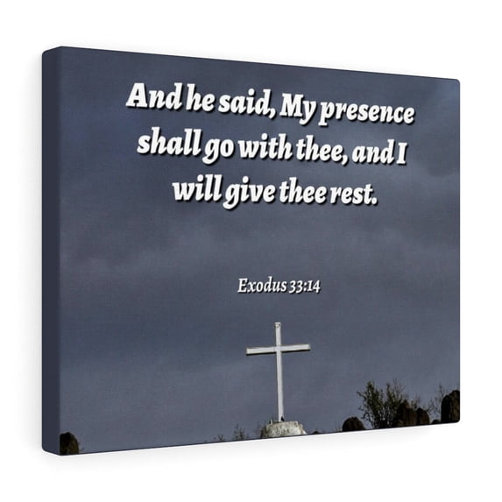

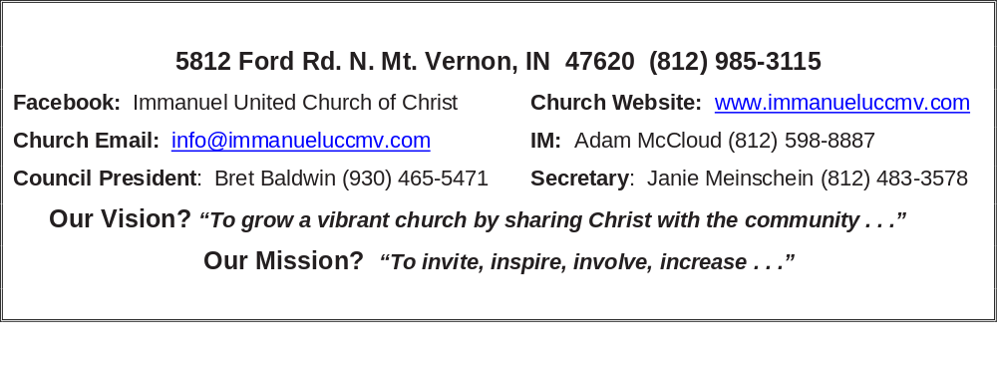

Twenty-Fourth Sunday after Pentecost
November 8, 2026
Adam McCloud, Interim Minister

RINGING OF THE BELL Keith Deig

WELCOME AND WORDS OF GREETING De Brown

PRELUDE

*PRAISE SONG #387 “We Gather Together” (vs 1)

*CALL TO WORSHIP De Brown

Leader: The world is filled with the glory of God, and we say,
ALL: Thanks be to you, O’ God!

Leader: The hills and valleys are filled with color, and we say,
ALL: Thank you!

Leader: The vines and trees are filled with fruit, and we say,
ALL: Thanks be to you, O’ God!

Leader: Our tables are overflowing with food, and we say,
ALL: Thank you!

Leader: We fill this house of God with our voices and begin with a hymn of thanksgiving!

*OPENING HYMN #1 “For the Beauty of the Earth (vs 1 & 2)

*PRAYER OF CONFESSION (Unison) De Brown

Gracious Creator, you have given us so much, but too often we take those gifts for granted. You call us to live in a caring community, but too often we place our wants and needs first, neglecting important mission work. You call us to share Your gifts with the world around us, but our worries that there may not be enough get in the way of our sharing. For all those times when we mistreat and misuse Your gifts, forgive us. Lead us back to the path of Your loving wisdom. Amen.

*WORDS OF ASSURANCE De Brown

God is a gracious giver. God is gracious in forgiveness.
God calls us to new life. We are a forgiven people!
Thanks be to God!

*GLORIA PATRI
Glory be to the Father, and to the Son, and to the Holy Ghost;
As it was in the beginning, is now, and ever shall be,
world without end. Amen.

CHILDREN’S MOMENTS Ashton Wagner

PSALM 23 Lay Leader-Bold lettering; All-Italics De Brown

Psalm 23

23 The Lord is my shepherd;
I shall not want.
² He makes me to lie down in green pastures;
He leads me beside the still waters.
³ He restores my soul;
He leads me in the paths of righteousness
For His name’s sake.

⁴ Yea, though I walk through the valley of the shadow of death,
I will fear no evil;
For You are with me;
Your rod and Your staff, they comfort me.

⁵ You prepare a table before me in the presence of my enemies;
You anoint my head with oil;
My cup runs over.
⁶ Surely goodness and mercy shall follow me
All the days of my life;
And I will dwell in the house of the Lord
Forever.

PRAYERS OF THE PEOPLE Adam McCloud
Silent Prayer ~ Pastoral Prayer ~ Our Lord’s Prayer

SERVICE OF GIVING
Offertory
*Response No. 382

Praise God, from whom all blessings flow;
Praise Him, all creatures here below;
Praise Him above, ye heavenly host;
Praise Father, Son, and Holy Ghost. Amen.

*Prayer of Dedication (In Unison) De Brown

Dear God of all Creation,

Thank you for the wonderful things you have made. Thank you for the universe full of stars and planets. Thank you for making each one of us, and for loving us all.
Bless our gifts of time, talent, testimony, and treasure, and lead us to steward them
to the glory of your name, and for furthering your kingdom on earth. We pray this in Jesus’ name, Amen.

SCRIPTURE De Brown

Exodus 33:14 - ¹⁴ The Lord replied, “My Presence will go with you, and I will give you rest.”

Matthew 28: 20 - I am with you always, to the very end of the age.”

Psalm 139: 7-8
⁷Where can I go from your Spirit?
Where can I flee from your presence?

⁸If I go up to the heavens, you are there;
if I make my bed in the depths, you are there.

HYMN #387 “We Gather Together” (vs 2-3)

SERMON “Thankful for His Presence” Adam McCloud

*CLOSING HYMN #525 “Now Thank We All Our God”
*BENEDICTION Adam McCloud

*BENEDICTION SONG “May the Good Lord Bless and Keep You”

May the good Lord bless and keep you
Whether near or far away
May you find that long awaited Golden day today
May your troubles all be small ones
And your fortune ten times ten
May the good Lord bless and keep you
'Til we meet again.

POSTLUDE

BUDGET/CHURCH COUNCIL ELECTION MEETING Bret Baldwin, Council Pres.

Used by Permission. CCLI License # 20658309, Streaming # 20658316

+++++++++++++++++++++++++++++++++++++++++++++++++++++++++++++++++++++++++++++
Today Next Week
Lay Leader:  Ushers/Greeters:  Pianist/Organist:  Children’s Moments: | De Brown  Nelda Hickey  Beth Folz  Ashton Wagner | Paula Boarman  Tim & De Brown  Beth Folz  Ashton Wagner

ATTENDANCE | LAST WEEK:65 LAST YEAR: 42


We wish to welcome all in the name of Christ.
We invite you to worship with us every Sunday...
and to become a part of this faith household.

We invite you to sign our Guest Book, located in the Narthex

OUR IMMANUEL UCC PRAYER LIST

*MEMBERS

*Charles Behrick *David Behrick *Cherry Chase *Cheryl Higgs

*Janice Jones *Sondra McNamara *Betty Michael *Dan Riddle

*Betty Schuessler Randy Boyer David Frye Norma Houghton

Tom Howard Cathy Hyatt Steve Majors Denis Lambrech

Kenny Meinschein Karen (Geier) Shelley Teresa Topper Heather Warner

Ken Willett Eli Williams

If you have names to be added or deleted from the Prayer List, please obtain permission from the person or a family member for their name to be published.
A phone call or a card will let people know we miss them and we care for them.


Today after Worship Service


We will elect 3 new 2027 – 2029
Council Members and
discuss/approve 2027 church budget.






NOVEMBER 22 –A Totenfest Service

A special service to remember all who have passed with the year.
A service of candle lighting & bell ringing.

***If you have family or friends that have passed away this year,
please leave a note on Janie’s desk in the church office so they may be listed
in the Totenfest Ceremony Remembrance page.



THIS WEEK

SUNDAY 8th TWENTY-FOURTH SUNDAY AFTER PENTECOST
9:00 a.m. Adult Sunday School
10:00 a.m. Worship
Budget & Election Meeting after Worship
5:30 p.m. – 6:30 p.m. AA Meeting

MONDAY 9th 8:30 a.m. Food Pantry

TUESDAY 10th

WEDNESDAY 11th Veterans Day

THURSDAY 12th 9:30 a.m. Exercise Class

FRIDAY 13th

SATURDAY 14th

SUNDAY 15th TWENTY-FIFTH SUNDAY AFTER PENTECOST
9:00 a.m. Adult Sunday School
10:00 a.m. Worship
5:30 p.m. – 6:30 p.m. AA Meeting


November 11 – Bobbie Hoebeke
November 12 – Charlotte Bailey
November 15 – Linda O’Risky


Gentle Exercise Class . . . designed for 40+
Every Thursday morning at 9:30 am in the Fellowship Hall
Breath & Movement 45 mins~
Discussion on creating a positive mindset 15 min~
Led by De Brown, certified Yoga Instructor and Immanuel UCC member!
*Suggested donation: $5-

