IMMANUEL UNITED CHURCH OF CHRIST
November 30, 2025
Rev. Robert B Walker, Minister

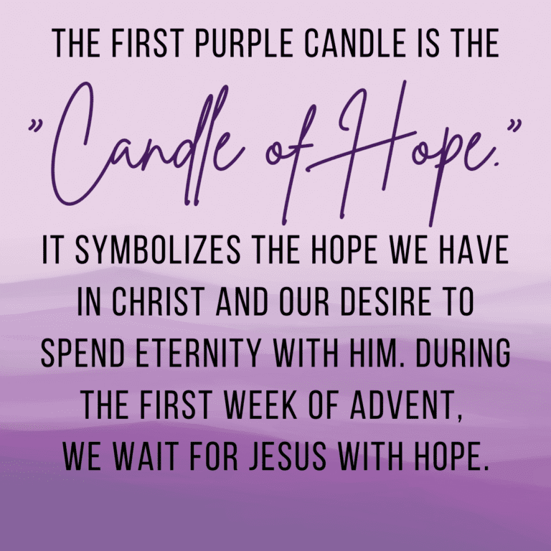

5812 Ford Rd. N. Mt. Vernon, IN 47620 (812) 985-3115
Facebook: Immanuel United Church of Christ Church Website: www.immanueluccmv.com
Church Email: info@immanueluccmv.com Administrative Assistant: Janie Meinschein
Our Vision? “To grow a vibrant church by sharing Christ with the community . . .”
Our Mission? “To invite, inspire, involve, increase . . .”

First Sunday of Advent
November 30, 2025
Rev. Robert B. Walker, Minister

RINGING OF THE BELL Keith Deig

WELCOME AND ANNOUCEMENTS Paula Boarman

PRELUDE

ADVENT WREATH LIGHTING #1 Paula Boarman

LIGHTING THE ADVENT CANDLE OF HOPE– (Justin, Ashton & Rose Wagner)

Lay Leader: The light shines in the darkness,

People: We come to worship, seeking the light of Christ once again.

Lay Leader: Shine into our lives and into your world this Advent.

People: Renew us as we light this Candle of Hope!

*Hymn of Hope #168 “Come, Thou Long-Expected Jesus”

*PRAYER OF ADORATION (In Unison) Paula Boarman

Almighty and everlasting God,
You hold all our days in your hands,
and embrace us in your everlasting arms.
In a tired and violent world, you are hope.
In a hectic and busy world, you are peace.
In a hurting world, you are comfort.
In Jesus Christ, you bring love into this world, and call us to embody his love in all we do and say. In our worship this day, we offer you our love and loyalty, Creator, Christ and Holy Spirit.
Make us one in worship and service, so that the world will see your hope at work in us and through us, making all things new. Amen.

*Gloria Patri
Glory be to the Father, and to the Son, and to the Holy Ghost;
As it was in the beginning, is now, and ever shall be,
world without end. Amen.

Time for the Young at Heart Rev. Bob Walker

SERVICE OF GIVING
Offertory –

*Prayer of Dedication (In Unison) Paula Boarman

God, our hope and our help, receive our gifts as seeds of gratitude for your gift to us in Christ Jesus. Bless these seeds with growth so that hope will sprout in people who struggle with despair, and places trying to rebuild after devastating loss. Be their hope and their help, through Christ our Lord. Amen.

SCRIPTURE – Matthew 24:36-44 Paula Boarman

³⁶ “But about that day or hour no one knows, not even the angels in heaven, nor the Son, but only the Father. ³⁷ As it was in the days of Noah, so it will be at the coming of the Son of Man. ³⁸ For in the days before the flood, people were eating and drinking, marrying and giving in marriage, up to the day Noah entered the ark; ³⁹ and they knew nothing about what would happen until the flood came and took them all away. That is how it will be at the coming of the Son of Man. ⁴⁰ Two men will be in the field; one will be taken and the other left. ⁴¹ Two women will be grinding with a hand mill; one will be taken and the other left.

⁴² “Therefore keep watch, because you do not know on what day your Lord will come. ⁴³ But understand this: If the owner of the house had known at what time of night the thief was coming, he would have kept watch and would not have let his house be broken into. ⁴⁴ So you also must be ready, because the Son of Man will come at an hour when you do not expect him.

HYMN# 87 “Leaning on the Everlasting Arms”

SERMON “We Must Be Ready” Rev. Bob Walker

THE LORD’S PRAYER Rev. Bob Walker

*CLOSING HYMN #174 “Lo! How a Rose E’er Blooming”

*PASTORAL BENEDICTION Rev. Bob Walker

*BENEDICTION SONG # 619 “I Love to Tell the Story” (verse 1)

I love to tell the story Of unseen things above,
Of Jesus and His glory, Of Jesus and His love;
I love to tell the story – Because I know ‘tis true,
It satisfies my longings, As nothing else can do.
I love to tell the story! ‘Twill be my theme in glory –
To tell the old, old story Of Jesus and His love.

POSTLUDE

Used by Permission. CCLI License # 20658309, Streaming # 20658316
+++++++++++++++++++++++++++++++++++++++++++++++++++++++++++++++++++++++++++++

Today December 7
Lay Leader  Ushers/Greeters:  Pianist/Organist: | Paula Boarman  Chris Moers, Tina & Tony Kissinger  Beth Folz | Bret Baldwin  OPEN  Gail Angel

ATTENDANCE | LAST WEEK: 51 LAST YEAR: 51


OUR IMMANUEL UCC PRAYER LIST

*Charles Behrick *David Behrick *Becky Brenner *Janice Jones

*Dan Riddle *Nelda Hickey Ken Willett David Frye

Kenny Meinschein Teresa Topper Becky Teeple

Tom Howard Jack Norvell Denise Norvell


TODAY WE CELEBRATE
1st SUNDAY OF ADVENT
“Candle of Hope”

Rev. Robert Walker - Worship

With Paula Boarman as Lay Leader

Lighting the Advent Candle of Hope – The Wagner Family


NEXT SUNDAY
2nd SUNDAY OF ADVENT
“ Candle of Peace”

Rev. Robert Walker – Worship

With Bret Baldwin as Lay Leader

0
ANNOUNCEMENTS

BLANKETS are needed for the homeless. There is a box in the Narthex.

HARVEST HOME FOOD PANTRY – Bring your gift of canned goods for our Harvest Baskets placed up front near the Alter. This offering goes to “The Harvest Home Food Pantry” at Salem Church


Today after worship

“hanging of the greens”

SUNDAY, DECEMBER 7th after Worship
CAKE & PUNCH CELEBRATION


We welcome 3 new Council Members
Angela Clark, Tim Brown, Diane Macke


And to say thank you
To our outgoing Council Members
Janie Meinschein, Tina Kissinger, Chris Moers


SUNDAY, DECEMBER 14th after Worship

COOKIE & CANDY WALK
We invite you to come, donate, bake or buy homemade cookies and candies. Containers will be provided. We are asking you to START BAKING so you can bring your favorite cookies and candies to keep our Mission Fund able to assist the needy of our community. This is just one of the many efforts of Immanuel to glorify God by giving to others of the bounty He has given us.



SUNDAY 30rd FIRST SUNDAY OF ADVENT
9:00 a.m. Adult Sunday School
10:00a.m. Worship
Hanging of the Greens after Worship
5:30 p.m. – 6:30 p.m. AA Meeting

MONDAY 1th

TUESDAY 2th

WED 3th

THURSDAY 4th 9:30 a.m. Gentle Exercise Class

FRIDAY 5th

SATURDAY 6th

SUNDAY 7th SECOND SUNDAY OF ADVENT
9:00 a.m. Adult Sunday School
10:00 a.m. Worship & Communion
Cake & Punch Celebration after Worship
5:30 p.m. – 6:30 p.m. AA Meeting




December 2 – Beth Folz November 30 - Minda & Shane Gray
December 5 – Jim Robinson, Gary Snodgrass December 6 – Charles & Cindy Naab
December 6 – David Behrick
December 7 – Kathy Guerrero


Gentle Exercise Class . . . designed for 40+
Every Thursday morning at 9:30 am in the Fellowship Hall
Breath & Movement 45 mins~
Discussion on creating a positive mindset 15 min~
Led by De Brown, certified Yoga Instructor and Immanuel UCC member!
*Suggested donation: $5-

