IMMANUEL UNITED CHURCH OF CHRIST
November 23, 2025
Rev. Robert B Walker, Minister



5812 Ford Rd. N. Mt. Vernon, IN 47620 (812) 985-3115
Facebook: Immanuel United Church of Christ Church Website: www.immanueluccmv.com
Church Email: info@immanueluccmv.com AdministrativeAssistant: Janie Meinschein
Our Vision? “To grow a vibrant church by sharing Christ with the community . . .”
Our Mission? “To invite, inspire, involve, increase . . .”

Twenty-Fourth Sunday after Pentecost
November 23,2025 –Rev. Robert B. Walker

TOTENFEST – A SERVICE OF REMEMBRANCE

RINGING OF THE BELL Keith Deig

WELCOME AND ANNOUCEMENTS Angela Clark

PRELUDE “Fantasia on Forest Green” Handbell Choir

*CALL TO WORSHIP Angela Clark

Lay Leader: Lord, you have been our dwelling place in all generations!

People: This coming year, for 155 years, your love has called this community to follow the path you set before us. May we continue to listen and follow your call this day, and in the days to come!

*OPENING HYMN #32 “How Firm a Foundation”

*PRAYER OF CONFESSION (Unison) Angela Clark

Eternal God, in every age you have raised up men and women to live and die in faith. We pray that we too may be worthy witnesses for you, even as we confess our failures in the attempt, admitting these now before you in the silence of our hearts.

(Silent Prayer)

(Let us continue in prayer)

Loving God, we gather here in the protective shelter of your healing love. We are free to pour out our grief as Jesus poured out His grief at the loss of His friend Lazarus. Help us to remember as Jesus remembered, that you are our Redeemer for all things. Amen.

*WORDS OF ASSURANCE Rev. Bob Walker

*GLORIA PATRI
Glory be to the Father, and to the Son, and to the Holy Ghost;
As it was in the beginning, is now, and ever shall be,
world without end. Amen.

PSALM 23

Angela Clark, Lay Leader: Italics All: Bold Print

23 The Lord is my shepherd;
I shall not want.
² He makes me to lie down in green pastures;
He leads me beside the still waters.

³ He restores my soul;
He leads me in the paths of righteousness
For His name’s sake.

⁴ Even though I walk through the valley of the shadow of death,
I will fear no evil;
For You are with me;
Your rod and Your staff, they comfort me.

⁵ You prepare a table before me in the presence of my enemies;
You anoint my head with oil;
My cup runs over.
⁶ Surely goodness and mercy shall follow me
All the days of my life;
And I will dwell in the house of the Lord
Forever.

PRAYERS OF THE PEOPLE Rev. Bob Walker
Pastoral Prayer~Lord’s Prayer

SERVICE OF GIVING

Lay Leader: God’s goodness overflows. Let us bear witness to the love of God and present our
offerings of thanksgiving to our loving God with generous hearts.

Offertory
*Response# 382
Praise God, from whom all blessings flow;
Praise Him, all creatures here below;
Praise Him above, ye heavenly host;
Praise Father, Son, and Holy Ghost. Amen.

*Prayer of Dedication(In Unison) Angela Clark

Jesus, you give us the gift of Life and the gift of Everlasting Life! We praise you and offer these offerings and tithes as a token of our appreciation. We dedicate our lives anew to love and worship you! Amen.

SCRIPTURE – I Thessalonians 4:13-18 Angela Clark

¹³ Brothers and sisters, we do not want you to be uninformed about those who sleep in death, so that you do not grieve like the rest of mankind, who have no hope. ¹⁴ For we believe that Jesus died and rose again, and so we believe that God will bring with Jesus those who have fallen asleep in him. ¹⁵ According to the Lord’s word, we tell you that we who are still alive, who are left until the coming of the Lord, will certainly not precede those who have fallen asleep. ¹⁶ For the Lord himself will come down from heaven, with a loud command, with the voice of the archangel and with the trumpet call of God, and the dead in Christ will rise first. ¹⁷ After that, we who are still alive and are left will be caught up together with them in the clouds to meet the Lord in the air. And so we will be with the Lord forever. ¹⁸ Therefore encourage one another with these words.

HYMN #409 “Who Is on the Lord’s Side?”

SERMON “Encourage One Another” Rev. Bob Walker

HYMN #588 “In the Garden”

TOTENFEST SERVICE OF REMEMBRANCE – Andy Baldwin

~Lighting of Candles& Bell Ringing~

Our Church Family Members

Our Community Friends buried in our Immanuel Cemetery

Name Deceased ` Burial
Anna Oschman November 14, 2024 November 19. 2024
Gregory Sauage January 4, 2025 January 13, 2025
Druscilla Keel January 13, 2025 June 21, 2025
Jay O’Risky August 3, 2025 August 16, 2025
Carolyn Koehnew March 4, 2023 November 15, 2025
Edwared Koehnew August 20, 2025 November 15, 2025
Donald Ray Morgan October 30, 2025 November 3, 2025
Frank Smith October 24, 2025 November 3, 2025
Mark A. Nix November 6, 2025 December 6, 2025

Friends & Family

Name Deceased Burial
Charlie Hoehn July 9, 2025 July 14, 2025
Samuel Hall August 17, 2025

CLOSING HYMN #495 “It Is Well with My Soul”

*PASTORAL BENEDICTION Rev. Bob Walker

*BENEDICTION SONG – #523 “God Be With You ‘Til We Meet Again”

God be with you ‘till we meet again, By His counsels guide, up-hold you,
With His sheep securely fold you: God be with you ‘til we meet again

POSTLUDE “Lord, Dismiss Us With Thy Blessing” Handbell Choir

Used by Permission. CCLI License #
+++++++++++++++++++++++++++++++++++++++++++++++++++++++++++++++++++++++++++++

Today November 30
Lay Leader  Ushers/Greeters:  Pianist/Organist: | Angela Clark  Tim & De Brown  Beth Folz | Paula Boarman  Chris Moers, Tina & Tony Kissigner  Beth Folz

ATTENDANCE | LAST WEEK: 45 LAST YEAR: 44

OUR IMMANUEL UCC PRAYER LIST

*Charles Behrick *David Behrick *Becky Brenner *Janice Jones

*Dan Riddle *Nelda Hickey Ken Willett David Frye

Kenny Meinschein Teresa Topper Becky Teeple

Tom Howard Jack Norvell Denise Norvell

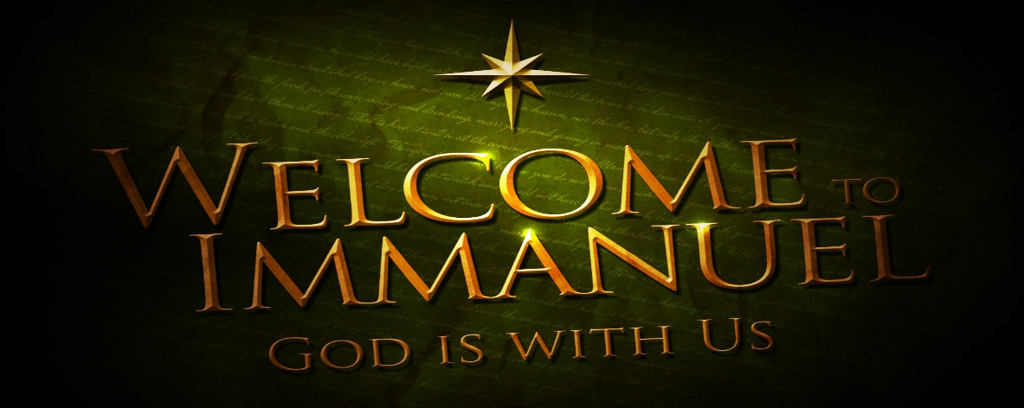


TODAY
WE WILL CELEBRATE TOTENFEST

Rev. Robert Walker – Worship

With Angela Clark as Lay Leader


NEXT SUNDAY, NOVEMBER 30
1st SUNDAY OF ADVENT

Rev. Robert Walker - Worship

With Paula Boarman as Lay Leader

ANNOUNCEMENTS

DECEMBER NEWLETTER ARTICLES are due in the office today.

NOVEMBER DONATION FOR AT THE CROSS MISSION is Peanut Butter. There is a basket in the Narthex.

BLANKETS are needed for the homeless. There is a box in the Narthex.

NO GENTLE EXERCISE CLASS this Thursday because of Thanksgiving Day. It will resume Thursday, December 4th.



The Community Thanksgiving Service will be held this evening
at St. Matthews Catholic Church in Mt. Vernon at 6:00 p.m.
Everyone is invited to attend!


“hanging of the greens”

NEXT Sunday November 30th after worship





SUNDAY 23rd TWENTY-FOURTH SUNDAY AFTER PENTECOST
TOTENFEST – A SERVICE OF REMEMBRANCE
9:00 a.m. Adult Sunday School
10:00a.m. Worship & Totenfest
5:30 p.m. – 6:30 p.m. AA Meeting
6:00 p.m. Community Thanksgiving Service at St. Matthews Catholic Church

MONDAY 24th

TUESDAY 25th

WEDNESDAY 26th

THURSDAY 27th

FRIDAY 28th

SATURDAY 29th

SUNDAY 30th FIRST SUNDAY OF ADVENT
9:00 a.m. Adult Sunday School
10:00 a.m. Worship
Hanging of the Greens after Worship
5:30 p.m. – 6:30 p.m. AA Meeting




November 27 – Sheryl Seifert November 30 - Minda & Shane Gray


Gentle Exercise Class . . . designed for 40+
Every Thursday morning at 9:30 am in the Fellowship Hall
Breath & Movement 45 mins~
Discussion on creating a positive mindset 15 min~
Led by De Brown, certified Yoga Instructor and Immanuel UCC member!
*Suggested donation: $5-

