IMMANUEL UNITED CHURCH OF CHRIST
November 16, 2025

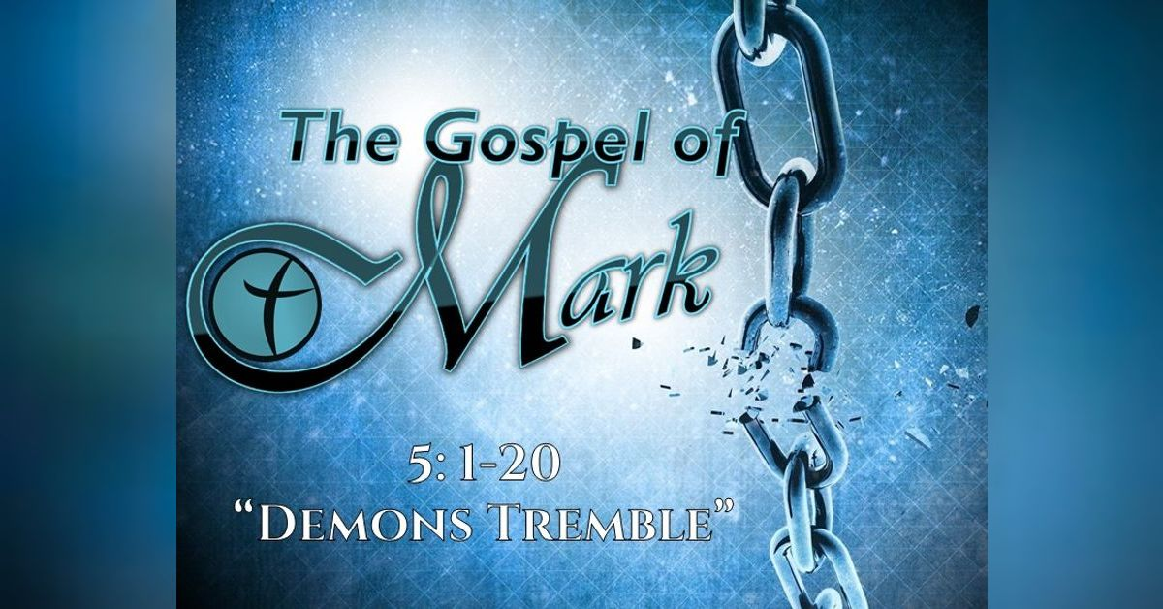

5812 Ford Rd. N. Mt. Vernon, IN 47620 (812) 985-3115
Facebook: Immanuel United Church of Christ Church Website: www.immanueluccmv.com
Church Email: info@immanueluccmv.com Administrative Assistant: Janie Meinschein
Our Vision? “To grow a vibrant church by sharing Christ with the community . . .”
Our Mission? “To invite, inspire, involve, increase . . .”

Twenty-Third Sunday after Pentecost
November 16, 2025
Speaker: Dr. Tom Hickey

RINGING OF THE BELL Keith Deig

WELCOME AND WORDS OF GREETING Mellisa Hall

PRELUDE

*PRAISE SONG #556 “There’s a Quiet Understanding”

*CALL TO WORSHIP Mellisa Hall

Leader: The steadfast love of the Lord never ceases; God’s mercies never come to an end.

People: They are new every morning; great is your faithfulness, O God.

Leader: The Lord is good to those who wait for him, to the souls that seek God.

People: It is good that we should wait quietly for the salvation of the Lord.

All: Let us worship God!

*OPENING HYMN #594 “Anywhere with Jesus”

*PRAYER OF CONFESSION (Unison) Mellisa Hall

Holy God, we need you. Too often, we fall short of your glory, and separate ourselves from you. We are powerless to save ourselves. You alone can save us through the grace offered to us in Jesus’ living, serving, dying, and rising again. We offer ourselves to you, trusting in your gracious mercy. Please forgive us for the sins and bring us to everlasting life.

WORDS OF ASSURANCE Mellisa Hall

The Lord is merciful and gracious, slow to anger, and abundant in loving kindness.
In the name of our Savior Jesus Christ, we are forgiven.

*GLORIA PATRI
Glory be to the Father, and to the Son, and to the Holy Ghost;
As it was in the beginning, is now, and ever shall be,
world without end. Amen.

CHILDREN’S MOMENTS Ann Baldwin

PRAYERS OF THE PEOPLE Dr. Tom Hickey
Silent Prayer ~ Pastoral Prayer ~ Our Lord’s Prayer

SERVICE OF GIVING
Offertory “Come, Ye Thankful People Come” Immanuel Dulcimers
“Come Though Fount of Every Blessing”

*Response No. 382

Praise God, from whom all blessings flow;
Praise Him, all creatures here below;
Praise Him above, ye heavenly host;
Praise Father, Son, and Holy Ghost. Amen.

*Prayer of Dedication (In Unison) Mellisa Hall

Lord—You are good and You are strong. You are faithful and You are loving. All that we have comes from Your hands: accept these gifts and empower us to be your loving, faithful people. Amen.

SCRIPTURE – Mark 5: 1-20 Mellisa Hall

5 They went across the lake to the region of the Gerasenes. ² When Jesus got out of the boat, a man with an impure spirit came from the tombs to meet him. ³ This man lived in the tombs, and no one could bind him anymore, not even with a chain. ⁴ For he had often been chained hand and foot, but he tore the chains apart and broke the irons on his feet. No one was strong enough to subdue him. ⁵ Night and day among the tombs and in the hills he would cry out and cut himself with stones.

⁶ When he saw Jesus from a distance, he ran and fell on his knees in front of him. ⁷ He shouted at the top of his voice, “What do you want with me, Jesus, Son of the Most High God? In God’s name don’t torture me!” ⁸ For Jesus had said to him, “Come out of this man, you impure spirit!”

⁹ Then Jesus asked him, “What is your name?”

“My name is Legion,” he replied, “for we are many.” ¹⁰ And he begged Jesus again and again not to send them out of the area.

¹¹ A large herd of pigs was feeding on the nearby hillside ¹² The demons begged Jesus, “Send us among the pigs; allow us to go into them.” ¹³ He gave them permission, and the impure spirits came out and went into the pigs. The herd, about two thousand in number, rushed down the steep bank into the lake and were drowned.

¹⁴ Those tending the pigs ran off and reported this in the town and countryside, and the people went out to see what had happened. ¹⁵ When they came to Jesus, they saw the man who had been possessed by the legion of demons, sitting there, dressed and in his right mind; and they were afraid. ¹⁶ Those who had seen it told the people what had happened to the demon-possessed man—and told about the pigs as well. ¹⁷ Then the people began to plead with Jesus to leave their region.

¹⁸ As Jesus was getting into the boat, the man who had been demon-possessed begged to go with him. ¹⁹ Jesus did not let him, but said, “Go home to your own people and tell them how much the Lord has done for you, and how he has had mercy on you.” ²⁰ So the man went away and began to tell in the Decapolis^{[b]} how much Jesus had done for him. And all the people were amazed.

HYMN #626 “It Took a Miracle”

SERMON “Demons” Dr. Tom Hickey

*CLOSING HYMN #581 “It Is No Secret”

*BENEDICTION Pastor Elisabeth

*BENEDICTION SONG “May the Good Lord Bless and Keep You”

May the good Lord bless and keep you
Whether near or far away
May you find that long awaited Golden day today
May your troubles all be small ones
And your fortune ten times ten
May the good Lord bless and keep you
'Til we meet again

POSTLUDE

Used by Permission. CCLI License # 20658309, Streaming # 20658316
+++++++++++++++++++++++++++++++++++++++++++++++++++++++++++++++++++++++++++++
Today November 23
Lay Leader  Ushers/Greeters:  Pianist/Organist:  Children’s Moments: | Mellisa Hall  Bret & Traci Baldwin  Beth Folz  Ann Baldwin | Angela Clark  OPEN  Beth Folz  Rev. Robert Walker

ATTENDANCE | LAST WEEK: 51 LAST YEAR: 55


OUR IMMANUEL UCC PRAYER LIST

*Charles Behrick *David Behrick *Becky Brenner *Janice Jones

Ken Willett David Frye Kenny Meinschein Teresa Topper Becky Teeple

Tom Howard Kiersten Ferguson-Cremin Jack Norvell Denise Norvell


ANNOUNCEMENTS

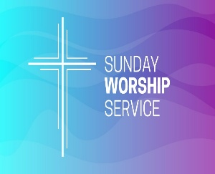
TODAY WE WELCOME

Dr. Tom Hickey – Worship

With Mellisa Hall as Lay Leader


NEXT SUNDAY, NOVEMBER 23
WE WILL CELEBRATE TOTENFEST

Rev. Robert Walker – Worship

With Angela Clark as Lay Leader



NOVEMBER DONATION FOR AT THE CROSS MISSION
is Peanut Butter. There is a basket in the Narthex.



BLANKETS are needed for the homeless.
There is a box in the Narthex.


DORCAS WOMEN’S FELLOWSHIP
will meet Thursday, Nov 20th at 1:00 p.m. at the church.
We will be cleaning and tidying some areas of the church.
All ladies are invited to attend.


Gentle Exercise Class . . . designed for 40+
Every Thursday morning at 9:30 am in the Fellowship Hall
Breath & Movement 45 mins~
Discussion on creating a positive mindset 15 min~
Led by De Brown, certified Yoga Instructor and Immanuel UCC member!
*Suggested donation: $5-



SUNDAY 16th TWENTY-THIRD SUNDAY AFTER PENTECOST
9:00 a.m. Adult Sunday School
5:30 p.m. – 6:30 p.m. AA Meeting

MONDAY 17th

TUESDAY 18th

WEDNESDAY 19th

THURSDAY 20th 9:30 a.m. Exercise Class
1:00 p.m. Dorcas Women’s Fellowship

FRIDAY 21st

SATURDAY 22nd

SUNDAY 23rd TWENTY FOURTH SUNDAY AFTER PENTECOST
9:00 a.m. Adult Sunday School
10:00 a.m. Worship Totenfest
5:30 p.m. – 6:30 p.m. AA Meeting



November 16 – Andrea Franks
November 17 – Chris Moers
November 18 – Josh Deig
November 21 – Grace Baldwin

