IMMANUEL UNITED CHURCH OF CHRIST
November 1, 2026

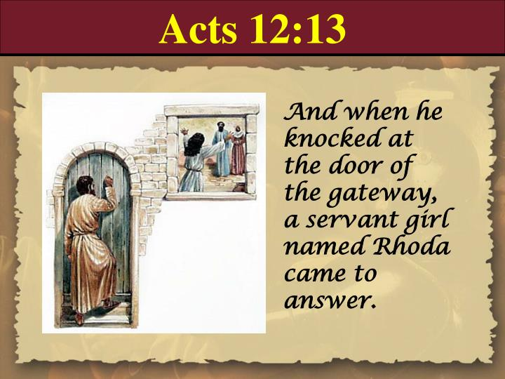

5812 Ford Rd. N. Mt. Vernon, IN 47620 (812) 985-3115
Facebook: Immanuel United Church of Christ Church Website: www.immanueluccmv.com
Church Email: info@immanueluccmv.com IM: Adam McCloud (812) 598-8887
Council President: Bret Baldwin (930) 465-5471 Secretary: Janie Meinschein (812) 483-3578
Our Vision? “To grow a vibrant church by sharing Christ with the community . . .”
Our Mission? “To invite, inspire, involve, increase . . .”

Twenty-Third Sunday after Pentecost
All Saints Day
November 1, 2026

RINGING OF THE BELL Keith Deig

WELCOME AND WORDS OF GREETING Bret Baldwin

PRELUDE “I Sing a Song of the Saints of God” Lyrics by Lesbia Scott

*PRAISE HYMN #385 “Holy God, We Praise Thy Name” (Verse 1)

*CALL TO WORSHIP Bret Baldwin

L: We worship in the spirit of generosity that arises from God’s good gifts!

P: We seek to participate in God’s mission in the world.

L: We gather on this Holy Day to witness in word and deed.

P: To share God’s love with all.

*OPENING HYMN #394 “Rejoice, Ye Pure in Heart”

*PRAYER OF CONFESSION (Unison) Bret Baldwin

Loving God, is it too good to be true? That you love us just as we are? You do not require perfection; not even “good works.” You ask that we come to you with humble hearts recognizing that you are the One who leads and empowers us to love. We love because you first loved us! Create within us loving and generous hearts and doors to all! May the Spirit of Christ shine in us all! Amen.
*WORDS OF ASSURANCE

Hear the Good news:
God, ever merciful and loving—forgives us.
God’s great mercy abounds renewing us each day.
Thanks be to God!

*GLORIA PATRI
Glory be to the Father, and to the Son, and to the Holy Ghost;
As it was in the beginning, is now, and ever shall be,
world without end. Amen.

CHILDREN’S MOMENTS Ashton Wagner

SPECIAL MUSIC “If We Never Meet Again This Side of Heaven” Adam McCloud

PRAYERS OF THE PEOPLE Adam McCloud
Pastoral Prayer ~ Silent Prayer ~ Lord’s Prayer

SERVICE OF GIVING
Offertory “There’ll Be Peace in the Valley” Thomas A. Dorsey
*Response No. 382
Praise God, from whom all blessings flow;
Praise Him, all creatures here below;
Praise Him above, ye heavenly host;
Praise Father, Son, and Holy Ghost. Amen.

*Prayer of Dedication (In Unison) Bret Baldwin

Gracious God, please use these gifts for furthering your realm on earth. Give us courage and a spirit of boldness to give freely of our time, talent, and testimony as well. Accept and bless this offering and the dedication of life and service which we aspire to each and every day, day by day. In Christ’s name we pray. Amen.

SCRIPTURE – Acts 12: 13-16 Bret Baldwin

13 Peter knocked at the outer entrance, and a servant named Rhoda came to answer the door. 14 When she recognized Peter’s voice, she was so overjoyed she ran back without opening it and exclaimed, “Peter is at the door!”
15 “You’re out of your mind,” they told her. When she kept insisting that it was so, they said, “It must be his angel.”
16 But Peter kept on knocking, and when they opened the door and saw him, they were astonished.

SERMON HYMN #345 “Crown Him with Many Crowns”

SERMON “How Do You Respond when God Answers” Adam McCloud

THE LORD INVITES US TO HIS TABLE
Invitation to Communion
Prayer of Consecration
Sharing The Bread and Cup
Prayer of Thanksgiving (Unison)

Eternal God, we thank you for your presence in this holy feast. May we know the presence of Jesus among us. Take us from this table, raised and restored, ready not to be served but to serve, in the power of the Spirit. Amen.

CLOSING HYMN #547 “The Church’s One Foundation”

*BENEDICTION

*BENEDICTION SONG “Let There Be Peace on Earth”

Let there be peace on earth and let it begin with me;
let there be peace on earth, the peace that was meant to be.
With God as our Maker, family all are we.
Let us walk with each other, in perfect harmony.

Let peace begin with me, let this be the moment now.
With every step I take, may this be my solemn vow:
To take each moment and live each moment
in peace eternally.
Let there be peace on earth, and let it begin with me.

POSTLUDE “For All the Saints” By Ralph Vaughn Williams

Used by Permission. CCLI License # 20658309, Streaming # 20658316
+++++++++++++++++++++++++++++++++++++++++++++++++++++++++++++++++++++++++++++

Today Next Week
Lay Leader:  Ushers/Greeters:  Pianist/Organist: | Bret Baldwin  Bret Baldwin Family  Judy Grebe | De Brown  Nelda Hickey  Beth Folz

ATTENDANCE | LAST WEEK:47 LAST YEAR: 48


We wish to welcome all in the name of Christ.
We invite you to worship with us every Sunday...
and to become a part of this faith household.

We invite you to sign our Guest Book, located in the Narthex

OUR IMMANUEL UCC PRAYER LIST

*MEMBERS

*Charles Behrick *David Behrick *Cherry Chase *Cheryl Higgs

*Janice Jones *Betty Michael *Dan Riddle *Betty Schuessler

Randy Boyer David Frye Norma Houghton Tom Howard

Cathy Hyatt Steve Majors Denis Lambrech Kenny Meinschein

Karen (Geier) Shelley Teresa Topper Heather Warner Ken Willett

Eli Williams

If you have names to be added or deleted from the Prayer List, please obtain permission from the person or a family member for their name to be published.
A phone call or a card will let people know we miss them and we care for them.

  TODAY, NOVEMBER 1ST  After Worship Service  Meet & Great our new Interim Minister  Adam McCloud, his wife Jade,  and son Logan.  We will be having soup and sandwiches for us to get to know them better and for them to get to know us better.  Everyone is invited! |     Next Sunday, November 8th  after Worship Service  We will elect 3 new 2027 – 2029  Council Members and  discuss/approve 2027 church budget.



THIS WEEK

SUNDAY 1st TWENTY-THIRD SUNDAY AFTER PENTECOST
9:00 a.m. Adult Sunday School
10:00 a.m. Worship & Communion
Meet & Greet after Worship with Adam McCloud & Family
5:30 p.m. – 6:30 p.m. AA Meeting

MONDAY 2nd

TUESDAY 3rd Election Day

WEDNESDAY 4th

THURSDAY 5th 9:30 a.m. Exercise Class

FRIDAY 6th

SATURDAY 7th

SUNDAY 8th TWENTY-FOURTH SUNDAY AFTER PENTECOST
9:00 a.m. Adult Sunday School
10:00 a.m. Worship
Budget & Election Meeting after Worship
5:30 p.m. – 6:30 p.m. AA Meeting


November 1 – Ron Higgs, Amanda Risher
November 2 – Jay Chase
November 3 – Karen Behrick, Steve Angel
November 5 – De Brown


Gentle Exercise Class . . . designed for 40+
Every Thursday morning at 9:30 am in the Fellowship Hall
Breath & Movement 45 mins~
Discussion on creating a positive mindset 15 min~
Led by De Brown, certified Yoga Instructor and Immanuel UCC member!
*Suggested donation: $5-

