IMMANUEL UNITED CHURCH OF CHRIST
October 26, 2025

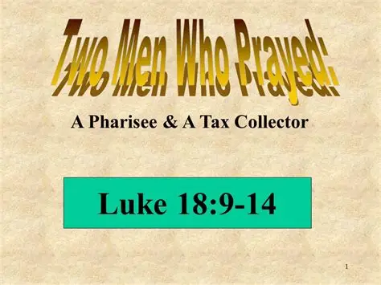

5812 Ford Rd. N. Mt. Vernon, IN 47620 (812) 985-3115
Facebook: Immanuel United Church of Christ Church Website: www.immanueluccmv.com
Church Email: info@immanueluccmv.com Administrative Assistant: Janie Meinschein
Our Vision? “To grow a vibrant church by sharing Christ with the community . . .”
Our Mission? “To invite, inspire, involve, increase . . .”

Twentieth Sunday after Pentecost
October 26, 2025 Guest Speaker: Dr. Tom Hickey

RINGING OF THE BELL Keith Deig

WELCOME AND WORDS OF GREETING Dennis Clark

PRELUDE “Holy, Holy, Holy” Handbell Choir

*PRAISE HYMN #161 “Breathe On Me, Breath of God” (Vs 2 only)

*CALL TO WORSHIP Dennis Clark

Lay Leader: Let us remember our baptisms daily, and rejoice that God calls us His own. We are God’s beloved children!

People: Baptized with water and the Holy Spirit, God’s Presence is a sign and seal of our common discipleship.

Lay Leader: We seek to center our lives on the love and witness of Jesus, our Savior.

People: With great joy we come before God and rejoice!

*OPENING HYMN #417 “Just As I Am, Without One Plea”

*PRAYER OF CONFESSION (Unison) Dennis Clark

Loving God, you love us with an unending love. When we forget that we are your children, forgive us. When we forget to follow the Light of Christ, forgive us. Lead us out of our neglectful ways, lead us back to you. Grant to us your strength to follow your Son Jesus, in whose name we pray. Amen.

*WORDS OF ASSURANCE Dennis Clark

Hear the Good News:
God loves us with an unending love since the beginning of time until the end of time.
Thanks be to God!

*GLORIA PATRI
Glory be to the Father and to the Son, and to the Holy Ghost;
As it was in the beginning, is now, and ever shall be,
world without end. Amen.

CHILDREN’S MOMENTS Judy Deig

SPECIAL MUSIC “It is Well With My Soul” Handbell Choir

PRAYERS OF THE PEOPLE
Silent Prayer ~ Pastoral Prayer ~ Our Lord’s Prayer Dr. Tom Hickey

SERVICE OF GIVING
Offertory “Praise Him” Dulcimers
“God is So Good”
“Oh, How I Love Jesus”
*Response # 382
Praise God, from whom all blessings flow;
Praise Him, all creatures here below;
Praise Him above, ye heavenly host;
Praise Father, Son, and Holy Ghost. Amen.

*Prayer of Dedication (In Unison) Dennis Clark

There is one body and one Spirit. There is one hope in God’s call to us. There is one Lord, one faith, one baptism, one God and Creator of us all. With gratitude in our hearts for God’s many gifts and for God’s Holy Spirit who graces our community, we give thanks. May the gifts we offer to God be pleasing in His sight. Amen.

SCRIPTURE – Luke 18: 9-14 Dennis Clark

⁹ To some who were confident of their own righteousness and looked down on everyone else, Jesus told this parable: ¹⁰ “Two men went up to the temple to pray, one a Pharisee and the other a tax collector. ¹¹ The Pharisee stood by himself and prayed: ‘God, I thank you that I am not like other people—robbers, evildoers, adulterers—or even like this tax collector. ¹² I fast twice a week and give a tenth of all I get.’

¹³ “But the tax collector stood at a distance. He would not even look up to heaven, but beat his breast and said, ‘God, have mercy on me, a sinner.’

¹⁴ “I tell you that this man, rather than the other, went home justified before God. For all those who exalt themselves will be humbled, and those who humble themselves will be exalted.”

HYMN “Standing in the Need of Prayer” (See attached sheet)

SERMON “A Community in Christ” Dr. Tom Hickey

*CLOSING HYMN #443 “I Need Thee Every Hour”

*BENEDICTION

*BENEDICTION SONG “Lord of Life”

Lord of Life, Lord of Love, Walk forever beside us,
Day by Day, Show the Way, With your Vision to guide us.
Striving to Follow Your Will and Way, Nothing can divide us,
Lord of Life, Lord of Love, Walk forever beside us.

POSTLUDE “Andante” by Felix Mendelssohn

Used by Permission. CCLI License # 20658309, Streaming # 20658316
+++++++++++++++++++++++++++++++++++++++++++++++++++++++++++++++++++++++++++++

Today November 2
Lay Leader  Ushers/Greeters:  Pianist/Organist:  Children’s Moments: | Dennis Clark  Nelda Hickey & Chris Moers  Gail Angel  Judy Deig | Bobbie Hoebeke  Janie Meinschein  Beth Folz  OPEN

ATTENDANCE | LAST WEEK: 55 LAST YEAR: 52


OUR IMMANUEL UCC PRAYER LIST

*Charles Behrick *David Behrick *Becky Brenner *Janice Jones

*Cindy Woodall Ken Willett David Frye Kenny Meinschein

Justin Russell Teresa Topper Tom Howard Kiersten Ferguson-Cremin


TODAY WE WELCOME

Guest Speaker: Dr. Tom Hickey

With Dennis Clark as Lay Leader


NEXT SUNDAY, NOVEMBER 2ND

Minister: Rev. Robert Walker

Worship & Communion

With Bobbie Hoebeke as Lay Leader

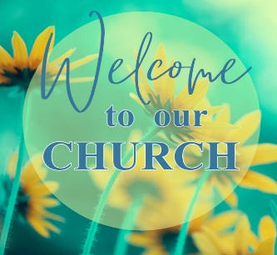
VISITORS
We invite you to sign our Guest book,
located in the Narthex, as well as the
attendance book in the pews.

ANNOUNCEMENTS

Sign-up sheets are in the Narthex.       | 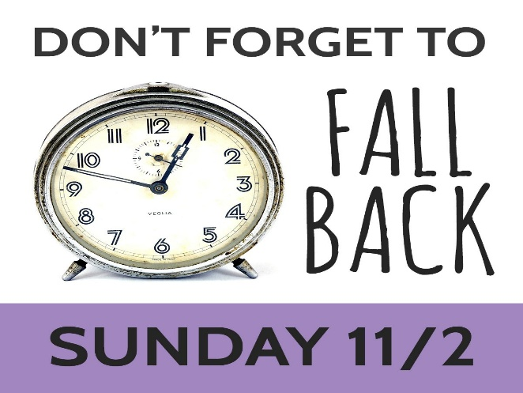

  FOOD COLLECTION  BOX & BAG CEREAL  I s needed for ATC Mission.  There is a basket in the Narthex.  Thank you for your donations! |   LUNCH BUNCH  Wednesday, October 29th  12 noon at ZAPS  Co-Leaders: Betty Schuessler & Ruth Duckworth  EVERYONE IS WELCOME!


TRUNK OR TREAT AT IMMANUEL UCC
This Friday, October 31st 5p-8p
If you would like to donate bags of candy,
there is a basket in the Narthex.


SUNDAY 26th TWENTIETH SUNDAY AFTER PENTECOST
9:00 a.m. Adult Sunday School
10:00 a.m. Worship
5:30 p.m. – 6:30 p.m. AA Meeting

MONDAY 27th

TUESDAY 28th

WEDNESDAY 29th 12:00 a.m. Lunch Bunch at Zaps

THURSDAY 30th 9:30 a.m. Exercise Class

FRIDAY 31st 3:00 p.m. Trick or Treat

SATURDAY 1st

SUNDAY 2nd TWENTY FIRST SUNDAY AFTER PENTECOST
Daylight Savings Time Ends. Don’t forget to Fall Backwards!
9:00 a.m. Adult Sunday School
10:00 a.m. Worship & Communion
5:30 p.m. – 6:30 p.m. AA Meeting


October 28 – Sydney Williams
October 29 – Pam Robinson
October 29 – Damon Chase
October 30 – Judy Berry
November 1 – Ron Higgs
November 1 – Amanda Risher
November 2 – Jay Chase


Gentle Exercise Class . . . designed for 40+
Every Thursday morning at 9:30 am in the Fellowship Hall
Breath & Movement 45 mins~
Discussion on creating a positive mindset 15 min~
Led by De Brown, certified Yoga Instructor and Immanuel UCC member!
*Suggested donation: $5-

