IMMANUEL UNITED CHURCH OF CHRIST
October 25, 2026

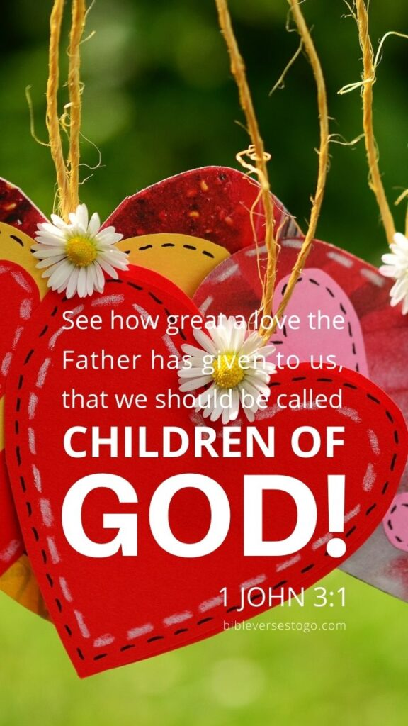

5812 Ford Rd. N. Mt. Vernon, IN 47620 (812) 985-3115
Facebook: Immanuel United Church of Christ Church Website: www.immanueluccmv.com
Church Email: info@immanueluccmv.com IM: Adam McCloud (812) 598-8887
Council President: Bret Baldwin (930) 465-5471 Secretary: Janie Meinschein (812) 483-3578
Our Vision? “To grow a vibrant church by sharing Christ with the community . . .”
Our Mission? “To invite, inspire, involve, increase . . .”

Twenty-Second Sunday after Pentecost
October 25, 2026

RINGING OF THE BELL Keith Deig

WELCOME AND WORDS OF GREETING Melody Oeth

PRELUDE “How Great Thou Art”

*PRAISE HYMN - #397 “I Will Serve Thee”

*CALL TO WORSHIP – Psalm 133: 1-3 Melody Oeth

L: How good and pleasant it is when God’s people live together in unity!

P: It is like precious oil poured on the head, running down on the beard, running down on Aaron’s beard, down on the collar of his robe.

L: It as if the dew of Hermon were falling on Mount Zion. For there the Lord bestows his blessing, even life forevermore.

*OPENING HYMN - #255 “Down at the Cross”

*PRAYER OF CONFESSION (Unison) Melody Oeth

Loving God, help us in our distrust that provokes our anxiety. Strengthen us—in faith—to walk more closely with You. Calm our worries. May we place our trust in You. Amen.
*WORDS OF ASSURANCE Melody Oeth

God gives us strength sufficient unto this day, tomorrow, and for all our tomorrows.
God forgives our sins and offers us new life in the Spirit.
Thanks be to God!

*GLORIA PATRI
Glory be to the Father, and to the Son, and to the Holy Ghost;
As it was in the beginning, is now, and ever shall be,
world without end. Amen.

CHILDREN’S MOMENTS Ashton Wagner

PRAYERS OF THE PEOPLE
Pastoral Prayer ~ Silent Prayer ~ Lord’s Prayer

SERVICE OF GIVING
Offertory “Victory in Jesus”
*Response No. 382
Praise God, from whom all blessings flow;
Praise Him, all creatures here below;
Praise Him above, ye heavenly host;
Praise Father, Son, and Holy Ghost. Amen.

*Prayer of Dedication (In Unison) Melody Oeth

Almighty and Loving God, as we bring our gifts before you, we seek to discern your purpose for them and for us and for our church, Immanuel. Inspire our vision to embrace new possibilities. We seek to glorify you, and go out into the world in peace sharing the good news of your Son, Jesus Christ. Amen.

SCRIPTURE Melody Oeth

1 John 3:1
See how very much our Father loves us, for he calls us his children, and that is what we are! But the people who belong to this world don’t recognize that we are God’s children because they don’t know him.

John 1:12-13
But to all who believed him and accepted him, he gave the right to become children of God. They are reborn—not with a physical birth resulting from human passion or plan, but a birth that comes from God.

HYMN – #314 “What a Day That Will Be”

SERMON “I am My Father’s Child” Adam McCloud

*CLOSING HYMN - #591 “Just a Closer Walk with Thee”

*BENEDICTION

*BENEDICTION SONG “Let There Be Peace on Earth”

Let there be peace on earth and let it begin with me;
let there be peace on earth, the peace that was meant to be.
With God as our Maker, family all are we.
Let us walk with each other, in perfect harmony.

Let peace begin with me, let this be the moment now.
With every step I take, may this be my solemn vow:
To take each moment and live each moment
in peace eternally.
Let there be peace on earth, and let it begin with me.

POSTLUDE

Used by Permission. CCLI License # 20658309, Streaming # 20658316
+++++++++++++++++++++++++++++++++++++++++++++++++++++++++++++++++++++++++++++

Today Next Week
Lay Leader:  Ushers/Greeters:  Pianist: | Melody Oeth  Chris Moers, Judy Berry  Adam McCloud | OPEN  Bret Baldwin Family  Judy Grebe

ATTENDANCE | LAST WEEK:50 LAST YEAR: 55


We wish to welcome all in the name of Christ.
We invite you to worship with us every Sunday...
and to become a part of this faith household.

We invite you to sign our Guest Book, located in the Narthex

OUR IMMANUEL UCC PRAYER LIST

*MEMBERS

*Charles Behrick *David Behrick *Cherry Chase *Cheryl Higgs

*Janice Jones *Betty Michael *Dan Riddle *Betty Schuessler

Randy Boyer David Frye Norma Houghton Tom Howard

Cathy Hyatt Steve Majors Denis Lambrech Kenny Meinschein

Karen (Geier) Shelley Teresa Topper Heather Warner Ken Willett

Eli Williams

If you have names to be added or deleted from the Prayer List, please obtain permission from the person or a family member for their name to be published.
A phone call or a card will let people know we miss them and we care for them.

NOVEMBER NEWSLETTER ARTICLES are due in the office today.

EVENTS IN THE TRI-STATE AREA (Details are on Bulletin Board)

St. Paul’s German Township Pancake Breakfast - October 31, 7a-10a, Pancakes, sausages, coffee, juice and milk. Proceeds will benefit the building fund for their new addition.

Drumstick Dash - November 7, 8a at Mission Grounds Washington Square Mall, All race proceeds support ERM’s Gobbler Gathering Thanksgiving food box giveaway

St. Peter’s UCC Highland Burgoo (Carryout Only) - November 7, 11a-1p, To reserve your phone order, call 812-909-4391

Gobbler Gathering (Evansville Rescue Mission) - November 24

TODAY  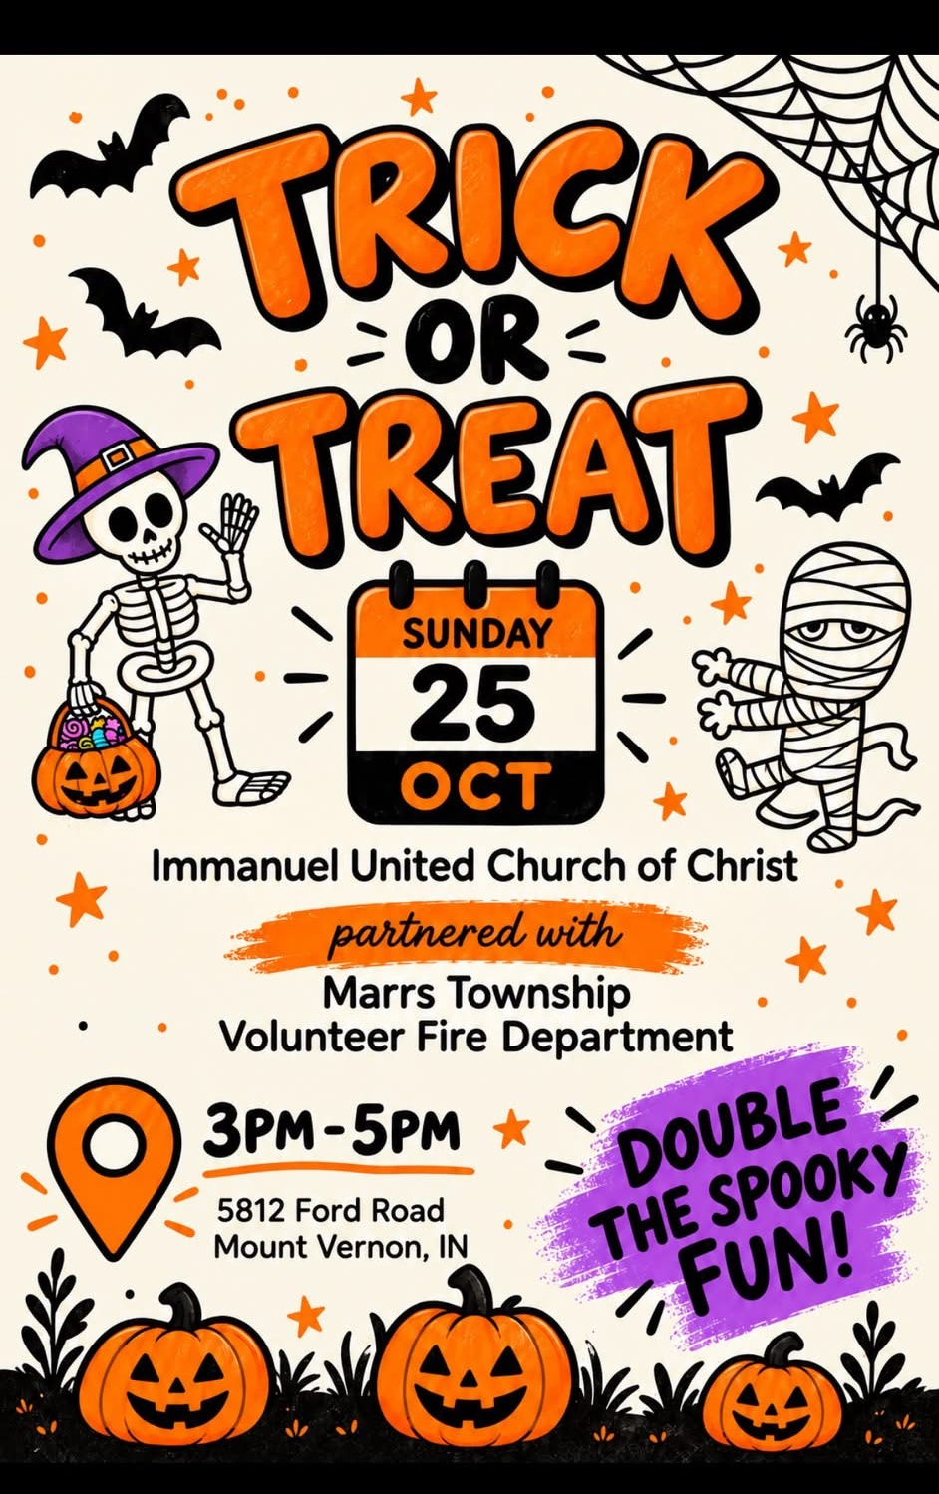 |   NEXT SUNDAY, NOVEMBER 1ST  Right after Worsip Service  Meet & Great our new Interim Minister  Adam McCloud, his wife Jade,  and son Logan.  We will be having soup and sandwiches for us to get to know them better and for them to get to know us better.  Sign up sheets in the Narthex.
  Next Sunday, November 1st  Be sure to change your clocks back 1 hour Saturday evening before you go to bed. |     Sunday, November 8th  after Worship Service


Zaps Tavern
3725 St. Phillips Road
Wednesday, October 28th
12:00 noon
EVERYONE IS WELCOME

THIS WEEK

SUNDAY 25th TWENTY-SECOND SUNDAY AFTER PENTECOST
9:00 a.m. Adult Sunday School
10:00 a.m. Worship
3:00 am – 5:00 p.m. Trick or Treat at Immanuel
5:30 p.m. – 6:30 p.m. AA Meeting

MONDAY 26th

TUESDAY 27th

WEDNESDAY 28th 12:00 p.m. Lunch Bunch at Zaps Tavern

THURSDAY 29th 9:30 a.m. Exercise Class

FRIDAY 30th

SATURDAY 31st Change clocks back before going to bed

SUNDAY 1st TWENTY-THIRD SUNDAY AFTER PENTECOST
9:00 a.m. Adult Sunday School
After worship – Meet & Greet with Adam McCloud & Family
5:30 p.m. – 6:30 p.m. AA Meeting


October 25 – Melody Oeth
October 28 - Sydney Williams
October 29 – Pam Robinson, Damon Chase
October 30 – Judy Berry
November 1 – Ron Higgs, Amanda Risher


Gentle Exercise Class . . . designed for 40+
Every Thursday morning at 9:30 am in the Fellowship Hall
Breath & Movement 45 mins~
Discussion on creating a positive mindset 15 min~
Led by De Brown, certified Yoga Instructor and Immanuel UCC member!
*Suggested donation: $5-

