IMMANUEL UNITED CHURCH OF CHRIST
October 19, 2025

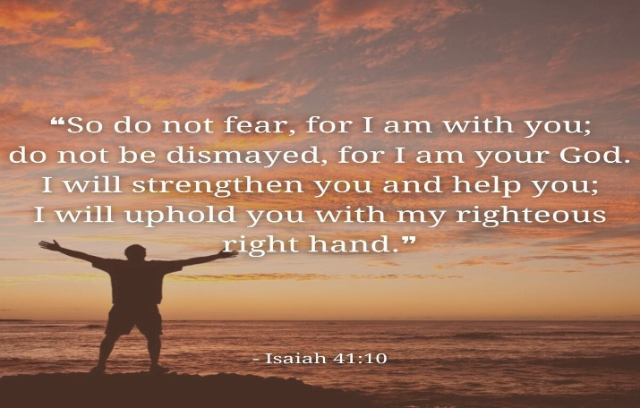

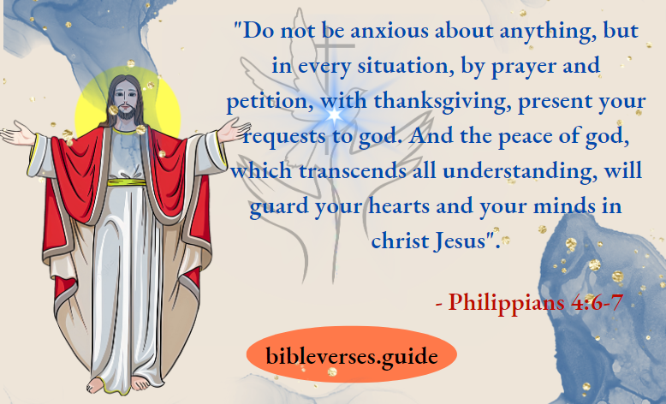

5812 Ford Rd. N. Mt. Vernon, IN 47620 (812) 985-3115
Facebook: Immanuel United Church of Christ Church Website: www.immanueluccmv.com
Church Email: info@immanueluccmv.com Administrative Assistant: Janie Meinschein
Our Vision? “To grow a vibrant church by sharing Christ with the community . . .”
Our Mission? “To invite, inspire, involve, increase . . .”

Nineteenth Sunday after Pentecost
October 19, 2025 – Congregational Discussion

RINGING OF THE BELL Keith Deig

WELCOME AND WORDS OF GREETING Bret Baldwin

PRELUDE

*PRAISE SONG #227 “There’s Something About That Name”

*CALL TO WORSHIP Bret Baldwin

Lay Leader: God is mighty in word and deed.

People: God’s mercy is everlasting.

Lay Leader: Blessed be the Holy and Living God!

People: Glory to God forever!

*OPENING HYMN #387 “We Gather Together”

*PRAYER OF CONFESSION (Unison) Bret Baldwin

Holy God, you call us to boldly proclaim your name. Too often we fail to do so. Forgive us. By the power of your Spirit, give us courage, and lead us away from fear to new life. May we return to faithful living, in Christ’s name we pray. Amen.

*WORDS OF ASSURANCE Bret Baldwin

Listen to the Good News:
God’s grace and mercy are never ending. Our sins are forgiven!
Praise be to God!
*GLORIA PATRI

Glory be to the Father, and to the Son, and to the Holy Ghost;
As it was in the beginning, is now, and ever shall be,
world without end. Amen.

PRAYERS OF THE PEOPLE Bret Baldwin
Silent Prayer ~ Pastoral Prayer ~ Our Lord’s Prayer

SERVICE OF GIVING
Offertory

*Response No. 382

Praise God, from whom all blessings flow;
Praise Him, all creatures here below;
Praise Him above, ye heavenly host;
Praise Father, Son, and Holy Ghost. Amen.

*Prayer of Dedication (In Unison) Bret Baldwin

God of grace and glory, your gifts are present all around. They surround us on every side. Today we return a portion of your many blessings to the mission of your Church: Immanuel United Church of Christ. We ask your blessings upon them. Inspire us with the gift of your Holy Spirit to be your people. We pray this in Jesus’ name. Amen.

SCRIPTURE – Isaiah 41: 10 and Philippians 4: 6-7 (See front cover) Bret Baldwin

CONGREGATION PRAYER (In Unison

Gracious God
We pray that you will be with us in this church meeting today. Please grant us through the Holy Spirit to be unified regardless of the outcome of our vote for a new pastor.
Help us to be humble and supportive of one another in the process. And we pray that you will guide our church in the next steps to be taken following our vote. Please help us to be the kind of church that you want us to be.
In Jesus’ name we pray. Amen

INFORMATION SHARE Pastoral Search Team/Church Council/Congregation

*CLOSING HYMN #466 “What a Friend We Have in Jesus”

*BENEDICTION Bret Baldwin

*BENEDICTION SONG #523 “God Be with You ‘Til We Meet Again”

God be with you ‘til we meet again, By his counsels guide, uphold you,
With His sheep securely fold you: God be with you ‘til we meet again.

POSTLUDE

Used by Permission. CCLI License # 20658309, Streaming # 20658316
+++++++++++++++++++++++++++++++++++++++++++++++++++++++++++++++++++++++++++++

Today October 26
Lay Leader  Ushers/Greeters:  Pianist/Organist:  Children’s Moments: | Bret Baldwin  OPEN  Beth Folz | Dennis Clark  Nelda Hickey, Chris Moers  Gail Angel  OPEN

ATTENDANCE | LAST WEEK: 40 LAST YEAR: 46


OUR IMMANUEL UCC PRAYER LIST

*Charles Behrick *David Behrick *Becky Brenner *Janice Jones

*Cindy Woodall Ken Willett David Frye Kenny Meinschein

Justin Russell Teresa Topper Tom Howard Kiersten Ferguson-Cremin



Next Sunday, October 26th at 10:00 a.m.

WE WELCOME

Guest Speaker: Dr. Tom Hickey

With Dennis Clark as Lay Leader

ANNOUNCEMENTS

BELL CHOIR will practice after worship today. If anyone is interested in joining, please talk to Beth Folz or Debbie Wells.

PLASTIC CAPS are still being collected. Please make sure they are clean and rinsed out if they have any food or liquid on them. This makes it easy for the individuals that are sorting them.

FOOD COLLECTION - BOX AND BAG CEREAL is needed for ATC Mission. There is a basket in the Narthex. Thank you for your donations.

NOVEMBER NEWSLETTER ARTICLES are due Thursday, November 23rd.


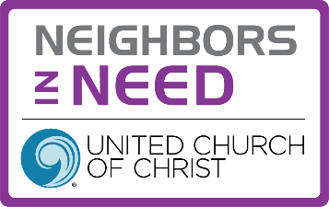




TRUNK OR TREAT AT IMMANUEL UCC
Friday, October 31st 5p-8p
If you would like to donate bags of candy,
there is a basket in the Narthex.



SUNDAY 19th NINETEENTH SUNDAY AFTER PENTECOST
9:00 a.m. Adult Sunday School
10:00 a.m. Special Congregation Discussion
5:30 p.m. – 6:30 p.m. AA Meeting

MONDAY 20th

TUESDAY 21st

WEDNESDAY 22nd

THURSDAY 23rd 9:30 a.m. Exercise Class
November Newsletter Articles Due

FRIDAY 24th

SATURDAY 25th 3:00 p.m. Chili Cook-Off

SUNDAY 26th TWENTIETH SUNDAY AFTER PENTECOST
9:00 a.m. Adult Sunday School
10:00 a.m. Worship
5:30 p.m. – 6:30 p.m. AA Meeting



October 24 – Duane Lawrence
October 25 – Melody Oeth


Gentle Exercise Class . . . designed for 40+
Every Thursday morning at 9:30 am in the Fellowship Hall
Breath & Movement 45 mins~
Discussion on creating a positive mindset 15 min~
Led by De Brown, certified Yoga Instructor and Immanuel UCC member!
*Suggested donation: $5-

