IMMANUEL UNITED CHURCH OF CHRIST
October 18, 2026

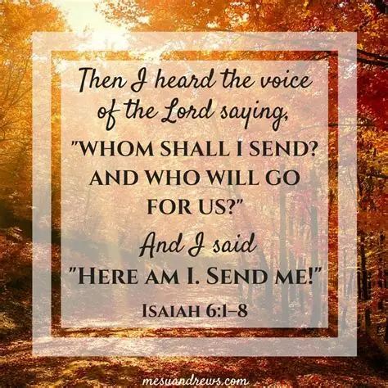

5812 Ford Rd. N. Mt. Vernon, IN 47620 (812) 985-3115
Facebook: Immanuel United Church of Christ Church Website: www.immanueluccmv.com
Church Email: info@immanueluccmv.com IM: Adam McCloud (812) 598-8887
Council President: Bret Baldwin (930) 465-5471 Secretary: Janie Meinschein (812) 483-3578
Our Vision? “To grow a vibrant church by sharing Christ with the community . . .”
Our Mission? “To invite, inspire, involve, increase . . .”

Twenty-First Sunday after Pentecost
October 18, 2026

RINGING OF THE BELL Keith Deig

WELCOME AND WORDS OF GREETING De Brown

PRELUDE

*PRAISE SONG #2040 “Awesome God” (2 times)

*CALL TO WORSHIP De Brown

L: Community of God, behold! Our hearts were made for the glory of God!

P: Sometimes we feel too small and insignificant to be of any notice to Jesus.

L: Let us remember: we are made in the image of God! In God’s likeness we have been called to live and love.

P: We are God’s children! We lift up our hearts to God, and sing praises to God’s name!

L: Come, let us rejoice in this day and be glad in it!

*OPENING HYMN #118 “A Mighty Fortress Is Our God”

*PRAYER OF CONFESSION (Unison) De Brown

Mighty God, you know us better than we know ourselves. Help us to be reflective of the ways we need to grow. Help up to live in response to your love, knowing that all good things come from your hands. When we neglect loving ways, empower us to renew our lives with your never-ending love. Help us foster the good that is in us, and help us grow our compassion. We pray this in the name of Jesus. Amen.

*WORDS OF ASSURANCE De Brown

We remember that God loves us with a tender, understanding heart.
He is closer to us than the very breath we breathe.
All: Thanks be to God!

*GLORIA PATRI
Glory be to the Father, and to the Son, and to the Holy Ghost;
As it was in the beginning, is now, and ever shall be,
world without end. Amen.

CHILDREN’S MOMENTS Ashton Wagner

PRAYERS OF THE PEOPLE Billy Thompson
Silent Prayer ~ Pastoral Prayer ~ Lord’s Prayer

SERVICE OF GIVING
Offertory

*Response No. 382
Praise God, from whom all blessings flow;
Praise Him, all creatures here below;
Praise Father, Son, and Holy Ghost. Amen.

*Prayer of Dedication (In Unison) De Brown

October blessings abound! May we recognize that all good gifts come from you, loving God. With gratitude in our hearts, we give thanks. Most Holy God, we offer these gifts knowing that you will use them to empower our community to faithfully witness to you. In Christ. Amen.

SCRIPTURE De Brown

John 6: 1-13
6 Some time after this, Jesus crossed to the far shore of the Sea of Galilee (that is, the Sea of Tiberias), ² and a great crowd of people followed him because they saw the signs he had performed by healing the sick. ³ Then Jesus went up on a mountainside and sat down with his disciples. ⁴ The Jewish Passover Festival was near.
⁵ When Jesus looked up and saw a great crowd coming toward him, he said to Philip, “Where shall we buy bread for these people to eat?” ⁶ He asked this only to test him, for he already had in mind what he was going to do.
⁷ Philip answered him, “It would take more than half a year’s wages to buy enough bread for each one to have a bite!”
⁸ Another of his disciples, Andrew, Simon Peter’s brother, spoke up, ⁹ “Here is a boy with five small barley loaves and two small fish, but how far will they go among so many?”
¹⁰ Jesus said, “Have the people sit down.” There was plenty of grass in that place, and they sat down (about five thousand men were there). ¹¹ Jesus then took the loaves, gave thanks, and distributed to those who were seated as much as they wanted. He did the same with the fish.
¹² When they had all had enough to eat, he said to his disciples, “Gather the pieces that are left over. Let nothing be wasted.” ¹³ So they gathered them and filled twelve baskets with the pieces of the five barley loaves left over by those who had eaten.

Isaiah 6: 1-8
6 In the year that King Uzziah died, I saw the Lord, high and exalted, seated on a throne; and the train of his robe filled the temple. ² Above him were seraphim, each with six wings: With two wings they covered their faces, with two they covered their feet, and with two they were flying. ³ And they were calling to one another:
“Holy, holy, holy is the Lord Almighty;
the whole earth is full of his glory.”
⁴ At the sound of their voices the doorposts and thresholds shook and the temple was filled with smoke.
⁵ “Woe to me!” I cried. “I am ruined! For I am a man of unclean lips, and I live among a people of unclean lips, and my eyes have seen the King, the Lord Almighty.”
⁶ Then one of the seraphim flew to me with a live coal in his hand, which he had taken with tongs from the altar. ⁷ With it he touched my mouth and said, “See, this has touched your lips; your guilt is taken away and your sin atoned for.”
⁸ Then I heard the voice of the Lord saying, “Whom shall I send? And who will go for us?”
And I said, “Here am I. Send me!”

HYMN #108 “Rock of Ages, Cleft for Me”

SERMON “In the Hands of the Master” Billy Thompson

*CLOSING HYMN #641 “Pass It On”

*BENEDICTION Billy Thompson

The grace of the Lord Jesus Christ and the love of God
and the fellowship of the Holy Spirit be with you all! (2 Corinthians 13:14)

*BENEDICTION SONG

Lord of Life, Lord of Love, Walk forever beside us,
Day by Day, Show the Way, With your Vision to guide us.
Striving to Follow Your Will and Way, Nothing can divide us,
Lord of Life, Lord of Love, Walk forever beside us.
POSTLUDE

Used by Permission. CCLI License # 20658309, Streaming # 20658316
+++++++++++++++++++++++++++++++++++++++++++++++++++++++++++++++++++++++++++++

Today October 25
Lay Leader:  Ushers/Greeters:  Pianist/Organist:  Children’s Moments: | De Brown  Terri, Jennifer, Debbie  Beth Folz  Ashton Wagner | Melody Oeth  Chris Moers, Judy Berry  Beth Folz  Ashton Wagner

ATTENDANCE | LAST WEEK:50 LAST YEAR: 40

OUR IMMANUEL UCC PRAYER LIST

*Charles Behrick *David Behrick *Cherry Chase *Janice Jones

*Betty Michael *Dan Riddle *Betty Schuessler David Frye

Norma Houghton Tom Howard Denis Lambrech Kenny Meinschein

Teresa Topper Ken Willett Eli Williams Heather Warner

Cathy Hyatt Randy Boyer Karen (Geier) Shelley

If you have names to be added or deleted from the Prayer List, please obtain permission from the person or a family member for their name to be published.
A phone call or a card will let people know we miss them and we care for them.


We wish to welcome all in the name of Christ.
We invite you to worship with us every Sunday...
and to become a part of this faith household.

We invite you to sign our Guest Book, located in the Narthex



Today we welcome our Guest Speaker
Billy Thompson.

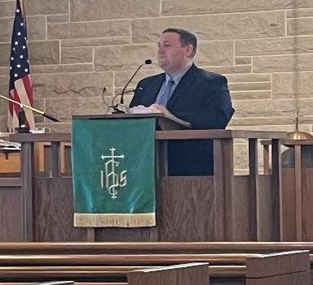

Next week, we welcome our Interim Minister,
Adam McCloud.

 | 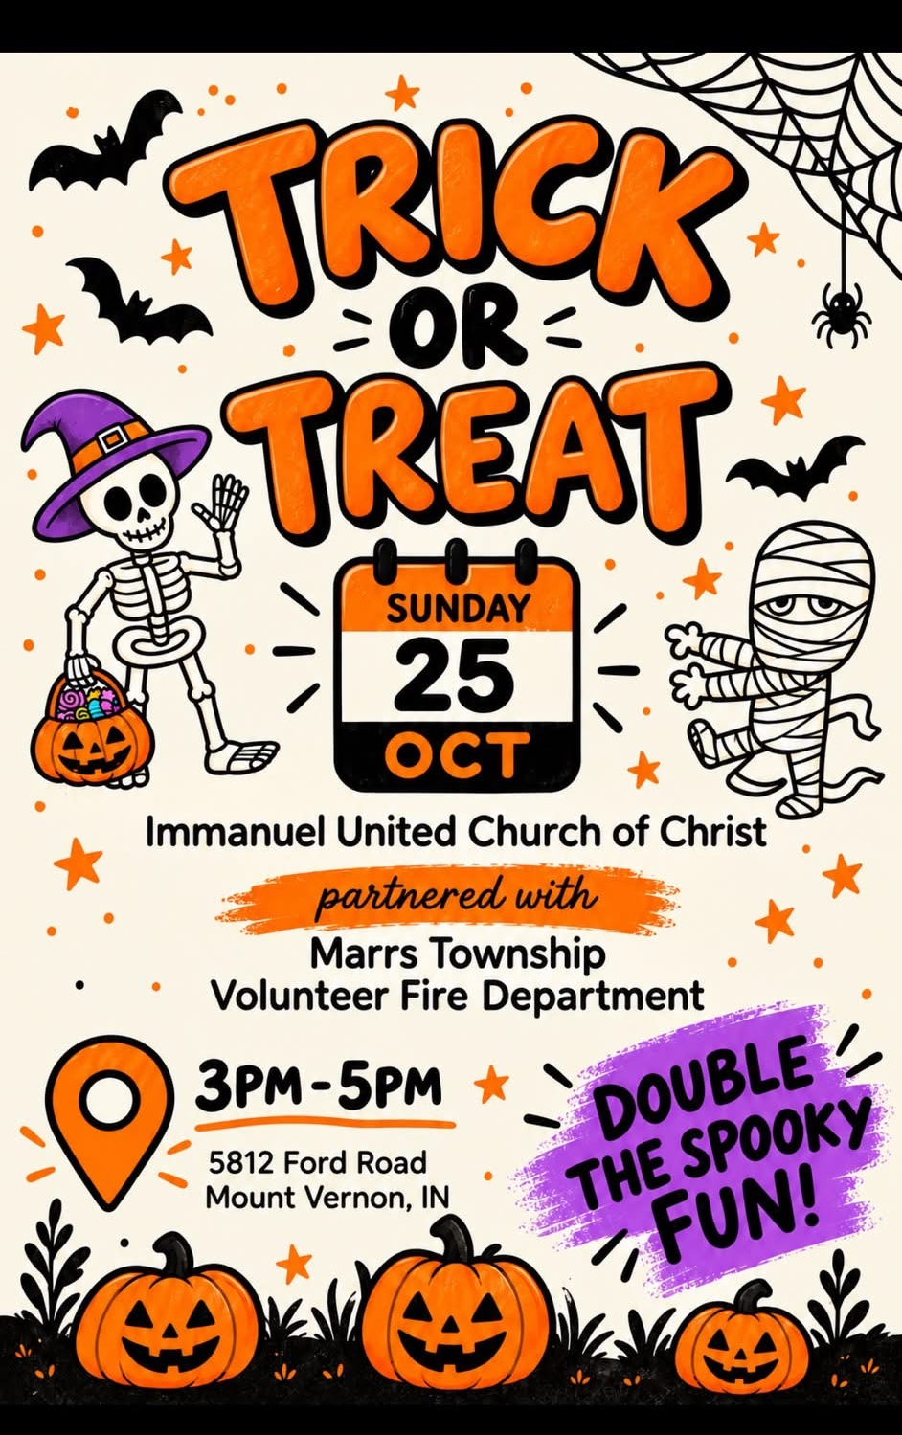

NOVEMBER NEWSLETTER ARTICLES are due in the office next Sunday, October 25th.

THIS WEEK

SUNDAY 18th TWENTY-FIRST SUNDAY AFTER PENTECOST
9:00 a.m. Adult Sunday School
10:00 a.m. Worship
5:30 p.m. – 6:30 p.m. AA Meeting
MONDAY 19th
TUESDAY 20th
WEDNESDAY 21st
THURSDAY 22nd 9:30 a.m. Exercise Class
FRIDAY 23rd
SATURDAY 24th 4:00 p.m. – 6:00 p.m. Chili Cook-Off
SUNDAY 25th TWENTY-SECOND SUNDAY AFTER PENTECOST
9:00 a.m. Adult Sunday School
10:00 a.m. Worship
3:00 p.m. – 5:00 p.m. Trick or Treat
5:30 p.m. – 6:30 p.m. AA Meeting


October 24 – Duane Lawrence
October 25 – Melody Oeth



