**IMMANUEL UNITED CHURCH OF CHRIST**

**October 12, 2025**

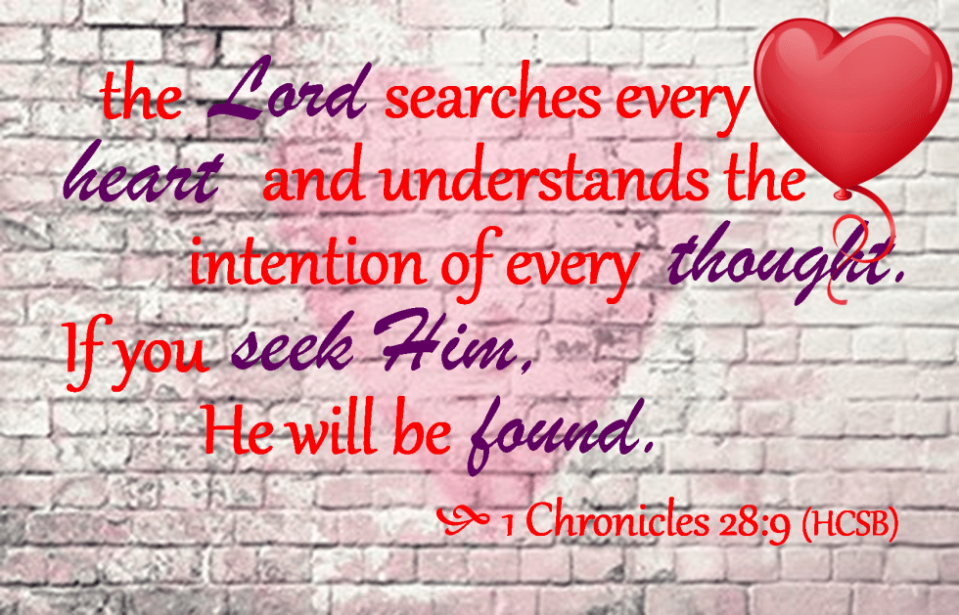

**5812 Ford Rd. N. Mt. Vernon, IN 47620 (812) 985-3115**

**Facebook:** Immanuel United Church of Christ **Church Website:** [www.immanueluccmv.com](http://www.immanueluccmv.com)

**Church Email:** [info@immanueluccmv.com](mailto:info@immanueluccmv.com) **Administrative** **Assistant:** Janie Meinschein

**Our Vision? *“To grow a vibrant church by sharing Christ with the community . . .”***

**Our Mission? *“To invite, inspire, involve, increase . . .”***

**Eighteenth Sunday after Pentecost**

October 12, 2025 – Guest Speaker: Lee Keitel

**RINGING OF THE BELL** Keith Deig

**WELCOME AND WORDS OF GREETING** Paula Boarman

**PRELUDE**

**\*PRAISE SONG #2025** (Black Hymnal) **“As The Deer”**

**\*CALL TO WORSHIP** Paula Boarman

Leader: See what love has been given to us, that we should be called children of God.

**People: By this we know love, that Jesus Christ has come in the flesh, and lived and died so that God’s love might be made plain among us.**

Leader: God’s amazing grace touches us each and every day.

**People**: **Therefore, let us go forth showing God’s grace to the world.**

Leader: Let us begin our worship, singing praises to God’s Holy Name.

**\*OPENING HYMN #107 “Amazing Grace! How Sweet the Sound”**

**\*PRAYER OF CONFESSION (Unison)** Paula Boarman

**Almighty and eternal God, we thank you that you have not left us alone in our sin and despair. Loving us, you bring us good news and set before us the way of true life. We confess that at times we wallow in self-pity and fail to live as an example of your love. Forgive us. Strengthen us giving us a clear vision of how we might live meaningful lives that extend your gift of grace to the other. Amen.**

**\*WORDS OF ASSURANCE** Paula Boarman

Hear these words that reassure: God loves us unconditionally.

In Christ, we receive grace and are offered new life in the Spirit

**\*GLORIA PATRI**

**Glory be to the Father, and to the Son, and to the Holy Ghost;**

**As it was in the beginning, is now, and ever shall be,**

**world without end. Amen.**

**CHILDREN’S MOMENTS** Teri McCormick

**PRAYERS OF THE PEOPLE** Lee Keitel

Silent Prayer ~ Pastoral Prayer ~ Our Lord’s Prayer

**SERVICE OF GIVING**

**Offertory**

\***Response No. 382**

**Praise God, from whom all blessings flow;**

**Praise Him, all creatures here below;**

**Praise Him above, ye heavenly host;**

**Praise Father, Son, and Holy Ghost. Amen.**

**\*Prayer of Dedication (In Unison)** Paula Boarman

**God of grace and glory, your gifts are present all around. They surround us on every side. Today we return a portion of your many blessings to the mission of your Church: Immanuel United Church of Christ. We ask your blessings upon them. Inspire us with the gift of your Holy Spirit to be your people. We pray this in Jesus’ name. Amen.**

**SCRIPTURE – 1 Chronicles 28: 4-10** Lee Keitel

**4**“Yet the Lord, the God of Israel, chose me from my whole family to be king over Israel forever. He chose Judah as leader, and from the tribe of Judah he chose my family, and from my father’s sons he was pleased to make me king over all Israel. **5**Of all my sons—and the Lord has given me many—he has chosen my son Solomon to sit on the throne of the kingdom of the Lord over Israel. **6**He said to me: ‘Solomon your son is the one who will build my house and my courts, for I have chosen him to be my son, and I will be his father. **7**I will establish his kingdom forever if he is unswerving in carrying out my commands and laws, as is being done at this time.’

**8**“So now I charge you in the sight of all Israel and of the assembly of the Lord, and in the hearing of our God: Be careful to follow all the commands of the Lord your God, that you may possess this good land and pass it on as an inheritance to your descendants forever.

**9**“And you, my son Solomon, acknowledge the God of your father, and serve him with wholehearted devotion and with a willing mind, for the Lord searches every heart and understands every desire and every thought. If you seek him, he will be found by you; but if you forsake him, he will reject you forever. **10**Consider now, for the Lord has chosen you to build a house as the sanctuary. Be strong and do the work.”

**HYMN #581 *“It Is No Secret”***

**SERMON “A Solemn Charge”** Lee Keitel

**\*CLOSING HYMN**  **#588 *“In The Garden”***

**\*BENEDICTION** Lee Keitel

**\*BENEDICTION SONG *“Let There Be Peace on Earth”***

***Let there be peace on earth and let it begin with me;***

***let there be peace on earth, the peace that was meant to be.***

***With God our Maker, family all are we.***

***Let us walk with each other, in perfect harmony.***

***Let peace begin with me, let this be the moment now.***

***With every step I take, may this be my solemn vow:***

***To take each moment and live each moment***

***in peace eternally.***

***Let there be peace on earth, and let it begin with me.***

**POSTLUDE**

Used by Permission. CCLI License # 20658309, Streaming # 20658316

**+++++++++++++++++++++++++++++++++++++++++++++++++++++++++++++++++++++++++++++**

**Today** **October 19**

|  |  |  |
| --- | --- | --- |
| Lay Leader  Ushers/Greeters:  Pianist/Organist:  Children’s Moments: | Paula Boarman  Janie Meinschein  Beth Folz  OPEN | Congregation  Discussion |

|  |  |
| --- | --- |
| **ATTENDANCE** | LAST WEEK: 48 LAST YEAR: 73 |



**OUR IMMANUEL UCC PRAYER LIST**

***\*Charles Behrick*** ***\*David Behrick******\*Becky Brenner*** ***\*Janice Jones***

***\*Cindy Woodall Ken Willett******David Frye Kenny Meinschein***

***Justin Russell Teresa Topper*** ***Tom Howard******Kiersten Ferguson-Cremin***



***Welcome***

***to our church***

**VISITORS: We invite you to sign our Guest Book, located in the Narthex., as well as the attendance book in the pews.**

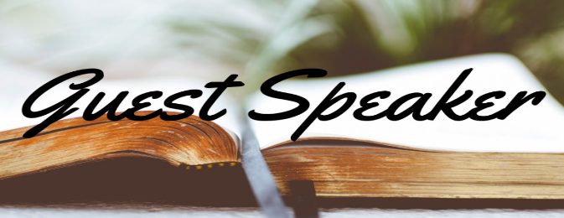

**Today, October 12th**

**WE WELCOME**

Lee Keitel

Lee Keitel is a native of Mount Vernon and married to his beautiful wife of 2 years, Jamie. They have a daughter, Ada, who's just over a year old. He earned his bachelor's degree from USI and will graduate from CBTS in May with his master's in biblical studies. He loves to learn, teach, and share the truth of God's Word and the Gospel of Jesus Christ.



**SPECIAL CONGREGATION DISCUSSION**

Mark your calendar for **next Sunday, October 19th**at 10:00a.m.

Instead of our normal church service, we will have a time for the congregation to share thoughts, concerns, and possibilities on a new minister with the church council, search committee, and each other.

We will also share scripture and singing!

**Please plan to attend and share with us!**

**ANNOUNCEMENTS**

**BELL CHOIR** will practice after worship today. If anyone is interested in joining, please talk to Beth Folz or Debbie Wells.

**PLASTIC CAPS** are still being collected. Please make sure they are clean and rinsed out if they have any food or liquid on them. This makes it easy for the individuals that are sorting them.

**ADULT SUNDAY SCHOOL** will not meet today. It will resume next Sunday, October 19th at 9:00 a.m.

**FOOD COLLECTION - BOX AND BAG CEREAL** is needed for ATC Mission. There is a basket in the Narthex. Thank you for your donations.



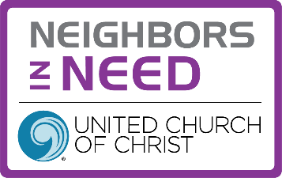



**TRUNK OR TREAT AT IMMANUEL UCC**

Friday, October 31st

5p-8p

If you would like to donate bags of candy, there is a basket in the Narthex.



**SUNDAY** **12th** **EIGHTEENTH SUNDAY AFTER PENTECOST**

NO ADULT SUNDAY SCHOOL

10:00 a.m.Worship

5:30 p.m. – 6:30 p.m. AA Meeting

**MONDAY 13th** 8:30 a.m. God’s Storehouse

**TUESDAY** **14th**

**WEDNESDAY** **15th**

**THURSDAY** **16th** 9:30 a.m. ExerciseClass

**FRIDAY** **17th**

**SATURDAY** **18th**

**SUNDAY** **19th NINETEENTH SUNDAY AFTER PENTECOST**

9:00 a.m. Adult Sunday School

10:00 a.m. Special Congregation Discussion

5:30 p.m. – 6:30 p.m. AA Meeting



*October 12 – Katherine Bailey*

*October 14 – Olivia Reller*

*October 15 – Leah Friedman*

 **Gentle Exercise Class . . . designed for 40+**

Every **Thursday morning at 9:30** am in the Fellowship Hall

Breath & Movement 45 mins~

Discussion on creating a positive mindset 15 min~

Led by De Brown, certified Yoga Instructor and Immanuel UCC member!

*Suggested donation: $5-