IMMANUEL UNITED CHURCH OF CHRIST
October 11, 2026

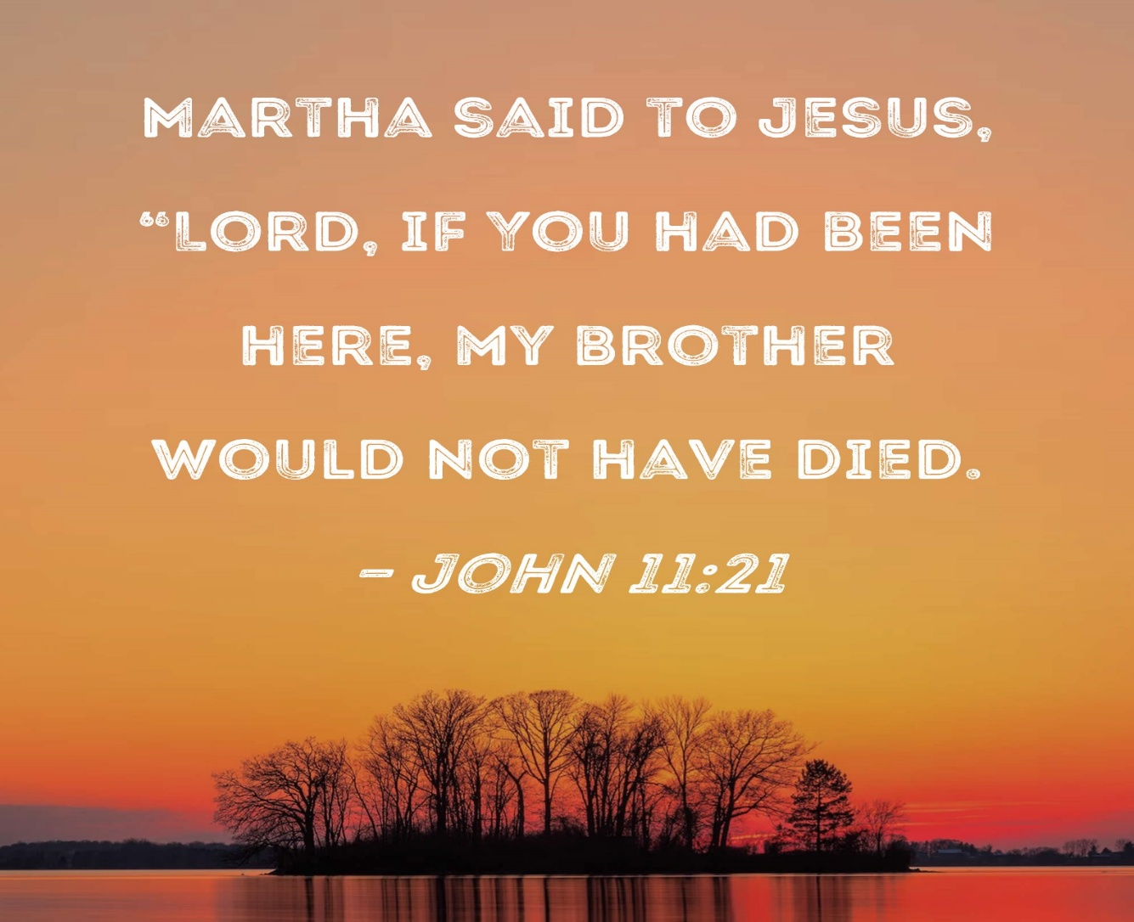

5812 Ford Rd. N. Mt. Vernon, IN 47620 (812) 985-3115
Facebook: Immanuel United Church of Christ Church Website: www.immanueluccmv.com
Church Email: info@immanueluccmv.com IM: Adam McCloud (812) 598-8887
Council President: Bret Baldwin (930) 465-5471 Secretary: Janie Meinschein (812) 483-3578
Our Vision? “To grow a vibrant church by sharing Christ with the community . . .”
Our Mission? “To invite, inspire, involve, increase . . .”

Twentieth Sunday after Pentecost
Interim Minister: Adam McCloud
October 11, 2026

RINGING OF THE BELL Keith Deig

WELCOME AND WORDS OF GREETING Paula Boarman
*Call for favorite hymns

PRELUDE

*PRAISE SONG #432 “Softly & Tenderly” (vs. 1)

*CALL TO WORSHIP Paula Boarman

L: We gather in the presence of God, through whom all people on earth receive their very breath and life.

P: We come here to be strengthened, that God might dwell in our hearts.

L: We seek to be grounded in God’s eternal love and in the love of Christ which surpasses all understanding.

P: In these moments, we put aside our weariness and turn to God for renewal!

L: May God’s vision be our vision, and may we feel His ever-present grace.

*OPENING HYMN #468 “Be Thou My Vision” (vs 1 & 2)

*PRAYER OF CONFESSION (Unison) Paula Boarman

God of all creation, you know us completely: how mean-spirited we can sometimes be as well as how good we can be. We humbly confess the mistakes we have made, the good we have neglected, and the promises we have broken. Help us foster the good that is in us, and help us grow our compassion. We pray this in the name of Jesus. Amen.

*WORDS OF ASSURANCE Paula Boarman

We remember that God loves us with a tender, understanding heart.
He is closer to us than the very breath we breathe.
All: Thanks be to God!

*GLORIA PATRI
Glory be to the Father, and to the Son, and to the Holy Ghost;
As it was in the beginning, is now, and ever shall be,
world without end. Amen.

CHILDREN’S MOMENTS Ashton Wagner

PRAYERS OF THE PEOPLE Adam McCloud
Silent Prayer ~ Pastoral Prayer ~ The Lord’s Prayer

SERVICE OF GIVING
Offertory
*Response No. 382
Praise God, from whom all blessings flow;
Praise Him, all creatures here below;
Praise Father, Son, and Holy Ghost. Amen.

*Prayer of Dedication (In Unison) Paula Boarman

This is the season of recognizing our blessings, and giving thanks. When we take time to pause taking stock of God’s good gifts, we are thankful. We seek to give back—to be faithful to God’s mission of furthering God’s glory here on earth. With gratitude in our hearts, we offer these gifts from our hands knowing that God will use them to empower His church to serve and faithfully witness to our One God, in Christ Jesus. Amen.

SCRIPTURE – John 11: 21-22 Paula Boarman

²¹ “Lord,” Martha said to Jesus, “if you had been here, my brother would not have died. ²² But I know that even now God will give you whatever you ask.”

HYMN #468 “Be Thou My Vision” (vs. 3 & 4)

SERMON “Even Now” kind of Faith Adam McCloud

*CLOSING HYMN #107 “Amazing Grace! How Sweet the Sound”
Verse 1 – All Verse 2 – Women
Verse 3 – Men Verse 4 & 5 – All

*BENEDICTION Adam McCloud

*BENEDICTION SONG

Lord of Life, Lord of Love, Walk forever beside us,
Day by Day, Show the Way, With your Vision to guide us.
Striving to Follow Your Will and Way, Nothing can divide us,
Lord of Life, Lord of Love, Walk forever beside us.
POSTLUDE

Used by Permission. CCLI License # 20658309, Streaming # 20658316
+++++++++++++++++++++++++++++++++++++++++++++++++++++++++++++++++++++++++++++

Today October 18
Lay Leader:  Ushers/Greeters:  Pianist/Organist:  Children’s Moments: | Paula Boarman  Nelda Hickey  Beth Folz  Ashton Wagner | De Brown  Terri, Jennifer & Debbie  Beth Folz  Ashton Wagner

ATTENDANCE | LAST WEEK:49 LAST YEAR: 48

OUR IMMANUEL UCC PRAYER LIST



*Charles Behrick *David Behrick *Cherry Chase *Janice Jones

*Betty Michael *Dan Riddle David Frye Norma Houghton

Tom Howard Denis Lambrech Kenny Meinschein Teresa Topper

Ken Willett Eli Williams Heather Warner, daughter of Sandy Heil

If you have names to be added or deleted from the Prayer List, please obtain permission from the person or a family member for their name to be published.
A phone call or a card will let people know we miss them and we care for them.


We wish to welcome all in the name of Christ.
We invite you to worship with us every Sunday...
and to become a part of this faith household.

We invite you to sign our Guest Book, located in the Narthex


Wesselman Woods Marrs Field Trip
This Thursday, October 15th
Student Time: 9-11:45
Help is needed between 8:30-12 noon. Any amount of time would be great.
There will be 2 second grade classes (41 students), 2 teachers plus parents.
Sign-up sheets are in the Narthex.
We will have a trail clean up on Sunday, October 11th after worship.

 |   Sunday, October 25th  3p-5p  If you would like to donate bags of candy,  There is a basket in the Narthex.

This is to support Addison Willett


THIS WEEK

SUNDAY 11th TWENTIETH SUNDAY AFTER PENTECOST
9:00 a.m. Adult Sunday School
10:00 a.m. Worship
Trail Clean-Up after Worship
5:30 p.m. – 6:30 p.m. AA Meeting

MONDAY 12th

TUESDAY 13th

WEDNESDAY 14th

THURSDAY 15th 9:00 a.m. Marrs Fall Field Trip

FRIDAY 16th

SATURDAY 17th

SUNDAY 18th TWENTY-FIRST SUNDAY AFTER PENTECOST
9:00 a.m. Adult Sunday School
10:00 a.m. Worship
5:30 p.m. – 6:30 p.m. AA Meeting



October 12 – Kate Bailey
October 14 – Olivia Reller
October 15 – Leah Friedman

There will be no Exercise class Thursday, October 15th.

It will resume on Thursday, October 22nd.

