IMMANUEL UNITED CHURCH OF CHRIST
January 18, 2026

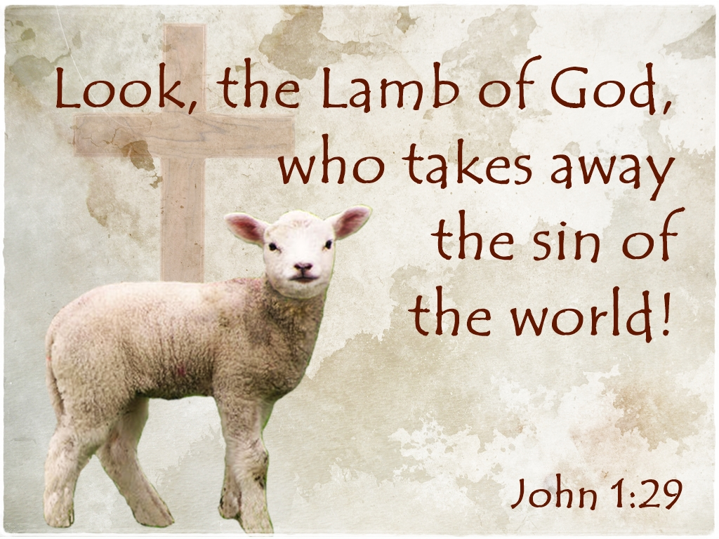

5812 Ford Rd. N. Mt. Vernon, IN 47620 (812) 985-3115
Facebook: Immanuel United Church of Christ Church Website: www.immanueluccmv.com
Church Email: info@immanueluccmv.com Administrative Assistant: Janie Meinschein
Our Vision? “To grow a vibrant church by sharing Christ with the community . . .”
Our Mission? “To invite, inspire, involve, increase . . .”

Second Sunday after the Epiphany
January 18, 2026

RINGING OF THE BELL Keith Deig

WELCOME AND WORDS OF GREETING Deb Wells

PRELUDE “Noel in G” By Louis-Claude Daquin, arr. By Lani Smith

*PRAISE SONG #171 “Joy to the World!”

*CALL TO WORSHIP - (based on Psalm 62) Deb Wells

L: In silence my soul waits for God, who alone is my hope.

P: God only is my rock and my salvation, my fortress; I shall not be greatly moved.

L: My deliverance and my honor rest on God, who is my mighty rock, and my refuge.

P: God only is my rock and my salvation, my fortress; I shall not be shaken.

L: Trust in God at all times, O people; pour out your heart before God.

*OPENING HYMN #170 “Thou Didst Leave Thy Throne”

*PRAYER OF CONFESSION (Unison) Deb Wells

We give thanks, merciful God, that in Christ you seek to unite all things in heaven and on earth. You seek to reconcile all people to one another and to you. When we fail to work toward unity, forgive us. Fill us with your Spirit and call us into reunion with You and our brothers and sisters. Amen.

*WORDS OF ASSURANCE Deb Wells

Hear the Good News:
In Christ, we are forgiven and offered new life in the Spirit.
Thanks be to God!

*GLORIA PATRI

Glory be to the Father, and to the Son, and to the Holy Ghost;
As it was in the beginning, is now, and ever shall be,
world without end. Amen.

CHILDREN’S MOMENTS Judy Deig

PASTORAL PRAYER Dr. Tom Hickey
Our Lord’s Prayer

SERVICE OF GIVING Deb Wells

Offertory “Of the Father’s Love Begotten” Gilbert M. Martin

Lay Leader: We hear in Psalm 103, “Bless the Lord, O my soul and all that is within me.
Bless his Holy Name!” May the offering today be a blessing unto God and
bless the mission God sets before us as Immanuel United Church of Christ.

*Response No. 382

Praise God, from whom all blessings flow;
Praise Him, all creatures here below;
Praise Him above, ye heavenly host;
Praise Father, Son, and Holy Ghost. Amen.

*Prayer of Dedication (In Unison) Deb Wells

Everlasting Father, thank you that you are the light of the world, guiding our steps on your path. Your word says that the earth is yours, and everything in it. The world and all its people belong to you. We recognize everything we have belongs to you. We acknowledge that our very lives belong to you. We now offer back to you a portion of what you have given us. May God the Father prepare our journey, Jesus the Son guide our footsteps and the Holy Spirit watch over us, on every path that we follow. Through Jesus Christ, our Lord, Amen.

SCRIPTURE – John 1:29-42 Deb Wells

John Testifies About Jesus
²⁹ The next day John saw Jesus coming toward him and said, “Look, the Lamb of God, who takes away the sin of the world! ³⁰ This is the one I meant when I said, ‘A man who comes after me has surpassed me because he was before me.’ ³¹ I myself did not know him, but the reason I came baptizing with water was that he might be revealed to Israel.”

³² Then John gave this testimony: “I saw the Spirit come down from heaven as a dove and remain on him. ³³ And I myself did not know him, but the one who sent me to baptize with water told me, ‘The man on whom you see the Spirit come down and remain is the one who will baptize with the Holy Spirit.’ ³⁴ I have seen and I testify that this is God’s Chosen One.”^{[a]}

John’s Disciples Follow Jesus
³⁵ The next day John was there again with two of his disciples. ³⁶ When he saw Jesus passing by, he said, “Look, the Lamb of God!”

³⁷ When the two disciples heard him say this, they followed Jesus. ³⁸ Turning around, Jesus saw them following and asked, “What do you want?”

They said, “Rabbi” (which means “Teacher”), “where are you staying?”

³⁹ “Come,” he replied, “and you will see.”

So they went and saw where he was staying, and they spent that day with him. It was about four in the afternoon.

⁴⁰ Andrew, Simon Peter’s brother, was one of the two who heard what John had said and who had followed Jesus. ⁴¹ The first thing Andrew did was to find his brother Simon and tell him, “We have found the Messiah” (that is, the Christ). ⁴² And he brought him to Jesus

HYMN #621 “Turn Your Eyes upon Jesus”

SERMON “Look and See Jesus” Dr. Tom Hickey

*CLOSING HYMN #2173 (Black Hymnal) “Shine, Jesus, Shine”

*BENEDICTION Dr. Tom Hickey

*BENEDICTION SONG “Go Tell It On The Mountains”

Go, tell it on the mountains, Over the hills and everywhere;
Go, tell it on the mountains that Jesus Christ is born!

POSTLUDE “Noel” Guilmant

Used by Permission. CCLI License # 20658309, Streaming # 20658316
+++++++++++++++++++++++++++++++++++++++++++++++++++++++++++++++++++++++++++++

Today January 25
Lay Reader  Ushers/Greeters:  Pianist/Organist: | Deb Wells  Greg & Sheryl Seifert  Gail Angel | Bret Baldwin  Nelda Hickey & Chris Moers  Beth Folz

ATTENDANCE | LAST WEEK: 46 LAST YEAR: 40

OUR IMMANUEL UCC PRAYER LIST



*Charles Behrick *David Behrick *Janice Jones *Dan Riddle

David Frye Tom Howard Kenny Meinschein Greg Renshaw

Jerry Smithhart Mildred Taylor Becky Teeple Dee Teeple

Teresa Topper Ken Willett

WE WELCOME OUR SUNDAY SPEAKERS

Today Next Sunday, January 25th
Worship Speaker: Dr. Tom Hickey Worship Speaker: Wendi Nelson
Lay Leader: Deb Wells Lay Leader: Bret Baldwin



WE WELCOME OUR GUESTS! We invite you to sign our Guest Book, located in the Narthex.

ANNUAL CONGREGATIONAL MEETING will be held after worship next Sunday, January 25th. We will have a lunch potluck following the meeting. The church will supply fried chicken. Members are welcome to bring sides and/or desserts. Please plan to attend.

PANCAKE BREAKFAST – St. Paul’s UCC German Township will be having a Pancake Breakfast on Saturday, January 24th from 7am-10am. They will be serving Pancakes, sausages, coffee, juice and milk. Cost is $10 a person. Proceeds will benefit the building fund for their new addition. St. Paul’s is located at 8701 Big Cynthiana Road.

IT’S A NEW YEAR!

Gentle Exercise Class . . . designed for 40+
Every Thursday morning at 9:30 am in the Fellowship Hall
Breath & Movement 45 mins~
Discussion on creating a positive mindset 15 min~
Led by De Brown, certified Yoga Instructor and Immanuel UCC member!
*Suggested donation: $5-



SUNDAY 18th SECOND SUNDAY AFTER THE EPIPHANY
9:00 a.m. Adult Sunday School
10:00 a.m. Worship
5:30 p.m. – 6:30 p.m. AA Meeting

MONDAY 19th Martin Luther King Jr. Day

TUESDAY 20th

WED 21th

THURSDAY 22th 9:30 a.m. Exercise Class

FRIDAY 23th

SATURDAY 24th

SUNDAY 25th THIRD SUNDAY AFTER THE EPIPHANY
9:00 a.m. Adult Sunday School
10:00 a.m. Worship
Annual Congregational Meeting after Worship
Pot Luck Dinner after Meeting
5:30 p.m. – 6:30 p.m. AA Meeting



January 19 – Carol Williams, Letha Deig
January 21 – Linda Deig, Terri McCormick, Charlene Baldwin
January 23 – Merritt Snodgrass



January 18 – Janie & Kenny Meinschein

