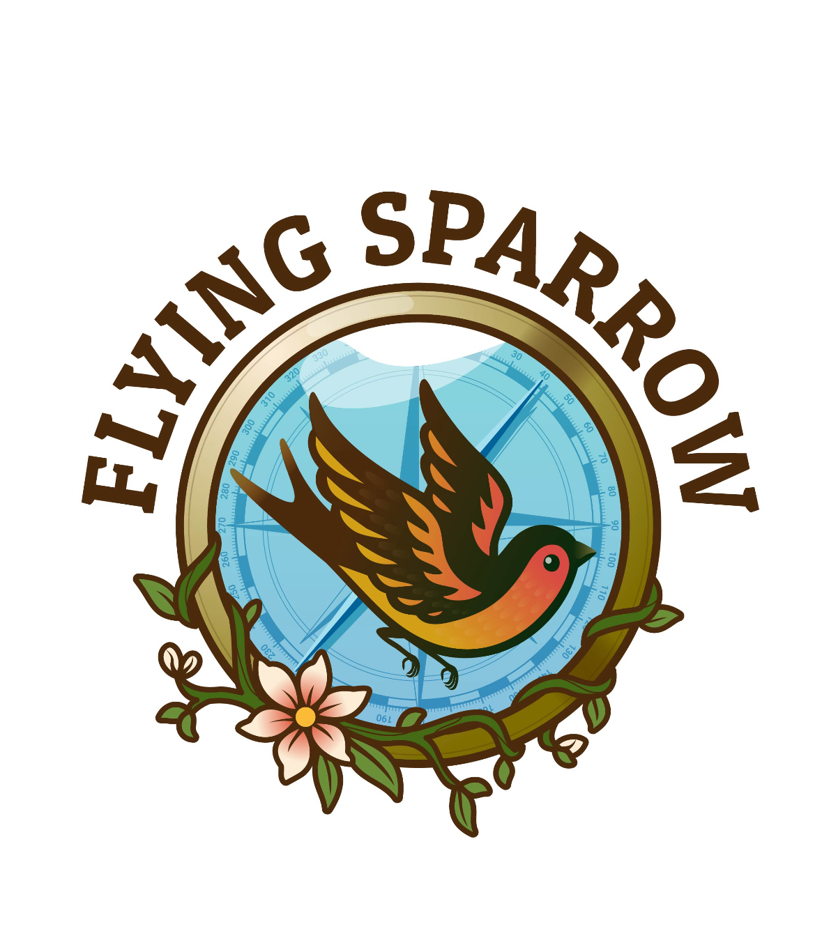

**Flying Sparrow – Social Media Video Questionnaire**

www.theflyingsparrow.com

1. 1. What is the name of your business or brand?

____________________________________________________________________________________

____________________________________________________________________________________

1. 2. Briefly describe what your business or brand does?

____________________________________________________________________________________

____________________________________________________________________________________

1. 3. What is the goal of this video? (e.g., awareness, promotion, launch, story)

____________________________________________________________________________________

____________________________________________________________________________________

1. 4. Who is your target audience?

____________________________________________________________________________________

____________________________________________________________________________________

1. 5. What key message or feeling should this video convey?

____________________________________________________________________________________

____________________________________________________________________________________

1. 6. Do you have a tagline, slogan, or phrase you want included?

____________________________________________________________________________________

____________________________________________________________________________________

1. 7. What social media platforms will this video be used on?

____________________________________________________________________________________

____________________________________________________________________________________

1. 8. Are there any colors, themes, or styles you'd like us to incorporate?

____________________________________________________________________________________

____________________________________________________________________________________

1. 9. Do you have existing footage, photos, or logos you'd like included?

____________________________________________________________________________________

____________________________________________________________________________________

1. 10. Is there a deadline or launch date we should know about?

____________________________________________________________________________________

____________________________________________________________________________________

1. 11. What kind of music or vibe do you imagine for the video?

____________________________________________________________________________________

____________________________________________________________________________________

1. 12. Are there any songs, genres, or moods you want us to draw inspiration from?

____________________________________________________________________________________

____________________________________________________________________________________

1. 13. Would you like to explore creative or artistic storytelling in this video? (If yes, what kind?)

____________________________________________________________________________________

____________________________________________________________________________________

1. 14. Are there any AI-powered tools or effects you're curious about using?

____________________________________________________________________________________

____________________________________________________________________________________

1. 15. Would you like us to suggest creative ideas based on your brand?

____________________________________________________________________________________

____________________________________________________________________________________

1. 16. Anything else we should know to make this video reflect your vision?

____________________________________________________________________________________

____________________________________________________________________________________

Submission Instructions & Contact Information

Please email any relevant materials to help bring your vision to life, such as:

- Brand logos

- Website or portfolio links

- Visual references, photos, or existing footage

- Music or mood inspirations

Submit all materials to: Jessica@theflyingsparrow.com

For questions or collaboration inquiries, contact:

Jessica Murray

Creative Director, The Flying Sparrow LLC

📞 Phone: +1 (402) 413-8390

Email: Jessica@theflyingsparrow.com