October 16, 2025
The Honorable Roger Williams  Chairman  House Committee on Small Business  U.S. House of Representatives  2361 Rayburn House Office Building  Washington, D.C. 20515 | The Honorable Nydia M. Velázquez  Ranking Member  House Committee on Small Business  U.S. House of Representatives  2361 Rayburn House Office Building  Washington, D.C. 20515
RE: Support for H.R. 5559 – Investments in Innovation Act of 2025
Dear Chairman Williams and Ranking Member Velázquez:
On behalf of SBI Counsel, P.C., a law firm dedicated to advocating for and supporting America’s small business owners and investors, we write to express our strong support for H.R. 5559, introduced on September 23, 2025, by Representative Strickland. This important legislation seeks to promote greater investment in socially and economically disadvantaged small business concerns (as defined under Section 8(a)(4) of the Small Business Act (15 U.S.C. § 637(a)(4))), by excepting investments in such small businesses from the leverage limit calculation for Small Business Investment Companies (SBICs).
As legal counsel to numerous 8(a) businesses and investors, we have seen firsthand the positive ripple effect that increased investment in small business set-aside programs can have on the small business sector and the economy at large. While many entrepreneurs have the vision, talent, and drive to succeed, they are too often shut out of traditional funding streams that are essential for growth and sustainability. By providing SBICs additional incentive and greater leverage to invest in socially and economically disadvantaged small businesses, this Committee can meaningfully address systemic barriers these businesses face in accessing capital.
The Trump Administration marked this year’s Small Business Week celebration with a proclamation that it would seek to power small businesses, the backbone of this nation’s economy, by reducing compliance and regulatory hurdles that disproportionately burden small businesses and manufacturers. Chief among these hurdles includes access to capital. H.R. 5559 is a timely and necessary measure that would help to increase participation of investors and unlock the full economic potential of small businesses. By encouraging public and private sector collaboration and expanding access to capital, this bill promotes the dignity and determination of entrepreneurs to hire people, develop innovative products or services, and acquire other companies.
We commend the Committee’s longstanding bipartisan work on issues affecting America’s small business ecosystem and urge you to take swift action to move this legislation forward. Expanding access to capital for socially and economically disadvantaged small business concerns is not just a matter of fairness, it is a strategic economic imperative.
Thank you for your continued leadership and consideration of this critical issue. We stand ready to support the Committee in advancing this effort and would welcome the opportunity to provide further insights based on our experience representing small business clients and investors across the country.
Sincerely,
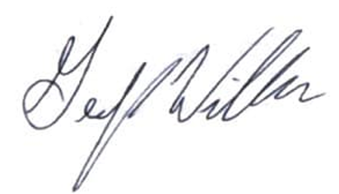
Geoffrey Williams
President
SBI Counsel, P.C.

