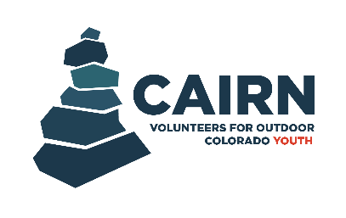

New Student Application

Applicant Information
Name (First & Last)*:
Preferred First Name:
Pronouns (optional):
Age*:
Email Address*:
All application decisions will be communicated via email so please input an email address that you check often.
Phone Number*:
Zip Code*:
High School Attending*:
Year of Expected High School Graduation*:
Parent/Guardian Name*:
Parent/Guardian Email Address*:
Parent/Guardian Cell Phone Number*:
Essay Questions
Please answer all questions completely and thoroughly.
VOC’s Cairn Program is designed to help students explore interests in natural resources, conservation, and environmental work through hands-on outdoor projects and leadership opportunities. Please describe your level of interest in these areas, and what would you hope to learn or explore through your participation? How does participating in this program align with your future goals?

Please list any relevant experience for participating in this program. This can include work experience, volunteer experience, extra-curricular experience (clubs or sports), or personal experience (for example: camping or other recreational activities)
No experience is necessary for this program, so it’s okay if you don’t have any relevant experience. This simply helps us get a better picture of who you are.

This program requires attending weekend projects every month and active participation throughout the school year. What might make it challenging for you to attend regularly (other commitments such as sports or clubs you participate in), and how would you handle those challenges?
Please be as honest as possible in your response.

Why is caring for the natural environment important to you?

Additional Information
Will you have access to reliable transportation to and from our monthly event locations?*:
Note: Events will range from as close as 30 minutes from Denver or as far away as 2 hours from Denver. Your access to reliable transportation to and from our monthly event locations does NOT automatically disqualify you from the program—as long as you are able to be dropped off at and picked up from our office in Denver, VOC can provide transportation in our vehicles on a first-come, first-served basis as requested.
Yes No

If you answered ‘No’ to the question above, will you have access to reliable transportation to and from the VOC Office in Denver?:
Please see the above note. If accepted into the program, we will need you to let us know before each event if you will need to utilize our transportation to and from the VOC Office in Denver (located at 600 S Marion St Pkwy, Denver, CO 80209), so that we can plan accordingly.
Yes No

What are you most interested in learning in this program? (check all that apply) *:
Careers in natural resources
Outdoor recreation activities (hiking, climbing, etc.)
Leadership skills
Making connections with new people
Volunteering/ Earning community service hours
Environmental issues impacting Colorado
Resume Building
Other: ______________________________________________
The fee for participating in this program is $200 for the year. This covers program costs, materials, tools, food, and transportation to other locations. Do you need a partial or full scholarship to participate in this program?*:
If you need a scholarship, please don’t hesitate to apply for the program.
Full scholarship needed Partial scholarship needed None needed

How did you hear about the Cairn Program?*

Any other comments or things we should know when considering you for this program?

