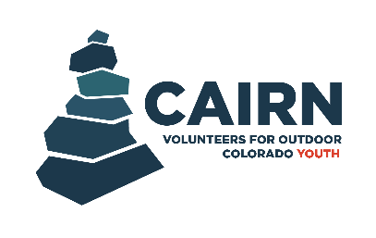

New Mentor Application

Applicant Information
Name (First & Last)*:
Preferred First Name:
Pronouns (optional):
Email Address*:
All application decisions will be communicated via email so please input an email address that you check often.
Phone Number*:
City*:
Zip Code*:
Will you be 25 years of age or older by September 1st, 2026?*
This question is being asked for driving insurance purposes.
Yes No
Employment Information
Current Employer (if applicable)*:
Position*:
Education History
Highest Level of Education Achieved*: Dropdown with “Some high school, Highschool diploma, Some college, Degree”
If you have earned a degree, please indicate what your degree is in and at what level:
Essay Questions
Please answer all questions completely and thoroughly.
Why are you interested in volunteering with VOC as a Cairn Mentor?*:

What does being a good mentor mean to you?*:

What extent of experience do you have working with or leading youth? Please provide examples from personal or professional experiences from past roles. Please describe your comfortability level leading youth in activities throughout this program (i.e. team-building, ice breakers, outdoor stewardship, etc.)*:

This program brings together students from different backgrounds and experience levels. How would you help create a welcoming and inclusive environment for everyone? *:

Additional Information
Please list any current certifications that you have that are related to working with youth:
Example: CPR, First Aid, etc.
Please note that no current certifications are required to serve as a mentor in the Cairn Program.

Please list your past/current volunteer experience, if any:

How did you hear about the Cairn Program?*

Any other comments or things we should know when considering you for this program?

References
Reference #1
Name*:
Relationship to Reference*:
Years Known*:
Preferred Contact Information (Phone number or email)*:

Reference #2
Name*:
Relationship to Reference*:
Years Known*:
Preferred Contact Information (Phone number or email)*:

Reference #3
Name*:
Relationship to Reference*:
Years Known*:
Preferred Contact Information (Phone number or email)*:

If I am accepted into this program, I commit to attending monthly events, actively engaging with students during activities, and communicating and collaborating with VOC staff throughout the program. By submitting this application, I confirm that I understand and can commit to these expectations.

