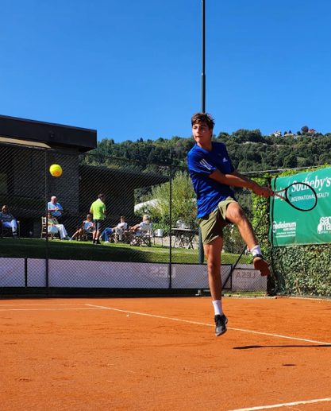
Player Profile

Name: Giovanni Volpi
Training Location: Golarsa Tennis Academy, Milan, Italy
Age: 18
Date of Birth: March 05, 2007
Graduating school: July 2026
Height / Weight: 6’1” / 154lbs
Plays: Right-handed, two-handed backhand
UTR Singles Current: 11.13
UTR Singles (High): n/a
ITF Singles Current: n/a (see notes below)
National Ranking: 2.6 (corresponds with 11-11.5 UTR)
NCAA Eligibility ID: #2512786970
GPA: 3.5
SAT: TBC
TOEFL/IELTS IELTS 7.5 (which corresponds to a range of 102-109 TOEFL
Target Degree: Economics, Finance, Investment Banking, International Trade
Budget: Up to $20k per year
Parents: Francesco & Josephine

Introduction

Dear Coach,

We are pleased to present to you Giovanni Volpi, from Italy, for an August 2026 start-date.

Giovanni has excelled academically, sustaining a 3.5 GPA in his Italian schooling and also securing an 8.5 IELTS result. In his tennis, Giovanni has made strong progress in his development, currently holding a 2.6 Italian ranking and training/competing with players in Milan who have current ATP rankings. His focus on strong Italian competition while he achieves the best possible academic results are testament to his ambition to succeed in both areas of his life.

We believe Giovanni will make a big impact in the American University he eventually joins, both in tennis and student-life. We hope his Player Profile gives you a good sense of Giovanni as a person, and we are available to set up an introduction call as soon as you wish.

Respectfully,
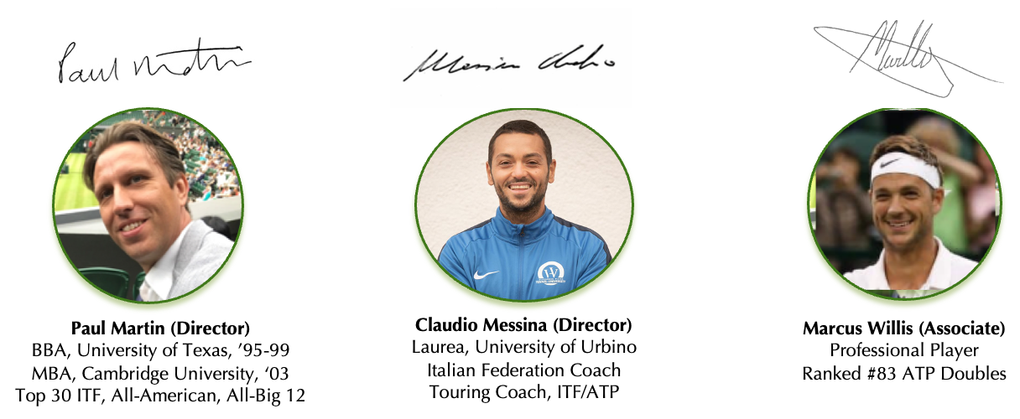

Supporting information

Key Tennis results – SINGLES & doubles

Giovanni has focused on high standard regional and national individual tournaments, and national club league team tennis representing his club in one of Italy’s strongest tennis regions. Due to his demanding academic schedule at one of Milan’s top schools, he has not been able to commit time to travelling for ITF events.
Giovanni is playing Italian in the Serie D1 team competition for Sporting Lesa and has lost only one singles match in two years against the experienced Andrea Ceccarello (ex 2.2 Italian ranking, former ATP doubles 1469 and ITF Junior 148 in 2011).

Giovanni has never trained full-time but he is still able, when he has no school engagements, to compete with Italy’s best 500 national players. His potential as a tennis player is still to be discovered when he will have the opportunity to train physically and technically in a proper way.
He is in school for 6 hours each day and must study for at least 2h30 each evening after school. Training has consequently been reduced to the remaining time.
Giovanni’s aim is to have the opportunity to simultaneously study and train at a high level.

Some of his important tennis experiences and results in the last few years include:

- 2021 Italian U14 National Team Championships Finalist

- 2022 Bavarian Junior Open – Augsburg, Germany (U16) – Reached R16

- 2022 Open Nautica Arona – Italy– Reached QF

- Defeated Mellerio Gabriele (currently 2.4, UTR 11.xx) 0-6 7-6 7-6
- Defeated Piano Lorenzo (currently 2.5, UTR 11.xx) 7-6 6-3
- Lost to Ravasio Gilberto (currenlty 2.3, UTR 11.88)

- 2023 Tennis Europe U16 – Milano 56° Torneo Avvenire BS16 – R16 Qualifying

- 2023 Tennis Europe U16 – Biella BS16 – Qualified for Main Draw
- Defeated Davide Urago (UTR 11.xx) 6-1 6-1
- Lost to Giovanni Boi (UTR 11.xx) 4-6 3-6
- Lucky Loose
- Lost to Paolo Vito Domenico Laviola (UTR 11.xx) 3-6 7-5 2-6

- 2023 ITF – J30 Cuneo, Italy – first ITF, lost in Qualifying
- Lost to Giovanni Boi (UTR 11.xx) 4-6 7-5 10-12

- 2024 Super Next Gen – Como, Italy (all U18 players of NW Italy) – Reached QF
- Defeated Dallan (currenlty 2.4, UTR 10.xx) 6-4 3-6 10-4
- Defeated Edoardo Cecchetti (currently 2.3, UTR 11.xx)
- Lost to Pansecchi Francesco (currently 2.5, UTR 11.xx)

- 2024 Prequalifying Internazionali BNL d'Italia 2025 (Master 1000 ATP) – Reached “Final Draw”
- Defeated Giannò Jacopo (2.5, UTR 11.xx)) 3-6 7-5 6-4
- Lost to Federico Sartori (currently 2.3) 6-1 6-4

- 2025 Super Next Gen – Milano, Italy (all U18 players of NW Italy) – Last 16

- 2025 ITF – J500 Trofeo Bonfiglio, Milan, Italy – Lost Qualifying
  - Lost to Ruslan Katsiusevic (ATP 1577 and ITF Junior 120), 6-2 6-2.

Key academic results
Giovanni is a serious student, and well-equipped to meet academic standards at university level.
Based on his results attending one of most prestigious high school of Milan, we are expecting Giovanni to achieve around 1300 on the SAT.
Giovanni’s goal is to study a business subject such as Economics, Finance, Investment Banking, or International Trade.
Giovanni’s father Francesco is an engineer and mother Josephine is a lawyer.

Qualification Level | Grades & Subject
Secondary School Graduation July 2026  “Istituto Leone XIII” - Milan (Italy) | A+ in Physical Education, Sport-Relate Disciplines, Civics  A in Art History  B in Italian Language and Literature, English Language and Culture, History, Philosophy, Mathematics, Physics, Natural Science  C in Sport Law and Economics
SAT | TBA
TOEFL/IELTS | IELTS Overall Band Score 7.5  Listening 8.5 – Reading 7.5 - Writing 6.0 - Speaking 8.5

key Tennis iNFORMATION
STYLE OF PLAY (in Giovanni’s own words)
I grew up playing an offensive tennis style and I like to dictate play with my forehand. My favourite players are Andy Murray, Thomas Machac, and Tommy Paul. I tend to use kick serves and construct the point on my forehand. I often use my two-handed flat backhand to hit the ball on the rise taking time away from my opponent. I try to analyse every point and understand the most efficient pattern to play next.

I grew up playing on clay and on indoor carpet. In summer I train on outdoor on clay and in winter I train on hard courts or on indoor clay.

I’m very comfortable with team competitions, having played singles and doubles in Italian Serie D for the last four years with about 90% of victories. In the long term, I intend to expand even more my technical background. In the near-term I am focused on strengthening my body in order to reach my peak condition next year.

CURRENT TRAINING ARRANGEMENTS
Giovanni currently trains at Golarsa Tennis Academy in Milan, one of the top tennis clubs in the city, under the supervision of Head Coach Laura Golarsa (former WTA 39 and Wimbledon quarter finalist).

His personal coach is Giacomo Oradini (former ATP 704). His practice partners are Leonardo Borrelli (ATP, 1966, ITF 491) and Alessio Luper (Italian ranking 2.6, currently playing Serie A2 Italian team competition).

Giovanni has trained with Andrea Pellegrino (ATP 140), Giovanni Oradini (ATP 585), Edoardo Santoni (ATP 1812) and has been a hitting partner for players such as Lorenzo Carboni (ATP 432), Filippo Baldi (best ATP ranking 144), Mathias Bourgue (best ATP ranking 140), Tim Handel (ATP 432) and Andrea Picchione (ATP 394).

PERSONAL REFERENCE
Giacomo Oradini, Giovanni’s Tennis Coach at Golarsa Academy in Milan
It is my great pleasure to write this letter of recommendation for Giovanni Volpi, whom I have had the privilege of coaching for the past 10 years as his tennis coach.
During this time, I have come to know Giovanni not only as an outstanding athlete, but also as a dedicated, disciplined, and highly motivated individual. His commitment to training, constant desire to improve, and strong work ethic clearly set him apart from his peers.
From a technical and tactical standpoint, Giovanni demonstrates excellent court awareness, strong fundamentals, and an impressive competitive mindset. He approaches every match and practice session with professionalism, focus, and determination. His ability to remain composed under pressure and his respect for teammates, opponents, and coaches make him a natural leader both on and off the court.
Beyond his athletic abilities, Giovanni is a respectful, responsible, and positive role model. He consistently shows maturity, accountability, and strong character, which I believe will allow him to thrive in a demanding academic and athletic environment such as yours.
I am confident that Giovanni will be a valuable addition to your tennis program and academic community. I give him my highest recommendation without reservation. Please feel free to contact me if you require any further information.

GIOVANNI’S PERSONAL STATEMENT

When I started playing tennis, I always enjoyed the game itself rather than focusing too much on the results. What mattered to me was improving every part of my game and enjoying the time I spent on the court.
I believe this attitude reflects an important part of who I am. Whether in my studies or my social life, I’m always thinking about how I can improve and become a better person, a better student, or a better tennis player. This approach feels genuine to me because it’s driven not by the desire for results, but by the wish to become the best version of myself.
Throughout my life, I’ve worked hard to keep all aspects of my life in balance. Academically, I dedicate around six hours a day to classes and over two hours to homework. At the same time, I train for tennis almost every day for three hours, constantly trying to find ways to improve.
I believe that the college experience will help me discover my limits as both an athlete and a student, allowing me to understand myself better. What excites me most about studying in the U.S. is the opportunity to pursue both my biggest passions – tennis, and a degree that will prepare me for life beyond sports. In Italy, we don’t really have a culture that allows you to be both a student and an athlete, so you often have to choose one path.
During this year before going to the U.S., I plan to work very hard on my physical fitness and on improving the technical aspects of my game. I also want to use my mental strength in a better way and continue doing my best academically.
I’m confident that living in a college environment will help me grow into a well-rounded person – both a successful athlete and a strong student – ready to take on challenges and do great things in the world of adults.

END

