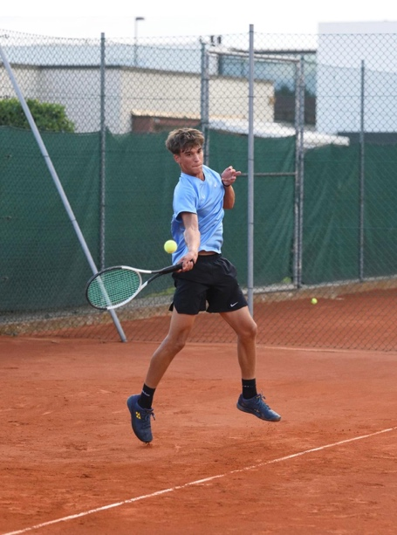
Player Profile

Name: Giovanni Ronzio
Training Location: AT Verona, Verona, Italy
Age: 18
Date of Birth: May18, 2007
Graduating school: July 2026
Height / Weight: 192cm, 76kg
Plays: Right-handed, two-handed backhand
National Ranking: 2.5 (corresponds with 11.5-12 UTR)
NCAA Eligibility ID: #2506635323
GPA: 3.5
SAT: Planned for December 2025 or March 2026
TOEFL: Planned for 2026
Target Degree: Sport Science or Physiotherapy
Budget: Up to $10k per year
Parents: Luca & Federica

Introduction

Dear Coach,

We are pleased to present to you Giovanni Ronzio, from Italy, for an August 2026 start-date.

Giovanni Ronzio is a promising Italian tennis player who has distinguished himself through notable achievements at both the junior and advanced competitive levels. Currently, he is concentrating on elite national singles tournaments and the Serie C team championship, representing his club in Verona – one of Italy's most competitive tennis regions.

Balancing a rigorous academic schedule at one of Verona’s leading schools, Giovanni has limited his participation in international junior ITF events to prioritize his education. Well-known for his versatility, competitiveness, tenacity, and determination in both singles and doubles, Giovanni holds an Italian Federation 2.5 ranking and continues to demonstrate consistent growth and dedication across various competitions.

Given his tennis skills and academic record, he is an excellent candidate for College Tennis. If Giovanni seems like a good fit for your University and Tennis Program, we would welcome hearing from you.

Respectfully, 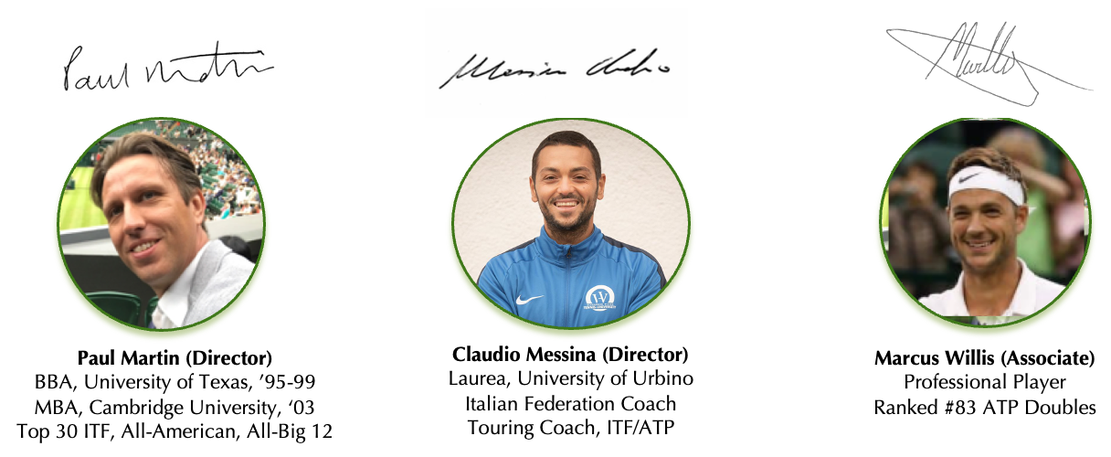

Supporting information

Key Tennis results – SINGLES & DoubleS

Giovanni has focused on high-standard regional and national individual tournaments, and national club league team tennis representing his club in one of Italy’s strongest tennis regions.
Currently competing in ITF Pro 15k tournament in Egypt (results below).

Most relevant recent results from Giovanni:

2024
National Tournament Open “Rovigo Don Bosco”
Result: Semi-Final

National Tournament Open “Città di Bardolino”
Result: Quarterfinal
Round of 16: Giovanni Ronzio def Biagio Gramaticopolo (Italian Ranking 2.2, #1060 ATP, UTR 12.xx)

National Tournament Open “AT Garda”
Result: Semi-Final
Giovanni Ronzio def #1 seed Edoardo Meggiorin (Italian Ranking 2.5)

2025
National Tournament Open “Villa Bartolomea”
Result: Winner
Final: Giovanni Ronzio def Edoardo Dolcetta-Capuzzo (UTR 11.xx, Italian Ranking 2.6)

Super Next Gen Italia 18&Under (Super Next Gen is one the most important Junior event in Italy)
Result: Semi-Final
Matteo Negrini def Giovanni Ronzio 57 62 64

ITF 15K Sharm Elsheikh 17-23 Nov Qualifying
Ronzio def Loukopoulos (ITF Ranking #2557, UTR 11.xx) 63 75
Campbell def Ronzio (ATP #1692, UTR 12.29) 61 62

ITF 15K Sharm Elsheikh 24-30 Nov Qualifying
Ronzio def Martens (ATP#1804, UTR 12.13) 62 26 12-10
Paulovic def Ronzio (UTR 11.xx) 63 61

ITF 15K Sharm Elsheikh Pre-Qualifying 22-23 Nov
Ronzio def Alexander Ushakov (UTR 11.87) 41 41
Ronzio def Jai Pareek (UTR 7.xx) 41 40
Ronzio def Cemi Tugra Duran (UTR 11.80) 41 40

TEAM COMPETITION
Serie C Club Matches competing for AT San Giovanni Lupatolo.
Giovanni played as #1 in the line-up and led the team, losing only one match during the competition against top 50 ITF Junior Gabriele Crivellaro in a close battle:
Gabriele Crivellaro (ITF Junior #47, UTR 12.98) def Giovanni Ronzio 62 46 62

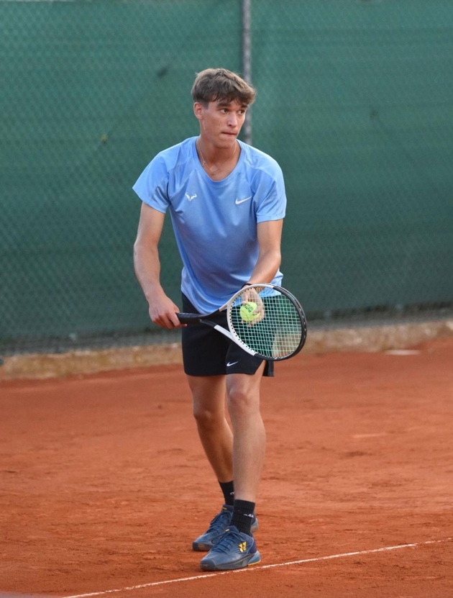

key Tennis informAtion
STYLE OF PLAY
Giovannie is known for his solid play and tactical awareness, especially in doubles where he coordinates well with partners.

Giovanni is a tennis player who counter-attacks from the baseline, but also approaches the net to finish points, and he is working to improve his transition game.

In addition to building his game from behind the baseline with precise returns and solid defense, Giovanni is increasingly moving forward to the net to quickly end points. His transition between defensive and offensive phases is improving thanks to dedicated training sessions, which help him vary the pace and surprise his opponents. Furthermore, he works on his volleying and on choosing the right moment to attack, essential aspects for becoming an increasingly complete and versatile player on the court.

CURRENT TRAINING ARRANGEMENTS
Giovanni trains at AT Verona Club with Coach Santiago Messora.

His weekly schedule includes 12 hours of tennis and 7.5 hours of fitness over 5 days. Twice a week, he practices with Stefano Napolitano (ATP #121).

Training sessions with Stefano Napolitano offer Giovanni valuable opportunities to spar with an experienced professional, helping him to raise his game and become more accustomed to the rhythm and intensity of high-level tennis. These joint practices also expose him to advanced strategies and shot selections. Giovanni’s dedication to maintaining this demanding schedule demonstrates his commitment to pursuing excellence in both the physical and technical aspects of the sport, aiming to progress steadily within the national and international tennis scene.

PERSONAL REFERENCE
Coach Vittorio Poli, former Professional Player, and Giovanni’s Coach from age 11-17

“I began coaching Giovanni when he was just 11, and his determination, tenacity, and fighting spirit quickly stood out – qualities he showed during both training and competitions. As our team got to know him better each day, it became clear that this passion and drive were fundamental parts of his personality; they shaped how he approached every aspect of life, even his daily routines. What impressed us most as Giovanni’s coaches was his eagerness to improve – not only as an athlete but, more importantly, as a person. Win or lose, he always responds positively, focusing on moving forward without holding onto frustration.

“Technically and tactically, Giovanni has transitioned from a defensive playing style to a more offensive and proactive one. He has also made significant progress in managing his emotions on and off the court – a testament to his growth and maturity, fostered through continuous dialogue with us, even when opinions differed. In summary, Giovanni has matured remarkably, evolving from a young athlete into someone who is developing in all aspects. We believe he possesses the qualities necessary to pursue a career as a professional tennis player. Moreover, Giovanni’s natural inclination for teamwork means that, in the right and motivating environment, he could become a valuable asset to any team.”

Key academic results

Giovanni is a serious student, and well-equipped to meet academic standards at university level.
Based on his English and Math grades, we are expecting Giovanni to achieve around 1100 in the SAT.
Giovanni’s goal is to study Sport Science or a pathway to help him study Physiotherapy.

Qualification Level | Grades & Subjects
Secondary School Graduation July 2026  “Istituto Paritario Figlie del Sacro Cuore di Gesù”- Verona (Italy) | GPA 3.5  - in following subjects: History, English Grammar & Literature, Math, Sport Activities, Sport Disciplines  B in following subjects: Italian Language, Philosophy, Sport Management  - in following subjects: Physics, Natural Science (Biology & Chemistry),
SAT | TBA
TOEFL | TBA

GIOVANNI’S PERSONAL STATEMENT

“My passion for tennis: it all began with Djokovic.”

I vividly recall the first time I watched Novak Djokovic play. As a child, I happened to catch one of his finals on television at home. Although tennis was still unfamiliar to me, there was something mesmerizing about his movements, his unwavering focus, and the almost choreographed precision of every shot. It wasn’t just his talent that drew me in; it was his resilience, dedication, and relentless pursuit of every point. Watching him felt like witnessing a message—through passion and sacrifice, anything is possible: “If you want it, you can achieve it.”

At four years old, I picked up my very first racket. My mother, who was a national FITP coach, encouraged me, and soon I was hooked on this amazing sport. What started as simple fun became a serious commitment – a constant personal challenge. Each practice, match, loss, and victory taught me valuable lessons, gradually shaping the athlete within me, patiently and passionately, one step at a time. Even now, when I step onto the court, I remember the spark Djokovic ignited in me and how both he and I share a deep love for this remarkable game. Tennis is now my journey. If, someday, even a single child feels inspired watching me play as I was watching Djokovic, then I’ll know I’ve truly accomplished something.

Although tennis entered my life when I was four, it was Djokovic’s performances that truly fueled my passion. I eagerly followed his matches and admired his composure during difficult times. His perseverance impressed me—not only did he fight for every point, but he also displayed elegance and respect for the game.

Djokovic’s greatness isn’t measured solely by his trophies, but also by the values he exemplifies: discipline, humility, and dedication. Observing him motivated me to train harder, strive for improvement, and dream without limits. Novak’s adaptability across surfaces and his athletic, aggressive style allow him to sustain high levels of performance throughout long matches. His exceptional court positioning keeps him close to the baseline and lightning-fast on his feet, always in the perfect spot to strike the ball.

Thanks to him, I found the courage to push through tough moments and setbacks. Each time I walk onto the court, I aim to channel a piece of his spirit. Today, I’m still here, racket in hand, eager to grow, and much of that drive I owe to Djokovic. Tennis has become more than just a game—it’s my passion and a lifelong lesson.
And in fact, this is also why I want to experience college life to compete in sports with international players and grow both personally and athletically while balancing studies and tennis. Living in a global environment will help me improve my English and expand my perspective. The American university system will let me pursue my passions for tennis and academics, providing the discipline and maturity needed for future challenges on and off the court.”

END

