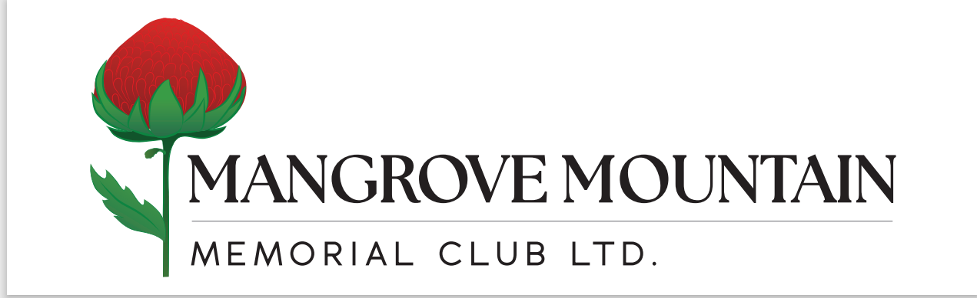
18 Hallards Road Central Mangrove NSW 2250 PH: (02)43731129

21st October 2026

ANNUAL GENERAL MEETING
Notice is hereby given that the Annual General Meeting of Members will be held at the Clubhouse on Sunday 15th November, commencing at 10.00 am.

Business
- To confirm the Minutes of the Annual General Meeting, 9th November 2025.
- To receive and consider the Report of the Board.
- To receive and consider the Accounts and the Report of the Auditor.
  - Any Member wishing to raise questions with the Auditor which could involve him in a detailed analysis of accounts or other records is requested to give Notice of those questions to the Secretary Manager within five (5) working days of the Annual General Meeting.
- To consider and if thought fit to pass as Ordinary Resolutions, the eight (8) resolutions relative to Directors and particular members benefits as detailed in “Annexure B” hereto.
- Announcement of Returning Officers and Scrutineers.
- Election of Patrons
- Election of four Board Members for the year 2027 – 2029.
Noting that due to our rotation, Two (2) Directors of the Board Richard Jack & Peter Coates will be standing down but will be offering their services as Directors for this year’s re-election.
There will be two (2) vacant positions to be filled.

- To deal with any business of which due notice has been given.
  - Any Member wishing to raise an item of general business is requested to give written notice of the nature of the business to the Secretary Manager within five (5) working days of the Annual General Meeting.
- To deal with any business of which due notice has not been given.

Nominations for the four Board members will be available from the Club Office from Sunday 25th October and will close at 10.30 am on Saturday 7th November 2026.

The Financial Statements for 2025/2026 will be made available on the Club’s website at www.mmmclub.com.au or if you would like a printed copy, please contact the Club on 02 4373 1129.

GOLF CLUB ANNUAL GENERAL MEETING
Notice is hereby given that the Annual General Meeting of the Men’s Golf Club will be held at the Clubhouse on Sunday 15th November 2026, following the Memorial Club’s Annual General Meeting.

JODIE MINNS
Secretary Manager

