

**Relationships, Sex and Health Education**

**Definition**

In accordance with Notre Dame Prep School’s ethos we aim to deliver a sex, health and relationships education programme to all our young people within a caring and informative framework, taking careful consideration of the Catholic beliefs and values within the School.

The DfE guidance states that “children and young people need to know how to be safe and healthy, and how to manage their academic, personal and social lives in a positive way”[1]. It is about the child knowing who they are as a human, developing a positive relationship with yourself and others, with the ability to make moral decisions.

Relationships education is focused on teaching the fundamental building blocks and characteristics of positive relationships, with particular reference to friendships, family relationships, and relationships with other children and with adults.[2] This includes discussion of families, those who care for me, caring friendships, online relationships and keeping ourselves safe.

The DfE also states ‘From the beginning of primary school, building on early education, pupils should be taught how to take turns, how to treat each other with kindness, consideration and respect, the importance of honesty and truthfulness, permission seeking and giving, and the concept of personal privacy.’

The topic of consent is taught and discussed in age appropriate manners, from the context of understanding one’s own and others’ boundaries in play with toys and books, to understanding personal space and consensual behaviour in friendships and within families.

**Schemes of Work and Delivery of Lessons**

Relationships, sex and health education is taught by class teachers, however we recognise that RSHE is a whole school issue. All teachers have a responsibility of care; as well as fostering academic progress they should actively contribute to the guardianship and guidance of the physical, moral and spiritual well-being of their pupils. Teachers will be expected to teach RSHE in accordance with the Catholic Ethos of the school. All staff have been included in the development of this policy and all staff should be aware of the policy and how it relates to them.

Teaching reflects the law (including the Equality Act 2010) as it applies to relationships so that young people clearly understand what the law allows and does not allow, and the wider legal implications of the decisions they may make.

The curriculum is sensitive and age appropriate in approach and content, and is adapted to suit the needs of the children at Notre Dame Prep School; taking positive action to offer additional support in terms of lessons and pastoral care if the need arises.

PSHRE, including Relationships, Sex and Health Education is taught using schemes of work from the PSHE Association, Ten Ten and Young Citizens. These lessons form a part of our PSHRE and Science Curriculum. A Fertile Heart is designed for Catholic Schools, It aims to ‘empower young people to be the best version of themselves through learning about love, relationships, respect and vulnerability.’

Our aim as a school is to ensure the children are well rounded individuals with Strong Catholic and Christian values that can be combined with their school life and beyond. The topics which will be left to be included in Science lessons will be in KS2: menstruation, changing bodies and puberty, life cycles, and how babies are made.

Whilst promoting Catholic values and virtues and teaching in accordance with Church teaching, we will ensure that pupils are offered a balanced programme by providing an RSHE programme that offers a range of viewpoints on issues. Knowing about facts and enabling young people to explore differing viewpoints is not the same as promoting behaviour and is not incompatible with our school’s promotion of Catholic teaching. We will ensure that pupils have access to the learning they need to stay safe, healthy and understand their rights as individuals.

Relationship, Sex and Healthy Education (RSHE) at Notre Dame must be inclusive and relevant and should meet the educational and emotional needs of all pupils. We believe it is important to address relationships education at primary level, because children should be able to develop confidence in talking, listening and thinking about feelings and familial and friendship relationships. Reproduction and growing up are presented to children in a sensitive, simple and straightforward way that is appropriate to their age, needs and understanding. In particular, the School supports pupils’ on-going emotional and physical development as they approach the transition to secondary school. This part of RSHE will be taught within the Science scheme under the National Curriculum.

## Values and beliefs

As a Catholic community we believe that relationship sex and health education (RSHE) is integral to the lifelong learning process and the belief that we have been uniquely created in the image and likeness of God. As such, all people have special value and worth. As well as acquiring knowledge and information, pupils will be encouraged to consider the importance of the following values, which are derived from the Schools’ value system:

* Respecting and valuing themselves and others;
* Understanding with sensitivity the needs and views of others;
* Maintaining sound moral standards with regards to relationships;
* Responsibility to the School, the family and the wider community;
* God loves us all and we are special to him.

**Parent Consultation**

NDPS has consulted with parents prior to the academic years commencing Sept 2021 and Sept 2020 as policies developed and consulted parents again annually with policy updates. Parents have been offered the full (current) Scheme of Work for perusal and comment. School has listened to concerns and feels confident that the current RSE offer represents balance in light of our Roman Catholic ethos

The Head Teacher and the Schools’ governing body shall aim to ensure that the RSHE programme reflects the parents’ wishes and the community they serve.

Sex Education is co-ordinated by the RSHE Co-ordinator and delivered through planned aspects within the Science curriculum lessons, though moral and ethical issues may be addressed when they arise from apparently unrelated topics.

The school is well aware that the primary role in children’s sex education lies with parents and carers. We wish to build a positive and supporting relationship with the parents of children at our school through mutual understanding, trust and co-operation. Therefore, we will make it clear what topics will be taught in RSHE, and which of those will be kept purely in Science lessons.

We will notify parents when particular aspects of sex education will be taught, by sending a letter outlining the key areas their child will be covering prior to the start of that half term.

**Right to Withdraw**

Under the Education Act 1993 parents have the right to withdraw their children from all or part of the sex education programme. This however, does not include those topics covered in the National Curriculum in Science. Parents wishing to exercise that right are asked to send a letter to the school requesting the withdrawal of their child from this part of the curriculum. Once a child has been withdrawn they cannot take part in later sex education without parental approval.

Parents are unable to withdraw children from relationship and health education, this is now compulsory in all primary schools

**Pupils with special educational needs and disabilities (SEND)**

RHSE is accessible for all pupils at Notre Dame Prep School. Teaching is differentiated and personalised to ensure children with SEND have access to the curriculum and participate in lessons.

RSHE is an important subject for all children, but particularly for those who may be more vulnerable; for example those with Social, Emotional and Mental Health needs or learning disabilities. These children are supported by teaching and support staff in lessons, and by the Pastoral team.

**Equality**

We will ensure RSE is sensitive to the different needs of individual pupils in respect to pupils’ different abilities, levels of maturity and personal circumstances; for example, their own sexual orientation, faith or culture and is taught in a way that does not subject pupils to discrimination. Lessons will also help children to realise the nature and consequences of discrimination, teasing, bullying and aggressive behaviours (including cyber-bullying), use of prejudice-based language and how to respond and ask for help. As a Catholic School we will follow the principle of inclusion and love for all of God’s children. This will coincide with the DfE’s guidance, ‘Care needs to be taken to ensure that there is no stigmatisation of children based on their home circumstances and needs, to reflect sensitively that some children may have a different structure of support around them.’

This policy should be read in conjunction with the school’s ethos statement, the PSHRE Policy, Child Protection Policy, the Equality Policy, Science and PSHE whole school scheme of work.

**Policy Review & Updates**

1. This policy has been produced using guidance from the DfE Statutory Guidance, the PSHE Association and from consultation with staff and parents.
2. Relationship Sex and Health Education will be monitored by the Head Teacher (Academic), who will liaise with the SMT and staff.
3. The full policy will be made available to all parents through the Schools’ website, and as a hard copy in the staff room and School office. This policy is available free of charge to anyone who requests a copy.
4. This policy will be reviewed regularly.

See Also:

* Appendix A – Teacher Audit – focussing on lessons in RSHE being taught in each year group and cross curriculum. Teachers filled this in referring to what they teach.
* Privacy and the Protection of Data Policy
* Safeguarding Policy
* This list is not exhaustive and other policies may apply

***Reviewed September 2025 by S Smith***

***Approved September 2025 by K Laudan***

***To be reviewed no later than September 2026***

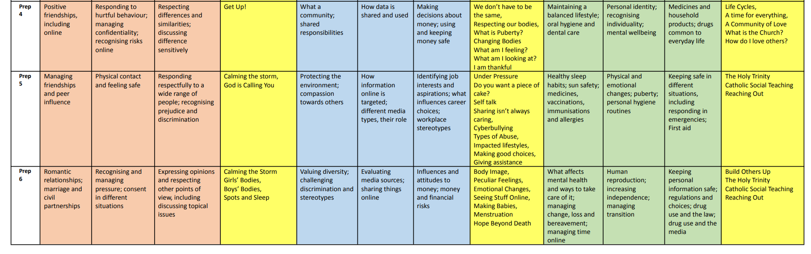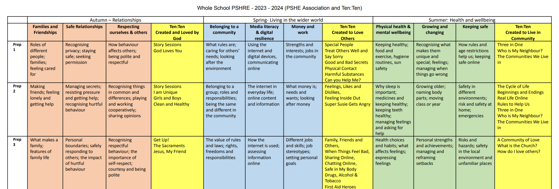

1. Relationships Education, Relationships and Sex Education (RSE) and Health Education: Statutory guidance for governing bodies, proprietors, head teachers, principals, senior leadership teams, teachers Page 4
2. Relationships Education, Relationships and Sex Education (RSE) and Health Education: Statutory guidance for governing bodies, proprietors, head teachers, principals, senior leadership teams, teachers Page 19