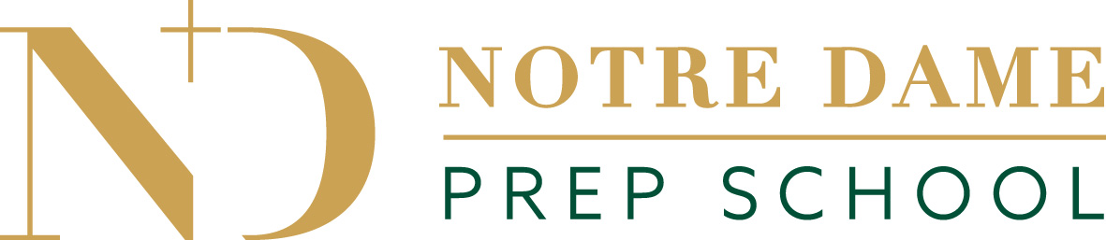

Early Years Funding/Charging Policy

In line with the Norfolk County Council Local Agreement 2025 the School will ensure the following:

- Compliance with the Early Education and Childcare Statutory Guidance for Local Authorities (June 2018) and Early Years Entitlements: Local Authority Funding Operational Guide 2025 to 2026.

- Deliver free entitlement to eligible children in accordance with Norfolk County Council guidelines.

- Obtain information required by the council and or the Department of Education in order to establish that each child claiming any free entitlement is eligible to receive it.

- Follow the national framework for the delivery of the free entitlement and the local variations applicable to the local agreement.

- Government funding is intended to cover the cost to deliver 15 hour a week of free, high quality, flexible childcare only. It is not intended to cover the cost of meals, consumables, additional hours or additional services.

- Additional hours and services will be charged at the current hourly rate where hours are not funded as Early Education by the Local Authority. Charges for additional services such as trips will be agreed in advance with families. School does make reasonable charges for visits and trips where appropriate and Meals and snacks too. There are no charges for consumables.

- The free entitlements will be delivered consistently so that all children accessing any of the free entitlements will receive the same quality and access to provision, regardless of whether they opt to pay for optional hours, services, meals or consumables.

- The entitlement is offered free. Parents will not be charged a “top-up” fee to recoup the difference between the amount received from the Local Authority and the current hourly rate.

- Invoices are produced once a term and are set out clearly to show funding accessed and also show any additional cost or provision purchased.

- The following additional charges will be applied:

- Deposit – A deposit of £400 will be charged to secure a place at this setting only if the intention is for a child to enter the main school after attending the nursery.

- Registration Fee - A registration fee of £50 is charged only if the intention is for a child to enter the main school after attending the nursery.

- Late Payments - Late Payments attract a 5% interest charge and an administration fee of £50.00

- Meals and Snacks - Meals and Snacks are chargeable if purchasing additional hours.

- Consumables - Consumables are not chargeable

- The Parent/Carer Form issued by the Council will be completed by every parent/carer attending the setting and claiming the free entitlement each term.

- The school will consult with parents once a year on our Nursery provision.

- All records relating to the funding will be kept for at least 7 years to include attendance records, all paperwork relating to claiming funding as required in the Provider Agreement (see also the school’s policy on Privacy and the Protection of data).

- All claims and paperwork required by the Council will be completed and returned within the required deadlines.

- The School will not unlawfully discriminate within the meaning and scope of any law, enactment, order, or regulation relating to discrimination (whether in age, race, gender, religion, disability, sexual orientation or otherwise).

- Compliance with the Health & Safety Act 1974.

- Compliance with Safeguarding Vulnerable Groups Act 2006.

- Compliance with the General Data Protection Regulations 2018

- Maintain adequate and suitable insurance cover.

- Inform Norfolk County Council within seven days of any claim in respect of personal injury, disease and death made against the school on behalf of a child, arising out of early education in respect of which the funding was claimed.

- Inform the Council of any changes to bank, contact details, ownership, staff/committee, corporate status, premises or any other material change that may affect the delivery of the free entitlement.

- Work with the Council and its agents to improve outcome for children in early years developing a good working relationship taking onboard help and advice given.

- Maintain the correct registrations applicable to an Independent School & Nursery.

- Inform Early Years Team when an inspection takes place.

- Keep and update a SEF for the setting.

- Employment of suitably qualified staff and provide adequate training.

- Operation and maintenance of various policies as laid out in the Provider Agreement.

- Provision for children with SEN or disability.

- Attend at least 2 network support meetings per year.

- Ensure a robust staff development plan is implemented.

PARENT INFORMATION EARLY YEARS GOVERNMENT FUNDING
AT NOTRE DAME PREP SCHOOL 2025/26

- Early Years Government Funding is available at the setting for 3 & 4 year olds for up to 15 hours per week on a flexible basis.*

- This funding is offered over a maximum of 38 weeks, 35 weeks during term time and 3 weeks of Holiday Club over the academic year.**

- Your child will qualify for funding as follows:

Children who are 3 between: | Government funding will be provided from the following:
1st April and 31st August | September
1st September and 31st December | January
1st January and 31st March | April

- Funding will cease when your child leave the Butterfly Nursery and no later than the term after your child’s 5th birthday.

- Notre Dame Prep School offers funding up to a maximum of 7 hours per day and 15 hours per week

- You will be required to complete, sign and return a ‘Parent Carer Claim Form’ every term. This form must be returned to the Bursar before ‘Headcount Day’ otherwise funding may be withdrawn and full fees will become payable.

- If your child attends another provision the Bursar must be informed immediately. Your child cannot attend more than two providers at any one time.

- The School’s invoices are produced on a termly basis (3 times per year) and will show the amount of funded hours. ‘Free Entitlement’ will be shown as a zero balance on the invoice. Additional hours attended at the provision will be shown separately along with the charge for those hours. In addition, snacks and hot lunches will be shown separately also

* Subject to availability
** Notification of funding requirements during the summer holidays must be notified to the Bursar before 1st April, applications received after this date cannot be processed.

EY FUNDING EXPLAINED

- Funding can be claimed the first term AFTER a child’s 3rd birthday

- Funding Finishes when a child leave the Butterfly Nursery and no later than a term AFTER a child’s 5th birthday

- Funding can be only claimed in Nursery

- NDPS only offers the 15 universal hours per week and not the extended entitlement of up to 30 hours

- NDPS only offers funding for 3 and 4 year olds and does not offer funding for 2 year olds

- Minimum sessions offered for 3 and 4 year olds is 3 full days (no part days offered)

CHILDCARE VOUCHERS

- Childcare vouchers are separate from EY Funding
- Childcare vouchers can be used for nursery fees
Childcare vouchers can also be used for after school care, holiday clubs, up to the age of 16
- A parent can arrange to have up to £243.00 per month paid into childcare vouchers. This is a tax-free sum deducted from wages before tax and therefore offers parents savings overall.
- Some employers offer a childcare voucher scheme through their payroll.
- If an employer does not offer a childcare voucher scheme you can still access the childcare vouchers via HMRC.

See Also:
Early Years Policy
Early Years Qualifications & Training Policy
Privacy and the Protection of Data Policy
This list is not exhaustive and other NDPS policies may apply

Reviewed September 2025 by S Smith
Approved September 2025 by L Campbell
To be reviewed no later than September 2026

