

**Policy for Critical Incidents and Lockdown Procedure**

**INTRODUCTION**

At Notre Dame Prep School we acknowledge the need to plan for possible critical incidents and with this in mind we do all we can to ensure that we are fully prepared for an event of this nature. Nothing can be without risk and any activity can result in tragedy. Serious incidents, in and outside school, may impact on families, peer groups, school and the wider community. Therefore, a planned response will better prepare those responsible to respond to challenges.

In planning the policy the School has been sensitive to:

• help teachers deal with sensitive issues and take into account their personal experiences

• the pupils’ backgrounds

• having an informed understanding of the different cultural and religious attitudes to disability, disasters, death, bereavement, mourning and funerals

• how different religions and cultures interpret the causes of disaster and explain the events

• the atmosphere of support and trust amongst its pupils and the extent to which they would be able to talk and share their feelings

This policy is intended to provide guidance for staff who may be involved in a serious incident affecting the school. In drawing up this plan, it is recognised that the Head Teacher will not always be present and therefore another member of the Critical Incident Team (CIT) must be nominated to manage an incident. Similarly, on school trips or out of school activities the person who will take charge in the event of an incident will be predetermined to avoid any confusion at the time of the incident.

**What is a serious incident?**

Incidents that involve property damage, bereavement, loss, trauma and injury can be effectively managed by the School through the implementation of the incident management plan. This may involve the school accessing education and/or other outside services as required.

**When does an incident become critical?**

An incident becomes a critical incident when it constitutes a serious disruption arising with little or no warning on a scale beyond the coping capacity of the school operating under normal conditions, and requiring the assistance of the Emergency Services, Norfolk County Council, Health and Safety Executive or other outside agencies.

Examples of critical incidents impacting on our school could include:

• death or serious injury as a result of violence, accident, self-harm

• sudden or traumatic illness

• major fire

• building, wall or tree collapse

• riot and/or civil disorder

• natural and/or man-made disaster

• terrorism

• missing person(s)/abductions

Incidents can occur anywhere, but are more likely:

• on the school site during school hours

• on school transport

• whilst the pupils are taking part in activities away from the school site

• on school premises as part of after school activities

• within the local community involving pupils from the school

• within the locality

**PRACTICES**

**How does the School help reduce the potential for serious incidents?**

**Pastoral Support**

The school has effective pastoral support procedures, which include strong links between pupils and class teachers and teaching assistants. These relationships are well developed and underpinned by a clear school ethos of care, trust and support with strong links with parents. The local Catholic Diocese is also able to lend pastoral support following a crisis.

**Pupil Behaviour Management Policy / Staff Behaviour Policy**

The School has an agreed set of expectations for behaviour which applies to all areas of school and all activities undertaken by the pupils. This is particularly important where activities themselves are potentially dangerous (e.g., sport, adventure activities) or are taking place in areas of the school which pose hazards (e.g., sport and during breaks and at lunchtimes).

Before embarking on out of school activities agreeing codes of behaviour with parents, pupils and staff before the event and a full risk assessment will help to reduce the potential for serious incidents.

**School Security**

Security system is in place to offer protection and enable ease of access to the school for pupils, staff, parents and visitors. Ongoing areas of consideration are:

• entry security to prevent unwelcome visitors entering the school

• out of hours security systems to reduce the potential for damage and vandalism

• an effective signing in and out procedure for all staff, visitors and volunteers in school

• emergency drills and procedures for all areas of the school site

All incidents on site should be reported to the Head Teacher for reasons of assessing the level of security risk as part of the school’s security strategy.

**Training**

Staff training on the prevention, management and response to incidents raises their awareness and understanding of these issues and what to do. Regular reminders and updates serve to keep the issues live and enhance the sensitivity of staff to preventative measures.

• Training in the school’s security procedures, health and safety, risk assessment and how to cultivate a sense of self-awareness are given to those with responsibilities in the areas

• Administrative staff in the School receive training to help them respond quickly and efficiently to any crisis and to queries from distressed families

• The aim of the School is to give basic first aid training to relevant members of staff to increase skills and confidence in treating injury and trauma and to make sure the school has an adequate number of qualified First aiders

• The Critical Incident Team (CIT) meets on a regular basis to consider rehearsing the school’s plan for a number of scenarios (e.g., during/after school hours, on/off site, part of/outside of school organised activities, how would the plan address an incident that involved an evacuation of the school site?) The CIT teams consists of the two Head Teachers and Caretaker. At the point at which this policy is invoked, and depending on which members of staff are on-site, and CIT Lead/Manager will be appointed. This manager will have oversight of all procedures for the duration of the process and will liaise with any outside agencies as required.

**Administrative Practice**

In the event of a disaster the School has good administrative and back-up systems to assist effective management and ensure a fast response, including:

• a list of all pupils and staff, with next of kin contact details held centrally at the school both on computer and hard copy, with back up discs. Additional back up is supplied by our IT support Net Central

• registers which are completed promptly at the beginning of each morning and afternoon session during the normal school day. Registers for extra-curricular activities and after school clubs are completed promptly from 3.30pm and a records kept

• names of pupils who are late or leave school early are recorded

• a visitors and volunteers signing in system

• a staff signing in-out system

**Health and Safety**

The School Health and Safety policy includes reference to all health and safety procedures and how these relate to the teaching and organisation in the school. This is particularly important for physical education activities, technological / practical work, science and outdoor education.

The policy gives clear guidelines and advice on the testing and maintenance of equipment, fixtures and fittings. All electrical, and fire-fighting equipment are inspected and tested annually. Regulations are published for the storage and security of potentially hazardous substances and chemicals, which are kept secure.

In addition

• regular health and safety checks on the buildings and site are conducted, with any potential dangers reported to the caretaker and the designated Health and Safety Officer

• staff with first aid qualifications are identified within the School

**Planning for Trips and Visits**

It is important to point out that “in loco parentis” is only a minimum standard. A member of staff on a trip may be judged more responsible than a pupil’s parent as the member of staff has had previous planned knowledge of the issues and risk assessments in place, and is therefore seen as being more experienced.

To this end it is essential that:

• permission for trips is sought from the EVC Coordinator and appropriate paperwork is completed

• a risk assessment for a new trip is taken by the trip leader

• staff on all trips follow the School Trips Policy

• parents and pupils are given clear information about the trip

• participating adults are informed of the risks and given clear guidelines and other relevant information

• a copy of all trip materials is left at school with a designated school contact

**CRITICAL INCIDENT PROCEDURES – TRIPS & VISITS**

All school trips are planned in line with the Educational Visits Guidelines. Staff are aware that all steps must be taken to ensure that children are safe at all times. There may, however, be a number of incidents which occur that may affect the trip and need unforeseen steps to be taken. These range from illness or accident to a child or member of staff or problems with transport. There should always be more than one member of staff on a visit staff and should always carry the school mobile phone. The lead teacher must establish the nature and extent of the emergency.

If an incident occurs the following steps should be followed:

1. The lead teacher must make sure all members of the party are accounted for and are safe.
2. If there are injuries immediately establish their extent as far as possible and administer appropriate first aid.
3. Establish the name(s) of the injured and call whichever emergency service is required.
4. Inform other party staff of the incident and explain that the emergency procedures are in operation.
5. The Head Teacher should be informed immediately of the extent of the incident and any action taken (all members of staff should have the Head Teacher’s mobile number on their mobile phones for emergency use).
6. Wherever possible a member of staff from the party should supervise throughout and arrange for the early return to school.
7. If any members of the party require hospital treatment, an adult should accompany them. If appropriate a second staff member should remain and liaise with the emergency services until the incident is over and all pupils are accounted for.
8. All contact should be controlled by the Head Teacher; no pupil should be allowed access to a telephone except with permission from the Head Teacher. The Head Teacher or Chair of Governors will control all contact with parents or media. The school will then follow guidance in the NDPS Critical Incident Planning Guide.

**Delays to Trips**

Sometimes problems occur to the timing of trips due to hold-ups or breakdowns.

1. Any delay to a trip should be reported to the school as soon as possible. If the delay will result in late arrival home of more than 30 minutes, the school will endeavour to make contact with Parents.
2. If problems occur on the outward journey the lead teacher must either contact the proposed venue to inform them of the delay or cancellation, or the school so they can inform the venue. The lead teacher will make decisions as to whether the visit can continue with changes or if it has to be aborted. The Head Teacher should be informed of any changes to the itinerary.

*See Trips & Visits Policy for further information*

**CRITICAL INCIDENT PROCEDURES IN SCHOOL**

In responding to an incident the aim should always be to ensure:

• rapid, well-planned and appropriate action is taken

• accurate information is provided

• normal school routines are maintained as far as possible, giving continuity to pupils

• immediate, sensitive and non-intrusive support is offered

**Specific roles and responsibilities**

The Head Teacher will take responsibility for overseeing the maintenance of the School’s CIT plan. The existing plans are reviewed and updated on a regular basis by the CIT and are included within a cycle of monitoring and evaluation as for other related policies. The Head Teacher must ensure that:

• the school’s incident management plan, these guidelines and contact information are accessible both during and after school hours and on and off the school site.

• all school staff are aware of the plan and how it is initiated as part of the induction process for new staff

• a school Critical Incident Team (CIT) is clearly identified with agreed responsibilities. Where these individuals, for whatever reason, are not available, identify who will act in their place

**On the occasion of a critical incident**

• The CIT will assemble in the Head Teacher’s office and the school will remain open after hours if necessary. If the incident occurs out of school time, the school will be opened to accommodate the CIT and others as necessary

• The CIT may be taken off duties, teaching load and administrative responsibilities, depending on the nature of the incident, and other school staff will be delegated these duties as required. Previous appointments, courses and meetings may be cancelled

• The Reception office will be informed as how to field enquiries and which Member of Staff is managing the process. Enquiries from the media may only be fielded by the designated Manager

• A member of the administrative staff (to cover future legalities) will log all data and communications, responses and decisions. Two copies of all materials should be filed in the incident file; one to be kept for school use and the other in case the material needs to be handed over to other parties

• The incident will be assessed by the CIT, and a timetable of action drawn up, and taken as appropriate

• The information will be discussed, then reassembled into agreed, specific statements for parents, media, etc., which may vary in length or detail. A spokesperson (the Head Teacher or Chair of Governors) will then deliver copies of the statement to those concerned

• Statements and guidelines on how to deal with the issues in their forms will be given out to staff at specific times in the staff room by the Head Teacher

• As far as possible, the school will run as normal

• However, in certain cases, all peripatetic lessons may be cancelled in the interests of keeping classes together and assemblies and meetings may be called

• All Notre Dame Prep school staff will be expected to act in the best interests of the children

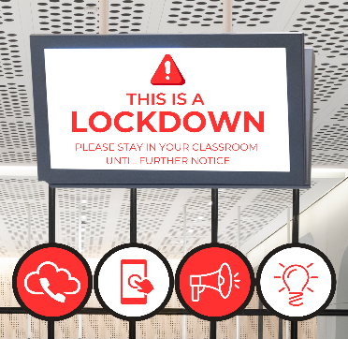

**LOCKDOWN PROCEDURE**

On very rare occasions it may be necessary to seal off the school so that it is not able to be entered from the outside. This will ensure that pupils, staff and visitors are safe in situations where there is a hazard in the school grounds or outside the school in the near vicinity. A lockdown is implemented when there are serious security risks, for example, near-by chemical spillage, proximity of dangerous dogs, serious weather conditions or attempted access by unauthorised persons intent on causing harm/damage.

**The SMT will take charge of the situation and will be known at the Critical Incident Team (CIT)**

The CIT will alert the staff that there is a lockdown by using the sports whistles which are located along both upper and lower corridors.

**The alert will be LOUD 2 SECOND SHORT BURSTS ON THE WHISTLE and will continue until everyone is alerted to the situation.**

The CIT will set up an effective communication channel in collaboration with the School Office. This, in the first instance, will be via walkie-talkies which are in each classroom or via staff personal mobile phones if the walkie-talkies are not available whatever reason. As this would be an emergency situation it is deemed okay to use a personal mobile phone if this enables clear and effective communication.

**Staff must ensure the following:**

* Keep all pupils in classrooms until given the all clear: Situation may be de-escalated depending on the circumstances by the CIT to allowing children to move around within the school, but to remain within the building.
* If you are out of class at the time of the incident (i.e. on the sports field or in the hall) then attempt to go back to the classroom if safe to do so. However, if this is too risky or dangerous then alert the CIT immediately via the School Office and await instruction.
* Close all doors (lock them if possible) and consider shutting windows and pulling down blinds. Turn off lights if necessary.
* A roll call will be taken using the fire registers once in lockdown positions **AN EMERGENCY COPY OF THE CLASS FIRE REGISTER WILL BE SUPPLIED TO EACH CLASSROOM FOR THIS PURPOSE** (these registers must not be used for any other reason). Staff to alert the CIT via the School Office immediately if any children are unaccounted for a personal phone may be used for this if a walkie/talkie is not available
* Keep pupils seated and away from doors and windows. If necessary, it may be best to ask the children to sit on the floor or under the desks
* Try to maintain a calm atmosphere in the classroom and keep alert to the emotional needs of the pupils
* Try to keep pupils engaged in quiet activity and games. Do not allow anyone out of the classroom during lockdown procedure in any circumstances unless part de-escalation has been permitted and children then to remain within the school building.
* Remain with the pupils at all times.
* Kitchen staff to remain in the kitchen.
* If the children are outside of the grounds i.e. on a school trip, teachers/teaching assistants should, depending on the situation, either move them back into the school or take them to a secure location as specified by the Critical Incident Team Manager
* Always follow the instructions of the Critical Incident Team.
* **Staff to remain in lockdown positions until informed by CIT that there is an all clear. This will be a verbal ‘All Clear’ message directly from a member of CIT.**
* At the end of the lockdown teachers should conduct a final roll call and notify the CIT via the School Office immediately if any pupils are not accounted for.

**The Critical Incident Team (SMT) will ensure the following:**

* Clear and effective communication with the staff at all times.
* Check all areas of the building and get all pupils and staff into classrooms or safe areas ensuring shared areas such as toilets are checked.
* Inform staff who are away on a trip the situation and where to ronde view.
* If necessary and safe to do so encourage parents who arrive at school to shelter in the school building in a ground floor classroom or hall
* If necessary, parents will be notified via email using the school SIMS system.
* Depending of the type and severity of the incident. Parents may be asked NOT to collect their children from school as it may put them and their child at risk.
* Pupils will not be released to parents during a lockdown.
* Parents will be asked not to call school as this will tie up emergency lines.
* Parents will be updated as regularly as possible during a lockdown and notified if the end of the school day will be extended.
* Arrange for a full debrief after any incident and, if necessary, implement any changes to procedures required.

**UNAVOIDABLE SCHOOL CLOSURES**

The school will endeavour to give parents as much notice as possible of any necessary closure. The school will remain open if at all feasible. Should it become necessary to close the school the following steps will be taken:

CLOSURE DURING THE SCHOOL DAY

1. The Critical Incident Planning Guide will be followed and a log kept
2. If school premises are unsafe, the children will be walked to Seventh Day Adventist Church (Emergency Base)
3. Notices will be placed on all entrances informing parents from where pupils may be collected
4. Parents will be contacted to collect their child
5. Children will only be allowed to leave with their parents or family members who are suitably authorised
6. Staff will remain on site until all pupils have been collected

LESS THAN 24 HOURS NOTICE

1. If the school is closed the following day, parents will be issued with a letter by email explaining the reasons why and how long the closure will last. Details on how parents will be informed of the re-opening will be outlined in the email and via the website.
2. If the school closure takes place overnight or during the weekend, parents will be informed by email and through the school website.
3. Online learning will be put in place via Google Classroom if the closure is likely to be for an extended period of more than 2 days

ADVANCE NOTICE OF CLOSURE

Any problem that may result in the closure of the school a few days hence will be discussed with the governing body before any final decision is made. All efforts to keep the school open will be taken and other possible venues will be explored. As above, online learning will be in place if the school will be closed longer than 2 days

**ILLNESS/ACCIDENTS**

If a serious outbreak of illness occurs including COVID-19 or a major accident happens at School the necessary authorities need to be informed to include the Health Protection Agency and RIDDOR – telephone numbers for these agencies are included in the Critical Incident Planning Guide. Please refer to the schools Medicine & First Aid Policy, Health & Safety Policy and Health & Hygiene Policy, Covid-19 Policy, Covid Outbreak Management Plan for further information.

**See also:**

* Pupil Behaviour Management Policy
* Staff Behaviour Policy
* Trips & Visits Policy
* Health and Safety Policy
* Health & Hygiene Policy
* Safeguarding Policy
* Privacy and the Protection of Data Policy
* Medication & First Aid Policy
* Missing Child Policy
* Covid-19 Risk Assessment
* Covid-19 Policy
* Covid-19 Outbreak Management Plan

*This list is not exhaustive and other NDPS policies may apply*

***Reviewed September 2025 by S Smith***

***Approved September 2025 by L Campbell***

***To be reviewed no later than September 2026***

**CRITICAL INCIDENT PLANNING GUIDE**

The advice and guidance is not exhaustive and should be read in conjunction with the school ‘Critical Incident’ policy.

**Critical Incident Management Team:**

* Head Teacher (Academic) Kim Laudan
* Head Teacher (Pastoral) Louise Campbell
* Caretaker Mick Bell

Substitutes may be required to cover absences. Additional staff may be needed depending on incident

**Immediate Action:**

* Head Teachers to be informed
* Critical Incident team meet and appoint Lead (Manager)
* Gather information
* Assess continuing risk
* Head Teacher briefs team

**The Head Teacher will:**

* Inform Chair of Governors
* Liaise with emergency services
* Review progress with team
* Inform staff
* Inform pupils, as appropriate
* Receive parents coming to school

**The Senior Management Team in liaison with the School Office will be:**

* Responsible for calling the emergency services
* Answer incoming calls
* Deal with the Press

**The Caretaker will:**

* Shut off electric, gas and water supplies if required

**Post Incident Action:**

* Incident team review procedures
* Debrief staff and pupils
* Write report as appropriate
* Consider post incident counselling

**EMERGENCY CONTACT DETAILS**

**SCHOOL CONTACTS**

**Head Teacher (Pastoral) & Designated Safeguarding Lead – Louise Campbell**

* Mobile: 07770 407058
* Home: 01953 884052
* [eyfs@notredameprepschool.co.uk](mailto:eyfs@notredameprepschool.co.uk)

**Head Teacher (Academic) & Deputy Designated Safeguarding Lead - Kim Laudan**

* Mobile: 07908 519006
* Home: 01603 662004
* [klaudan@notredameprepschool.co.uk](mailto:klaudan@notredameprepschool.co.uk)

**Caretaker – Mick Bell**

* Mobile: 07572 869902

**Chair of Governors – Kevin Long**

* Mobile: 07971 160184
* Home: 01603 860184
* [klong@notredameprepschool.co.uk](mailto:klong@notredameprepschool.co.uk)

**School Chaplain – Fr Andrew Eburne**

* Work: 01603 326179
* Mobile: 07587 153298

**EMERGENCY SERVICES**

**Norfolk Police**

* Emergency 999
* 0845 456 4567
* 101 (Non-Emergency)

**Ambulance / Fire and Rescue Service**

* Emergency 999

**CHILD PROTECTION**

**CADS (Children’s Advice and Duty Service)**

* 0344 800 8020

**Children’s Services MASH team**

* 01603 762445
* [mash@norfolk.gcsx.gov.uk](mailto:mash@norfolk.gcsx.gov.uk)

**Duty Police Sergeant (Safeguarding):**

* 01603 276151
* [mashsupervisors@norfolk.pnn.police.uk](mailto:mashsupervisors@norfolk.pnn.police.uk)

**Children’s Services LADO team**

* 01603 307797

**NSPCC Whistleblowing Helpline**

* 0808 800 500

[help@nspcc.org.uk](mailto:help@nspcc.org.uk)

**PREVENT DUTY**

**Prevent Concerns**

* **020 7340 7264**
* **E:** [**counter.extremism@educationgsi.gov.uk**](mailto:counter.extremism@educationgsi.gov.uk)

**Anti-Terrorist Hotline**

* **0800 789321**

**SCHOOLS INSPECTORATE, ASSOCIATION & NORFOLK COUNTY COUNCIL**

**Independent Schools Inspectorate**

* 020 7600 0100

info@isi.net

**Independent School Association**

* 01799 523619

**Norfolk County Council Critical Incident Line**

* 07623 912974

**ACCIDENT & MEDICAL**

**Health Protection Unit (East Anglia)**

* 0844 225 3546

**Norfolk & Norwich Hospital**

* 01603 286286

**RIDDOR**

* 0845 300 9923

**UTILITIES**

**Gas**

* Smell Gas – 0800 111 999

**Electricity**

* UK Power Networks – 0800 783 8838

**Anglian Water**

* Leak/Burst Water Mains: 0800 771 881

**GDPR**

**Information Commissioners Office (ICO)**

* 0303 123 1113

**RADIO STATIONS**

**Local Radio**

* Radio Norfolk – 0800 389 7321
* Heart – 0333 200 2000

**COVID-19**

|  |  |
| --- | --- |
| **DFE Helpline COVID-19** | **0800 046 8687 Option 1** |
| NHS Helpline General | 111 |
| NHS Covid Helpline | 119 |
| School DFE Number | 926/6114 |
| School URN  (Unique Reference Number) | 121239 |
| School UON  (Unique Organisation Number) | 29286283 |
| School Company Number | 01162325 |
| School Charity Number | 269003 |

**Critical Incident Pro-forma**

|  |  |  |  |  |  |
| --- | --- | --- | --- | --- | --- |
| Date of incident | | |  | | |
| Summary of incident and those effected: | | | | | |
| Member of staff in overall charge of coordinating incident | | |  | | |
| Members of staff responsible for coordinating the following: | | |  | | |
| CALLING EMERGENCY SERVICES | | |  | | |
| EVACUATION | | |  | | |
| FIRST AID | | |  | | |
| HEALTH & SAFETY | | |  | | |
| PARENT LIAISON | | |  | | |
| PRESS | | |  | | |
|  | | | Y/N | | Time |
| Emergency services called | | |  | |  |
| Chair of governors informed | | |  | |  |
| Parents informed | | |  | |  |
| Norfolk County Council Informed | | |  | |  |
| School closed | | |  | |  |
| Summary action taken: | | | | | |
| Debrief to include action/learning points following conclusion of incident: | | | | | |
| Policies/Risk Assessments to be updated: | | | | | |
| Any additional information to add: | | | | | |
| Individual report forms attached to this report: | | Y/N | | | |
| Emergency Services | |  | | | |
| Evacuation | |  | | | |
| First Aid | |  | | | |
| Health & Safety | |  | | | |
| Parent Liaison | |  | | | |
| Press | |  | | | |
| Signed: | Name: | | | Date: | |

**Critical Incident Area of Responsibility Report form:**

|  |  |  |  |
| --- | --- | --- | --- |
| Date: | |  | |
| Name of staff member: | |  | |
| Area of responsibility:  (i.e. Emergency Services, Press, Parent Liaison, First Aid, H & S) | |  | |
| Details of action taken: | | | |
| Signed: | Name: | | Date: |

**EMERGENCY SHUT OFF LOCATIONS**

**Gas Shut Off**

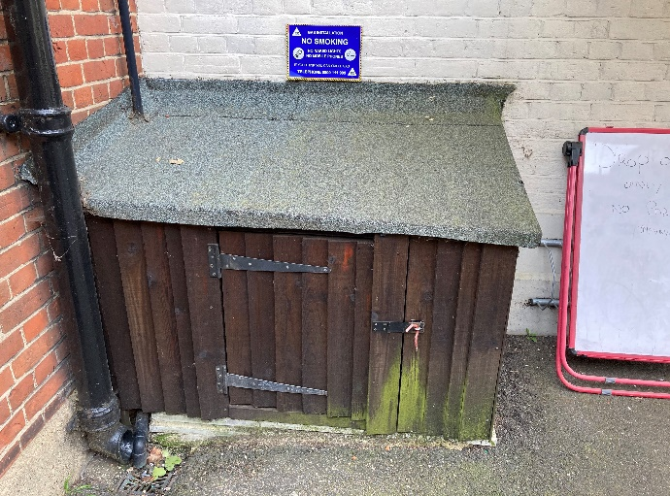**Location: Cupboard by Dereham Road Access Gate**

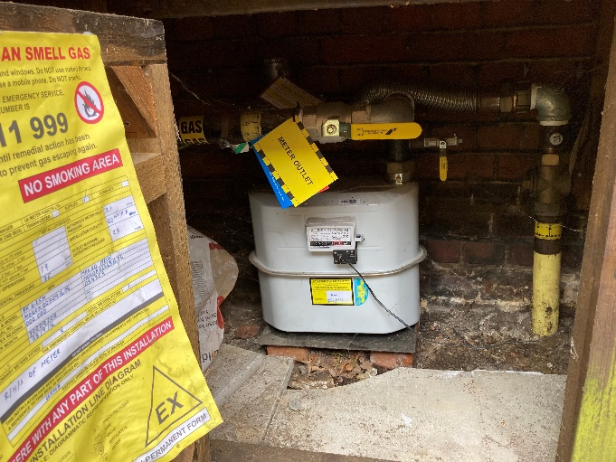



**Electricity Shut Off**

**Location: Large Green Cabinet by Kitchen**

**(Key inside hanging up just inside the hall door)**

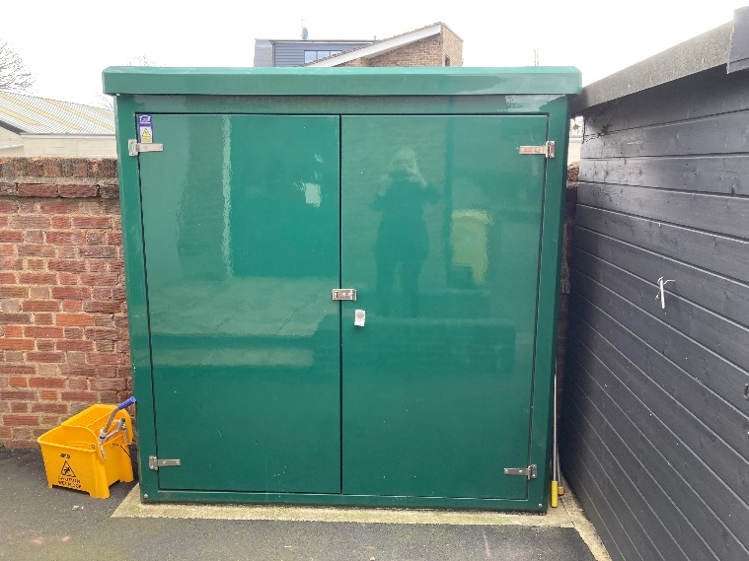

**Water Meter & Shut Off**

**Location: Front Lawn – Right of Car Park**

