**Viking is victorious in Shipman 28 National Championships at the Royal St. George Yacht Club.**

After a four-race series contested in the waters of Dublin bay on Friday 21st and Saturday 22nd June hosted by the Royal St. George Yacht Club, IRL 409 “Viking” helmed by Fergus Mason, Colm Duggan and Oliver McCrohan prevailed over the seven boat fleet.

Details of the Shipman, a robust and seaworthy Scandinavian one-design yacht conceived of by the eminent Olle Enderlein and primarily constructed in Ireland in the 1970s and 80s can be found on <www.irishshipmanassociation.com>

Race management was under the careful eye of Suzanne McGarry (RO), who succeeded in getting two races away each day in often tricky wind conditions – seeing competitors adapting to 20kt conditions and becoming becalmed as the sea breeze diminished later in the evening on Friday and also dropping off inshore towards Seapoint on Saturday afternoon (Race 4 in conjunction with DBSC Saturday series and involving transfer of Suzanne to join Harry Gallagher on “Spirit of the Irish”). All in all the testing conditions bore fruit for Viking, holding John Clarke of IRL 528 “Joslim” to a second place finish overall.

The Shipman fleet also run a handicap series won this year by Alain Deladinnie on IRL 639 “Poppy”

The Prizegiving Dinner was held in the Royal St. George on Saturday night, during which the ample silverware of this esteemed class was bestowed for another year on the winners of each race in the scratch and handicap series and overall. The fleet also invites White-sails competitors (no spinnakers) to encourage Shipman crews of all abilities to participate.

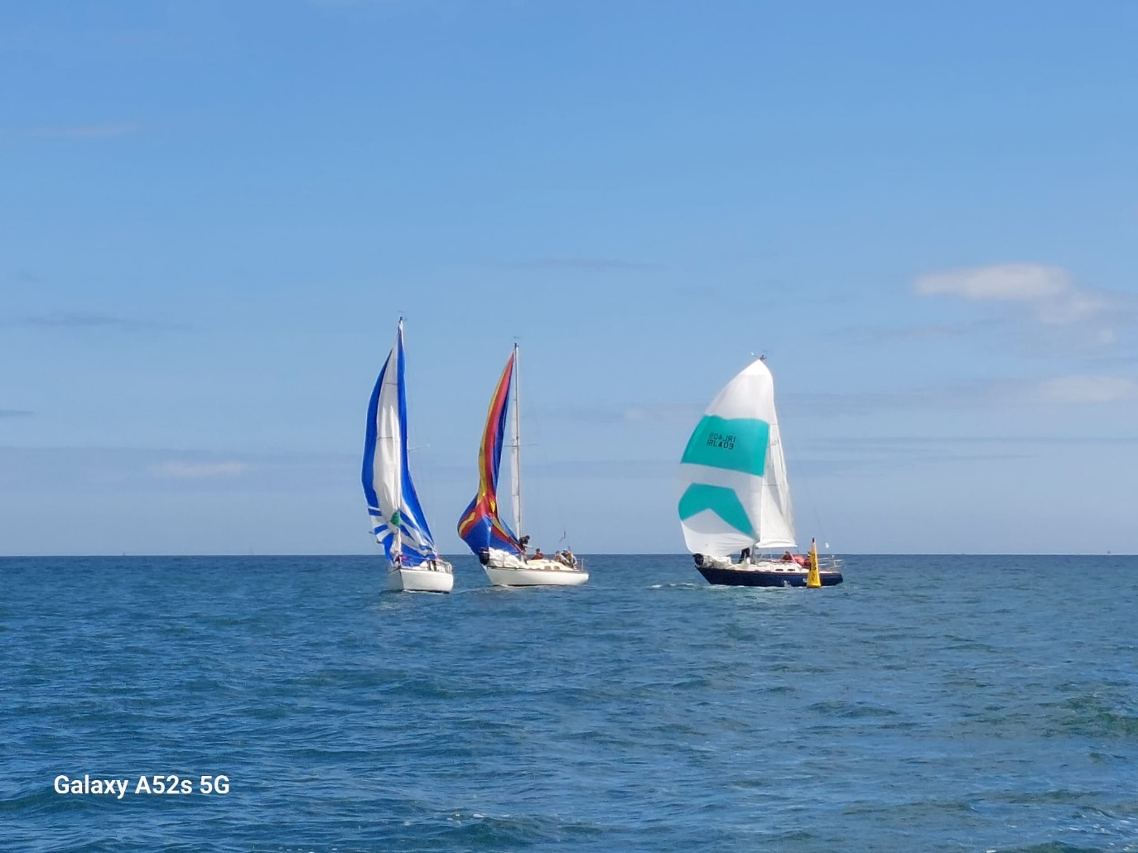

Viking takes the inside line at the Gybe

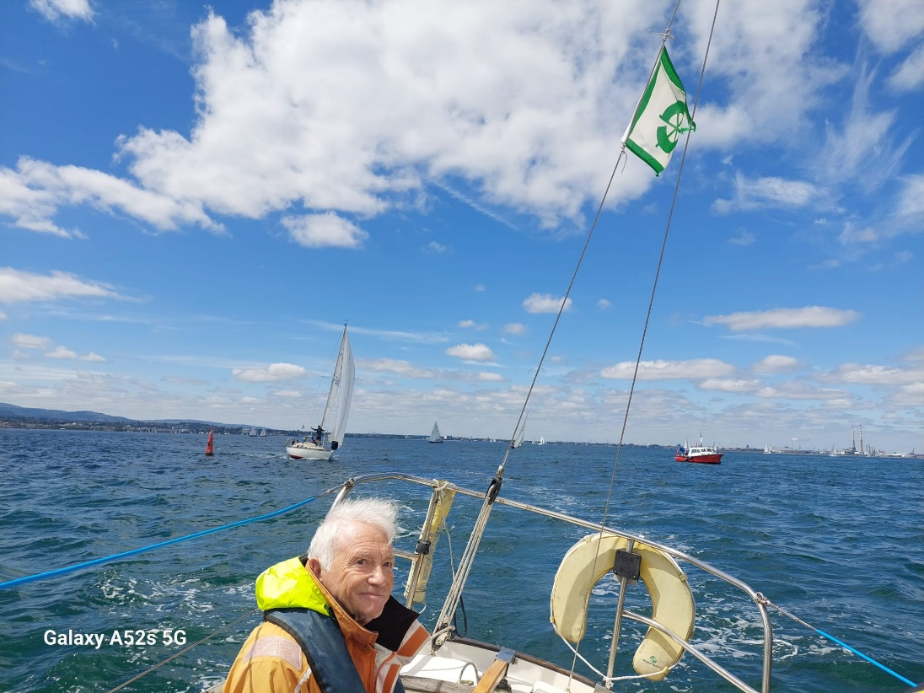

John Clarke 1st in Race 3 on IRL 528 “Joslim”

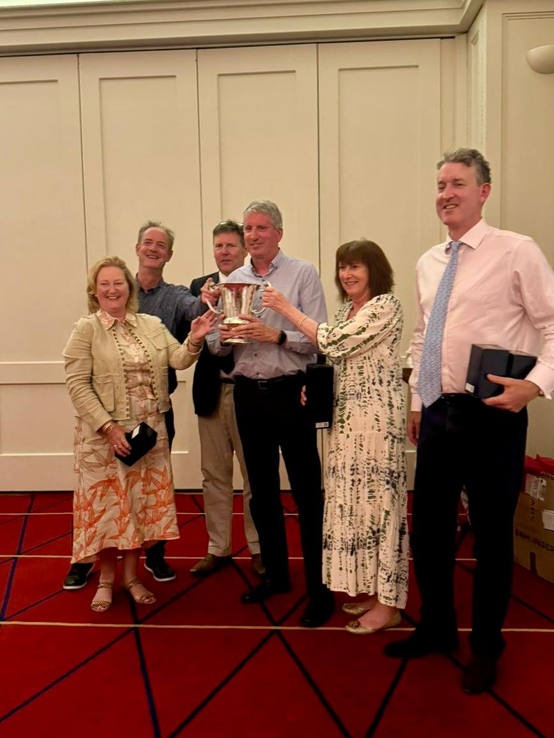

Shipman 28 National Champions 2024, IRL 409 “Viking” Partners and crew receiving the O’Connor Cup from BJ Maher (Commodore Shipman Association, 3rd from left) Pictured left to right, Orna Tubridy, Colm Duggan, BJ Maher, Fergus Mason, Maureen Mason and Hugh Anderson

