Update on loan payment

Pride in our past

faith in our future

Our balance due is **$10,083.47**. Thank you to everyone who has sent in additional funds. If you would like to make a donation, please scan the QR code or stop by the Parish Office. May we continue to be bold in our faith, so our church can serve our families for generations to come.

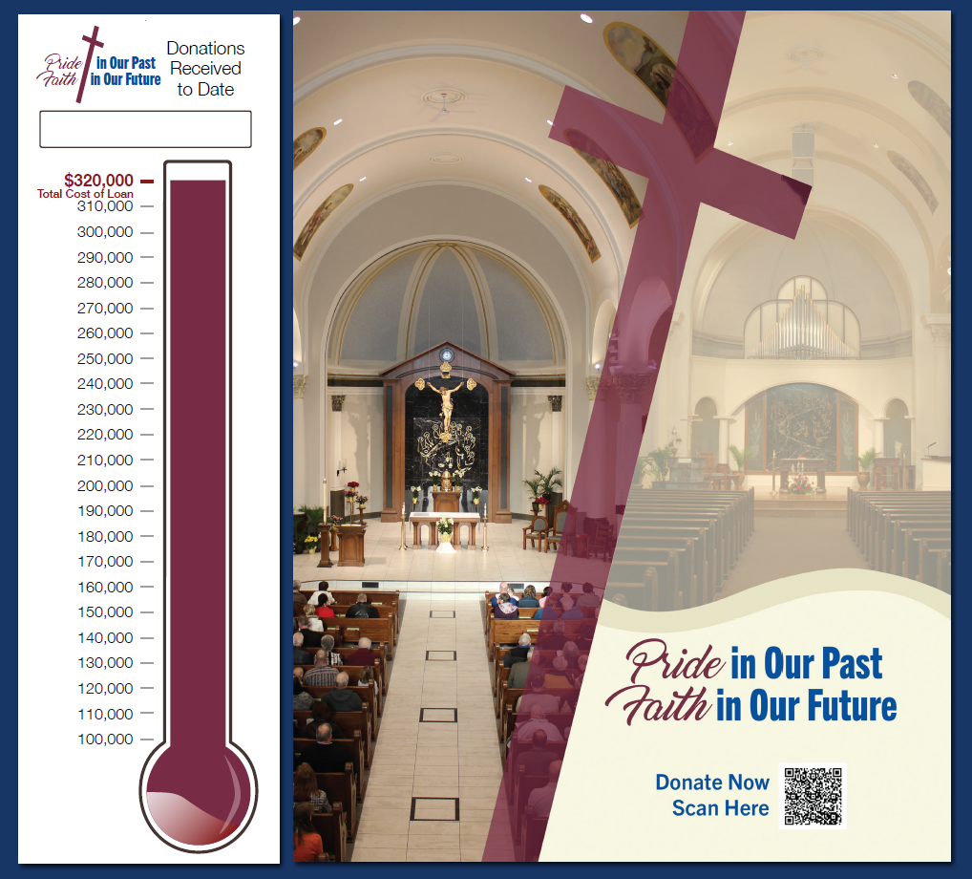

**Only**

**$10,083.47**

**To go!**

**$309,916.53**