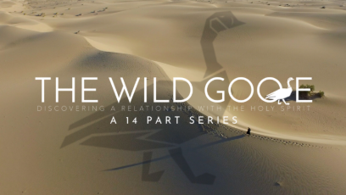
This fall we will be presenting a series entitled The Wild Goose, a 14-part series with Father Dave Pivonka discovering a deeper relationship with the Holy Spirit.
The wild goose is a Celtic Christian symbol for the Holy Spirit, representing its unpredictable, untamable, and transformative presence in our lives. The Holy Spirit often works in ways that challenge, guide, and transform our expectations. It encourages openness to God’s guidance, even when it leads to unexpected or challenging experiences. By embracing the Spirit’s wild and untamed nature, we can experience a deeper intimacy with God.
Kelly will begin this on Wednesday, September 16 at 6PM in the Parish Office building. The goal will be to end at about 7:15PM. Each video segment is about 25 minutes in length and a discussion will follow.
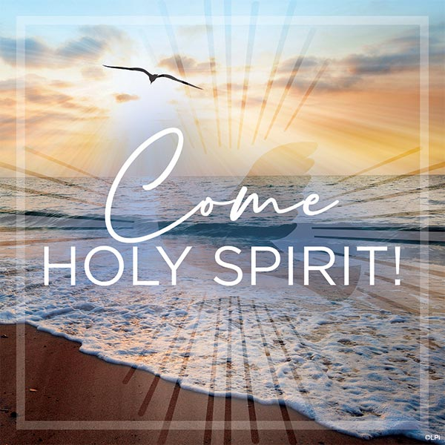
Full Schedule
- September 16: God’s Love Poured Out
- September 23: The Breath of God
- September 30: Baptism in the Holy Spirit and Fire
- October 7: The Spirit and Our Lady
- October 14: Gifts of the Holy Spirit
- October 21: The Spirit and The Eucharist
- October 28: The Spirit of Adoption
- November 4: The Spirit and the Sacraments
- November 11: The Fruits of the Holy Spirit
- November 18: The Spirit and the Desert
- December 2: The Spirit Convicts
- December 9: The Spirit’s Freedom
- December 16: The Spirit’s Witness
- December 23 (possibly move to 21 or 22): The Spirit Remembers
If you miss a night, this whole series can also be found on WildGooseTV on YouTube. Also, besides the first three segments, each episode can be watched without watching the others.

