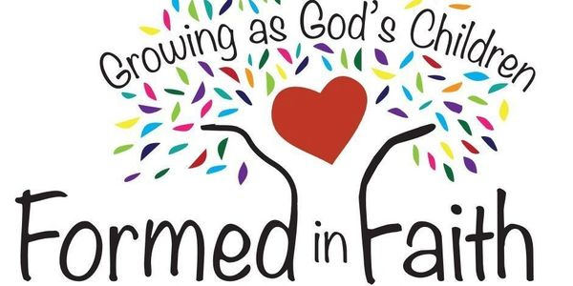
THIRD GRADE GOOD NEWS CENTER
Third graders will be learning about the CHURCH. As sinners, God loves us so much that he gave us Jesus, our Savior, to show us the way to conquer sin and death. As baptized Catholics we are the People of God. As part of the church community, we gather to hear His word and grow in faith and love.

Each of us is also part of a domestic church - our families- where we first learn about loving others and following Christ. Third graders are also learning that community (and communion) between persons means mutual giving of ourselves, and this is evident in God's revelation of himself to us in the Blessed Holy Trinity.

We will be learning about the Sacraments, in particular the Eucharist. As we concentrate on the Our Father, we will learn how to pray, ways to pray and types of prayers. We are off to a great start, with a great group of students.

Janet Maxa and Charlene Krupp

FOURTH GRADE GOOD NEWS CENTER
Our class started out with getting to know the Bible by looking up scripture passages. We talked about creation and how God keeps everyone and everything in His loving care.
They learned that God is always faithful and answers our prayers and He gave us the Ten Commandments to show us how to love Him and one another.
In the upcoming future we will be doing a couple of service projects. Thanks for sharing your children with us.
Deb Butcher and Barb Rodriguez
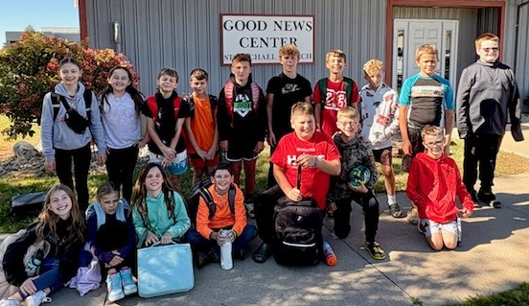
FIFTH GRADE GOOD NEWS CENTER
How do we fit into God’s Plan? Do we live in His love for us? How can we re-create ourselves to be a faithful people?
Created in God’s image, we are to respect and care for one another and for all creation. Inspired by the Bible and taking part in the Sacraments and all the Church’s traditions will help us achieve our part in God’s Plan.
Our words and actions, how we use our time, talent and treasures will reflect our love in the Holy Trinity and for each other.
The emphasis for 5th graders is the Seven Sacraments. We will focus on bringing ourselves into God’s plan and His love for us. We will study each sacrament individually including signs, symbols and participation.
We look forward to a great year.
Janet Maxa and Sarah Krupp

