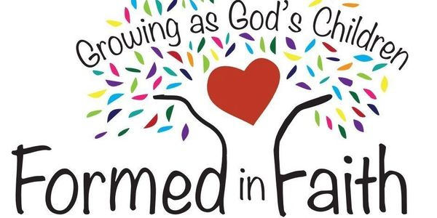

THIRD GRADE
As our Lenten journey begins, we will count the days to Easter, including how we incorporate prayer, fasting and almsgiving into our lives. Are we using God's gifts of time, talent and treasure to serve others? These sacrifices show our love for God and others. Our continued study of the Church will include the Four Marks of the Church, Morality, and the Sacraments. Thank you for sharing your children with us this year.

Janet Maxa and Charlene Krupp

FIFTH GRADE
5th graders began their Lenten journey with a focus on prayer, fasting and almsgiving as we renew our hearts and our relationship with God. We will pray the Stations of the Cross and review symbols and events of the Lenten season. We will study each of the seven Sacraments. Our concentration on the parts of the Mass will include our call to participate in and serve the Church.

Janet Maxa and Sarah Krupp

SEVENTH GRADE
Our 7th grade students at the Good News Center have been growing in their understanding of what it looks like to act out their faith. How that looks different for everyone depending on how open they are and how the Holy Spirit uses them. They then worked on a unit to understand the Gifts of the Holy Spirit, which included thinking about how the Holy Spirit is working in their life, what Gifts of the Spirit they see in themselves, and/or what gifts they would like to ask for a strengthening in. Yes, ALL but for them to start focusing on some is a big step forward in their faith. Please pray for them as they are also working on Confirmation preparations with a plan to be Confirmed in 2027.

