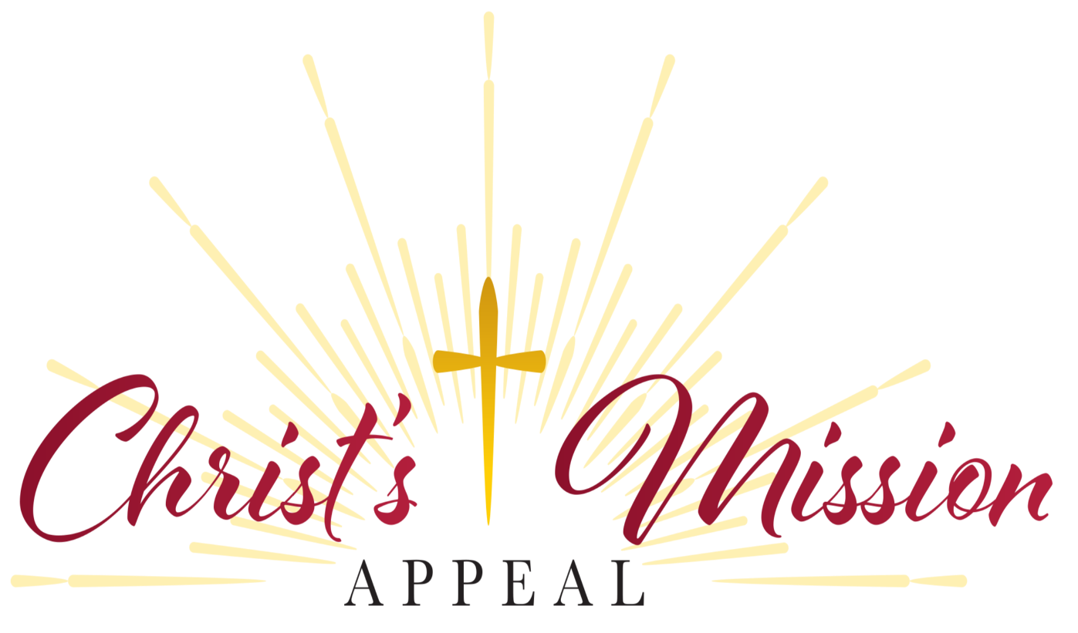

Stewardship and Development – Halfway Through Christ’s Mission Appeal – Two-thirds Towards Goal
Contributions continue to come in for the 2025-26 Christ’s Mission Appeal campaign, and five parishes have achieved and exceeded their goals. Overall, throughout the Diocese of Saginaw, with the generosity of donors, Christ’s Mission Appeal is at 66% toward the target. The close date for this campaign April 5. Some other data includes: four parishes are at 90%-99% of their targets; 11 parishes are between 75% and 89%; and 23 parishes are at 50%-74% towards goals.
Thank you for all you do to make Christ’s Mission Appeal successful.

SAINT MICHAEL PARISH ASSESMENT is $76,819
PLEDGED: $80,035.22 (105%)
PARTICIPATION: 225 (49%)

