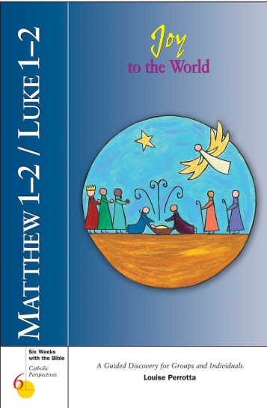
Bible Study
Sunday evenings at 6:30 beginning November 9th in the parish office building. Led by Nancy Ebenhoeh & Melissa Baker

Thursday mornings at 8:30 beginning November 6th in the parish office building. Led by Kelly Knieper

We will be using this study by Louise Perrotta on the Infancy Narratives from Matthew 1&2 and Luke 1&2.

We have books available for $12 or a free will donation. We currently have 17 books but can order more if needed. The sooner Kelly knows she can get more books before the sessions start.

Description: The birth of Christ is recorded in two of the Gospels: Matthew and Luke. In Matthew 1-2/Luke 1-2: Joy to the World the two versions of the birth of Christ are explored and explained.
For busy adults who want to study the Bible but don’t know where to begin, Six Weeks with the Bible provides an inviting starting point. Each guide is divided into six concise, 90-minute segments that introduce one book or theme from the Bible. All biblical text is printed in the guides, which means no additional study aids are required.

Please call Kelly to register and leave a message if she is away from her desk. (989) 845-7011 ext. 3

